[1.0 Purpose 1](#_Toc361815308)

[2.0 Responsibilities 1](#_Toc361815309)

[3.0 Associated Documents 1](#_Toc361815310)

[4.0 Overview 1](#_Toc361815311)

[5.0 Procedure 1](#_Toc361815312)

# Purpose

The purpose of this user guide is to explain the process of marking quartz wafers used in manufacturing crystals. This guide will provide examples of some of the many crystals currently in production.

# Responsibilities

Crystals Department engineering/management is responsible for maintaining this procedure. Authorized Crystals Department technicians are responsible for carrying out this procedure.

Affected Department / Product Group / Support Group: Crystals Department

# Associated Documents

ISO 9001, QAM, QSM, AS9100

# Overview

Crystals used to manufacture sensors are cut from quartz wafers. To indicate where a wafer must be marked, each crystal has an associated template. The template has lines on it to indicate how the wafer is marked by length and location. To ensure proper orientation of the wafer on the template, the template also has a notch location indicator to align with the notch on the wafer. For compression cut crystals, the template has a plus mark location to be marked on the wafer.

# Procedure

1. Select the template indicated on the job paperwork. Normally, these are printed with the job paperwork. Figure 1 shows an example template for marking 4729-01 crystals.



Figure 1 Example Template

1. Lay the wafer on the template and orient it so that the notches line up. See Figure 2. Compression cut wafers have an offset notch, so the wafer may need to be flipped over to ensure proper orientation.

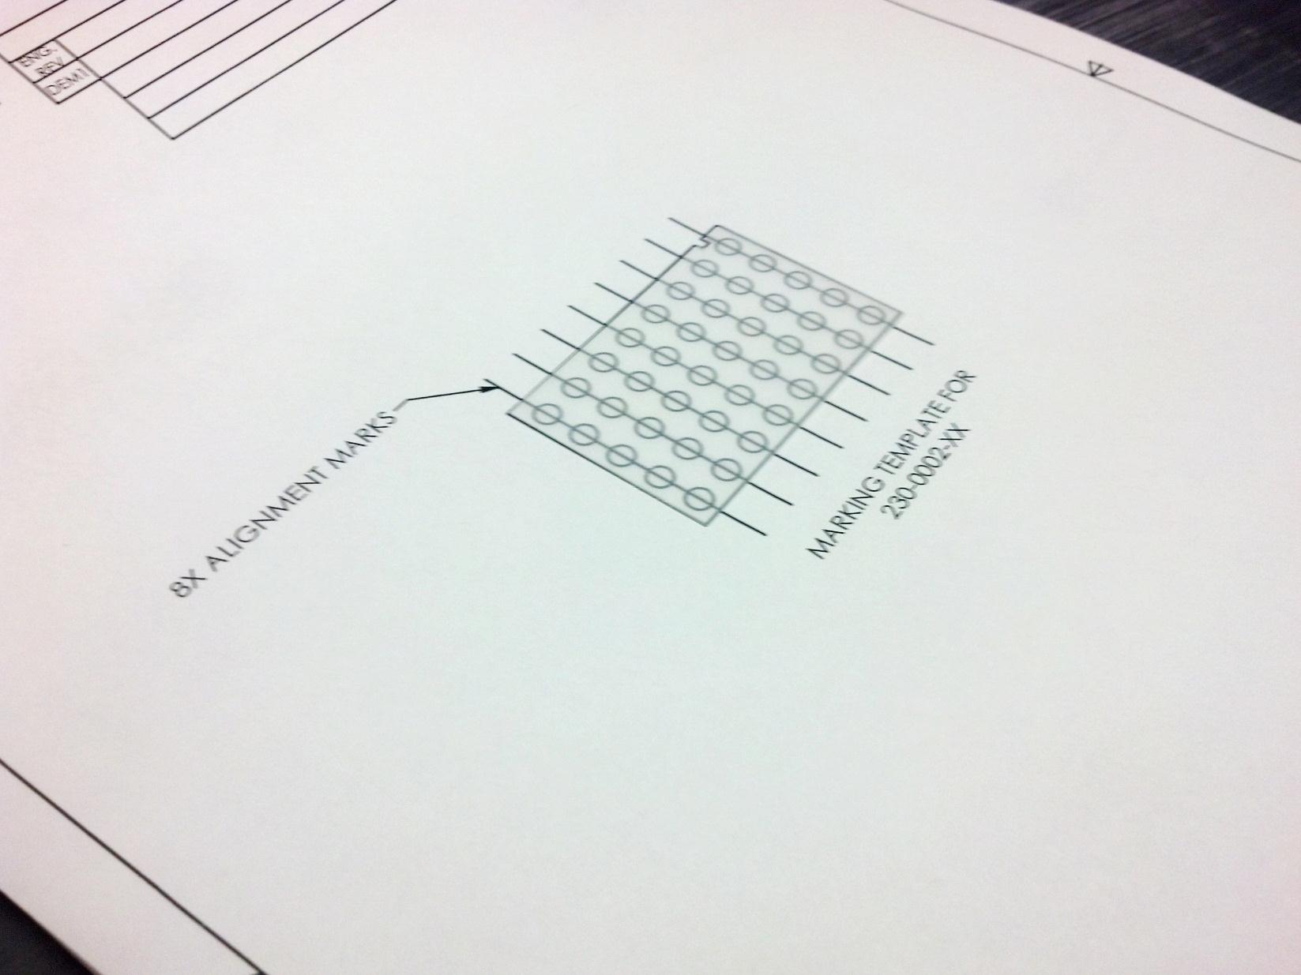

Notches must line up

Figure 2 230-0002-07 Wafer on Template

1. Scribe the lines as indicated by the template. Use an aluminum stylus for unplated wafers and a plastic tipped stylus for plated wafers. See Figure 3 and Figure 4.

|  |  |
| --- | --- |
| C:\Users\crust\Desktop\IMG_20130716_091651_532.jpg  Figure 3 Aluminum Stylus | C:\Users\crust\Desktop\IMG_20130716_091932_617.jpg  Figure 4 Plastic Tipped Stylus |

1. Mark the plus marks as required. Pay close attention to their locations to ensure they will appear on the part after it is machined.