Purpose 1

1.0 Responsibilities 1

2.0 Associated Documents 1

3.0 General Practice 1

4.0 Procedure 1

# Purpose

This user guide describes how to test the polarity of quartz stones, sections, wafers and crystals using the Arbor Press and tester.

# Responsibilities

Crystal Department engineering / management is responsible for maintaining this procedure.

Crystal Department technicians are responsible for carrying out this procedure.

# Associated Documents

ISO 9001, QAM, QSM, AS9100

# General Practice

Polarity testing is performed throughout the production cycle of preparing quartz raw material (stones) first into sections, then into wafers, then finally into crystals. The procedure is essentially the same for each form but handling the quartz necessarily changes based on its form at its current point in the cycle.

NOTE: Never handle finished crystals with bare hands. Oils from fingers can contaminate the crystal surfaces. Always use the appropriate tweezers or finger cots.

# Procedure

1. Turn on the power to the tester. See Figure 1. No warm up time is needed.
2. Set the tester with the following:
3. Set the range to 50.
4. Set the time constant to L (Long).
5. Set the switch to GND.
6. Lift the Arbor Press handle to raise the column.
7. Place the quartz under the column on the Arbor Press, orienting the quartz as follows:

* To test the quartz in compression (X-orientation), align the +X axis upward.
* To test the quartz in shear (Y-orientation), align the +X axis facing away from you.

1. Lower the Arbor Press handle to slowly lower the column until it contacts the quartz.
2. Set the tester switch to OPR.

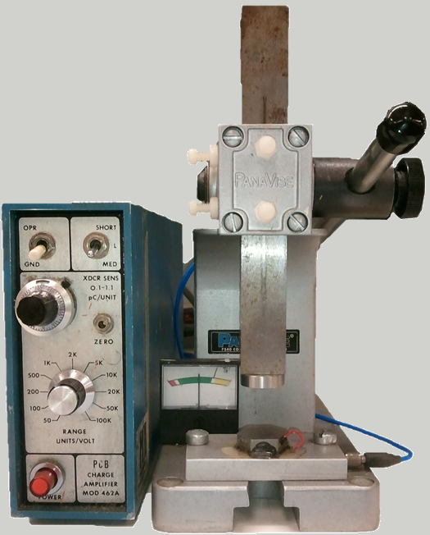

6

2c

9

8

7

3

5

7

4

2b

2a

1

Figure 1: Tester and Arbor Press

1. Apply pressure to the quartz as follows:

* To test the quartz in compression (X-orientation), use the Arbor Press handle to apply pressure in pulses.
* To test the quartz in shear (Y-orientation), use the Arbor Press handle to apply continuous pressure while using a finger to apply pressure in pulses to the column, just above the quartz.

1. While applying the pressure as described above, observe the deflection of the tester’s indicator needle:

| **Direction of Needle Deflection** | **Compression (X-orientation) Testing** | **Shear (Y-orientation) Testing** |
| --- | --- | --- |
| Toward the Positive (+) Sign | Indicates +X is up | Indicates +X is facing away from you |
| Toward the Negative (–) Sign | Indicates +X is down | Indicates +X is facing toward you |

* If the needle deflects too wildly, switch the range knob to a higher number and re-test.
* If the needle drifts without pressure being applied, set the tester switch to GND and re-test.
* If the needle pegs to either side, there is a short-circuit.

1. Set the tester switch to GND.
2. Lift the Arbor Press handle to raise the column and release the quartz, then remove the quartz from the press.
3. If the quartz is found to be marked incorrectly, notify your supervisor or engineering.
4. When you are finished testing polarity, turn off the power to the tester.