Purpose 1

1.0 Responsibilities 1

2.0 Associated Documents 1

3.0 General Practice 1

4.0 Procedure 1

# Purpose

This user guide describes how to test the polarity of quartz stones, sections, wafers and crystals using the Arbor Press and tester.

# Responsibilities

Crystal Department engineering / management is responsible for maintaining this procedure.

Crystal Department technicians are responsible for carrying out this procedure.

# Associated Documents

ISO 9001, QAM, QSM, AS9100

# General Practice

Polarity testing is performed throughout the production cycle of preparing quartz raw material (stones) first into sections, then into wafers, then finally into crystals. The procedure is essentially the same for each form but handling the quartz necessarily changes based on its form at its current point in the cycle.

NOTE: Never handle finished crystals with bare hands. Oils from fingers can contaminate the crystal surfaces. Always use the appropriate tweezers or finger cots.

# Notes on the New 462P Amplifier

1. The shorting switch is meant to simultaneously discharge the crystal, as well as reset the amplifier and the output display. It should be used any time there is erratic output, or drifting.

UP = continuously shorting

MIDDLE = normal operation (no shorting)

DOWN = momentary shorting

1. The sensitivity switch (mV/pC) adjusts the gain of the amplifier by factors of 10. Lower settings should be used with high-output ceramic crystals, and higher settings should be used with Quartz crystals. Always start from a low setting and increase until the desired output is reached. Setting the sensitivity too high for a particular crystal can overload the amplifier and cause incorrect or erratic output.
2. The gain knob is redundant. It provides from 1x to 100x post-gain. Eventually this will be eliminated, but currently it can be used for finer control over the output signal. Keep this knob around half of its travel, or higher.

# Procedure

1. Turn on the power to the tester. See Figure 1. No warm up time is needed.
2. If using old 462A amplifier:
3. Set the range to 50.
4. Set the time constant to L (Long).
5. Set the switch to GND.
6. If using new 462P amplifier:
7. Set the sensitivity to the lowest setting to start (0.1mV/pC).
8. Set gain knob to roughly half of its travel or higher.
9. Set the shorting switch to its middle position for normal operation.
10. Lift the Arbor Press handle to raise the column.
11. Place the quartz under the column on the Arbor Press, orienting the quartz as follows:

* To test the quartz in compression (X-orientation), align the +X axis upward.
* To test the quartz in shear (Y-orientation), align the +X axis facing away from you.

1. Lower the Arbor Press handle to slowly lower the column until it contacts the quartz.
2. If using the old 462A amplifier, set the tester switch to OPR.

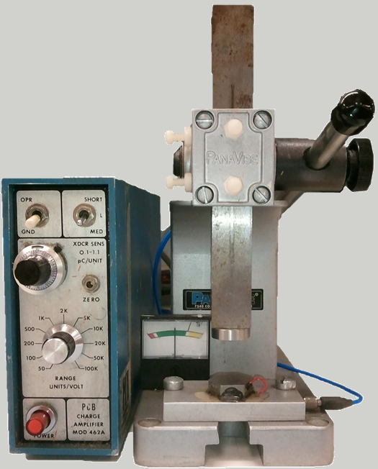

6

2c

9

8

7

3

5

7

4

2b

2a

1

Figure 1: Old 462A Amp and Arbor Press

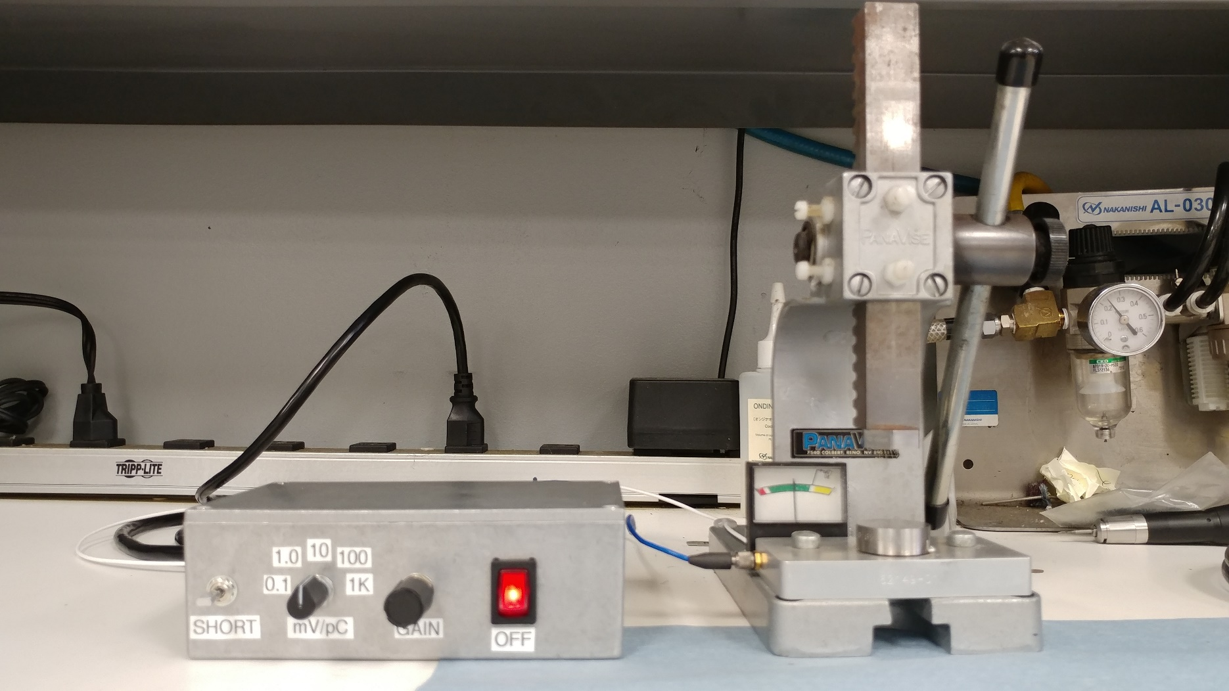

Shorting switch

Sensitivity switch (pre-gain)

1x to 100x post-gain

Figure 2: New 462P Amp and Arbor Press

1. Apply pressure to the quartz as follows:

* To test the quartz in compression (X-orientation), use the Arbor Press handle to apply pressure in pulses.
* To test the quartz in shear (Y-orientation), use the Arbor Press handle to apply continuous pressure while using a finger to apply pressure in pulses to the column, just above the quartz.

1. While applying the pressure as described above, observe the deflection of the tester’s indicator needle:

| **Direction of Needle Deflection** | **Compression (X-orientation) Testing** | **Shear (Y-orientation) Testing** |
| --- | --- | --- |
| Toward the Positive (+) Sign | Indicates +X is up | Indicates +X is facing away from you |
| Toward the Negative (–) Sign | Indicates +X is down | Indicates +X is facing toward you |

1. Set the tester switch to GND.
2. Lift the Arbor Press handle to raise the column and release the quartz, then remove the quartz from the press.
3. If the quartz is found to be marked incorrectly, notify your supervisor or engineering.
4. When you are finished testing polarity, turn off the power to the tester.

# Troubleshooting with Old 462A Amplifier

* If the needle deflects too wildly, switch the range knob to a higher number and re-test.
* If the needle drifts without pressure being applied, set the tester switch to GND and re-test.
* If the needle pegs to either side, there is a short-circuit.

# Troubleshooting with New 462P Amplifier

* If the needle deflects too wildly, toggle the shorting switch and re-test.

Note: The column must be touching the crystal in order to discharge it with the shorting switch.

* If the needle still deflects wildly, try a lower sensitivity setting.
* If the needle drifts without pressure being applied, toggle the shorting switch and re-test.
* If the needle pegs to either side, check for a short-circuit. If there is no short, the amplifier chip may be blown. If this happens, contact engineering. Note, there should be a spare chip on the inside lid.