Purpose 1

1.0 Responsibilities 1

2.0 Associated Documents 1

3.0 General Practice 1

4.0 Notes on the New 462P Amplifier 2

5.0 Procedure 3

6.0 Troubleshooting with Old 462A Amplifier 7

7.0 Troubleshooting with New 462P Amplifier 7

# Purpose

This user guide describes how to test the polarity of quartz stones, sections, wafers and crystals using the Arbor Press and tester.

# Responsibilities

Crystal Department engineering / management is responsible for maintaining this procedure.

Crystal Department technicians are responsible for carrying out this procedure.

# Associated Documents

ISO 9001, QAM, QSM, AS9100

# General Practice

Polarity testing is performed throughout the production cycle of preparing quartz raw material (stones) first into sections, then into wafers, then finally into crystals. The procedure is essentially the same for each form but handling the quartz necessarily changes based on its form at its current point in the cycle.

NOTE: Never handle finished crystals with bare hands. Oils from fingers can contaminate the crystal surfaces. Always use the appropriate tweezers or finger cots.

# Notes on the New 462P Amplifier

1. The **shorting switch** is meant to simultaneously discharge the crystal, as well as reset the amplifier and the output display. It should be used any time there is erratic output, or drifting.

UP = continuously shorting

MIDDLE = normal operation (no shorting)

DOWN = momentary shorting

1. The **sensitivity switch** (mV/pC) adjusts the gain of the amplifier by factors of 10. Lower settings should be used with high-output ceramic crystals, and higher settings should be used with Quartz crystals. Start from a low setting and increase until the desired output is reached. Setting the sensitivity too high for a particular crystal can overload the amplifier and cause incorrect or erratic output.
2. **Red/green illumination** is triggered roughly when the needle “pegs” to its max or min. To ensure consistent results, sensitivity should be set such that a “click” can be heard when pulsing the crystal (the needle hitting its mechanical limit). Setting sensitivity too low may cause the LED to illuminate incorrectly on the “backswing” of the needle.
3. **Red/green illumination** on-time can be adjusted using the potentiometer in the lower right corner of the circuit board. It can be disabled by unplugging the blue wire of the LED. **Unplug unit before opening enclosure.**

# Procedure

1. Turn on the power to the tester. See Figure 1. No warm up time is needed.
2. If using old 462A amplifier:
3. Set the range to 50.
4. Set the time constant to L (Long).
5. Set the switch to GND.
6. If using new 462P amplifier:
7. Set the sensitivity to the lowest setting to start (0.1mV/pC). Increase later as needed.
8. Set the shorting switch to its middle position for normal operation.
9. Lift the Arbor Press handle to raise the column.
10. Place the quartz under the column on the Arbor Press, orienting the quartz as follows:

* To test the quartz in compression (X-orientation), align the +X axis upward.
* To test the quartz in shear (Y-orientation), align the +X axis facing away from you.

Note: Do not test ceramic in shear mode with the 462P amp and arbor press assembly.

1. Lower the Arbor Press handle to slowly lower the column until it contacts the quartz (gently).
2. If using the old 462A amplifier, set the tester switch to OPR.
3. Apply pressure to the quartz as follows:

* To test quartz in compression (X-orientation), use the Arbor Press handle to apply pressure in quick pulses. The column should stay in contact with the crystal the entire time (don’t “ram” the crystal).
* To test the quartz in shear (Y-orientation), use the Arbor Press handle to apply continuous pressure while using a finger to apply pressure in pulses to the column, just above the quartz.

1. While applying the pressure as described above, observe the deflection of the tester’s indicator needle:

| **Direction of Needle Deflection** | **Compression (X-orientation) Testing** | **Shear (Y-orientation) Testing** |
| --- | --- | --- |
| Toward the Positive (+) Sign | Indicates +X is up | Indicates +X is facing away from you |
| Toward the Negative (–) Sign | Indicates +X is down | Indicates +X is facing toward you |

1. Be sure to pulse the crystal at least two times to minimize the chance of a false reading.

Note: When using LED aid, wait between pulses until the needle has settled and the LED has turned off before pulsing again. LED on-time can be adjusted or disabled - if desired, notify the supervisor.

1. Set the tester switch to GND.
2. Lift the Arbor Press handle to raise the column and release the quartz, then remove the quartz from the press.
3. If the quartz is found to be marked incorrectly, notify your supervisor or engineering.
4. When you are finished testing polarity, turn off the power to the tester.

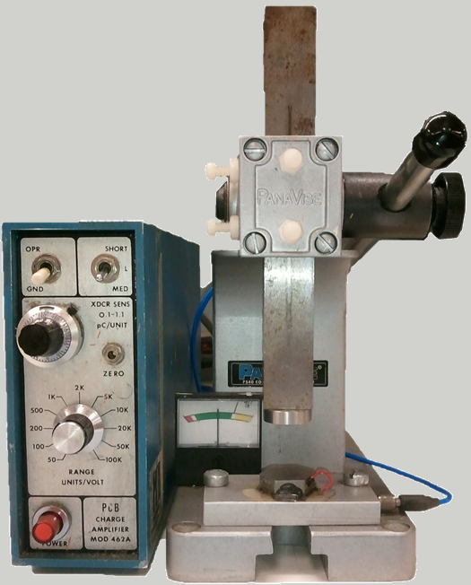

6

2c

9

8

7

3

5

7

4

2b

2a

1

Figure 1: Old 462A Amp and Arbor Press

Shorting switch

Sensitivity switch (gain)

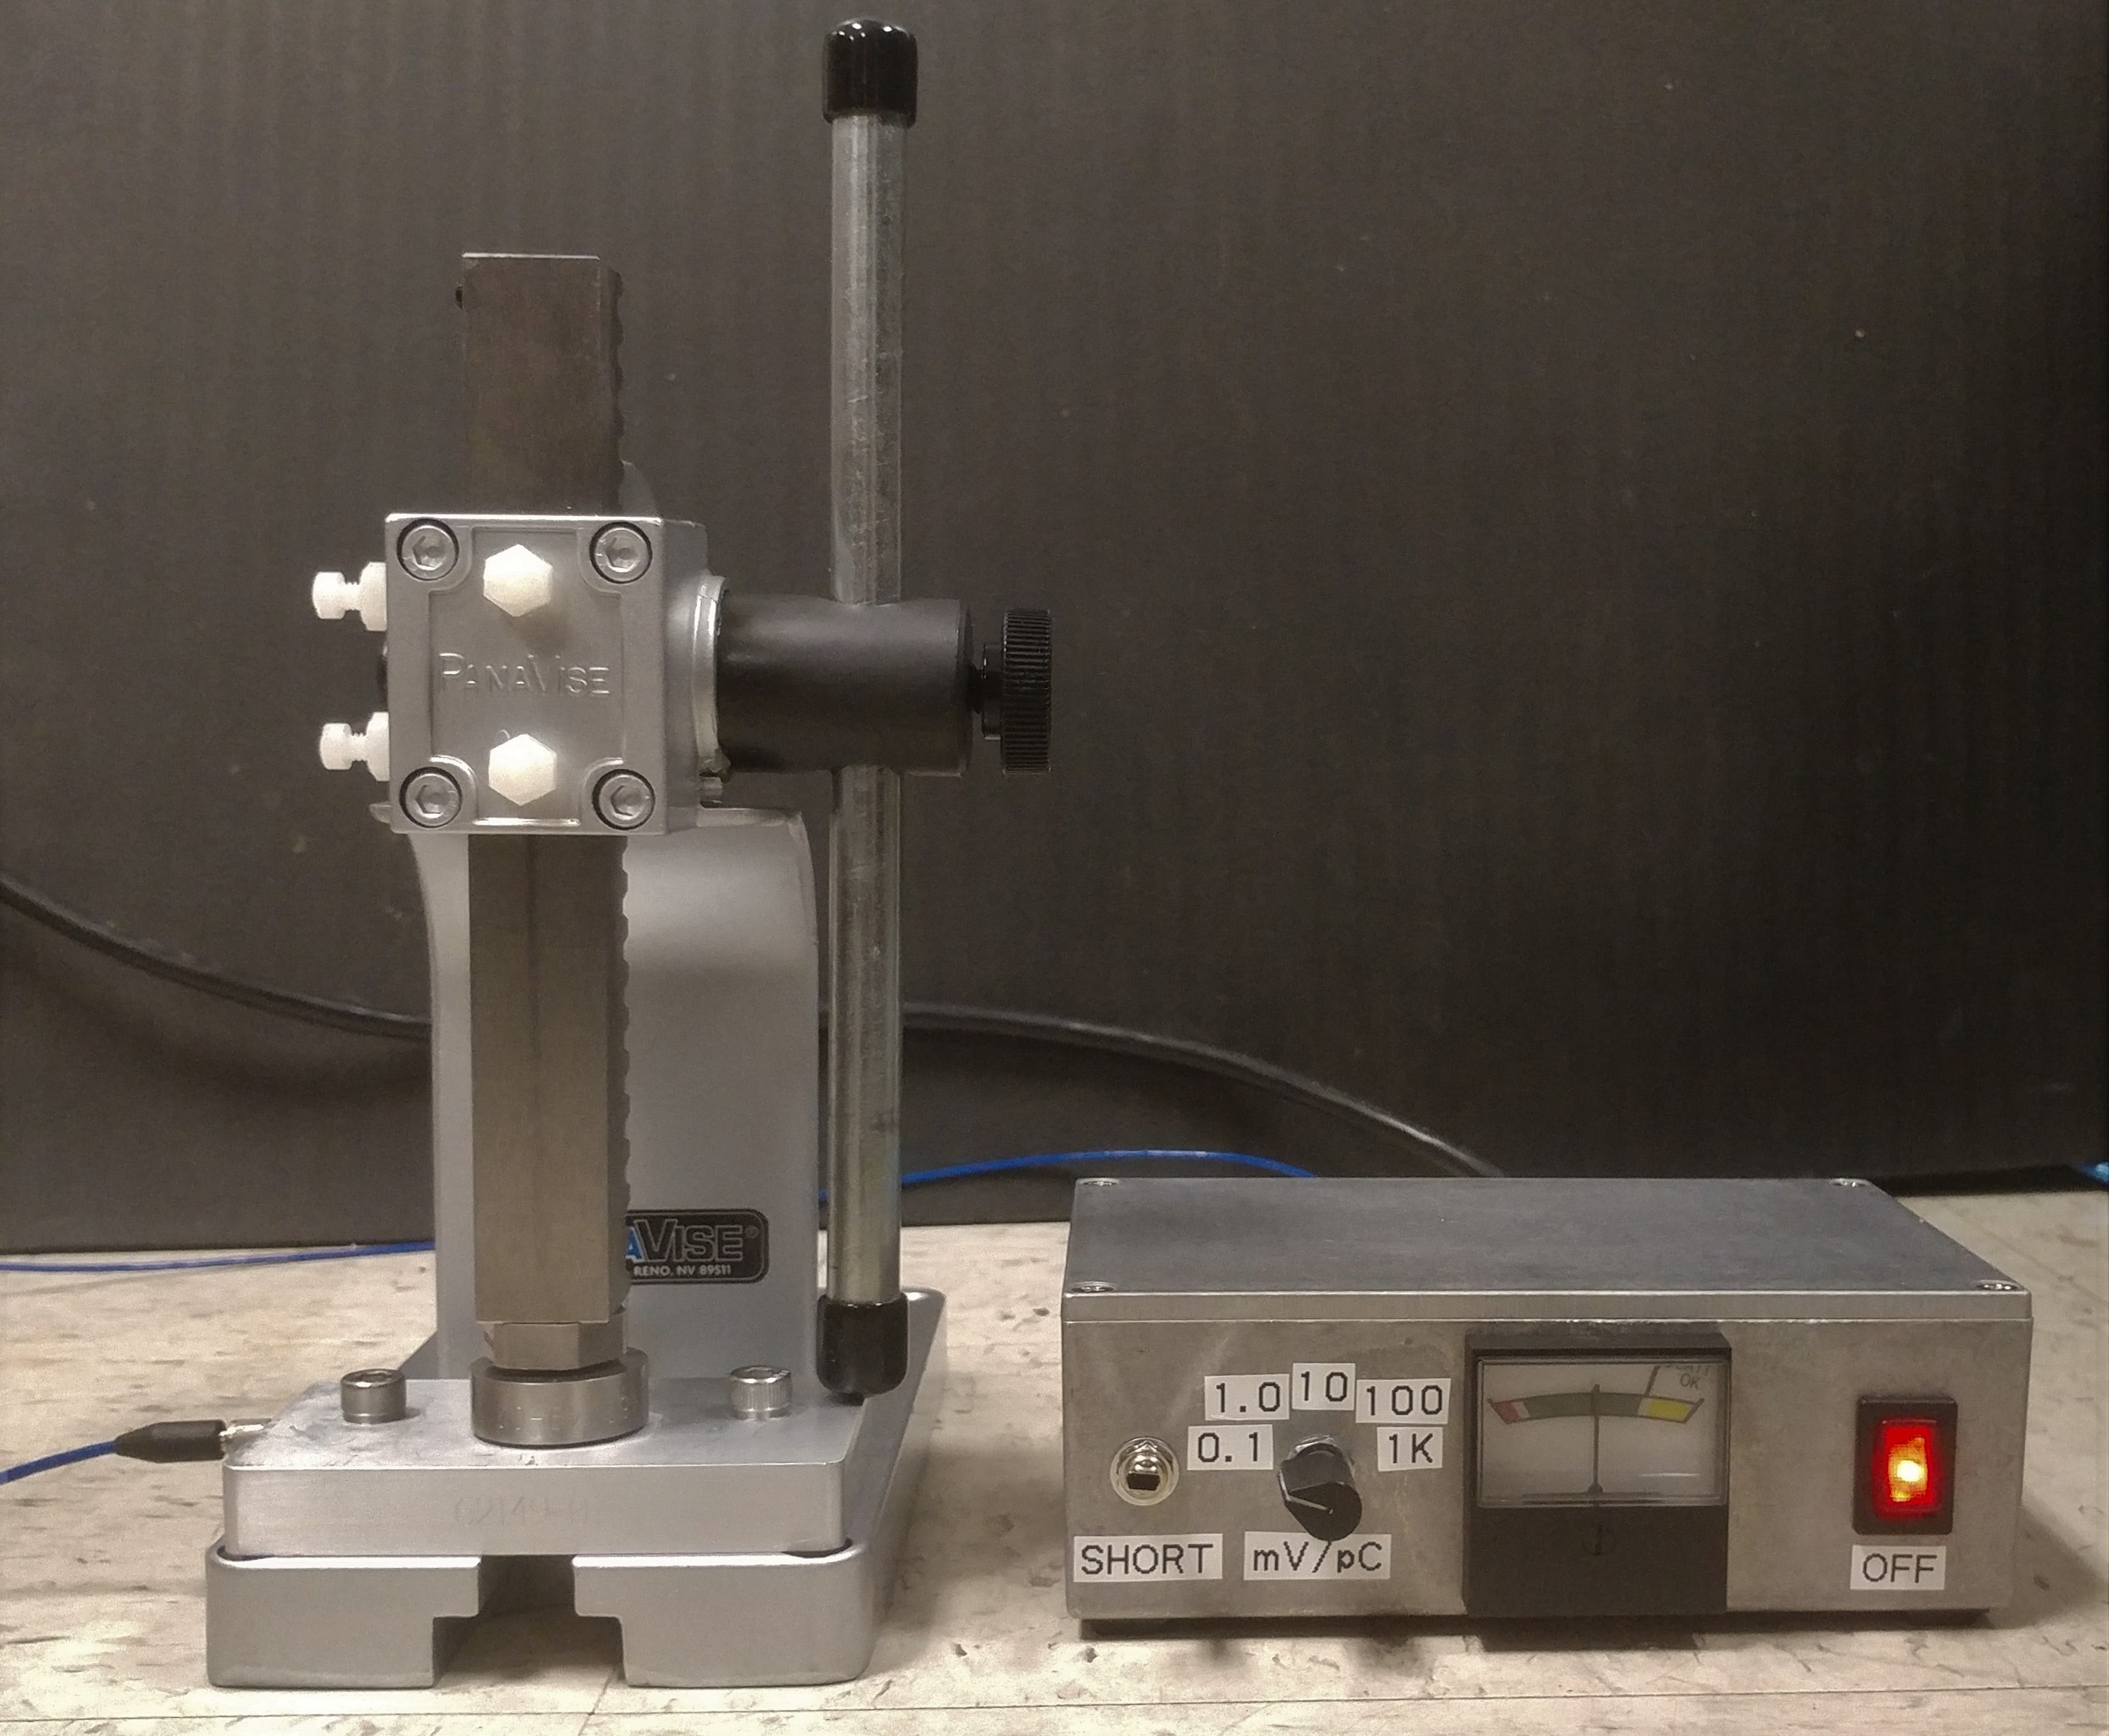

Figure 2: New 462P Amp and Arbor Press

**CTRL+CLICK HERE FOR VIDEO DEMO**

Tip: Higher gain settings usually work better, as long as the output is not erratic. It is only suggested to start from a low setting to avoid incorrect outputs caused by overloading the amp. As long as the output is consistent, higher settings are OK.

This can be seen in the video, where position 3 is “enough” to get good output. However, positions 4 and 5 still give consistent output, and they will be easier to use than position 3.

**Figure 3: Video Demo of Polarity Testing**

# Troubleshooting with Old 462A Amplifier

* If the needle deflects too wildly, switch the range knob to a higher number and re-test.
* If the needle drifts without pressure being applied, set the tester switch to GND and re-test.
* If the needle pegs to either side, there is a short-circuit.

# Troubleshooting with New 462P Amplifier

* If the needle deflects too wildly, toggle the shorting switch and re-test.

Note: The column must be touching the crystal in order to discharge it with the shorting switch.

* If the needle still deflects wildly, try a lower sensitivity setting.
* If the needle drifts without pressure being applied, toggle the shorting switch and re-test.