1.0 Purpose 1

2.0 Responsibilities 1

3.0 Associated Documents 1

4.0 Procedure 1

4.1. General Description and Practice 1

4.2. Safety Precautions 2

4.3. Part Numbers (Fired Stock) 3

4.4. Stokes F4 Press Setup and Operation 3

4.5. Using the OTC 55 Ton Press 7

4.6. Testing the Pieces 7

5.0 Appendix 8

# Purpose

The purpose of this procedure is to describe the process used to press ceramic tablets from ceramic powder.

# Responsibilities

Crystal Department engineering and management are responsible for maintaining this procedure.

Crystal Department technicians are responsible for carrying out this procedure.

# Associated Documents

ISO 9001, QAM, QSM, AS9100, CR025, CR034

# Procedure

## General Description and Practice

This procedure describes the tools and methods used to fabricate pressed ceramic parts from ceramic powder batches. It describes the general set-up and operation of the Stokes F4 and OTC 55 TON mechanical die presses used to form the ceramic shapes, as well as the techniques used to insure the highest quality parts.

The three keys to producing quality pressed parts are cleanliness, proper material handling techniques, and proper equipment operation.

It is important that the tools used during the pressing operation be kept clean. This includes the press itself, the die table, the die set, and the feed shoe, as well as scoops that are used to transfer the powders from the batch container to the feed shoe. The micrometer, calipers and scale should also be kept clean. Always insure that the die set is clean before beginning any pressing operation, and promptly wipe it clean it after completion of a press run.

Great care is taken to prevent the batches from being contaminated during the batching operation. Care must also be taken to prevent foreign material from contaminating the batch during the pressing operation. Always keep the jars of batch material closed when not removing powder to fill the feed shoe. Do not return spilled batch material to its container, or try to recover the “tailings” left over from a press run, since these materials may have picked up contaminants.

Refer to the appropriate section for proper set-up and operation of the press. Make sure that the presses are properly maintained. Make sure that the micrometer or calipers used to measure the pressed parts are reading accurately, and be sure that the scale is tared and level before weighing any parts.

The pressing of ceramic powders can be somewhat sensitive to environmental conditions such as temperature and humidity. While there is no exact range required for these conditions, in periods of high humidity the powder may absorb moisture from the air, changing its pressing characteristics. It may be required to dry the powder in an oven prior to pressing under these conditions. However, check with the engineer before drying any batches.

## Safety Precautions

In the following operations, either a four-ton or fifty five-ton mechanical press will be used. Currently, there are no fail-safe brakes or pinch point guards on some of the moving parts. Therefore, it is imperative that the operator understands the safe use of this equipment. The back of the Stokes press has an open, rotating flywheel. The front of the Stokes press has an open, reciprocating upper punch and crosshead assembly. By following some simple rules and guidelines, these presses can be operated safely.

* IN THE CASE OF ANY INJURY, INFORM YOUR SUPERVISOR IMMEDIATELY.
* While the press is in motion, do not attempt to make any adjustments, clear the die table, or allow your hands to come close to the upper punch and crosshead assembly. As the upper punch descends into the die cavity to compress the powder, it will compress anything else that gets in its way, such as tools and fingers, resulting in damage to the press and / or serious injury. Turn off the press and allow it to come to a complete stop before making any adjustments.
* While the press is operating, keep the lower punch cover closed except to make setups. Keep your hands clear of the assembly. Turn off the press prior to making any adjustments.
* Make sure the feed shoe is either removed from the die table or is attached to the shaker rod. Do not operate the press with the feed shoe on the table but not connected to the shaker rod, as this could damage the press.
* In case of any accidents or damage to the equipment, notify your supervisor immediately.
* It is generally recommended as safe practice to wear a dust mask whenever working with fine powders, since all fine powders can be irritating to the nasal passages, throat and lungs. When pressing parts out of PZT material, it is recommended that the operator wears a NIOSH-approved dust mask (3M 8233 or equivalent), since PZT contains lead, which is a hazardous material.
* When cleaning the area and the die tables and presses, do not use any type of compressed air to “blow off” the powders, as this will generate airborne particles. Use the lead vacuum to clean up any powder, and wipe the areas clean with a wet paper towel or the special lead dust cleaner wipes. Discard the used towels in the appropriate hazardous waste container.
* Any scrap parts, powder, or setup pieces of ceramic material must be discarded in the appropriate hazardous waste container. Do not throw away in the normal trash.

## Part Numbers (Fired Stock)

Each pressed part will have a distinct part number. The drawing provided with the job will show the “fired” dimensions of the part being pressed. These dimensions are slightly smaller than the dimensions of the pressed part to account for shrinkage after the subsequent ceramic firing process. The router or batch qualification traveler will specify which die set to use to press the desired piece.

For each new pressing job, create a record for the pressing data by creating a new copy of CR034. Custom versions of CR034 exist for each part number and should be saved in the correct folder by that number. The folder can be found on the network: R:\Crystals\Batching Data\Density Measurements.Save a new copy of CR034 in the proper folder with the following naming convention: Mat’l Spec (Powder Lot)(Job No.) Press Date.xlsx. An example of this is as follows: PCB370 (140-4)(CR9421) 3-21-2017.xlsx.

The pressing log should also be filled out for each fired stock job. The log can be found on the network: R:\Crystals\Ceramics\Powder Pressing Log.

## Stokes F4 Press Setup and Operation

The F4 is capable of generating 4 tons (8,000 lbs) of force, while the OTC 55 TON can generate 55 tons (110,000 lbs). The F4 is used most often due to the small size of the parts produced.

The Stokes press is a single station eccentric cam press. It applies pressure from both the top and bottom simultaneously to produce parts of uniform density. A stationary core rod can be used so that parts with holes can be produced. The sequence of operations that take place as the press is operating is as follows:

* The shaker arm pulls the feed shoe across the die table, pushing the last piece pressed from the die area.
* The lower punch drops to its die fill position.
* The shaker arm agitates the feed cup back and forth across the die opening, filling the cavity with powder.
* The feed cup is pulled away from the die area as the upper punch begins to descend towards the die.
* At the instant the top punch enters the die cavity, the lower punch is pushed upward toward the top punch. Therefore, the powder is compressed equally from the bottom as well as from the top.
* The top punch is pulled from the die cavity. For a short distance of about 0.010”, the bottom punch travels upwards with the top punch so that there is not a sudden release of pressure.
* The bottom punch raises from the pressing position to the eject position flush with the die table, ejecting the pressed piece from the die.
* The shaker arm pulls the feed shoe across the die table, pushing aside the pressed part, and starts the sequence again.

### Maintenance of the Stokes F4

Refer to the equipment manual and Preventative Maintenance sheet for appropriate maintenance procedures.

### Removing the Die Set from the Press

1. Remove the feed shoe from the press. Be careful not to hit the upper punch when lifting the feed shoe off of the die table.
2. If there was a core rod used with the old die set, loosen the lock nut on the bottom of the core rod assembly and remove the split clamp. Drop the core rod assembly down, and separate the core rod shafts as required. Remove the core rod from the upper core rod shaft by unscrewing the core rod.
3. Remove the upper punch by loosening the upper punch locking screw, and pulling the top punch from the punch holder. Do not allow the punch to drop freely. This will damage the punch tip and / or die.
4. The lower punch and die are released by removing the lower punch locking screw and removing the 4 hold-down cap screws from the die clamp ring. If necessary, vacuum out any powder that fell into the hold-down screws before removing the hold-down screws.
5. Remove the die from the table by first removing the die clamp ring, then lifting out the die. Be careful not to lose the shims which are used to adjust the height of the die in the table. Remove the lower punch by lifting it up through the die table.
6. Thoroughly clean the punches, die and core rod of all powder before storing. If the powder will not wipe off, wash in a beaker of methanol in the ultrasonic cleaner for a few minutes, then wipe clean. When the die set is clean and dry, store it in its proper drawer.
7. Clean the press of all loose powder using a brush and the lead vacuum cleaner. Make sure all areas where the punches and dies must seat are clean. If necessary, wipe clean with a paper towel soaked in methanol. Clean the screw threads and holes so that the locking screws will thread freely.

### Installing a Die Set into the Stokes F4 Press

1. Check the new die set for cleanliness. Clean if necessary. Identify the top punch from the bottom punch.
2. If there is a core rod in the die set, screw the core rod into the upper core rod shaft. Install the core rod assembly through the core rod bracket, and feed it upward. Attach the lower core rod shaft, and continue to feed the core rod assembly upward. Attach the core rod split clamp onto the core rod assembly above the core rod bracket, and slightly tighten the set screws in the clamp. Screw the core rod lock nut onto the core rod. Loosely adjust the height of the core rod by means of the lock nut and split clamp on either side of the base bracket.
3. Insert the bottom punch into the lower punch holder (over the core rod if there is one). Push the punch down into the holder as far as possible. Insert the lower punch lock screw and tighten.
4. Slip the die over the lower punch and push down until level with the die table. Set the die clamp ring over the die. Install the four (4) cap screws in the clamp ring and tighten.
5. The lower punch must be adjusted so that its face is exactly flush with the die table or a few thousandths of an inch above the die table. This position is called the eject position. The use of a straightedge or steel rule will help in determining the position of the lower punch with respect to the die table. To adjust, turn the machine over slowly by hand until the lower punch is at its highest position. Loosen the two locking cap screws on the upper collar on the lower plunger assembly. Turn this collar either to the left or to the right until the punch is at its proper level. Tighten the cap screws making sure that the split of the collar is equal on both sides of the plunger shaft. The adjustment of the ejection level may shift as the locking screws are tightened and may need to be readjusted several times before it is correctly set. Turn the machine over a revolution or two to make sure that the adjustment is correct.
6. Adjust the core rod so that the tip is flush with the top of the bottom punch or a few thousandths of an inch below the bottom punch. This is done by means of the nut and split collar at the bottom of the core rod assembly. Use the collar above the support bracket to adjust the level of the tip and use the bottom nut as a locknut. You will find though, that as the assembly is tightened, the level of the tip will change. It may take several tries to get the tip in the proper position. The clamping screws of the upper clamp must be tightened before tightening the lower nut. The split of the clamp should be approximately equal on both sides of the core rod base. Again, the use of a straightedge or ruler will make this positioning easier.
7. Refer to the router or batch qualification traveler for the density range required. Once this information is determined, the die fill and other press settings can be adjusted appropriately.
8. Adjust the lower punch to the proper die fill position. As a starting point, assume a fill depth of twice the desired press thickness. To adjust this position, loosen the lock screw on the fill position collar, and turn the collar as necessary to lower the bottom punch to the desired depth of fill. Tighten the lock screw on the collar, and check to see if the position of the punch moved. If the punch moves on locking, loosen the set screw and repeat the process until the depth of fill is adjusted to the desired reading once the locking screw is tightened. Rotate the press by hand through one complete cycle to make sure the indicator indicates the correct eject and die fill positions.
9. Rotate the press in a forward direction past its die fill position. You will notice that at the lowest level, the rocking lever will push the bottom punch up to a stationary position. Then it will move up approximately 0.010” shortly thereafter, remain stationary for a short time, and then move up to its ejection position, which is level with the die table. Now rotate the press to the first stationary position after the die fill position. This is the point where the upper punch will be at its lowest position and the most amount of pressure is being applied to the piece to be pressed. This is the bottom punch press position, the point in the pressing cycle to which the bottom punch must be adjusted to for pressing. Loosen the locking screws of the lowest collar of the lower plunger. Rotate the collar either to the left or to the right until the lower punch is in the proper position for pressing. Tighten the locking screws on the collar. If the position of the lower plunger shifts on tightening, readjust so that it is in the proper position with the locking screws tightened. Rotate the press by hand through its cycle, checking the position of the lower punch throughout its cycle. Make any changes as necessary.
10. Insert the upper punch into the upper punch holder. Push the punch up into the holder as far as possible. Insert the upper punch locking screw into the threaded hole and tighten.
11. Adjust the upper punch to its uppermost position by loosening the locking handwheel on the left side of the upper plunger assembly and turning the adjusting handwheel on the right side of the upper plunger assembly. The punch is at its uppermost position when the screw in the eccentric bushing appears to be at the bottom.
12. Rotate the press by hand until the upper punch is just above the die. Make sure that the upper punch is aligned with the ID of the die. If necessary, slightly loosen the set screws on the upper punch holder and align the upper punch with the die ID. Slowly turn the flywheel to lower the punch slightly into the die. Tighten the set screws in the upper punch holder. Rotate the press by hand again through a cycle to confirm the upper punch to die alignment.

### Final Adjustments for Density

1. Insert the feed shoe back into the die table and reattach the shaker rod.
2. Fill the feed shoe with the material to be pressed.
3. Turn the press over by hand in the forward direction until the upper punch is in its lowest position of the cycle. Use the hand cranks on the upper crosshead assembly to lower the upper punch until some (not much) pressure is being applied by the upper punch. Now turn on the press and press 1 to 2 pieces.
4. Weigh the pieces and compare with the desired weight. If necessary, adjust the middle collar of the plunger assembly to adjust the die fill to be closer to the desired mass. Then make the calculation of what the bottom punch position should be at the pressing position and adjust the lowest collar to that position. Again, turn the press over to the pressing position and adjust the top punch so that it is applying only a small amount of pressure. Turn on the press and press 1 to 2 pieces. Continue to weigh, compare, adjust and press samples of pieces until the pieces have approximately the right amount of mass.
5. Use a micrometer or calipers to measure the dimensions of the last pieces pressed that have the correct mass. Calculate the density of the piece using CR034. Compare this density to the desired pressed density for the piece.
6. Loosen the left hand crank of the upper plunger assembly and turn the right hand crank to make the upper punch go down if the density was low and up if the density was high. The density of the piece should be adjusted to within the range shown on the router or batch qualification traveler. The upper punch should only be changed in small increments, either up or down. When pressing small diameter pieces, the punches can be easily damaged by excessive pressure if the upper punch is lowered too much at one time. Start with the density low and build up to the proper density range.
7. After several pieces have been pressed within the desired density range, snap a couple of pieces in half or cut in half using a razor blade to check for laminations. Examine the broken edges under a microscope with adequate lighting. The broken surface should look rough and granular. Signs of laminations are small cracks parallel to the pressed faces, and visible lines or layers within the broken surface. Even minor laminar cracks at the very outer edges of the piece are cause for rejection, since these can propagate during the subsequent firing process and lead to reject pieces later in the process. Refer to the Appendix for examples.
8. If laminations are present, make the appropriate setup adjustments to reduce the density. Press several pieces, then check again for laminations. If the laminations cannot be eliminated after several attempts to lower the density, stop pressing and notify the engineer.

### Pressing Pieces

1. Once the press is operating at the proper density with the motor running, begin pressing the desired quantity of pieces. Make sure that the press has been oiled at the beginning of the run or at least at some point earlier in the day.
2. Add powder to the feed shoe as necessary. Try to keep the level of powder in the feed shoe at a consistent level, between full and half-full, at all times. This will help maintain consistent pressed density. Never let the feed shoe run out of powder, as the density of the last parts pressed will be considerably lower than desired.
3. After each pressing job, turn off the press and check for powder buildup on the punch faces. If necessary, wipe off the punch faces with an alcohol-dampened kimwipe.
4. As the pieces build up on the die table and chute, they must be removed. A storage container or disposable beaker can be positioned to catch the pieces as they come down the chute. Turn off the press and sweep pieces down the chute with a brush. Do not allow too many pressed pieces to lay on the die table, as they could interfere with the press operation.
5. When finished pressing, turn off the press. Clean the material from the shoe, die table, and work table, and dispose of material in the hazardous waste container. Use the lead vacuum to remove remaining powder from the die table. Wipe the punch faces clean.

## Using the OTC 55 Ton Press

1. Retract press
2. Set up press with bottom punch and die held up by boards.
3. Add premeasured material to the die cavity.
4. Level the powder with a plastic spatula, to help insure a consistent density in the pressed part.
5. Carefully insert the top punch into the die, making sure that the die set is centered under the press piston.
6. Depress the foot lever to begin applying pressure to the die. Keep you hands away from all moving parts of the die. Continue to let the press come down until the desired pressure is reached, for achieving the needed density
7. Release pressure from the press by pressing the back of the foot pedal until there is sufficient space to remove the top punch.
8. Carefully remove the top punch.
9. Remove the boards holding up the Die.
10. Apply force to the die set so that the pressed part can be removed from the die set.
11. Repeat steps 1 to 10 to achieve the desired number of parts.

## Testing the Pieces

1. Check the dimensions and density of the pressed pieces periodically to make sure that it is not deviating outside of the acceptable range. The sampling rate will be noted on the router. Record the measurements of the sample set on CR034.
2. Test the dimensions of the pressed pellets directly from the parts. When pressing glass frit preforms – which have very low strength – only measure the thickness directly, and measure the diameters from the die body and core rod.
3. After testing the dimensions and mass of each sample, destructively tested for defects, as before. The samples should be snapped in half or cut in half using a razor blade. Refer to the appendix for photographs of examples of defects.
4. Large blocks pressed on the OTC press do not need to be destructively tested. In this case, only the setup pieces for each press run need to be broken.

# Appendix

Table I. Troubleshooting Pressing Defects

| **Problem** | **Probable Cause/Explanation** | **Suggested Action** |
| --- | --- | --- |
| Laminations | Excessive pressing force or trying to press at too high of a density. As the pressing force is released, the pressed part tries to expand too much while still in the die, leading to lamination cracks. | Lowering the density usually will correct this condition. |
|  | Entrapped air in the pressed part. This can happen if the press is running at too high of a speed. | Slowing down the pressing speed should allow the air to escape from the powder during the pressing cycle. |
|  | Excessive die wear. As a die becomes worn, a “belly” forms in the die, resulting in the diameter of the die where the pressing takes place being slightly larger than the diameter that the part is ejected through. As the part is ejected, laminations and other cracks will be generated in the part. | A new die is required. |
|  | Excessive buildup of powder on the punch faces. This can be a result of either the powder being too wet, or worn punch faces. The pressed piece may not release from the punch face as it should, resulting in laminations as the pressure is released or when the feed shoe tries to clear the pressed piece away from the pressing area. | If the powder is too wet, drying in an oven should eliminate the problem. If the punch faces are worn, send the punch out to be refinished per the drawing. |
| Variations in Density | The bottom punch is sticking in the die. This can lead to changes in the die fill. | Make sure the bottom punch is dropping to the proper fill position during the pressing cycle. If it is not, tear down the die set up and clean the die. |
|  | Loose punches. | Check that the lock screws are tightened on both the upper and lower punches. |
|  | Condition of the powder. Excessive fines and / or poor granulation can cause inconsistent die fill. |  |
|  | Die fill collar is loose. | Check that that the collar is tight. |
| Press Labors Hard During Pressing or Ejection | Unusual creaking or knocking sounds during the pressing cycle can be due to material between bottom punch and die. | Remove the bottom punch and clean. |
|  | These same sounds can be caused by trying to press at too high of a density. | Reducing the density should eliminate the problem. |
|  | Due to the compressibility of the material (moisture content, granulation, etc.) and / or the size of the punch, the size piece at the density desired is beyond the capabilities of the press. | Contact the supervisor or engineer if this condition exists. |

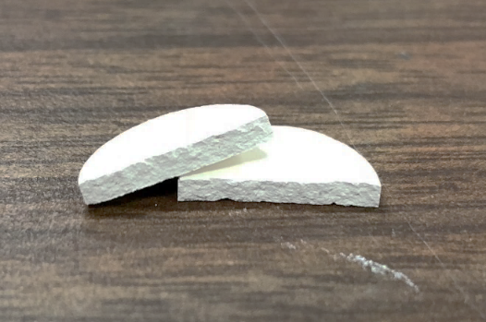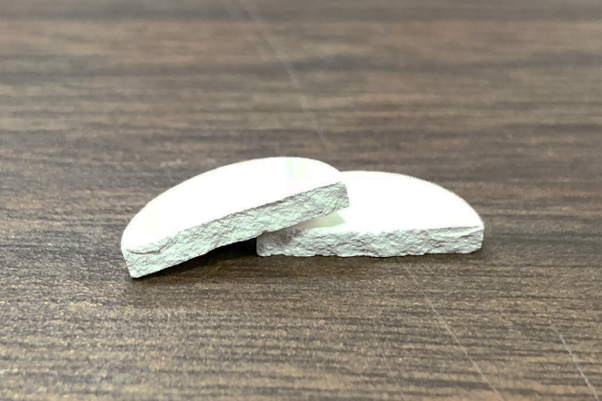

Figure 1. Example of a ½” disk, illustrating both a featureless (left) and end-capped (right) fracture surface. The image on the right shows the defect extending diagonally inward from the edge, and is a typical example of the defect when we find it. In extreme cases, this defect can extend all the way to the center of the part in a conical shape. The defect is typically associated with high fines content or overpressing the parts, and can be remedied by decreasing the pressed density target.

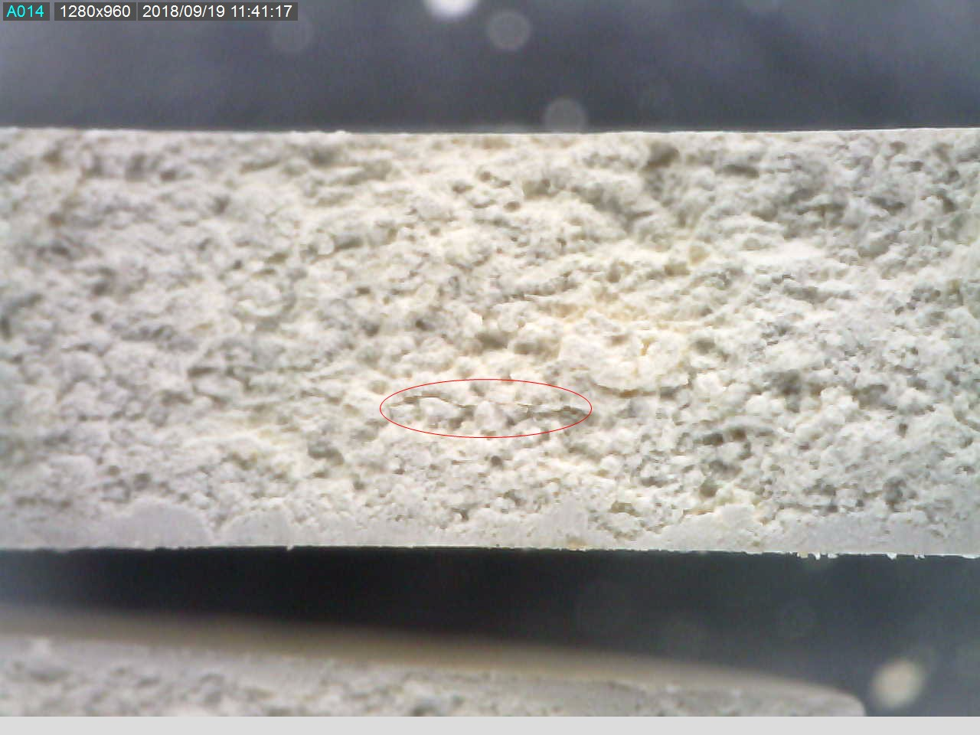

**Figure 2. Example of a ¼” disk, cut in half using a razor blade, illustrating a delamination defect in the bulk. The bottom surface shows the penetration of the razor edge in the pressed part. The internal crack is circled.**