1.0 Purpose 1

2.0 Responsibilities 1

3.0 Associated Documents 1

4.0 Procedure 1

4.1. General Description 1

4.2. Safety Precautions 1

4.3. General Practice 2

4.4. Equipment 2

4.5. Binder Burnout (BBO) 3

4.6. High Fire 3

4.7. Measuring Dimensions and Density 4

4.8. Inspecting for Defects 4

5.0 Appendix 5

# Purpose

The purpose of this procedure is to describe the process used to fire pressed ceramics.

# Responsibilities

Crystal Department engineering and management are responsible for maintaining this procedure.

Crystal Department technicians are responsible for carrying out this procedure.

# Associated Documents

ISO 9001, QAM, QSM, AS9100, CR025, CR034

# Procedure

## General Description

This procedure describes the process used to fire pressed ceramics. Ceramic firing, also called sintering, is a densification process. Pressed pieces are heated to very high temperature which causes the individual ceramic grains in the pressed piece to fuse together, forming a dense compact.

The firing process used for piezoelectric ceramics is a two stage firing process. The first stage, a slow ramping, low temperature process, is called “binder burnout” (BBO). The pressed ceramics contain an organic binder material that provides strength to the unfired pieces. This binder must be completely burned out of the pieces prior to high temperature firing or contamination and defects will result. The slow heating rate of the binder burnout process allows the organic material to slowly and completely diffuse out of the ceramic. The second stage, called high fire (HF), heats the burned out pieces to temperatures in excess of 1000ºC causing the ceramic particles to fuse together. Achieving maximum density of the fired ceramics is critical for piezoelectric properties. After this process, the ceramics are well above 95% of theoretical density.

## Safety Precautions

In the following procedure, electrically heated, high temperature furnaces are used. Appropriate caution should be used when working with this equipment. While the furnaces have safety interlocks on the doors that will turn off the power to the heating elements when opened, the furnace may still be extremely hot inside. It is imperative that the furnace temperature be checked before opening any furnace door.

Never remove anything from a furnace that is above 200ºC. When removing items from a furnace, use the proper insulated gloves and / or tongs. Set hot items on the appropriate insulated surfaces, not onto regular work bench tops.

Only trained personnel are authorized to operate high temperature furnaces. Improper operation can lead to overheating of the furnace, resulting in possible furnace damage and lost product, and possibly cause a fire. If the operator has any question on furnace operation, consult the responsible engineer.

## General Practice

Proper use of the furnaces is crucial to producing high quality crystals. Failure to perform the binder burnout and high fire processes as specified can cause defects which are not detectable until much later in the process. Traceability is of utmost importance. Always label firing trays and crucibles with appropriate information using a high temperature pencil.

Proper handling of the parts prior to burnout and firing is crucial in order to avoid contamination after firing. Do not use the same plastic storage dishes for pressed parts of both PZT and BT materials. Do not let unfired parts sit around uncovered, as dust accumulated onto the surfaces can cause contamination. Do not handle the unfired pieces with bare hands. Use tweezers or wear latex gloves or finger cots. (Fired parts may be handled with bare hands.). Parts that have been through binder burnout but not high fired are very fragile and should not be handled if possible. Handle the crucibles with care.

Do not open furnaces containing the high density alumina crucibles until the furnace has cooled to below 150ºC. Opening the furnace above this temperature may cause the crucibles to thermal shock. It is acceptable to binder burnout both PZT and BT in the same BBO run, so long as the parts are loaded properly. However, separate high fire furnaces are required. PZT must not be fired in the BT furnace, and BT must not be fired in the PZT furnace.

## Equipment

* Nabertherm N250/65HA Binder Burnout Furnace
* Nabertherm N300/14 High Temperature Furnaces, 1 for PZT, 1 for BT
* PC with ControlTherm software
* Mettler XSR104 Electronic Balance
* High Density 99.5% Alumina Crucibles and lids
* Platinum foil
* Conditioned zirconia sand, Tamfire 100
* High temperature pencil
* Tweezers
* Insulated gloves
* PbZrO3 atmosphere pellets
* 0-1” micrometer
* 6” calipers

## Binder Burnout (BBO)

1. Pressed materials are loaded into high density alumina crucibles for BBO and firing. Place a platinum foil sheet into the crucible. Do not touch the platinum foil with bare hands. Label the crucible using a high temperature pencil / china marker. Label it with the job number for normal production, or the powder lot for batch qualification.
2. Sprinkle a dusting of zirconia sand onto the foil. Use the conditioned sand if firing PZT parts.
3. Carefully place a layer of pressed parts onto the foil. The parts may touch edges but should not overlap.
4. If another layer of parts is to be loaded on top of the first layer, sprinkle a layer of sand onto the parts, then place the next layer directly on top of the previous layer. Continue this process as required by the router.
5. Break apart 4-5 atmosphere pellets and spread the pieces throughout the crucible. Repeat for each crucible. Do NOT cover the crucibles with lids at this time.
6. Load the crucibles into the BBO furnace. Space evenly within the furnace. Close the furnace door, and tighten the latches. Make sure the vents are open on top of the furnace. Open the exhaust hood vent and turn on the blower if necessary.
7. Refer to the router or batch qualification traveler for BBO profile information. Start the appropriate profile on the controller. The controller will drive the furnace through its profile.

## High Fire

1. Refer to the router or batch qualification traveler for the furnace number and profile number for the parts to be fired.
2. Make sure that the BBO run has been complete, and that the BBO furnace is cool enough to open. Do not open unless it is below 150ºC or the crucibles may crack. Check to make sure the HF furnace to be used is cool.
3. Carefully transfer the crucibles of burned out parts into the appropriate HF furnace. Do not tip the crucibles, especially if the parts are stacked in more than one layer. Space the load towards the center of the furnace.
4. For PZT parts, place a lid onto each crucible. Check to make sure it fits and is seated properly.
5. Close the furnace door, and secure the latches. Close the vent on the bottom of the furnace.
6. Open the ControlTherm software program on the PC. Refer to the router or batch qualification traveler for the furnace and program numbers for the parts to be fired. Select the furnace number to be fired. Select the correct profile number on the controller and begin the run. The controller will drive the furnace through the profile. The ControlTherm software will record the furnace run.
7. When the furnace run has been completed, verify the thermal profile executed properly using the ControlTherm program.
8. When the furnace has cooled below 150ºC, open the door and remove the crucibles from the furnace. If still hot, place them on the appropriate surface to cool.
9. Note any unusual conditions of the parts (spots, discoloration) or crucibles (cracks) on the router or batch qualification traveler.
10. Once the parts are cool, remove them from the crucibles or lids. Clean off any sand from the parts.
11. Store the parts in plastic bags, and label them with the powder lot and job number.

## Measuring Dimensions and Density

1. Each lot of fired parts needs to be measured for dimensions and density after firing. Density is particularly critical to achieving optimum piezoelectric properties in the finished crystal. While the finished crystal dimensions for most crystals are generated by post-fire machining, some parts are fired to size, so it is important to get accurate dimensional measurements also.
2. Measure the fired dimensions of a sample of parts using calipers, micrometers or gage pins. The sample size for the fired measurements should be the same as the sample size from the pressed measurements. Record the dimensions on CR034.
3. Prepare the electronic scale for weighing. Check that it is balanced and the bubble is centered in the level indicator. Check that it is clean, that the beaker of water is full and clean, and that the suspended wire is submerged in the water to at least 1 inch above the loop. Make sure that the wire is not touching the side of the beaker, and that there are no air bubbles clinging to the wire. Close the lid over the weighing tray. Tare the scale to zero.
4. Weigh a part on the scale. Record the mass in grams, to at least 2 decimals, on CR034 under “Dry Mass”.
5. Place the same part onto the loop in the wire suspended under the scale in a beaker of water. Be careful to make sure there are no air bubbles clinging to the parts. Record the mass in grams, to at least 2 decimals, on CR034 under “Wet Mass”.
6. Repeat steps 4 and 5 for the rest of the sample.

## Inspecting for Defects

1. The specimens previously tested for dimensions and density are to be tested for the presence of physical defects in the fired state. Defects to inspect for are voids, inclusions, end-capping and delamination.
2. Load the part into the vice, centered over the V-notch. Set the pin on to the part, centered. The pin pictured below is a cutoff from a paperclip. Turn the handle to touch off the part.

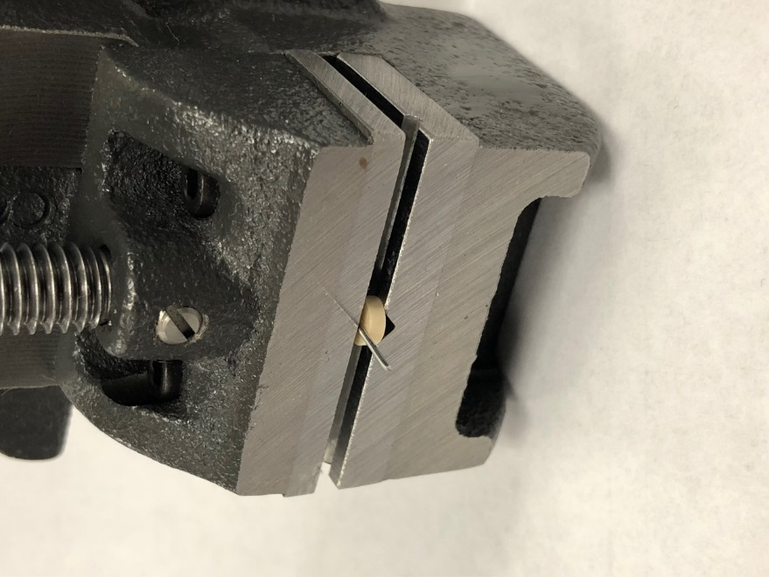 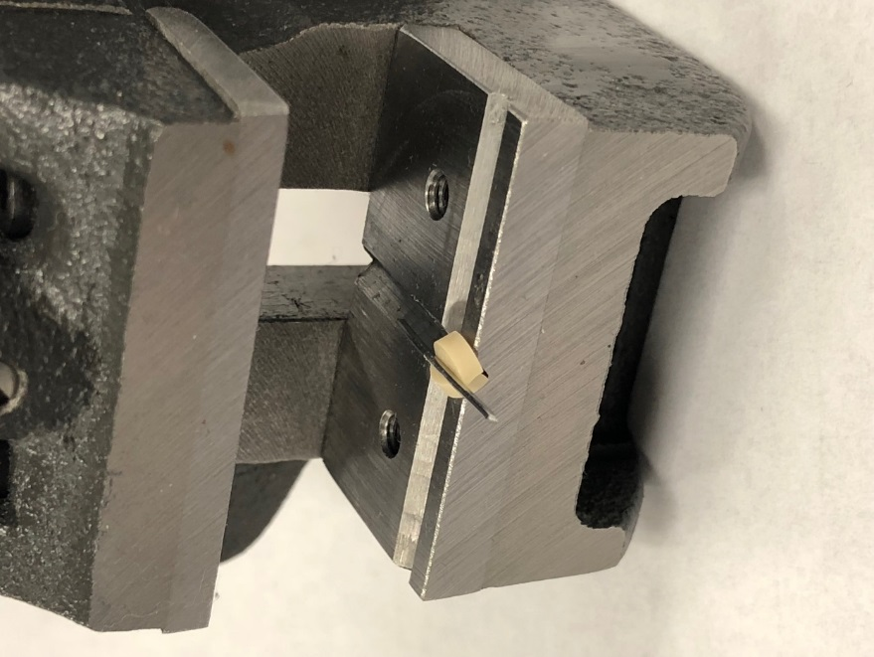

1. Crank the handle to break the part. Turn the handle to open the jaws. Retrieve the broken part with tweezers. Properly broken parts should break cleanly in half down the middle third. Parts broken outside the middle third are not valid. Parts broken into multiple pieces are only valid if one piece is larger than one third.
2. Look at the parts under magnification using a light microscope (7x to 30x). Illuminating the parts by placing them against a fiber light will make it easier to observe internal features. The parts should be featureless and uniform, except for the edges. Consult the appendix for photographs of known defects.

NOTE: Large blocks pressed in the OTC press and glass frit performs do not need to be destructively tested. Visually inspect under magnification only, unless defects are found.

1. If defects are found in **ANY** of the samples, notify the Supervisor, Lead Technician or Engineer.

# Appendix

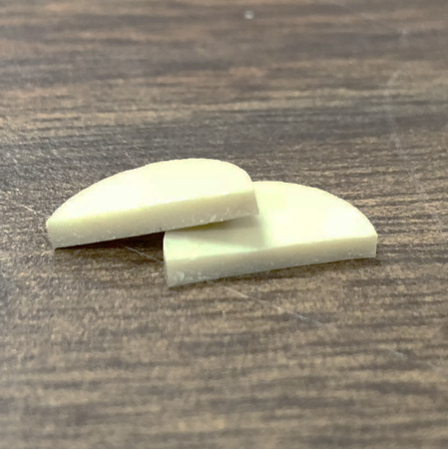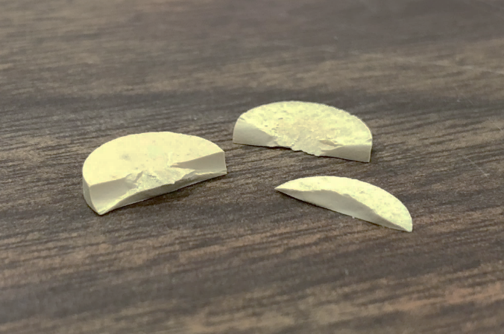

Figure 1. Example of a ½” disk, illustrating both a featureless (left) and end-capped (right) fracture surface. The image on the right is not common, but is an extreme example of this defect, extending throughout the entire volume of the part. In this case, the powder contained too much fines content and not enough binder, resulting in excessive friction during compaction. This defect can also be remedied in less severe cases by decreasing the pressed density.

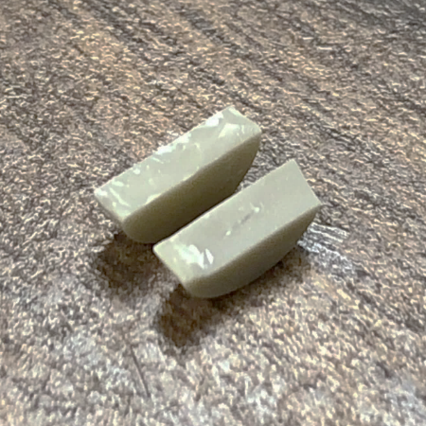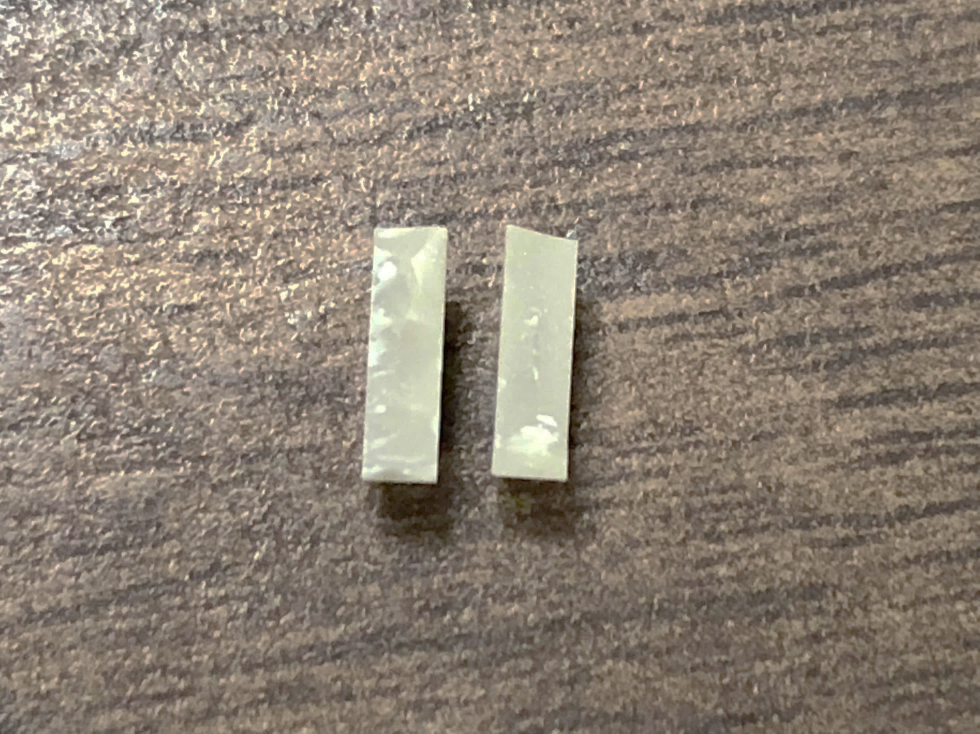

Figure 2. Example of a ¼” disk, illustrating delamination in the fracture surfaces. The image on the left shows the defect visible as a “step” disrupting the fracture surface near the middle of the thickness. The image on the right shows the defect extending across the middle third of the diameter. This is a typical example of the defect when we find it. This defect is associated with excessive friction of the part against the die walls during ejection, but there are other causes. It is typically remedied by replacing worn out press tooling.

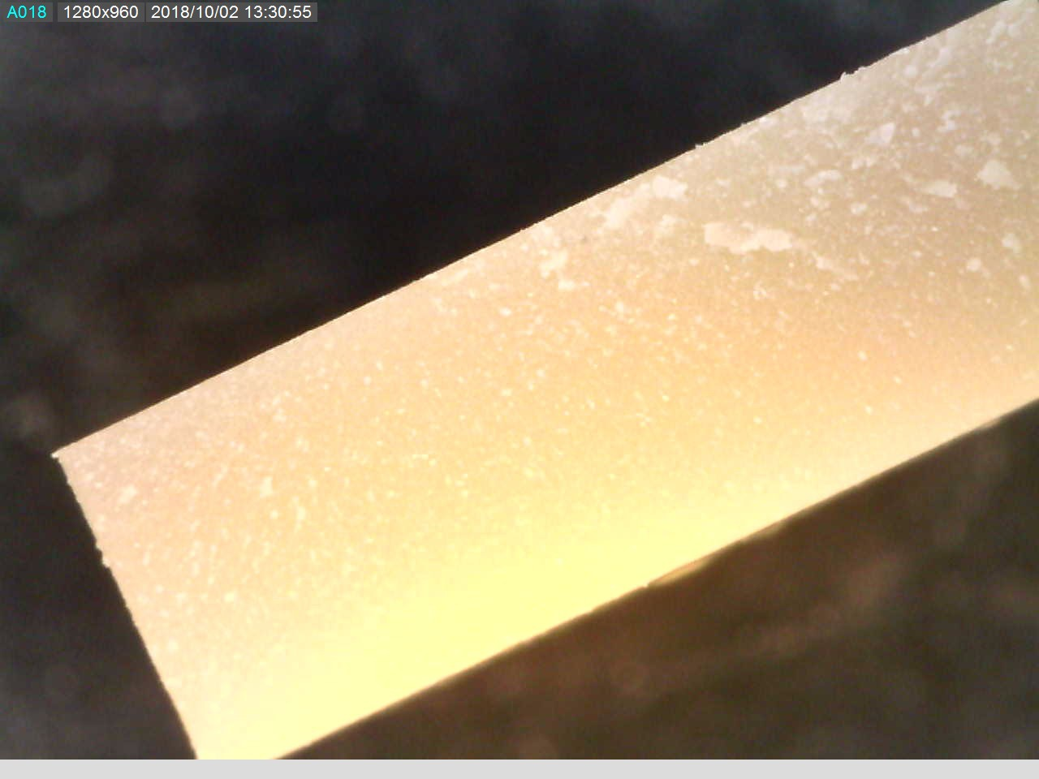

Figure 3. This is an example of a defect-free part when viewed under magnification and illumination. The bulk has no features and the surface has only slight flaking.

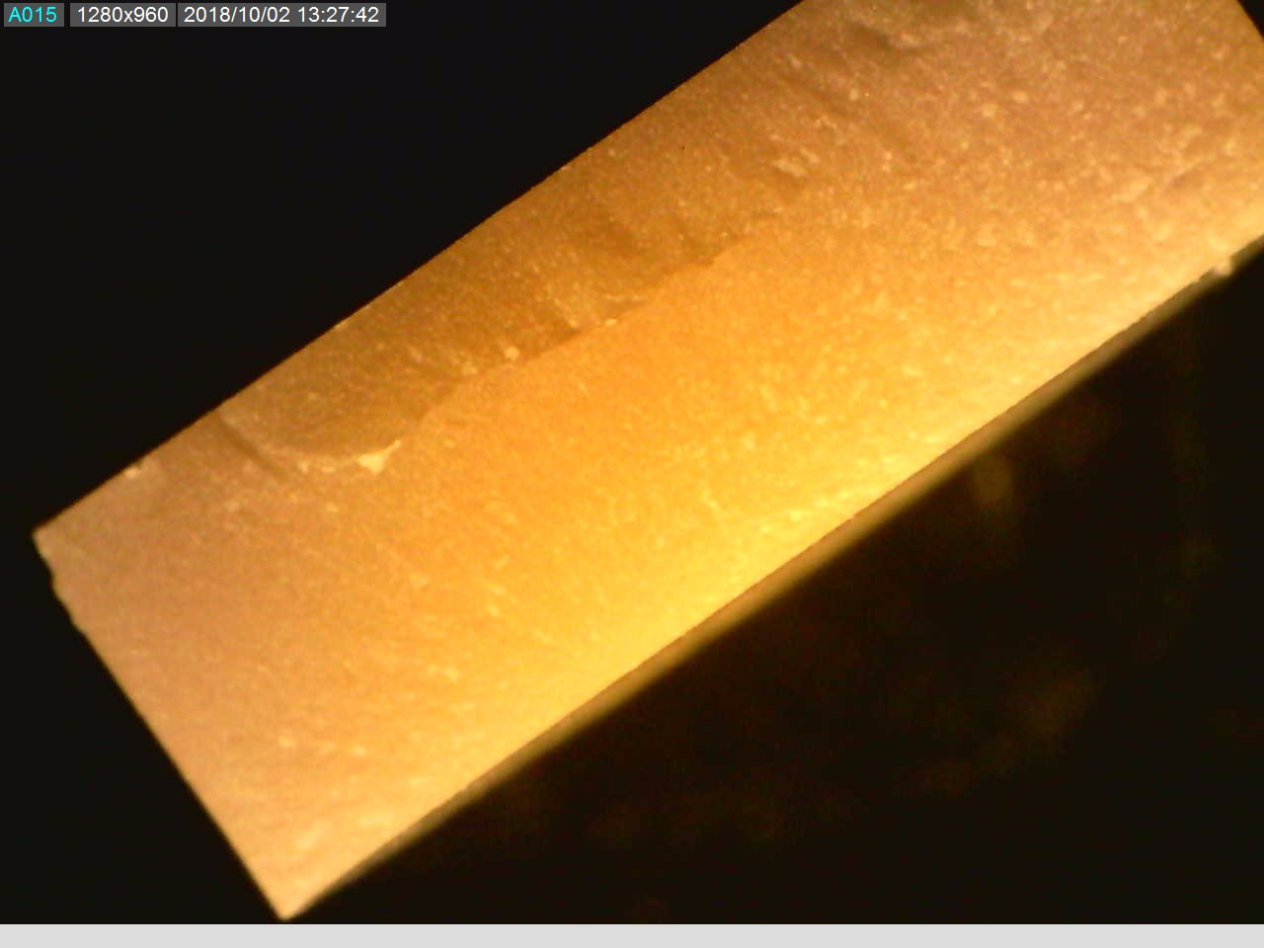

Figure 4. This is an example of a defective part with a lamination, when viewed under magnification and liiumination. The fracture surface curls around the internal flaw and the light is discontinuous through the bulk.

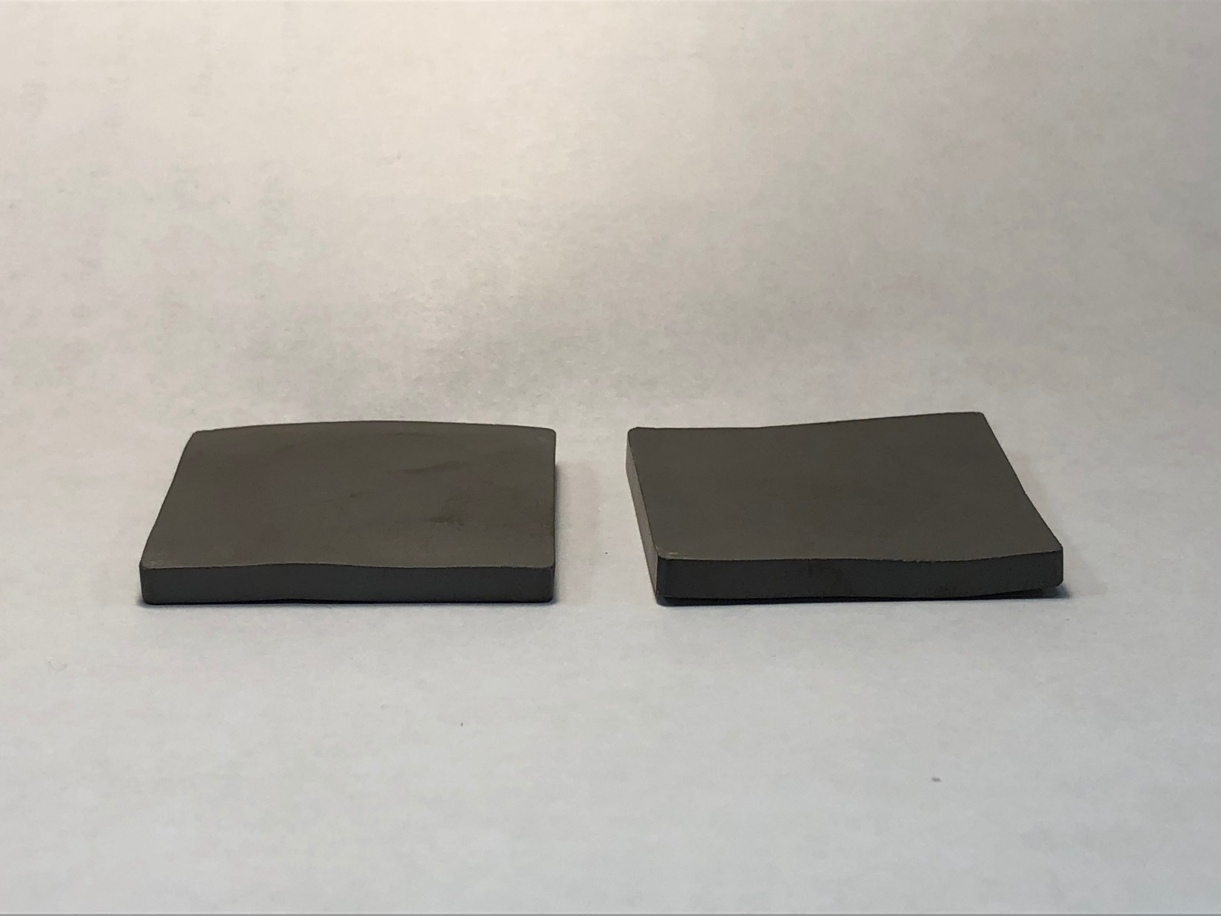

Figure 5. This is an example of defective parts with insufficient flatness. While the thickness at any location may be within specification the uniformity is insufficient. Parts such as these may break under the load of a lapping plate. In order to remove all the irregular surface it is likely it would be machined undersized. These parts should be scrapped out using reason code: Flatness OOT.