Purpose:
The purpose of this procedure is to describe the process used to apply conductive thick film metalization to ceramic crystals.

Responsibilities:
Crystal Department engineering/management is responsible for maintaining this procedure.
Crystal Department technicians are responsible for carrying out this procedure.

Associated Documents: ISO 9001, QAM, QSM, AS9100

- General Description and Practice

This procedure describes a method to apply a thick film electrode onto crystals. Gold (Au), platinum-gold (Pt-Au), or silver (Ag) thick film paste is used in this procedure. Essentially, a thick film paste is a suspension of metal and glass particles, along with organic binders, in a solvent-based solution. The wet paste is applied to a ceramic crystal through a screen printing process. The printed paste is dried in an oven and fired at high temperature to bond the metal to the ceramic.

Cleanliness is particularly important in any plating process. Any contamination on the utensils or parts being plated may prevent the plating from adhering to the crystal surface. Therefore, it is very important that once the ceramic pieces have been cleaned prior to plating, the operator should only handle the pieces when wearing latex gloves or finger cots, or use tweezers. Fixtures, tooling, etc., should be handled in the same manner.

- Safety Precautions

The operator may come into contact with the following materials and equipment which requires caution:

- Warm to hot drying ovens (80° - 150°C)
- High temperature furnaces
- Volatile solvents

Common sense and good laboratory practice should be used at all times.

IN THE CASE OF ANY INJURY, INFORM YOUR SUPERVISOR IMMEDIATELY.

  - Handling Volatiles

With volatile solvents such as methanol, ethanol, isopropanol, or acetone, the vapors should not be inhaled. These solvents must be used in a fume hood. In addition, most of these solvents are usually extremely flammable and those flames may not be visible.

  - Use of Ovens

When inserting into or removing anything from an oven that is warmer than 60°C (140°F), use a set of gloves or mitts and the appropriate utensils that allow the operator to perform the operation without risk of burns.

  - Use of Belt Furnace

The belt furnace is used to fire the thick film plating onto the ceramic surface. This process occurs at temperatures between 600ºC and 900ºC. When removing trays from the belt after firing, use tongs appropriate for handling the trays safely. Under no circumstances should an operator reach into the furnace while it is operating.

- Equipment

  - AMI Model 485 Screen Printer and Vacuum Pump
  - HMI Model 885PC Screen Printer and Vacuum Pump
  - Various developed screens
  - Various vacuum tooling plates
  - Alumina substrates (PCB 100-15650-00)
  - Aluminum trays
  - Drying Oven
  - Ultrasonic Cleaner
  - SierraTherm Belt Furnace
  - 150mm x 75mm crystallizing dish
  - Tweezers

- Chemicals

  - Dupont 7095 Silver Paste
  - Heraeus 3616 Platinum-Gold Paste
  - Metech 3993 Thinner
  - Methanol
  - Isopropyl Alcohol
  - Microclean Solution, 5%
  - Kimwipes and Paper Towels

- Preparing for Screen Printing

Note: Proceed with the following only if the pieces are still clean from the previous process.

  - Refer to the router for the printer, paste, screen number, tooling plate, and firing profile to be used for this part.
  - Set the SierraTherm furnace to the appropriate recipe for the electrode paste to be used.
  - Allow the furnace to stabilize at the profile for 2 hours minimum before firing any parts.
  - Weigh the jar of paste, and fill out CR014, Metalization Log.

- Setting Up the MSP-485 Screen Printer
  - Attach the correct screen number and tooling plate to the screen printer.
  - Set up and adjust the screen printer per the operating manual.
  - Load a crystal into the tooling plate.
  - Align the screen pattern to the crystal.
  - Apply paste to the screen.
  - Place the clear mylar mask over the carriage.
  - Initiate the print cycle. When the cycle is complete, check the alignment of the printed pattern to the crystal.
  - Wipe the printed paste off the mylar with a kimwipe.
  - Repeat steps 5.6 and 5.7 as necessary until the pattern is aligned.
  - Once properly aligned, remove the mylar mask, wipe clean, and set aside.
  - Screen print the electrode pattern on one side of the crystal.
  - Remove the printed part from the tooling plate and inspect the print under a 10x microscope. Refer to the visual guidelines in the Appendix for examples of defects. If necessary, adjust the screen printer as required to achieve a consistent printed pattern. Unacceptable prints may be washed off the parts using the appropriate solvent, followed by oven drying. Carefully inspect the cleaned parts for paste residue after the washing process prior to rescreening.

- Setting Up the MSP-885PC Screen Printer
  - Power up the screen printer by pressing the green button, if it is not already on, and allow the printer hardware and software to turn on. The red E-Stop button must also be pulled out.
  - Press the blue Main Air reset button. The dial indicator will slowly charge up to 40psi, then quickly charge up to 80psi.
  - Log in to the software on the screen, user name “Crystals Production”, password “HMI”.
  - Turn and hold the yellow switch to raise the printer head.
  - Click the “Initialize” software button and allow the printer to complete its initialization process.
  - Load the program for the crystal to be printed, according to its item number, if it is not already selected.
  - Load the screen into the screen frame holder, if it is not already, by turning the switch.
  - Press the yellow button to power up the vacuum system, if it is not already.
  - Load a part onto the tooling plate. The vacuum can be momentarily disabled using the foot pedal while the part is loaded, then released to re-engage the vacuum suction under the part.
  - Press the foot pedal to cycle the part under the screen and check its alignment. Notify your Supervisor, Engineer, or Lead Technician if there is a problem.
  - Press the foot pedal again to cycle the part back out.
  - Apply paste to the screen.
  - Turn and hold the yellow switch to lower the printer head.
  - Press the “play” software button to put the printer into Run mode.
  - Test print the first part and check the alignment of the pattern. If no changes have been made to the screen frame holder and tooling plate stage micrometers, no changes to the alignment should be necessary. If small changes to the alignment are needed, and you have been trained to do so, adjust the stage micrometers, clean the part, and retry. Otherwise, notify your Supervisor, Engineer, or Lead Technician.

- Screen Printing Parts
  - Once the screen printer has been properly aligned, begin printing the first side of the parts.
  - Set each printed part onto an alumina substrate or aluminum sheet tray.
  - Repeat the printing process until all crystals from the lot are printed on one side.

NOTE: Once an acceptable print pattern is established, do not inspect each part under the microscope. Inspect prints only occasionally thereafter to monitor print quality.

  - Add paste to the screen as necessary to maintain consistent print quality.
  - After a substrate or tray has been filled, place the substrate or tray of parts into the drying oven. Refer to the paste product data sheet for drying temperature and time.

NOTE: Both the 7095 Silver Ink and 3616 Pt-Au Ink require 15 minutes at 150°C.

  - After the required drying time, remove the parts from the oven and allow them to cool.
  - Print and dry the second side of the parts by repeating this process.

- Belt Firing Parts

NOTE: Prior to firing, check the SierraTherm furnace conditions. Refer to the computer monitor for the proper zone heating requirements. Make sure the zones are at their proper temperatures, the belt speed is correct, the air is flowing, and the chiller is operating. When the zones are at the correct temperature the bars will appear green. They will appear red if the zone is too hot, or blue if the zone is too cool. In either of these cases, notify the Supervisor, Leadperson, or Engineering before proceeding.

  - Place the substrate of parts onto the furnace belt and allow them to fire through the furnace.
  - Set a timer as a reminder of when the parts will be exiting the furnace.
  - As the trays exit the furnace, remove them from the belt.
  - Print and fire the second side of the parts, if this is not already done.
  - After all the parts have been fired, place them in the appropriate packaging and return them to job box for further processing.

- Cleanup

  - Use a spatula to collect unused paste from the screen, squeegee, and flood bar, and return it to the original jar.

  - If the next job is a different item number, remove the screen from the printer. Wipe the screen, squeegee and floodbar with a solvent-dampened kimwipe to remove any remaining paste. Otherwise, the screen can be left on the machine. If this is to be done, place several paper towels under the the screen on the table slide rails to catch any solvent that may drip through.
  - Dispose of the soiled kimwipes in the red container. This material is collected, and can be sold for precious metal salvage. Do not throw away any paste-containing wipes in the trash.
  - Weigh the paste jar and record the weight in the “End Jar Wt.” column of CR014.

- Paste Recertification Process (Shelf Life Extension)

In the event that the shelf life of a jar of paste expires, it is acceptable to recertify the paste and extend the shelf life through the following process. Crystals to be used for paste recertification should be from known good batches. They can be either test samples or crystals from a production job. They should be clearly labeled with the crystal batch and fire number, and nominal d33 from the batch test samples. BT crystals will be used for recertifying #3616 Pt/Au paste, and PZT crystals will be used for #7095 Ag paste.

  - Select 10 pieces of the appropriate recertification crystals.
  - Fill out CR029 “Thick Film Paste Recertification Form”.
  - Set up the screen printer, as previously described.
  - Print and fire the samples, as previously described.
  - Clean up the printer, as previously described, when finished.
  - Measure the thickness of the pieces after firing, and record the average on CR029.
  - Calculate and record the average fired print thickness per CR029. If out of range, stop and notify the engineer. If acceptable, continue this process.
  - Pole the samples per CR1035. Record d33 on CR017.
  - Age the samples per CR1036. Record after-age d33 on CR017.
  - Record the average poled and after-age d33’s on CR029. If d33 is within range on CR029, and the print thickness calculated previously is within range, the paste can be recertified and the expiration date changed.
  - Deliver the paste and the completed CR029 to the Receiving Inspection area so a new expiration sticker can be issued (6 months out). Receiving Inspection will modify the QCS notes for that lot, scan CR029 and store the electronic copy in the appropriate Quality Records folder (per CS002 Document Index).
  - If d33 is out of range, stop and notify the engineer. Do not change the expiration date on the jar.

- Referenced Documents: CR014, CR017, CR029, CR1035, CR1036

- Appendix: Visual Guidelines for Printing Defects and Rework

Reject or Rework  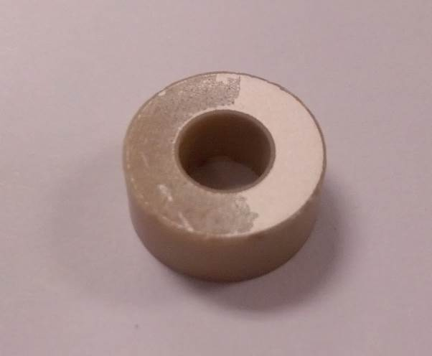  Part of the printed area is missing. This typically results from not having enough ink on the screen during the print cycle. Rework unfired parts or reject fired parts, using Scrap Code 551: “Plating/Coating Missing”. | Accept  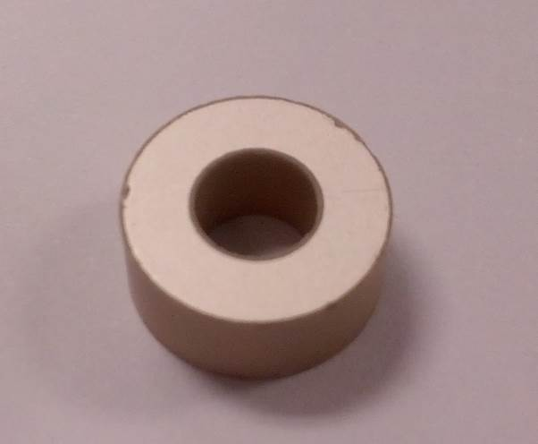  The entire screen pattern is printed uniformly.

Reject or Rework  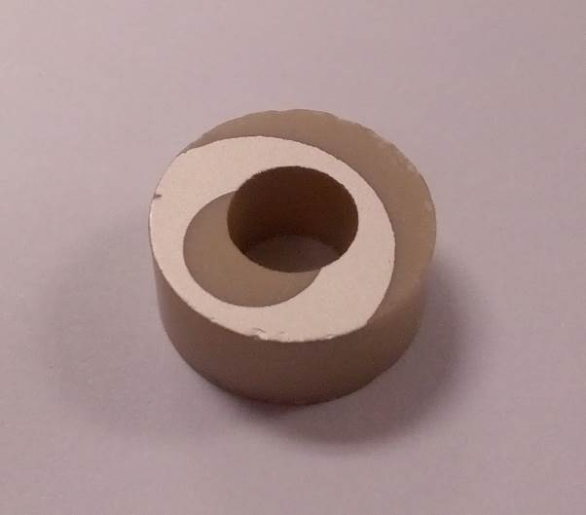  The printed pattern is misaligned with the part. This typically results from incorrect setup of the printer or parts not aligned correctly in the vacuum tooling. Rework unfired parts or reject fired parts, using Scrap Code 553: “Plating/Coating Misaligned”. | Accept  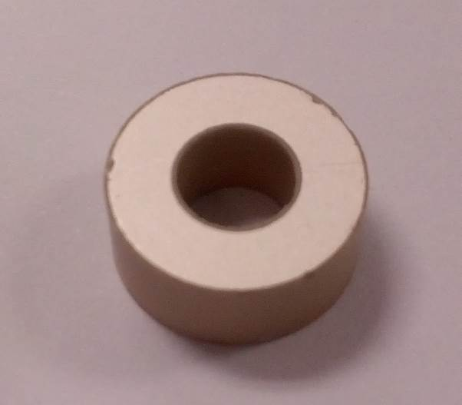  The screen pattern is perfectly centered on the OD and ID of the part.

Reject or Rework  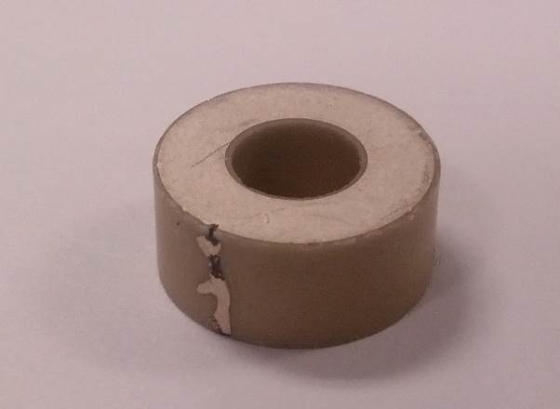  Electrode ink was applied the edge of the part during printing. This will typically result in a short during poling, as evidenced by the black arc marks on the part. Rework unfired parts or reject fired parts, using Scrap Code 552: “Plating/Coating on Incorrect Surface”. | Accept  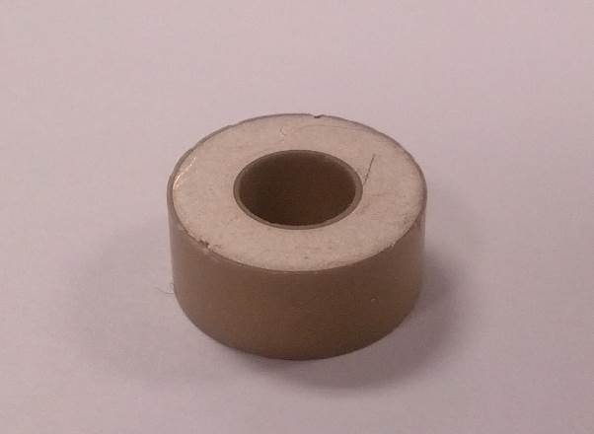  The screen pattern is applied only to the top and bottom surfaces of the part and not to the edges.

