1 Poling Preparation: 1
2 Poling: 4
3 Cleaning After Poling: 9

Purpose:
The purpose of this procedure is to describe the process used to polarize ceramic crystals.

Responsibilities:
The Crystals Department Engineering and Management is responsible for maintaining this procedure.
The Crystals Department Technicians are responsible for carrying out this procedure.

Associated Documents: ISO 9001, QAM, QSM, AS9100, CR015, CR1040

Poling Preparation:

Equipment
No. 2 Pencil
Vacuum Oven
Heat Resistant Gloves
Various sizes of Pyrex Beakers and Dishes
Mesh Metal Basket

Chemicals
Dow Corning #550 Silicone Oil (PCB p/n 100-8375-00)

Safety Precautions

Use of Ovens
When inserting into or removing anything from an oven that is warmer than 60°C (140°F) use a set of gloves or mitts and the appropriate utensils that allow the operator to perform the operation without risk of burns.

Vacuum Bake in Silicone Oil

Check that the vacuum oven is on and that it is set to 100ºC, as marked on the dial (See Figure 1).

NOTE: The vacuum oven should always be on and at a temperature of 100ºC ± 10ºC.

Place the crystals in a glass dish and cover with silicone oil to a depth of about 1/2 inch.

NOTE: If there is already a silicone oil filled dish in the vacuum oven then the parts may be placed directly in that dish, making sure that the crystals are covered to a depth of ½ inch.

NOTE: For smaller crystals, it is easier to place the crystals in a metal basket and then place the basket in the dish of silicone oil.

Label the dish with the job number using a No. 2 pencil.

Place the dish in the vacuum oven

Close and latch the oven door.

Close the vent valve and open the vacuum valve. (See Figure 1).

The oven should evacuate to a minimum gage reading of 20 inHg. Figure 1 shows the acceptable gage reading range.

Vacuum should be maintained for at least one hour with the pump running.

NOTE: At this time, the oil and parts should have stopped bubbling. Parts made of PZT material usually debubble within 15 minutes, but still need to remain in the vacuum for the minimum of one hour. If bubbling is still seen after one hour then allow the parts to stay in the vacuum until completely debubbled. In some cases, the crystals will need to remain in the vacuum oven overnight to completely de-air.

Track the in/out date and time on the white board.

Keep the crystals in the oven under vacuum until they can be poled.

NOTE: There is no maximum time that crystals can sit in oil in the vacuum oven as long as they remain completely submerged. It is common to prepare a job of crystals for poling the next day by vacuum baking them overnight.

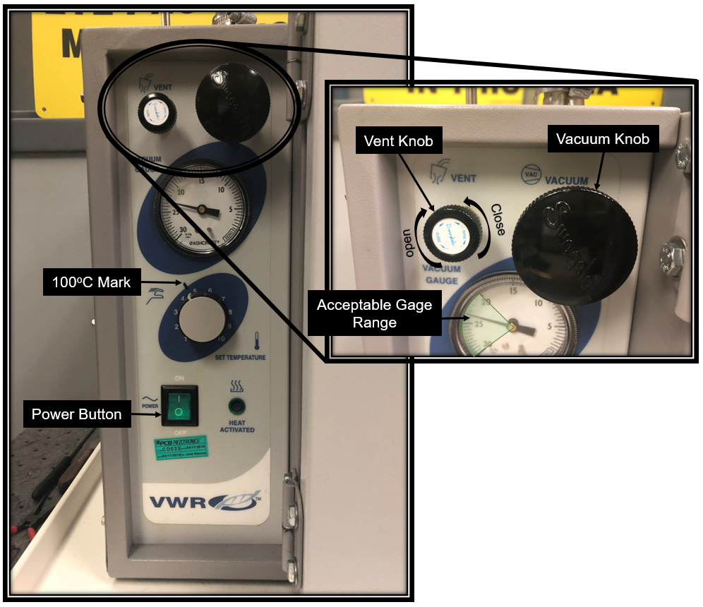
Figure 1: Vacuum Oven Controls

Preheating the Poling Baths

Before poling can begin, the oil baths must be heated to the appropriate temperature. This takes at least an hour depending on the initial temperature of the oil bath/heater when it is turned on. Therefore, each poling bath should be turned on as early as possible in the morning when there is work scheduled for that day.

The baths may be preheated to the appropriate temperature, according to the router, by setting the temperature controller either manually or using the software provided. If you are using the software to turn it on automatically, set it to turn on an hour before the shift. To manually set the temperature, press the soft up or down arrow buttons on the temperature controller to adjust the temperature setting. (See figure 2) The controller will begin to heat the oil as soon as this is done. Before poling can begin each shift the temperature should be confirmed using the handheld probe and adjusted if required.

The allowable temperature deviation from the target is +/-10 degrees. If the actual bath temperature (as measured using the handheld probe) is outside these limits, the controller should be adjusted.

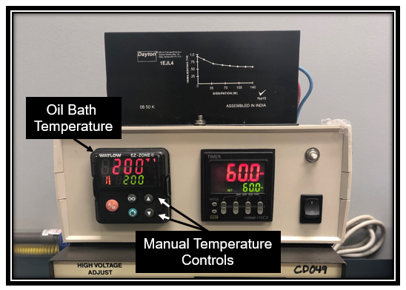
Figure 2: Poling Box Temperature Controller

Poling:

General Description and Practice
This procedure describes the process used to polarize piezoelectric ceramic sensing elements. In the polarization (or poling) process a strong electric field is applied to the crystals. The electric field causes microscopic changes within the ceramic, resulting in polarization of the crystals. It is this polarization that gives the crystals their piezoelectric sensitivity.

Equipment
Poling Stations
Digital Thermometer
Various sizes of Pyrex/Metal Beakers and Dishes
All Metal Tweezers
Dental Prong tool
Paper towels and Pig mats
MACOR dummy parts

Chemicals
Dow Corning #550 Silicone Oil (PCB p/n 100-8375-00)

Safety Precautions
In the following procedure, high voltage DC power supplies are used as well as hot silicone oil baths and various ovens. Caution and common sense should be used when working with this equipment.

Working with Poling Stations
The poling process requires the application of high DC voltage to the crystals. Voltages at 10kV DC are common and some crystals may require even higher voltages. Care must be taken to avoid electrical shock. Power supplies must be turned off before loading and unloading poling boxes. During the poling process, charge is built up on the crystals. Metal tweezers must be used to unload the parts, connecting both sides of the electrodes and creating a short, which will discharge the crystals. The poling boxes are filled with silicone oil that is heated to 400°F in many cases, so caution must be used to prevent burns.

General Practice
- The poling process aligns the piezoelectric sensitivity in the ceramic crystals. The level of aligning in a poled crystal, while mostly determined from chemical formulation and firing, is influenced by the effectiveness of the poling process. Therefore, it is necessary to carefully control process conditions such as poling voltage, oil temperature and poling time.
- The poling process involves applying a high voltage across the crystals. This causes high stress in the material, which can result in dielectric breakdown or arcing of the ceramic if procedures are not carefully followed. Cleanliness, handling of the crystals and process conditions greatly influence the quality and consistency of poled crystals.
- It is important not to touch the crystals with bare hands, as finger oils can leave a conductive residue on the crystals, which can cause breakdown under high voltage. Always use metal tweezers, finger cots, or gloved hands to handle the crystals.
- The silicone oil in the poling boxes will get contaminated over time with small chips of crystal and electrode material. It should be changed about every six months as per the Preventative Maintenance Plan.
- Crystals should be handled gently. Any chipping of the edges or cracking can result in charge concentration during poling, which can cause the crystal to breakdown.
- Care should be taken not to scratch the electrodes, especially those on compression crystals, which are the permanent electrodes.

Procedure

NOTE: The Crystals Department has several poling boxes, all capable of accepting a variety of parts. It is frequently necessary to have as many of them as possible running parts simultaneously. This entire process should be repeated, both in series and in parallel, as many times as necessary to pole the entire crystal job.

Turn the power supply power off, if it is not already.

Turn the power supply voltage control knob all the way to zero (fully CCW), if it is not already.

Turn the poling control box power on, if it is not already.

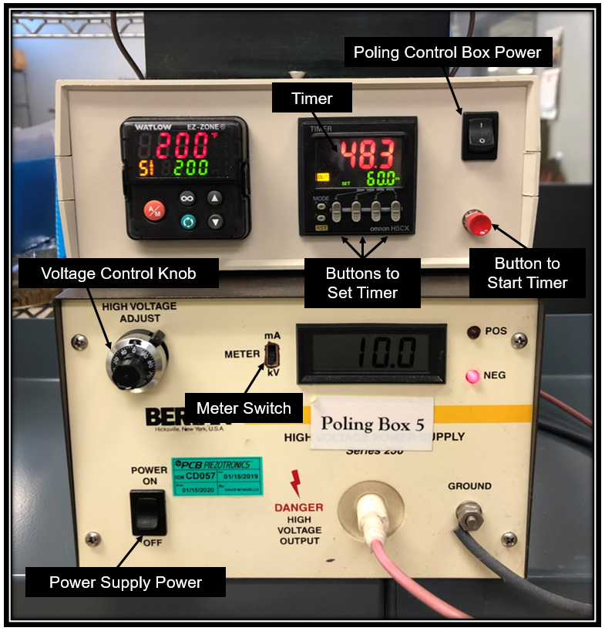
Figure 3: Poling Control Box and Power Supply

Remove the dish of parts from the vacuum oven using heat resistant gloves.

Open the lid to the poling box.

Transfer the appropriate number of parts from the glass dish to the poling box using metal tweezers.

Place the parts underneath the prongs using metal tweezers and a dental prong tool.

NOTE: Use the dental prong tool to gently pull up the prong of the poling electrode then slide the part underneath it using the tweezers.

NOTE: Make sure the prongs are contacting the plated surface of the crystals.

NOTE: For large parts, it is acceptable to have more than one prong contacting the plated surface.

If there are not enough crystals to use all the prongs, place a single Macor dummy part under each unused prong.

Close the lid to the poling box.

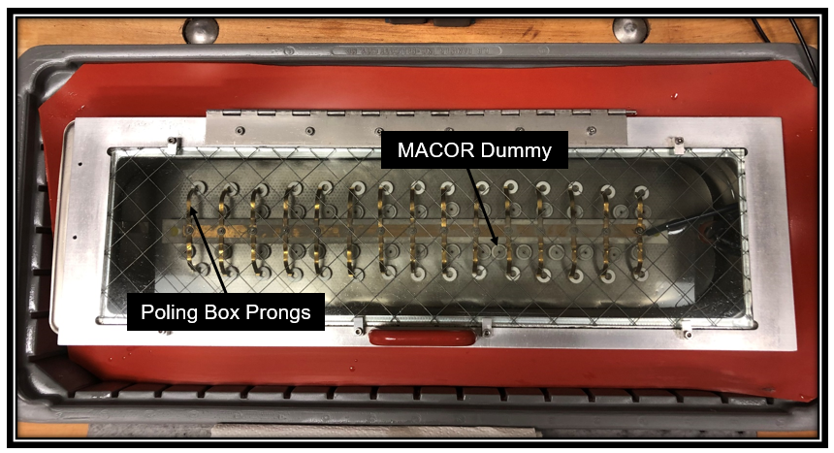
Figure 4: Poling Box

Set the timer on the poling control box to the time identified on the router.

Turn the power supply power on.

Set the power supply meter switch to kV, if it is not already.

Start the timer on the poling control box.

Slowly dial up the voltage on the power supply to the value specified on the router.

NOTE: To check that that the voltage is being dialed up at an acceptable rate, switch the power supply meter from volts to milliAmps. The current should maintain a level of .025mA while voltage is being increased. If the current spikes higher than this value then hold the control steady, don’t move the dial up or down, until the current levels back out to about .025mA. Make sure to switch back and forth between volts and amps to monitor both until the specified voltage is achieved.

NOTE: It should take at least 10 seconds but not longer than 5 minutes to dial up to the voltage level specified.

Fill out the poling log with the required information.

Throughout the poling run, monitor the poling voltage and temperature to be certain the right conditions are being maintained.

NOTE: If a failure of a part occurs during the poling time, the voltage indication may drop to zero, or the current indication may increase to the supply maximum. If this occurs, refer to the following section.

When the timer times out, the power supply will turn off.

Turn the power supply voltage control knob all the way to zero (fully CCW).

Let the poling box sit untouched for at least 15 seconds after the power supply has been turned off to confirm it has fully discharged.

NOTE: This may be done using the seconds hand of a wall clock.

Open the lid to the poling box.

Remove the crystals from the poling box using metal tweezers and/or a dental prong tool.

Set the crystals on a paper towel in front of the box.

Use clean paper towels to pat off most of the oil.

NOTE: Removing as much of the oil as possible at this stage is important to improve the efficiency of the chemical cleaning process. Pig mats may be used to surround the poling bath to provide additional absorbent surface.

Failures during the Poling Process

In the event of a poling failure you may hear a cracking/snapping sound.

Check to see if any parts have cracked or have obvious burn marks across the edges.

Lower the voltage to zero and turn off the power supply.

Open the lid to the box and replace any suspect/defective crystals with dummies.

Turn the power supply back on and begin applying voltage again.

Dispose of defective parts in the precious metal waste container.

If there is another failure in the same poling box stop the poling run and notify the Lead Technician, Supervisor or Engineer.

Cleaning After Poling:

Equipment
Splash Goggles
Nitrile Gloves
All Metal Tweezers
Various sizes of Pyrex Beakers and Dishes
Digital Timer
Permanent Marker

Chemicals
Lenium ES (PCB p/n 100-8087-40)

Safety Precautions

Lenium ES:
Ingestion of Lenium may be harmful, and prolonged exposure will cause skin irritation. Refer to the Lenium-ES SDS for more information.

PPE:
Use safety goggles during operation

Handling Solvents
The vapors of solvents such as lenium should not be inhaled. Splash goggles and nitrile gloves must be worn while working with this solvent.

Discharging the Crystals

The crystals may still be warm from poling when they are placed in the vapor degreaser, allowing them to regain charge. For larger parts, the cleaning process will require metal tweezers to be used when moving the crystals. The tweezers should contact the part below the liquid surface and connect both electrodes, creating a short that will discharge the crystals. Caution must be used when discharging the parts as it may cause a spark that could ignite a flame.

Use of Ovens
When inserting into or removing anything from an oven that is warmer than 60°C (140°F) use a set of gloves or mitts and the appropriate utensils that allow the operator to perform the operation without risk of burns.

Daily Start-Up/Checks for the Vapor Degreaser:

Check around the machine for any evidence of leaks or chemical spills.

Check that the solvent level in the back tank, “boiling side”, is about 1/2” below the wall separating it from the front tank, “clean side.” When needed, add Lenium-ES to the non-boiling side to bring up to proper level.

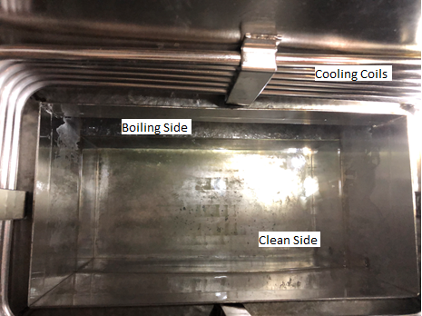
Figure 5: Interior of Baron Blakeslee LK-612 Vapor Degreaser

Check that the machine is plugged in.

Switch on the heater. The temperature should now be displayed on the control screen.

Check that the temperature is set to 154ºF. This can be done by pressing the set button on the control panel. If the temperature is not set correctly use the up and/or down arrows until the screen reads 154ºF.

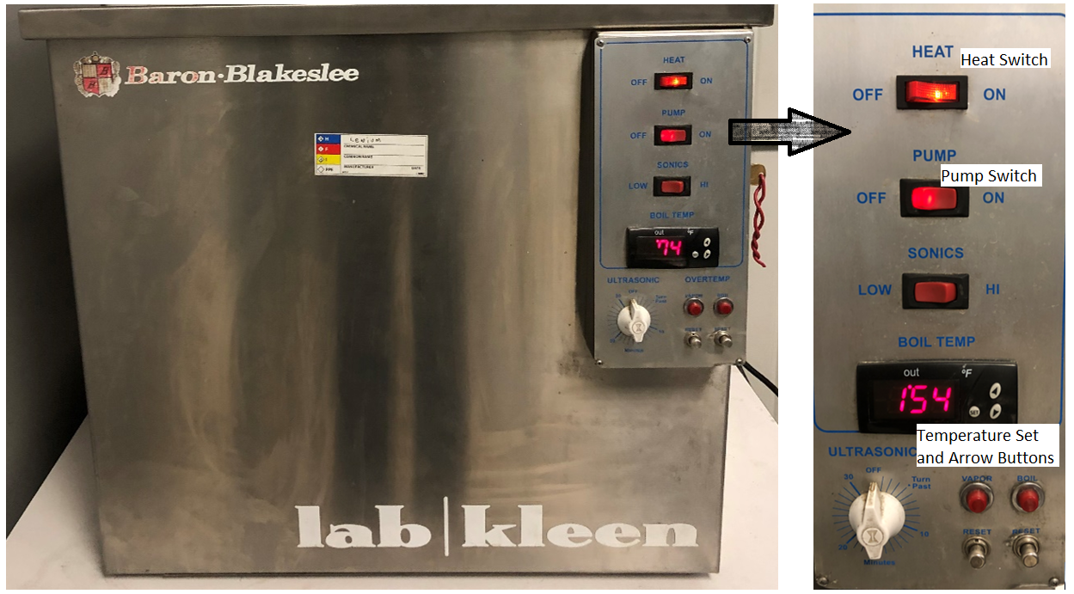
Figure 6: Vapor Degreaser Controls

Check that the Safety Controls inside the panel on the right side of the vapor degreaser are set properly. The SVC limit should be set to 144ºF and the HTC limit should be set to 169ºF. If these values are not correct they may be adjusted by holding down the set button and turning the knob to the desired temperature.

NOTE: The value of the REF or refrigeration control will change while the machine is running. This control should NOT be adjusted.

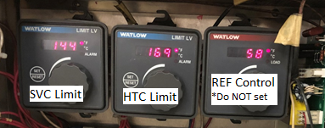
Figure 7: Vapor Degreaser Safety Controls

Switch on the pump.

Allow the machine to heat up for approximately one hour or until the control panel reads 154ºF. To confirm that the solvent has actually reached a boil, turn off the pump and visually inspect the “boiling side”. If the Lenium is boiling, switch the pump back on.

NOTE: If after an hour the “boiling side” has not reached a full boil, increase the set temperature. If the temperature needs to be set higher than 160ºF to achieve a boil notify the lead technichian, supivisor or engineer. The lenium may be contaminated and/or the system may need to be cleaned out.

Using the Vapor Degreaser

Push lid on degreaser back to open.

Lay metal “ladder” across the open degreaser (Figure 8).

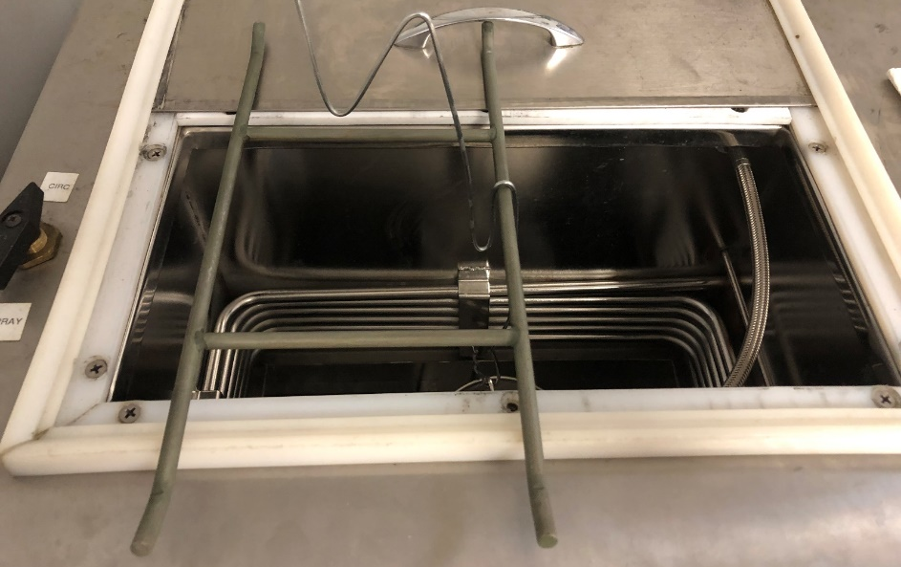
Figure 8: “Ladder” placed over open Vapor Degreaser

Put crystals into an appropriately sized mesh basket using all metal tweezers. Make sure that the parts are not stuck together and spread them out so that there is minimal layering of crystal on top of crystal.

NOTE: Make sure that the parts have been blotted to remove excess amounts of oil before placing them in a basket.

Attach the mesh basket handle to a hook and then hang the hook off the “ladder” so that the parts are fully submerged in the “clean side.”

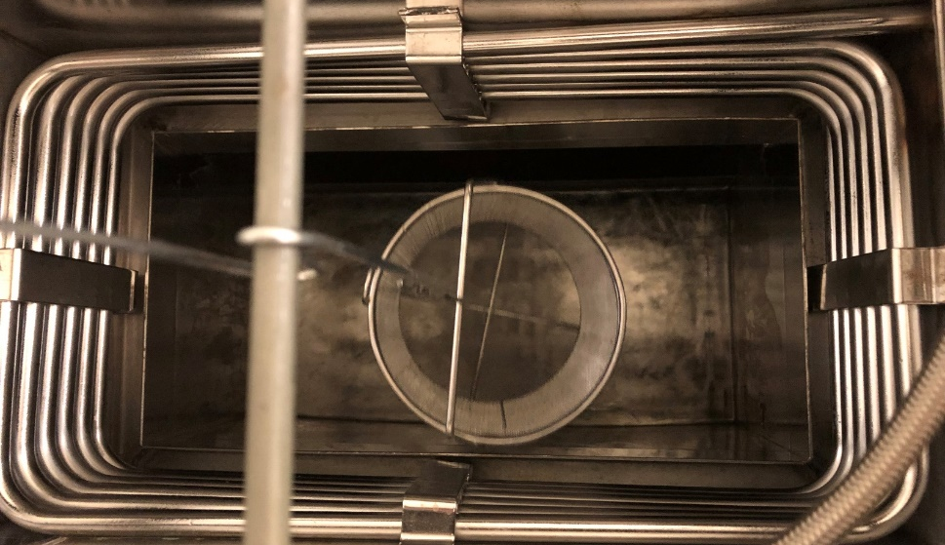
Figure 9: Mesh basket hanging in Degreaser

Gently agitate the parts in the solvent with up and down twisting motion. It is acceptable for parts to enter and exit the Lenium during this process.

Let the basket hang submerged for five minutes.

Again gently agitate the parts in the solvent with up and down twisting motion. It is acceptable for parts to enter and exit the Lenium during this process.

Remove the hook from the “ladder” and slowly start to lift the basket out of the liquid and into the vapor blanket to drip. The parts should be below the cooling coils but no longer submerged in Lenium.

Hang the hook on the “ladder” and let the basket hang in the vapors for 5 minutes.

Remove the hook and very slowly lift the basket out of the vapor degreaser. The parts should dry fully as they move above the cooling coils.

Remove the “ladder” from the top of the degreaser and slide the cover closed.

Visually inspect the parts for any remaining oil residue. If any crystals are not clean, repeat steps for those parts until all the oil has been removed.

Gently transfer cleaned crystals into a shallow Pyrex dish.

Label the dish with the Job Number using a permanent marker.

End of Day Shut Down

Check that there are no parts remaining in the degreaser.

Check that the cover is completely closed.

Turn the pump switch to off.

Turn the heat switch to off.

