# General Practice

Typically, ceramic crystals are tested for the correct piezoelectric coefficient (sensitivity) after they are poled and again after they are aged. Once the crystals have been processed into their final state, they are then polarity tested and marked, and then final measurements are made on the electrical properties and dimensions. Refer to the router for the acceptable values for each measurement as this information may or may not be called out explicitly on the drawing. Refer to the router and drawing for polarity marking requirements and to Appendix 1 for examples.

Never handle finished crystals with bare hands. Oils from fingers can contaminate the crystal surfaces and cause Insulation Resistance failures. Always use the appropriate tweezers, gloves or finger cots.

## Sampling

The quantity of pieces to be tested for electrical properties for each job is defined by the AQL 0.065 Level I Sampling Plan for Major Defects, as shown below, unless otherwise specified on the router.

The polarity testing and marking processes are to be completed for all pieces, unless otherwise specified on the router.

AQL 0.065 Level I Sampling Plan for Major Defects

MAJOR – Critical Defect – product is out of specification on critical dimensional or visual features.

AQL’s for Designated Features

Major = 0.065 Level I, Single Normal

|  |  |
| --- | --- |
|  | 0.065 Single Normal |
| LOT SIZE | SAMPLE SIZE Ac Re |
| 1. to 8 | 2 0 1 |
| 1. to 15 | 2 0 1 |
| 1. to 25 | 3 0 1 |
| 1. to 50 | 5 0 1 |
| 1. to 90 | 5 0 1 |
| 1. to 150 | 8 0 1 |
| 1. to 280 | 13 0 1 |
| 1. to 500 | 20 0 1 |
| 1. to 1200 | 32 0 1 |
| 1. to 3200 | 50 0 1 |
| 1. to 10000 | 80 0 1 |
| 10001 to 35000 | 125 0 1 |
| (Application) | MAJOR Features |

## Data Records

Record the values measured on each sample on worksheet CR017 or as directed by router. After all samples have been measured, calculate and record statistics required on the worksheet. Be sure to measure all specimens and record all values for the correct sample size, even if the values fall outside of the acceptable limits.

Worksheet CR017 also exists as an electronic form and several tests have been integrated with it. These electronic files can be found in [R:\Crystals\Test Data](file:///C:\Users\ssteffan\AppData\Local\Microsoft\Windows\Crystals\Test%20Data) where they are then indexed into folders by part number. To create an electronic worksheet for a new job, open the CR017 file in the test data folder and name it according to the job (e.g. CR5115.xlsx) then save it in the folder according to the part number.

## Out of Specification Product

If measured values do fall outside acceptable limits, contact the Supervisor, Lead Technician or Engineer before proceeding to the next operation. If it is determined that 100% testing and sorting is required, mark this on the router.

Sort parts into separate dishes using the sorting mat. Parts are to be sorted into three categories, acceptable, unacceptable (reject), and suspect. The suspect category is reserved for parts that you are unsure about and/or want your supervisor, lead technician or engineer to look at.

Segregate non-conforming crystals by placing into a Non-Conforming product bin. Out-of-tolerance crystals that are plated with precious metal should be placed into the appropriate scrap container for metal reclaim.

NOTE: Under no circumstances are PZT crystals to be discarded into the trash. They must be discarded in the appropriate hazardous materials container.

Count the number of crystals remaining, note the quantity accepted on the router and sign off the router as required. Record the quantity of scrapped crystals along with the scrap code next to the router notes at that operation.

# Equipment

* 1. PCB Piezoelectric Meter (CA1411)

This custom hardware is used to measure the d33 of all piezoelectric ceramic crystals.

It is also used to test the polarity of compression disk or compression ring crystals.

* 1. KCF PM3001 Piezoelectric Meter

This hardware is used to measure the polarity of shear plate crystals.

* 1. Arbor Press Polarity Tester

This hardware is used to measure the polarity of shear tube crystals.

* 1. Agilent 4263B LCR Meter (CA1684)

This hardware is used to measure the Capacitance and Dissipation of all ceramic crystals.

It has the additional benefit of being instrumented for automatic data collection into worksheet CR017.

* 1. QuadTech 1659 Digibridge

This hardware can also be used to measure the capacitance of crystals, but is used manually only.

This equipment is currently out of service and in storage.

* 1. Keithley 6517A High Resistance Meter (CA1593)

This hardware is used to measure the Insulation Resistance of all ceramic crystals.

It is equipped with a shielded test box (8002A) and custom test fixture (39304-01).

It has the additional benefit of being instrumented for automatic data collection into worksheet CR017.

* 1. QuadTech 1863 Megohmmeter (CD034)

This hardware can also be used to measure IR, but is used manually only.

* 1. 0-1” Micrometers

This hardware can be used to measure the Outer Diameter, Length, Width, or Thickness of crystals.

It has the additional benefit of being instruments for automatic data collection into worksheet CR017.

* 1. Precision Pin Gauges

These gauges are used to test the Inner Diameter of compression ring or shear tube crystals.

There are two sets of Class-Z pins (tolerance of 0.0001”) from 0.011” to 0.250” and 0.251” to 0.500”.

# Sensitivity and Polarity Testing

## Sensitivity (d33) and Polarity Measurement of Compression Crystals using the PCB d33-meter

NOTE: This measurement can only be taken on compression crystals. If called out on shear crystal drawings, the measurement needs to be taken after aging prior to removal of poling electrodes during machining.

* + 1. Turn on the hardware, if it is not already on: the ICP power supply, the Charge amplifier, the Shaker power supply, and the computer.
    2. Turn on the software. A shortcut to the program is found on the desktop of the computer.
    3. Depress the stage of the d33 meter and load a crystal between the tips. It is important that the crystal be level between the two tips, and not crooked. It is also a best practice that the crystal is touched by the tips as close to the center as possible. Parts should always be room temperature and picked up with metal tweezers to short the parts before placing into the d33 meter. Failure to do so could cause serious electrical damage to the charge amplifier.

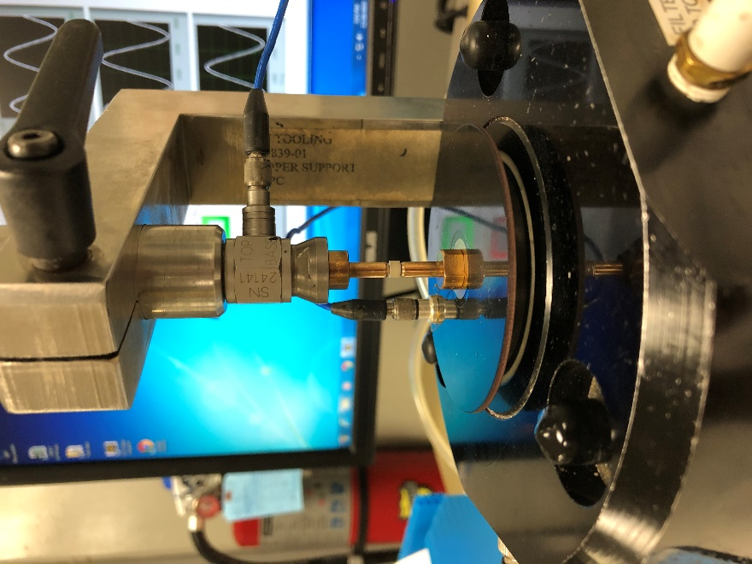

Test sample, between tips

d33 Meter stage

Force Sensor

Force arm and knob, holding column

* + 1. Adjust the height of the force sensor column so the shaker is near, but not at, the bottom of its travel. When this is done, the 3 black rubber tubes visible underneath the stage will be level.

Rubber tube is level

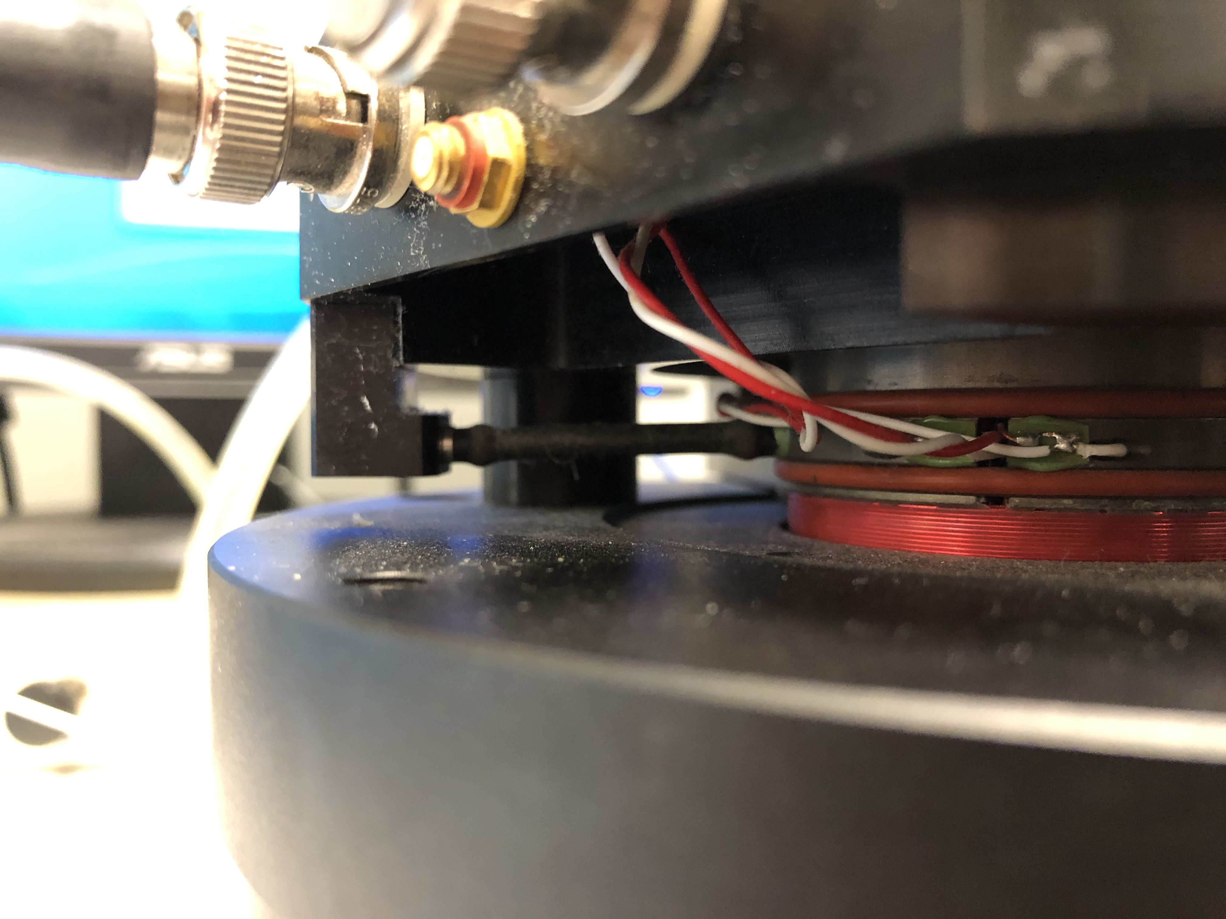

* + 1. If only the polarity is being measured, no further setup is required. Polarity is displayed as either positive or negative with a large indicator that is green when positive and red when negative. A crystal inserted into the d33 meter with the positive compression surface facing upwards will indicate positive polarity. A crystal inserted with the positive compression surface face down will indicate negative polarity.

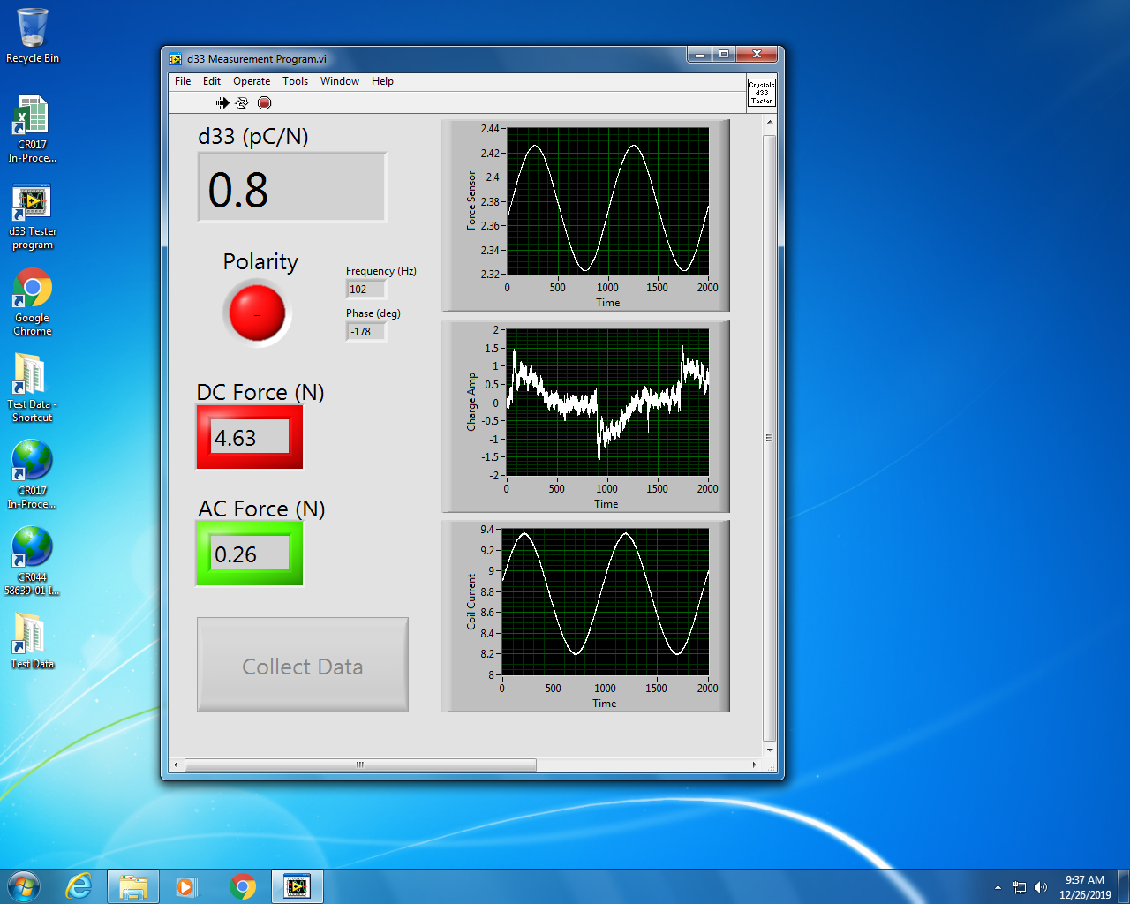

Button disabled – DC Force out of range

Noisy signal – no sample present

* + 1. If the piezoelectric coefficient is being measured, the DC and AC forces must be within the calibration ranges in order for the measured value to accurate. This means the DC force is 5 Newtons within 5%, and the AC force is 0.25N within 5%. When both of these parameters are within the acceptable ranges, they will be displayed in green. When either is out of range, it will be displayed in red and the data collection button will be disabled. They may be adjusted by turning their respective knob on the Shaker Power Supply. They are not independent of each other, and sometimes a change to one may cause the other to need readjustment.
    2. Note the d33 reading in the top left corner of the software window. The number indicates the charge output from the crystal in picocoulombs per Newton (pC/N). There will also be 3 data raw signals on the right side of the software window. If the crystal is being read correctly, all 3 of these signals will be sine waves. If no crystal is present, the charge amplifier signal will have a noisy appearance instead. If the tips are not touching, the force sensor signal will have a noisy appearance. If the shaker is powered off, the coil current signal will be noisy.

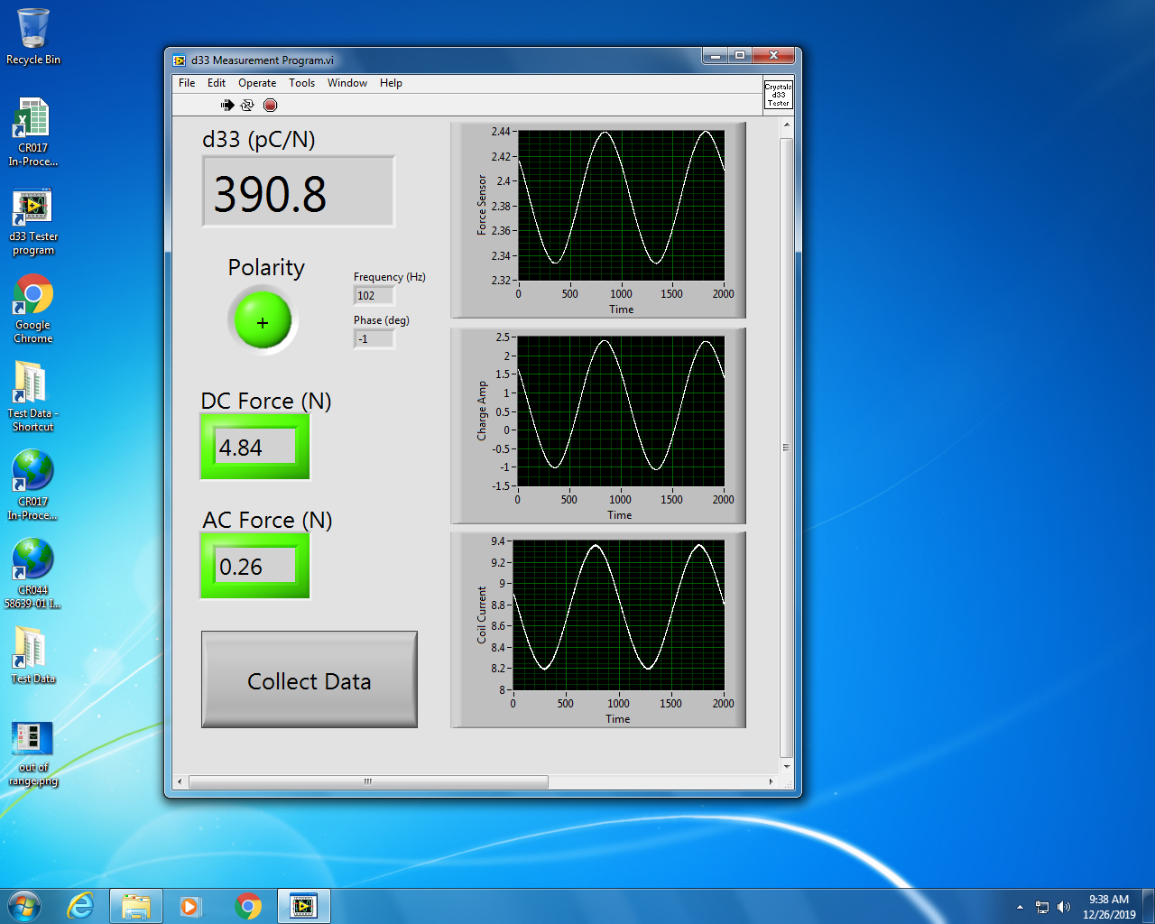

Button is activated – Forces are in range, ready to measure.

3 clean, clear Sine waves – sample is being measured correctly.

* + 1. Once the crystal is loaded and both of the forces are in range, the Collect Data button will be active. Press this button to collect a measurement of the d33 and export it to Excel. Once the button is pressed, the software will sample the signals for 10 second, discard the first 5 seconds while the signal is settling, and average the last 5 seconds. This average will automatically be sent to the active cell in the open Excel program.
    2. Refer to the router and drawing for the acceptable d33 range for the crystal being tested. Measure the appropriate sample size or the entire job, as indicated on the router, and save the data on CR017, or elsewhere if indicated.
    3. Close the software when the testing is complete. If this is not done, and the software is still running in the background when the computer is locked, another person will not be able to use it when they log on to the computer.

## Polarity Measurement of Shear Plate Crystals using the KCF PM3001 d33-meter

* + 1. Turn on the d33-meter. Allow the meter to warm up for one hour minimum. Make sure that there is a sample crystal loaded in the force head.
    2. Check to see that the range setting on the meter is set to the appropriate range for the crystals to be checked. If not, change the setting and calibrate the meter using the appropriate standard crystal per the operating manual. If the range is correct, check the calibration of the d33-meter with the appropriate standard per the operating manual for the meter, and adjust as necessary.
    3. Insert a crystal into the force head, adjusting the opening between the contacts as necessary to slightly clamp the crystal. Turn the knob on the force head CCW to open the gap between the contacts until the crystal “rattles” between the contacts, then tighten (turn CW) just enough to eliminate the rattle. The opening between the contacts is now set for proper measurement.
    4. Note the reading on the display. The number indicates the charge output from the crystal in picocoulombs per Newton (pC/N). Polarity is also indicated. A crystal inserted into the fixture with the polarity notch facing up will indicate positive polarity. A crystal inserted with the notch facing down will indicate negative polarity.
    5. Observe the polarity indicated on the display. Incorrectly notched crystals should be segregated.

## Polarity Measurement of Shear Tube Crystals using the Arbor Press/PCB 462A Polarity Tester

* + 1. Turn on the polarity tester, if it is not already. No warm up time is required.
    2. Set the OPR/GND switch to GND and the time constant to short.
    3. If needed, change the upper contact tip based on the size of the crystals being tested.
    4. Place a crystal onto the concave base contact and position it as concentric as possible. If the crystal polarity has already been marked, position it positive side up.
    5. Set the OPR/GND switch to OPR and gently lower the anvil until the upper contact makes contact with the crystal.
    6. Apply pressure to the crystal in quick, gentle pulses. Be sure to do this at least two times to minimize the chance of a false reading.
    7. Observe the needle deflection as pressure is applied to the crystal:
    8. If the needle deflects to the left, the crystal’s positive polarity surface is facing up.
    9. If the needle deflects to the right, the crystal’s positive polarity surface is facing down.
    10. If the needle deflects too wildly or not at all, adjust the range knob and re-test.
    11. If the needle drifts without pressure being applied, set the OPR/GND switch to GND and re-test.
    12. If the needle pegs to either side, there is a short-circuit.

NOTE: If the crystal output appears to vary within a job, notify your Supervisor or Engineering.

* + 1. Reset the OPR/GND switch to GND between measurements to zero the needle.

## Marking the Polarity of Crystals

* + 1. If the router directs you to mark the polarity, mark the crystal as indicated on the drawing after testing that crystals’s polarity. This is to be done with a black Sharpie pen, unless otherwise noted on the router.

NOTE: It is critical that the polarity dot does not bridge the OD and ID electrodes. On smaller crystals, it is acceptable to mark the OD edge to prevent this. Refer to Appendix 1 for examples.

* + 1. Best Practices for Marking Crystals:
       1. When lining up the crystals on a plate for marking, make sure there is sufficient space between each crystal to ensure you are not accidently hitting the one next to the one you are marking. With the smaller crystals the spacing could be about the same size as the crystal itself.
       2. Make sure the marked crystals have dried before placing them in the dish with other crystals so the polarity mark can’t be transferred to other crystals.
       3. Make sure the marking pen tip is in good working order and is not to big for the job.
       4. If any crystals are jumbled, make sure they are retested before marking.
       5. If there are any questions reguarding the marking pen, parts them selves, or with the equipment being used notify your supervisor or department engineer.
    2. If the router directs you to re-test crystals already marked, measure the appropriate number of parts as indicated on the router. Segregate any mismarked parts that are found, inform your Supervisor and initiate TA081 to clean, re-mark and re-test those pieces.

# Capacitance Testing

## Capacitance and Dissipation Measurement using the Agilent 4263B LCR Meter

* + 1. Turn on the LCR meter and allow it to warm up for one hour minimum.
    2. Make sure the tweezer fixture (16334A) is properly connected to the meter.

For manual testing:

* + 1. Confirm the settings on the display:
    2. Measuring Cp and D
    3. FREQ: 1kHz
    4. LVL: 1000mV
    5. MAN(ual) trigger
    6. If the meter is not configured correctly, talk to the Supervisor, Lead Technician or Engineer.
    7. Grasp a crystal using the tweezers so the tips contact the electrode surfaces.
    8. Press the TRIG button to test the sample.
    9. The measured values will be displayed on the front panel of the instrument.
    10. Repeat this sequence for all specimens to be measured and record the values on CR017.

For automated data collection:

* + 1. Open the software on the desktop titled “Crystal Cap Test”.
    2. Open the CR017 worksheet for the current job, or create a new one as described earlier.
    3. Highlight the first empty cell in the Capacitance column.
    4. Grasp a crystal using the tweezers so the tips contact the electrode surfaces.
    5. Click the button on the data capture program to run the test.
    6. The Capacitance and Dissipation values will be automatically sent to the correct cells and the cursor will advance downward.
    7. Repeat this sequence for all specimens to be measured.
    8. Once all the samples have been tested be sure to save the file before closing or printing it.

# Insulation Resistance Testing

## Test Conditions

For any of the test methods listed here, unless otherwise specified on the drawing or router:

* + 1. The test voltage shall be 50V.
    2. The minimum acceptable Insulation Resistance shall be 1x1011 Ohms.
    3. The maximum acceptable time to test the Insulation Resistance shall be 60 seconds.
    4. If the measurement indicates that the IR exceeds the minimum acceptable, and is steady and increasing, the test may be stopped and the value recorded.

## Insulation Resistance Failures

It is common for crystals to fail the Insulation Resistance test if they are not clean or it is very humid. In addition to measuring the bulk resistivity of the crystals, the IR test also captures the surface resistivity which is affected by those factors. In the event of an IR failure, the Technicians should proceed immediately to the procedure outlined below:

* + 1. Bake the crystals in the vacuum oven at 125°C for a minimum of 8 hours (typically overnight).
    2. Remove them from the vacuum oven and place them in a dessicator until cooled.
    3. Retest the IR of a new sample, saving the data on a new worksheet (e.g. CR5115 rework.xlsx).
    4. If the new sample passes the IR test, proceed as usual per the router.
    5. If the IR fails, clean the crystals in an Ultrasonic bath for 30 minutes, submerged in Methanol.

NOTE: This will likely remove the polarity mark and require the crystals be remarked and retested.

* + 1. Dispose of the methanol in the waste solvent container and repeat the vacuum bake process.
    2. If the IR sample fails again, contact the Supervisor, Lead Technician or Engineer as above.

## Insulation Resistance (IR) Measurement using the Keithley 6517 Electrometer

Hardware Start-up:

* + 1. Turn on the Keithley 6517A Electrometer and allow it to warm up for at least 1 hour to ensure highest accuracy.
    2. If the meter is already running, ensure it is in “ZeroCheck” mode. If it is not press the (Z-CHK| button to enable. In this state, the output is shunted to ground.
    3. Press the (R) button to select the Resistance measurement mode.
    4. Press either of the (▲) and (▼) buttons below the display to highlight the voltage source value. The voltage source level is on the bottom right of the display.
    5. Use the (◄ | ►) buttons to move the cursor and the (▲) and (▼) buttons to change the value to the required voltage level.
    6. The cursor will disappear after a few moments and the level will be set.

Fixture Compensation:

* + 1. Connect the 8002A test fixture to the 6517A using a total of four [4] cables:
       1. Positive and negative banana leads
       2. A three-lug triaxial cable
       3. A gray interconnect cable
    2. Press the test fixture (39304-01) over the posts inside the 8002A box and tighten the setscrews on either side of the fixture until they contact the posts.
    3. Tighten the screw on the bar so the bar is not resting on the specimen post. (Open circuit). Close the 8002A fixture and lock the lid.
    4. Press the (I) button to select the Current measurement mode.
    5. Press the (Z-CHK| button to disable ZeroCheck mode, then press the (OPER) button to enable the output. An indicator on the right side of the panel will be illuminated while the output is live.
    6. Press the triangular RANGE up or down buttons to select the 2 nA range.
    7. Press the |REL) button to compensate for the fixture loss.
    8. Press the (OPER) button to turn the output off and then the (Z-CHK| button to enable ZeroCheck mode.
    9. Press (CONFIG| and then (R) to bring up the “Configure Ohms” menu.
    10. Select “AmpsRel” using the (◄ | ►) and |ENTER) buttons.
    11. Select “Enable” using the (◄ | ►) and |ENTER) buttons.
    12. Press the (EXIT| button to get out of the menu.
    13. Press the (R) button to return to Resistance measurement mode.
    14. Press the triangular RANGE up or down buttons to select the 2 nA range.

For manual testing:

* + 1. Open the fixture and mount the specimen to the fixture, then close the fixture and latch the lid.
    2. Press the (Z-CHK| button to disable ZeroCheck mode, then the (OPER) button to enable the voltage output.
    3. Measure the part for the time required, as in section 5.1, then record the measurement.
    4. Press the (OPER) button to disable the output and then the (Z-CHK| button to shunt the output to ground.
    5. Repeat this sequence for all specimens to be measured and record the values on CR017.

For automated data collection:

* + 1. Open the software on the desktop titled “Crystal IR Test”.
    2. Enter the desired test voltage and maximum time to test, as in section 5.1.
    3. Open the CR017 worksheet for the current job, or create a new one as described earlier.
    4. Highlight the first empty cell in the IR column.
    5. Open the fixture and mount the specimen to the fixture, then close the fixture and latch the lid.
    6. Click the button on the data capture program to run the test.
    7. The Insulation Resistance value will be automatically sent to the correct cell and the cursor will advance downward.
    8. Repeat this sequence for all specimens to be measured.
    9. Once all the samples have been tested, be sure to save the file before closing it or printing it.

## Insulation Resistance (IR) Measurement using the QuadTech 1863 Megohmmeter

* + 1. Turn on the megohmmeter. (No warm-up is required.) Connect the test leads.
    2. Set the measurement voltage, as in section 5.1.
    3. Set the toggle switch to MEASURE.

NOTE: Be careful not to touch the metal tips on the test leads when the toggle switch is set to MEASURE. There will be voltage across the leads at this setting.

* + 1. Place the crystals to be measured onto the test plate, with one metalized surface in contact with the plate. Touch one lead to the test plate, and the other to the other metalized surface of the crystal.
    2. Adjust the multiplier knob on the megohmmeter as necessary to cause needle deflection. Typically, the setting should be either 10G or 100G.
    3. Typically, for ceramic crystals, the needle will climb slowly from the left side of the scale to towards the right. If the needle reaches the right end of the scale, adjust the multiplier knob to the next higher setting.
    4. Test the part to the required IR specification, as in section 5.1.
    5. Repeat the test on the appropriate number of samples per the sampling plan. Record the data points on CR017 as “> (drawing callout)”.

# Dimensional Testing

* 1. Refer to the drawing and router for the dimensions to be tested as well as the sampling.
  2. Use micrometers to measure outside diameter and thickness. Use pin gauges to measure inside diameter. Record dimensions on CR017.

# Appendix 1: Polarity Marking Visual Guide

|  |  |
| --- | --- |
| IMG_20121211_084630 | IMG_20121211_085250 |
| IMG_20121211_083829 |  |

Figure 1. Shear Tube Crystal Polarity Mark Examples.

Top Left: 5342-01 and similar parts

Top Right: 7056-01and similar parts

Bottom Left: 41104-01 and similar parts

|  |  |
| --- | --- |
| IMG_20121211_083515 | IMG_20121211_084845 |
| IMG_20121211_083227 |  |

Figure 2. Compression Ring and Disk Crystal Polarity Mark Examples.

Top Left: 27572-01 and similar parts

Top Right: 40265-01 and similar parts

Bottom Left: 15628-01