# Equipment Required

* Impedance Analyzer: Keysight E4990A
* Test Fixture: PCB A/N 63324-01
  + Selected Accessory: 16089 A/B/C/D/E
  + Fixture Compensation: OPEN (w/ clean alumina wafer between pins) & SHORT (pins touching)
* Effective Coupling Measurement Software: E4990A keff Measurement.exe

# Procedure

## Startup

* **Turn on the Impedance Analyzer.** Let it warm up for a period of at least 30 minutes before beginning measurements.
* **Connect the Test Fixture to the Impedance Analyzer.** Connect the four BNC connectors to the front of the Impedance Analyzer. Connect the cable to the test fixture.
* **Perform OPEN / SHORT Compensation.** Whenever a fixture is attached to the analyzer, or the analyzer was previously turned off, the OPEN/ SHORT Compensation must be performed. See OPEN / SHORT section for details.
* **Start up the computer and log in.**
* **Open a new copy of the worksheet from TCS.** The required worksheet will be provided on the router. Fill out the header information on the worksheet.
* **Load the Effective Coupling Measurement Software.** Select the communications address for the impedance analyzer from the dropdown menu. The VISA Resource Name will appear like “GPIB_::_ _::INSTR”. Enter the sweep start and stop frequencies into the software (if necessary). The required sweep range will be provided on the router.

## Measurement

* **Load a specimen into the test fixture.** Lift the top fixture mass to allow a specimen between the center pins. Using gloved hands, place the specimen near-center between the pins and gently lower the top fixture mass onto the specimen. Gently tap the top fixture with a finger to ensure the specimen is settled and balanced in the fixture.
  + Do NOT twist or spin the specimen while between the pins.
    - Causes unnecessary wear to pins; scratches plated surface of part
  + Do NOT hold the specimen in hands except while loading/ unloading to avoid thermal interactions.
    - Heating part with hands changes output value
  + Do NOT allow the specimen to contact any other part of the fixture except for the pins.
    - Shorting part to fixture will change output value
* **Click the software button to run the test.** The test will automatically execute a Capacitance/ Dissipation test at 1kHz, followed by an Impedance sweep over the frequency range entered. When it is complete, the data will be updated at the bottom of the software window and the sweep will be displayed on the front panel screen of the analyzer. Sweep should be smooth and free of signal noise or distortions; if signal distortion is present the test may need to be repeated or the specimen under test (SUT) may be damaged, chipped, cracked, etc.

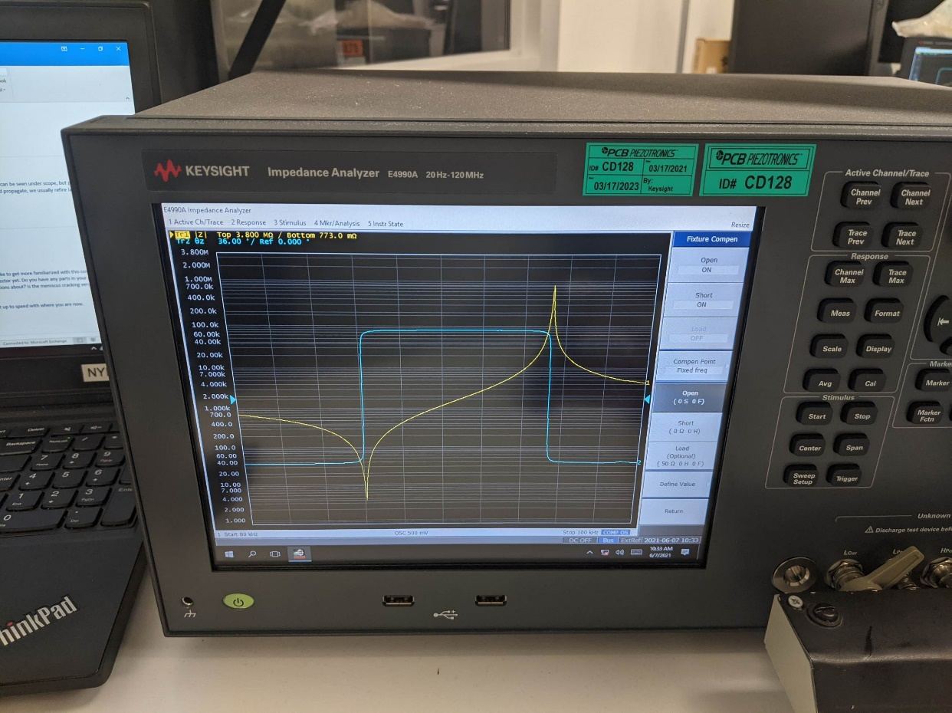

Figure 1. Clean Signal (Analyzer Front Panel)

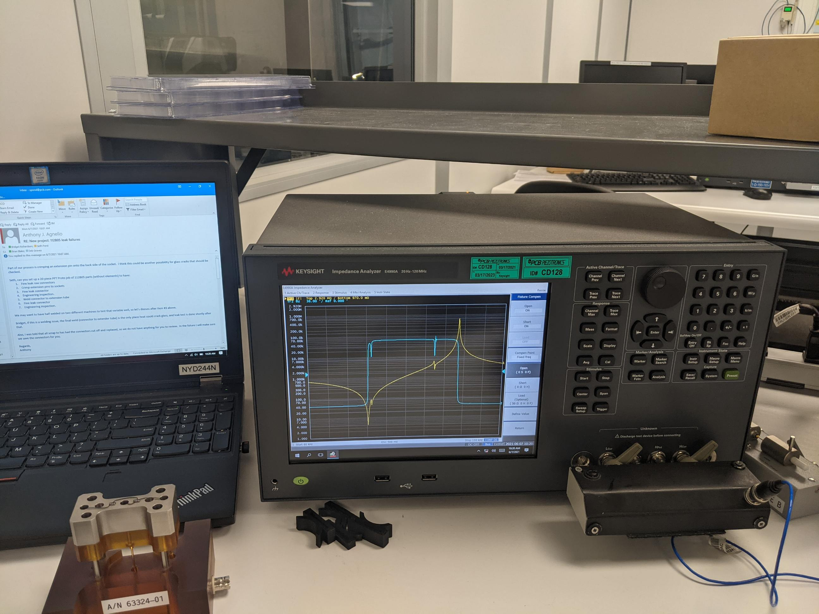

Figure 2. Noisy Signal due to Damaged Specimen (Analyzer Front Panel) - Unacceptable

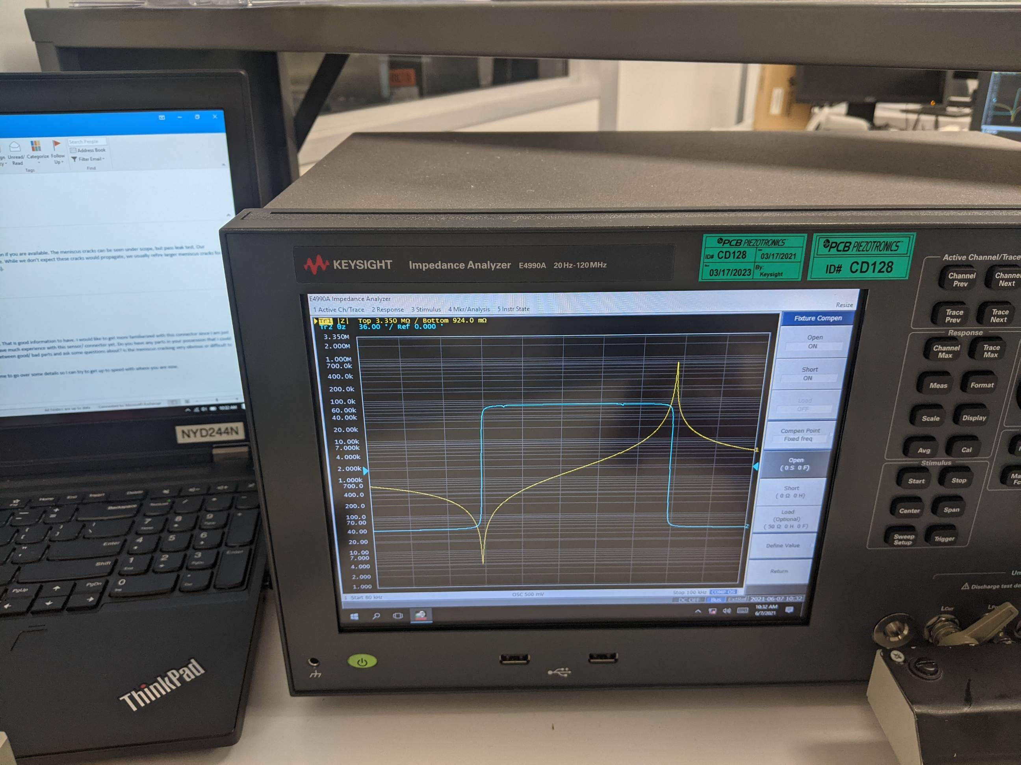

Figure 3. Slight Noise in Signal (Analyzer Front Panel) - Acceptable

* **Click the software button to export the data to the worksheet.** The export function will send data to the highlighted cell in the worksheet. Make sure the cursor is in the right place: “Sample 1, Start F”. This should only need to be checked once, as the cursor will move down one cell each time it is used.
* **Determine whether the sample passes or fails.** Evaluate the data according to the requirements of the part. Acceptable ranges for parameters will be given on the router. The Upper Specification Limit (USL) and Lower Specification Limit (LSL) may be entered directly into the worksheet and capability information will be calculated automatically. If it is determined the sample fails, notify the Supervisor, Engineer, or Lead Technician.
* **Repeat the test process for the remaining specimens in the sample.**

## Shutdown

* **Save the data in the worksheet.** Save the data in the location “R:\Crystals\Test Data\[part number]”. Name the file using the job number then the form number. This may be done by typing manually or scanning the barcode on the router. An example of this is “R:\Crystals\Test Data\58639-01\NCR0000046-0000 CR042.xlsx” or follow instructions for saving provided in router.
* Print the worksheet. (Optional)
* **Close the worksheet file.**
* Close the measurement software. (Optional)
* Log out of the computer. (Optional)
* Turn off the Impedance Analyzer. (Optional)
* **Check to make sure a specimen was not left in the fixture.**

## Alternate Equipment

In the event the E4990A is unavailable, this measurement may be conducted using an alternative set of hardware and software:

* Impedance Analyzer: HP 4194A
* Test Fixture: HP 16034E
* Effective Coupling Measurement Software: keff Measurement.exe
* The VISA Resource Name is “GPIB0::17::INSTR”.

## Open / Short Compensation

* This must be performed anytime a fixture is attached to the analyzer or if the analyzer was previously turned off.
* Before starting the Open / Short compensation, press the **green Preset button** on the front of analyzer to reset instrument to default settings. See Figure 4.
* Using the on-screen menu, select: **Instrument Setup.** See Figure 5.
* Next select: **Fixture Compen.** See Figure 5.
* **Load a clean alumina wafer between pins of the test fixture.** See Figure 6.
* Next select: **Open.** See Figure 5.
  + The analyzer will now run a sweep and the window under OPEN will change from OFF to ON
* **Remove the wafer so the pins of the fixture are touching.** See Figure 6.
* Next select: **Short.** See Figure 5.
  + The analyzer will now run a sweep and the window under SHORT will change from OFF to ON
* The OPEN / SHORT Compensation in now complete. The home screen will display “COMP OS” ” indicating that the Open and Short Compensation factors have been programmed. See Figure 7.

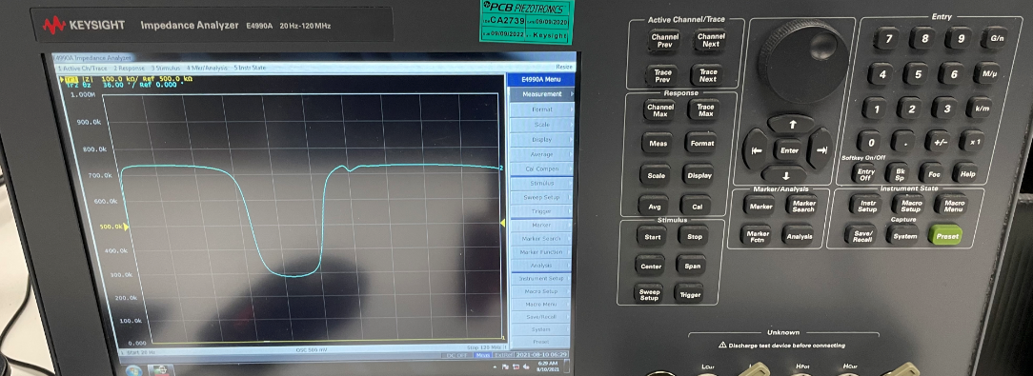

Figure . Front Panel

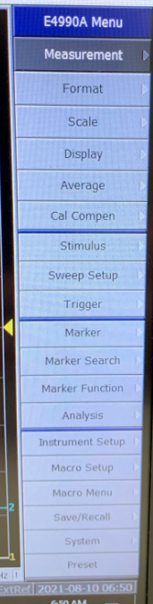 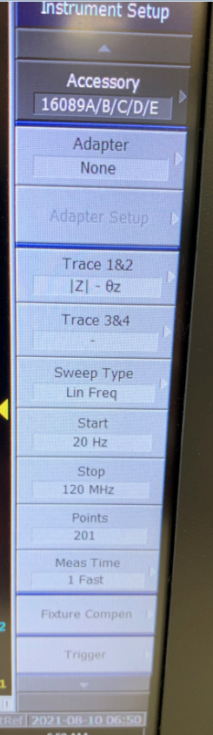 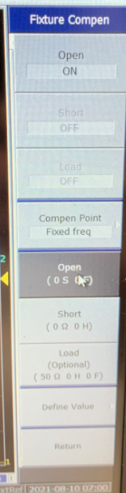 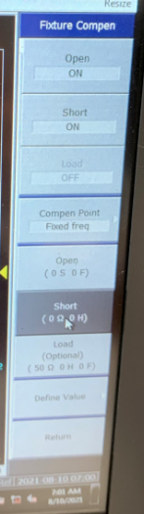

Figure 5. Steps for OPEN / SHORT Compensation

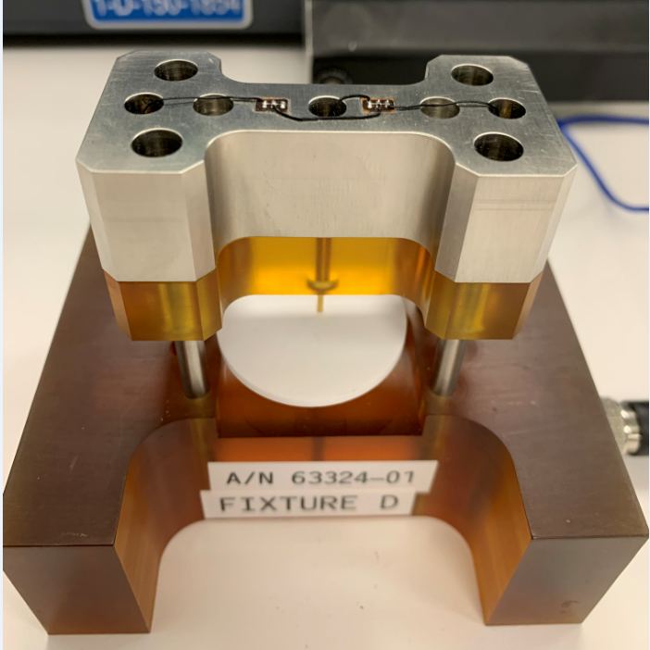 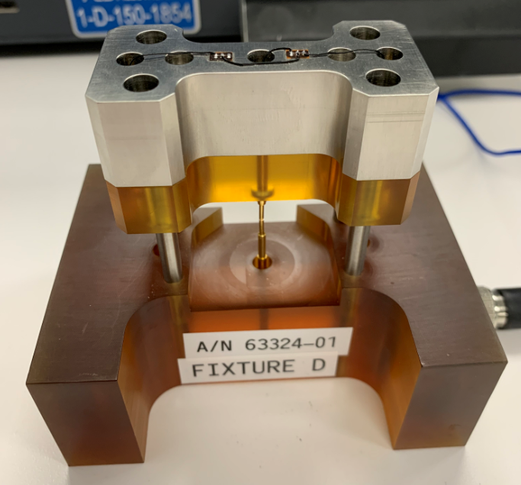

Figure 6. OPEN (left) and SHORT (right)

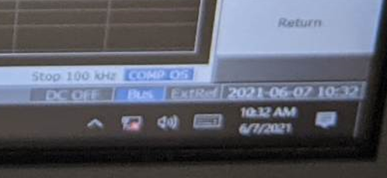

Figure 7. Comp OS