**Purpose:**

The purpose of this procedure is to describe the process used to generate slots in annular shaped ceramic crystals.

**Responsibilities:**

Crystal Department engineering / management is responsible for maintaining this procedure. Crystal Department machinists are responsible for carrying out this procedure.

**Associated Documents: ISO 9001, QAM, QSM, AS9100, CR1041**

**Procedure:**

1 General Description and Practice 1

2 Safety Precautions 1

3 Equipment and Materials 2

4 Mounting Parts 2

5 Setup and Slotting 3

6 Slotting the Crystals 4

## General Description and Practice

This procedure describes the process used to slot ceramic crystals using the ADT Dicer. The Dicer is equipped with a resinoid-bonded diamond-impregnated blade for this process.

Parts to be slotted on the Dicer are mounted onto a steel arbor with a thermoplastic adhesive (wax). The loaded arbors are then mounted into a V-block fixture that is positioned on the square vacuum chuck of the dicer. The slots are then cut into the crystals using an automated program. Following slotting, the crystals are demounted from the block and arbor, and cleaned prior to further processing.

## Safety Precautions

Only trained crystal machinists may operate the Dicer. Use appropriate caution when operating the machine.

Crystals are mounted onto the arbors using thermoplastic adhesives, which are melted on a hot plate. Use caution when using the hot plate and handling the melted adhesives and hot crystals. Use tweezers to handle the crystals, and tongs or other appropriate handling methods to remove the hot arbors from the hotplate.

The thermoplastic adhesives are dissolved with solvents, such as acetone. These solvents are flammable and should be handled cautiously. Do not heat solvents on the hot plate.

## Equipment and Materials

ADT Dicer

100-17015-00 - .012" X 4.60" OD 45 MICRON DICING BLADE

100-17015-60 - 4.0" FLANGE KIT, 4.35" OD

Hot plate

Tweezers

0-1” micrometer

Calipers

Paper towels

Shop rags

Gage Pins per Table 1

Stronghold 7036 Blanchard Wax adhesive (100-8376-20)

Slotting base fixtures per table 1

71119-01 - FIX-XTAL DICER SLICING ALIGNMENT

Aluminum foil

Microscope

Beakers and dishes for solvents

Methanol

Acetone

Isopropyl Alcohol

Ultrasonic cleaner

Drying oven

## Mounting Parts

* 1. Turn on the hot plate, and ~~set the dial to about 130.~~ allow ~~the hot plate~~ it to heat up to 175ºC +/- 15º.
  2. Gather the appropriate slotting base fixture and arbors for the crystal being slotted. Reference Table 1 for part-fixture combinations.
  3. Load the crystals onto the slotting arbor(s). Reference Table 1 for an estimate of the number of crystals to load per arbor. This number will depend on the job number and the thickness of the crystals.Set the loaded arbors onto the hot plate to warm up. After the pieces have warmed up, melt thermoplastic wax adhesive onto the OD of the crystals on the arbors*.*

|  |  |  |  |
| --- | --- | --- | --- |
| Crystal Part Number | Slotting Fixture  Part Number | Gage Pin Part Number | Est. No. Crystals Per Pin |
| 5342-01  13340-01  41658-01  48698-01 | 71190-01 | 100-16905-70 | 40-50 |
| 17744-01 | 100-16414-60  or  100-15626-00 | 75-100 |
| 59865-01 |  | 100-15161-70 | 25-30 |
| 22446-01 | 71191-01 | 100-16905-90 | 10-12 |
| 22446-02 | 100-16905-80 | 20-25 |
| 4372-04 |

Table 1: Slotting Fixture Part Numbers for Ring Shear Ceramic Crystals

* 1. Use tweezers to grab the ends of the arbor, and gently roll the crystals around on the hot plate in order to get a good coating of wax around the crystals and arbor. Use tweezers to gently push the crystals together and center on the arbor.
  2. Using tweezers, remove the arbor(s) from the hot plate and place them into the fixture, starting with the first row. Then place the fixture ~~it~~ onto the cooling plate to let the crystals, and arbors cool.

## Setup and Slotting

* 1. Load the square vacuum chuck onto the dicer per the ADT 7120 Manual, section 8.3, if required.

Make sure the 100-17015-00 - .012" X 4.60" OD 45 MICRON DICING BLADE is mounted on the 100-17015-60 - 4.0" FLANGE KIT, 4.35" OD ~~4.350” Flange~~, which is in turn mounted on the spindle.

* + 1. If the blade is not correct, perform a “blade change” per ADT 7120 Manual, section 8.2.2.3.
  1. Check that the ~~DI~~ water level in the ~~sump~~ coolant tank is adequate.
  2. If necessary, clean the vacuum chuck and fixture bottom with a shop rag.

## Slotting the Crystals

* 1. Turn on the mist collector by pushing in the “START” button.
  2. To assign the appropriate program press the “To Dice” button on the touch screen, as shown in figure 1.

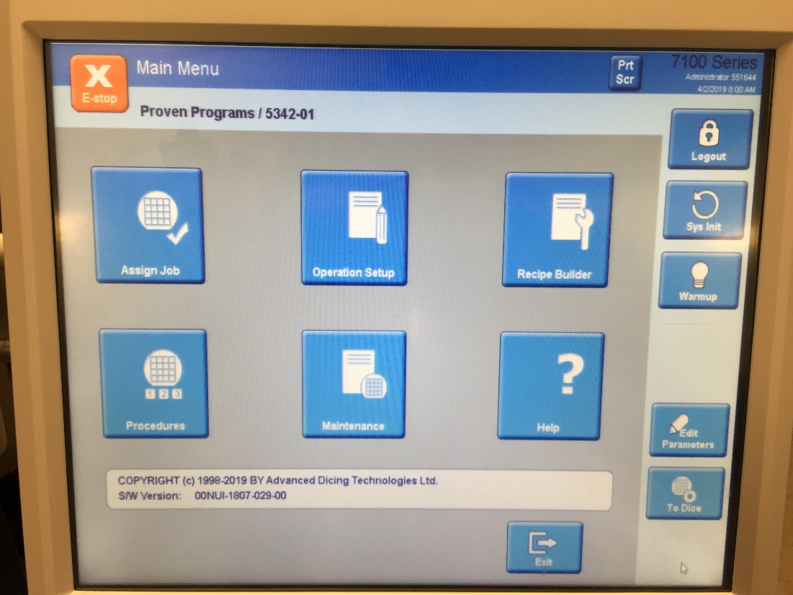

*Figure 1*

* 1. Press the “Run” button (Figure 2). Then scan the **part number** on the router using the scan gun attached to the dicer. The Dicer will ask you to scan a “Lot No” and a “Substrate no.”

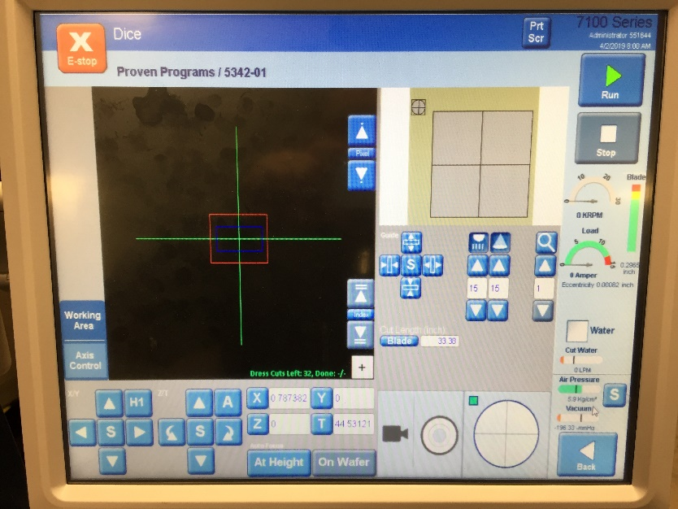

*Figure 2*

* 1. Select the “Lot No”, scan the Job Number when the screen in Figure 3 appears. Hit “OK”, your screen should look like Figure 4.

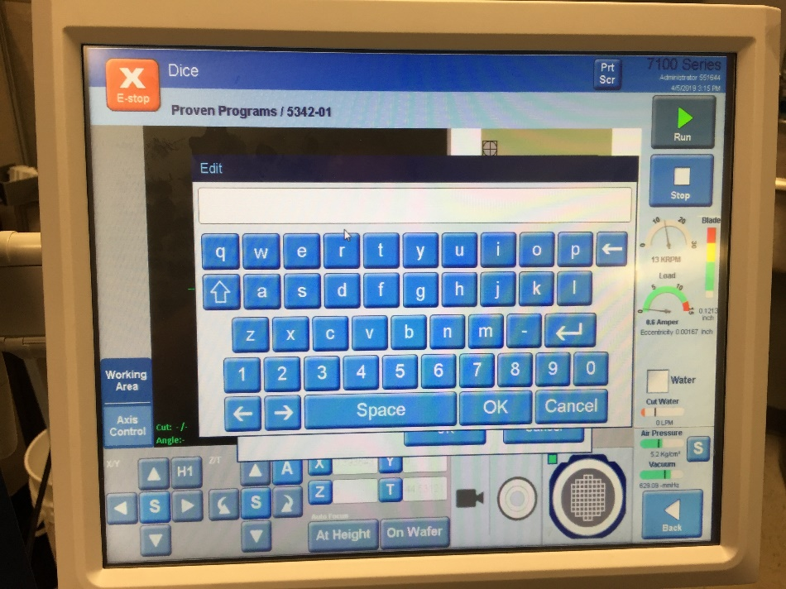

*Figure 3*

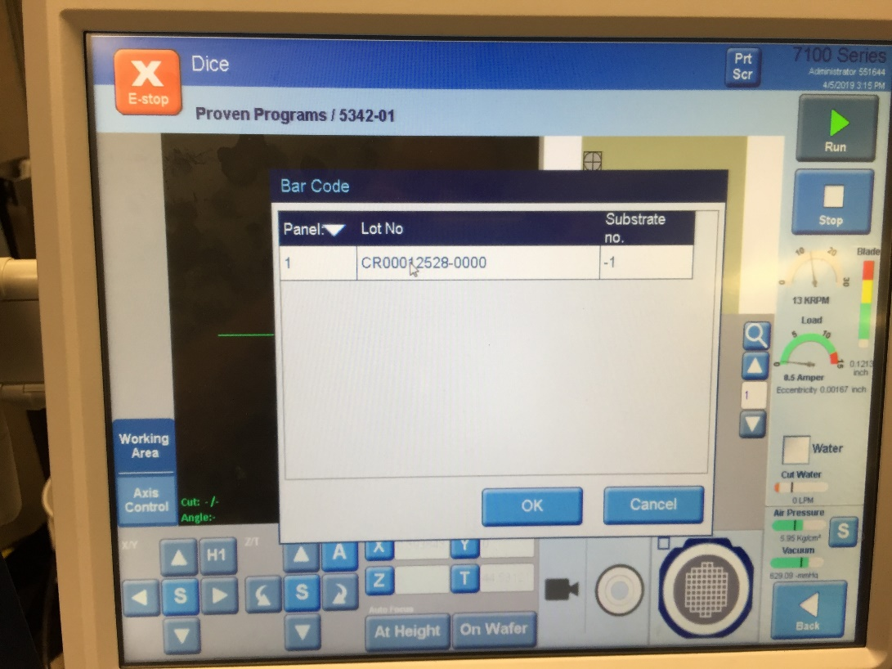

*Figure 4*

* 1. Select the “Substrate no.” and scan the operation number on your job when your screen looks like Figure 5, hit “CLOSE”.

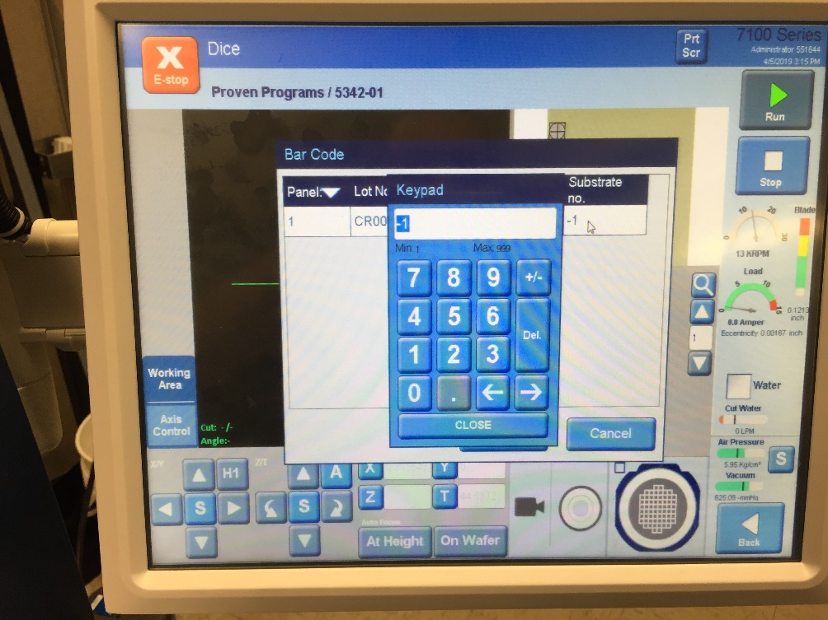

*Figure 5*

* 1. The “Bar Code” Page should like Figure 6, click “OK”.

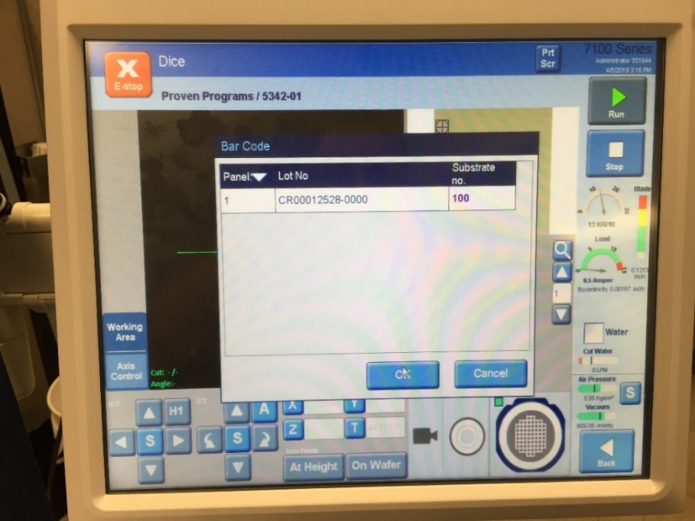

*Figure 6*

* 1. The Dicer will then ask you to “Place Workpiece on Chuck”, as shown in Figure 7.

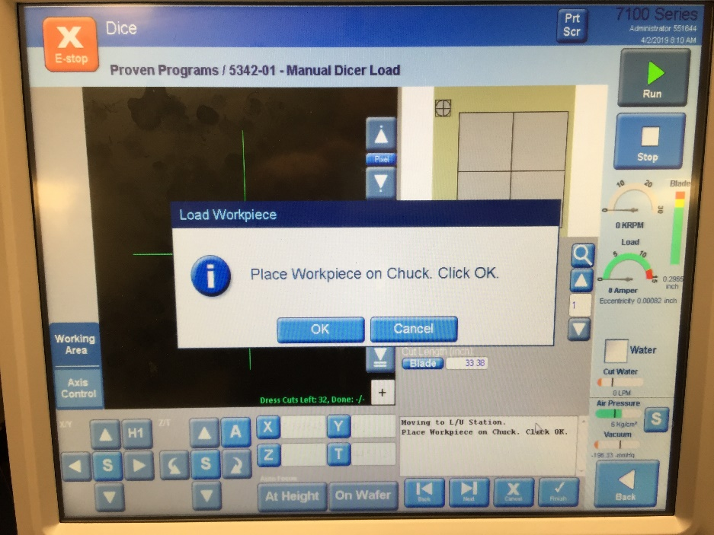

*Figure 7*

* 1. Place Fixture 71119-01 onto the chuck as shown in Figure 8.

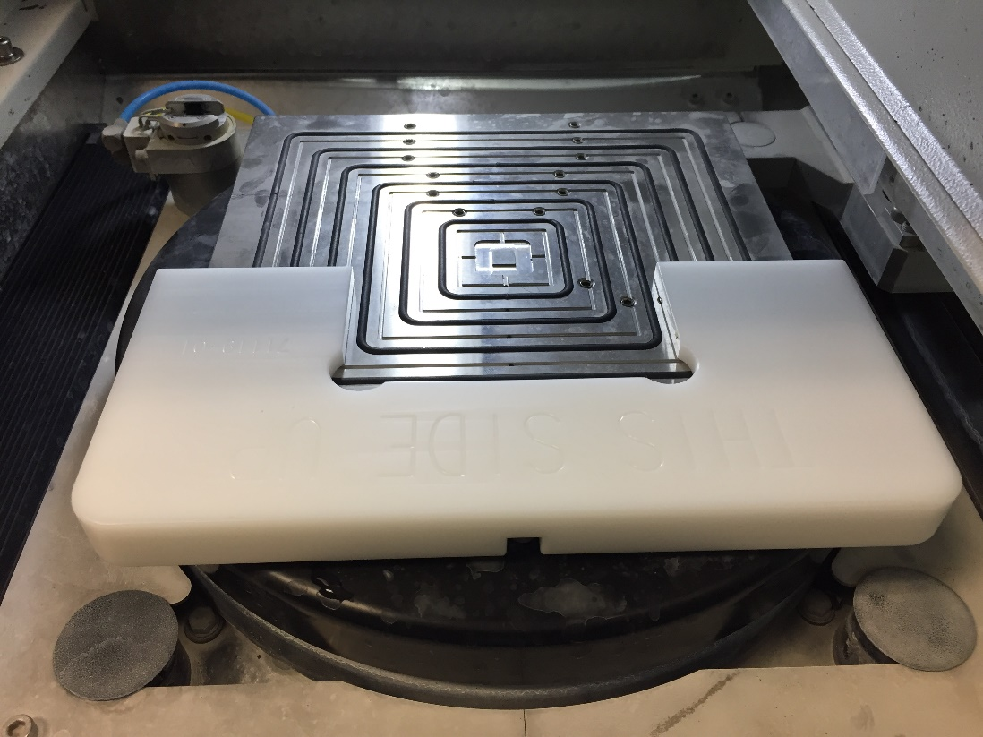

*Figure 8*

* 1. Place the V-Block fixture with your mounted crystals onto the chuck, inside fixture 71119-01 as shown in Figure 9.

Left Align Point

Right Align Point

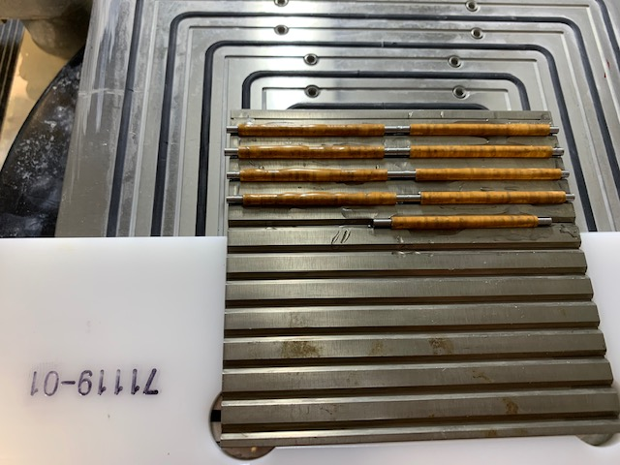

*Figure 9*

* 1. Remove Fixture 71119-01 carefully so that you do not move The V-Block fixture.
  2. Click “OK”.~~The Dicer will automatically dress the blade, align the fixture, and begin slotting on its own.~~ Follow the alignment instructions on the screen. Aligning the fixture to similar locations as shown in figure 11. The “cut position” will be at the location shown in Figure 12. Once complete, the dicer will start slotting.

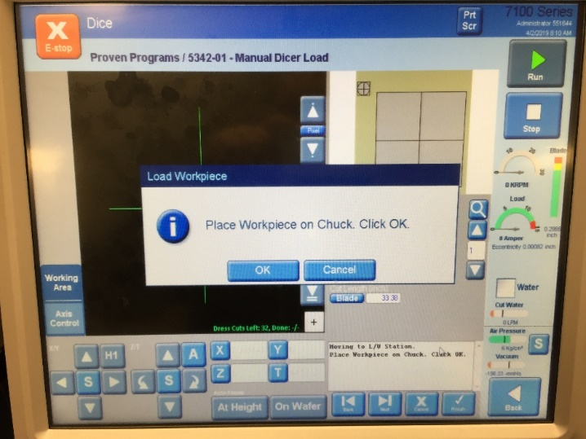

Alignment instructions will

appear here.

*Figure 10*



*Figure 11*

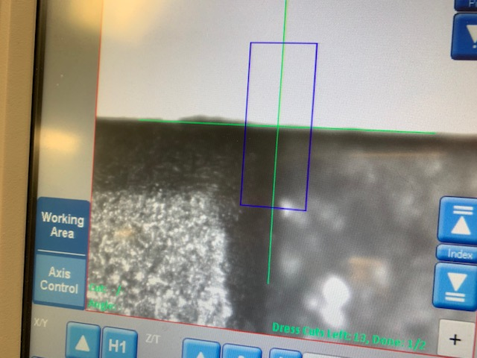

*Figure 12*

* 1. When the slotting cycle is complete, open the Dicer’s loading/unloading door and use compressed air to remove the ~~DI~~ water and sludge from the slotting base fixture and table.
  2. Remove the slotting base fixture from the table by clicking the “OK” button in Figure 13.

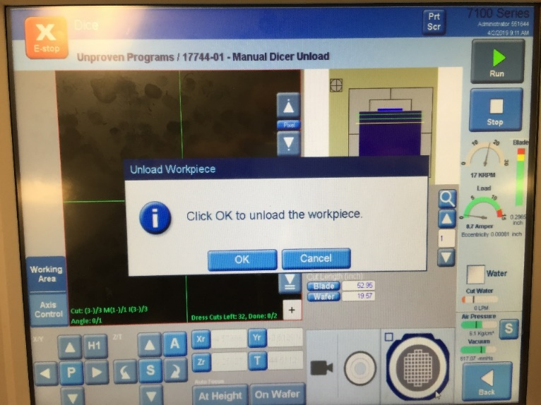

Figure 13

6.9 Remove the arbors from the V-Block fixture by setting it onto the hot plate and allowing it to heat up until the crystals can be removed from the V-Block and arbor.

6.10 Use tweezers to carefully slide the parts off the arbor. Take care and do not slide the parts across the surface of the hot plate when removing them from the rod. Place the parts into a beaker of acetone, and allow them to soak until they can be separated. Cover the beaker with tin foil, and label with the job number.

6.11 Once separated, place the parts into a beaker of clean acetone labeled with the job number, cover the beaker with foil and allow the parts to sit in the acetone overnight.

6.12 The slotting base fixture can be cleaned by placing in the Lenium Degreaser. Arbors are disposable, throw into trash can.

6.13 Clean up the Dicer if necessary.

1. ***Cleaning Crystals After Slotting***
   1. After the parts have soaked overnight in acetone, place the dish in the ultrasonic cleaner for a minimum of 30 minutes.
   2. Remove the beaker from the ultrasonic bath. Pour off the acetone into the waste solvent can. Cover the parts with acetone and place in the ultrasonic cleaner for a minimum of 30 minutes.
   3. Pour off the acetone into the waste solvent can. Cover the parts with methanol and place in the ultrasonic cleaner for a minimum of 30 minutes.
   4. Pour off the methanol into a waste container.
   5. Dry the parts in an oven at 110ºC for a minimum of 30 minutes.
   6. Remove the parts from the oven. Inspect the parts under a microscope. Reject those that are cracked or severely chipped, and segregate by placing into the appropriate Non-Conforming product bin.

**NOTE: Do not discard lead-containing crystals in the trash. They must be discarded in the appropriate hazardous waste container.**

* 1. Place the parts into a plastic Petri dish labeled with part number, job number and batch number. Fill out documentation as required. Place the crystals and documentation on the in-process staging shelf.