User Guide: Testing Powder Using the Hall Flowmeter

Contents
PURPOSE 1
RESPONSIBILITES 1
AFFECTED DEPARTMENTS / PRODUCT GROUPS / SUPPORT GROUPS: 1
ASSOCIATED DOCUMENTS 1
GENERAL DESCRIPTION AND PRACTICE 2
SAFETY PRECAUTIONS 2
EQUIPMENT 2
SETUP 3
TEST METHOD 4
REPORTING RESULTS 5
EXAMPLE WORKSHEET 6
EXAMPLE TEST SPECIFICATION 6

PURPOSE
The purpose of this procedure is to describe the process used for measuring the flow rate and apparent density of granulated or otherwise free-flowing powder, using the Hall Flowmeter.

RESPONSIBILITES
Crystals Engineering is responsible for maintaining this procedure.
Crystals Production is responsible for carrying out this procedure.

AFFECTED DEPARTMENTS / PRODUCT GROUPS / SUPPORT GROUPS:
Crystals Department

ASSOCIATED DOCUMENTS
ISO9001, QAM, QSM, AS9100

GENERAL DESCRIPTION AND PRACTICE
This procedure describes the process for measuring the flow rate and apparent density of powder using a Hall Flowmeter funnel and cup. In this test, a known mass of powder is poured through a funnel into a small cup with a known volume. By measuring the time it takes this powder to flow through the funnel, we may calculate its flow rate. By measuring the mass of powder that fills the cup we may calculate its apparent density. These properties allow us to determine whether the powder batch will behave consistently during pressing.

SAFETY PRECAUTIONS

HANDLING FINE AND/OR TOXIC POWDERS
When working with fine powders, avoid inhaling or ingesting the dust generated by the handling process. Use a dust collection bench as the primary work area and wear appropriate dust masks, lab coats and gloves when handling the powders. It is imperative that the operator washes his/her hands thoroughly before eating, drinking, or smoking in order to prevent ingesting any dust. Very fine dust is found mostly in operations dealing with raw materials, dried, ball-milled powders, and very fine, granulated powders.

EQUIPMENT
- Hall Flowmeter funnel, cup, tray and stand
- Balance, capable of measurements to the nearest 0.01g.
- 6” Ruler
- Plastic weighing trays
- Brush for cleaning cup
- Digital stopwatch/timer
- Height gage

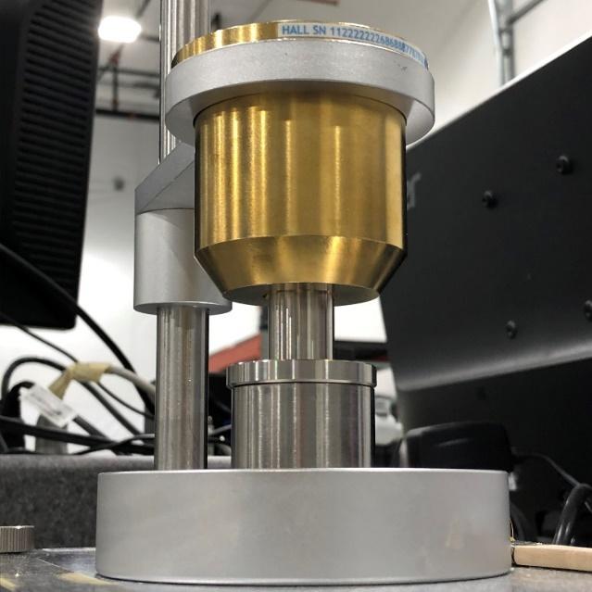
Figure 1
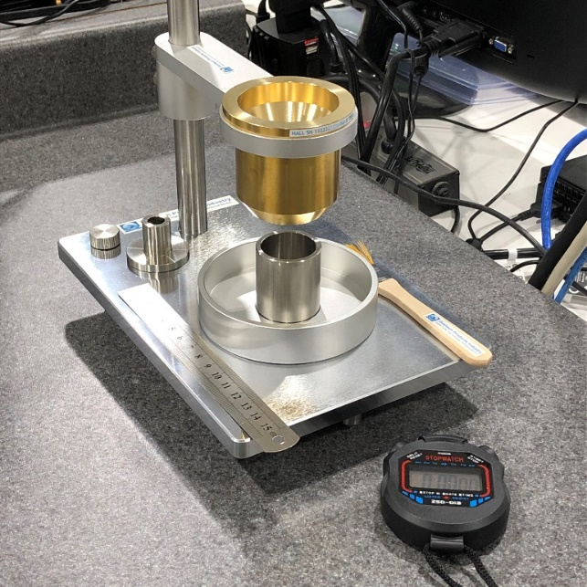
Figure 2
SETUP
- Place the Hall Flowmeter stand on a clean workbench.
- Level the base by turning the adjustable feet.
- Adjust the funnel holder ring upward so it is well clear of the cup and tray below.
- Select either the Hall or Carney funnel, per the test specification, and insert it into the ring.
- Place the tray and cup under the funnel.
- Adjust the height of the funnel downward over the cup to 1 inch using the height gage. Reference Figure 1 and Figure 2.

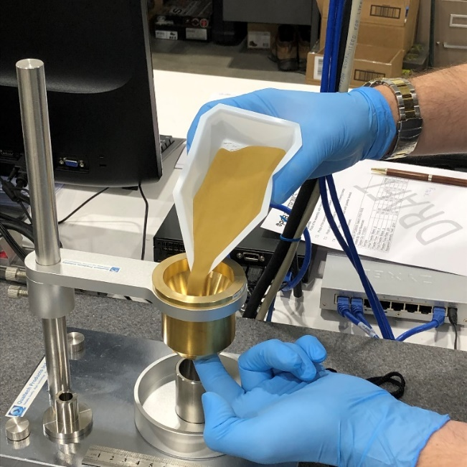
Figure 3
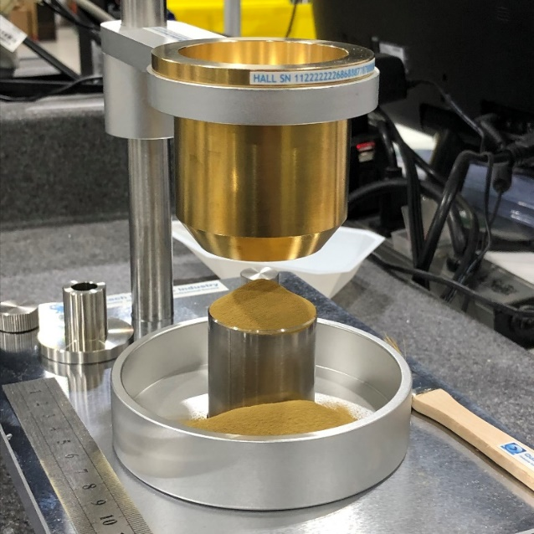
Figure 4
TEST METHOD
- Weigh three samples of powder in clean plastic weighing trays, per the test specification.
- Record the mass of each sample to the nearest 0.01 grams.
- Place the empty cup on the balance and tare the mass of the cup.
NOTE: The reference mass of the clean, empty cup should be approximately 115.75 grams.
- Place the empty cup back into the subassembly.
- Block the opening of the funnel with your finger and prepare the timer.
- Pour the pre-weighed powder into the funnel. Reference Figure 3.
- Remove your finger from the funnel and begin the timer.
- Allow all the powder to flow into the cup.
NOTE: Powder should be to the point of overflowing. Reference Figure 4.
- Stop the timer when the powder runs out and record this time to the nearest 0.01 seconds.
NOTE: If the powder stops flowing at any point in the middle of the test: stop the test, record DNF (did not flow) for the time, then move on to the next sample. If a second sample fails, the powder is not useable as is. Notify your Supervisor/Engineering/Leadperson for disposition.
- Remove the funnel and set it aside.
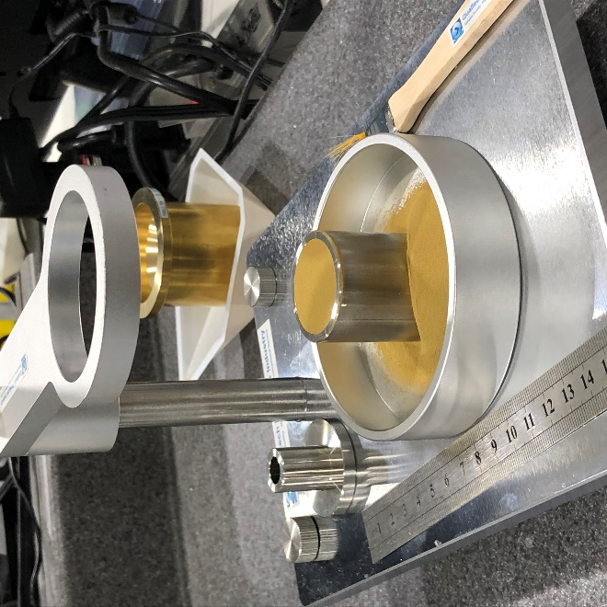
Figure 5
- Use the 6” ruler to cut the excess powder off the top of the cup, flush to the edge. Reference Figure 5.
- Pick up the cup and gently brush away any powder stuck to the sides using the brush.
- Weigh the powder to the nearest 0.01 grams using the tared balance and record this mass.
- Pour the powder in the cup and tray back into the plastic weighing tray.
- Repeat this test for the two remaining samples.
- When testing is complete, clean and dry the funnel, tray and cup.
- Dispose of the powder and weighing trays in the appropriate lead waste receptacle.

REPORTING RESULTS
- Report the initial mass, flow time and final mass for all three samples.
- For each trial, divide the initial mass by the flow time to yield the flow rate.
- For each trial, divide the final mass by 25cm³ (the cup volume) to yield the apparent density.
- Calculate the average flow rate and average apparent density from the three samples.

EXAMPLE WORKSHEET
Material ID: PCBXXX Batch XXX-XXX
Tested By: David Bowman
Tested On: 1/1/2021
Sample | 1 | 2 | 3 | Average
Initial Powder Mass, g | 75.00 | 75.00 | 75.00
Powder Flow Time, s | 59.00 | 60.00 | 61.00
Final Powder Mass, g | 50.00 | 50.50 | 51.00
Powder Flow Rate, g/s | 1.27 | 1.25 | 1.23 | 1.25
Apparent Density, Hall, g/cm³ | 2.00 | 2.02 | 2.04 | 2.02

EXAMPLE TEST SPECIFICATION
Test powder using (Hall/Carney) funnel, per CR1060.
Initial Mass = XX.X grams.
Minimum Acceptable Flow Rate = X.XX g/s
Minimum Acceptable Density = X.XX g/cm³

