**Contents**

PURPOSE 1

RESPONSIBILITIES 1

AFFECTED DEPARTMENTS / PRODUCT GROUPS / SUPPORT GROUPS 1

ASSOCIATED DOCUMENTS 1

GENERAL DESCRIPTION AND PRACTICE 1

SAFETY PRECAUTIONS 2

ELECTRODE CALIBRATION 2

ELECTRODE STORAGE 5

ELECTRODE CLEANING 5

APPENDIX: EQUIPMENT AND CHEMICALS 7

APPENDIX: FILLING THE REFERENCE ELECTRODE 7

PURPOSE

This document provides a general guide of how to calibrate, operate, clean and maintain the pH meter and the electrode.

RESPONSIBILITIES

Crystal Department engineering / manufacturing management is responsible for maintaining this procedure.

Crystal Department technicians are responsible for carrying out this procedure.

AFFECTED DEPARTMENTS / PRODUCT GROUPS / SUPPORT GROUPS

Crystals Department

ASSOCIATED DOCUMENTS

ISO 9001, QAM, QSM, AS9100

GENERAL DESCRIPTION AND PRACTICE

This document explains how to calibrate, operate, clean and maintain the pH meter system. The main purpose of the pH meter system is to monitor the chemical plating (and other similar) processes in order to detect any deviation from the optimum pH.ranges. The proper use and maintenance of the system will ensure precise and accurate pH measurements and will extend the lifespan of the electrode.

SAFETY PRECAUTIONS

The operator may come into contact with the following materials and equipment that requires caution:

* Acid/Base solutions

Common sense and good laboratory practice should be used at all times.

IN THE CASE OF ANY INJURY, INFORM YOUR SUPERVISOR IMMEDIATELY.

**HANDLING ACIDS AND BASES**

* In any operation that calls for the use of strong acids or bases, use rubber gloves, yellow aprons and sleeves and safety goggles.
* Avoid all contact, especially the eyes, with these strong solutions and avoid breathing the vapors.
* Always prepare and use the solutions in the fume hood.
* Avoid splashing and spills of any of the acid or base solutions. If for any reason some of the acid comes into contact with the skin, flush immediately with water for a minimum of 5 minutes and neutralize with soda from the acid spill kit. An Emergency Eyewash station and shower is available in the lab and should be used if necessary.
* In the case of any accidents, inform your supervisor.
* Where there is a major spill not in contact with the skin, call your supervisor and then neutralize an acid with soda or dilute a base with water and then clean as with any spill.
* When mixing an acid solution, always add the acid to the water.

ELECTRODE CALIBRATION

*NOTE: Calibration of the meter should be done at a minimum of once per week. Use fresh pH buffers. The pH meter is setup with automatic buffer recognition and automatic calibration. Select pH buffers that bracket the expected sample pH (e.g. for measuring acidic chemical plating solutions, select buffers with a pH of 4.01 and 7.00 in order to calibrate).*

1. Take the protective cap out of the electrode filling hole. See Figure 1.
2. Unscrew the cap of the electrode storage container and then remove the electrode from the cap and the storage container. See Figure 1.

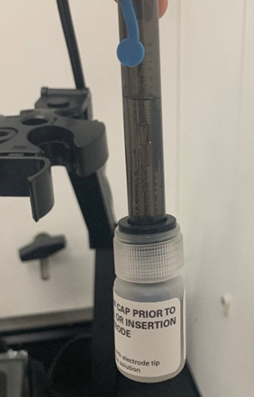

Electrode Storage Container

Protective Cap on Electrode Filling Hole

Storage Container Cap

Figure 1 Electrode Attached to Storage Container

1. Turn on the meter by pressing “Power”. See Figure 2.
2. Press **mode (enter)** until you get the pH displayed on the screen. See Figure 2.

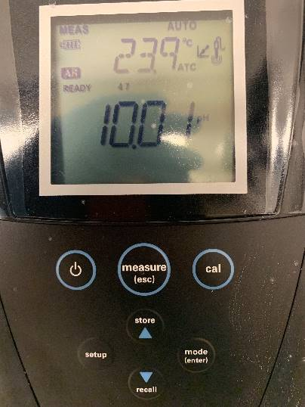





pH display

Power

Figure 2 pH Meter Display

1. Press **cal**. See Figure 2. Rinse the electrode with DI water, blot dry with a lint-free tissue (without touching the electrode bulb) and place into the buffer pH 4.01. Make sure the electrode bulb is completely submerged in the solution.
2. Wait for “READY” to appear on the screen.
3. Rinse the electrode with DI water, blot dry with a lint-free tissue (without touching the electrode bulb) and place into the buffer pH 7.00. Make sure the electrode bulb is completely submerged in the solution.
4. Press **cal**.
5. Wait for “READY” to appear on the screen.
6. Press mode (enter) to save and end calibration.
7. Once the second point of the calibration is completed, the slope will be displayed. The slope should be between 92 and 102%. If the slope is outside of this range, notify your Engineer/Supervisor/Leadperson. The meter will automatically proceed to measurement mode after calibration .
8. Rinse the electrode with DI water and discard the buffers in the appropriate waste container.

**pH MEASUREMENT**

1. Take the protective cap out of the electrode filling hole. See Figure 1.
2. Unscrew the cap of the electrode storage container and then remove the electrode from the cap and the storage container. See Figure 1.
3. Turn on the meter by pressing “Power”. See Figure 2.
4. Press **mode (enter)** until you get the pH displayed on the screen. See Figure 3.







pH display

“READY”

Figure 3 pH Meter Display

1. Collect enough sample in a 50 mL beaker to cover the electrode.
2. Rinse the electrode with DI water, blot dry with a lint-free tissue (without touching the electrode bulb) and place into the sample. Make sure the electrode bulb is completely submerged in the solution.
3. Press **measure (esc).** See Figure 3.
4. Record the pH of the sample when “READY” appears on the screen and the pH stops blinking.
5. Remove the electrode from the sample and rinse it with DI water. Discard the waste in the appropriate waste container.
6. Repeat the same process with all other samples using clean 50 mL beakers.

ELECTRODE STORAGE

*NOTE: Properly storing the electrode after every use will prevent crystallization of the filling solution and will keep the electrode clean prior to next use. This is important so that the electrode element and reference chamber does not dry out.*

1. Insert the plastic cap into the filling hole.
2. Fill the storage solution container with pH electrode storage solution.

*NOTE: Change out the storage solution in the storage container once a week minimum.*

1. Place the electrode inside the storage solution container.



Electrode Storage Container

Protective Cap on Electrode Filling Hole

Storage Container Cap

Figure 4 Electrode Properly Stored

ELECTRODE CLEANING

*NOTE: Follow these cleaning instruction at a minimum of once per week or if the electrode becomes noticeably dirty.*

1. Clean any salt deposits from the exterior of the electrode by rinsing with DI water and wiping with a lint-free tissue.
2. Fill a plastic beaker with DI water.
3. Unscrew the cap of the electrode storage container and then remove the electrode from the cap and the storage container. See Figure 1.

*NOTE: Change out the storage solution in the storage container once a week minimum.*

1. Rinse the electrode in the beaker filled with the DI water.
2. Pour enough of cleaning solution D into a 50 mL beaker to cover the electrode junction (~1 inch), as shown in Figure 5.

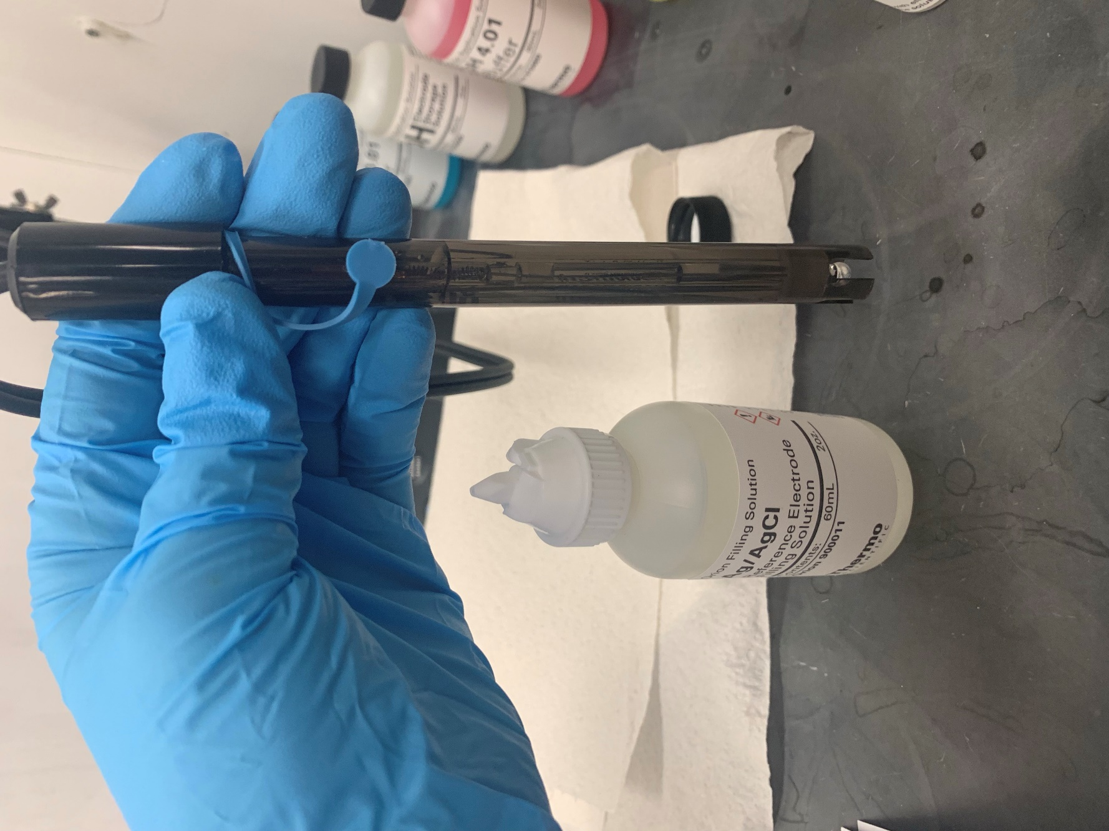

This portion of the electrode should be submerged

Electrode Bulb

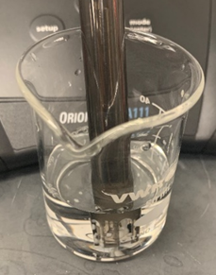

Figure 5 Electrode in Cleaning Solution

1. Gently stir the electrode in the solution for a minimum of 60 seconds.
2. Remove the electrode from the solution and rinse it in the beaker with DI water thoroughly to remove the cleaning solution.
3. Blot dry the electrode with a lint-free tissue without touching the electrode bulb.
4. Discard the cleaning solution into the appropriate waste container.

APPENDIX: EQUIPMENT AND CHEMICALS

|  |  |
| --- | --- |
| **EQUIPMENT** | **CHEMICALS** |
| pH meter (Orion Star A111 Benchtop or equivalent) | Buffer pH 4.01 (PCB p/n 100-17216-20) |
| AgCl Electrode (Orion 9157BNMD or equivalent) | Buffer pH 7.00 (PCB p/n 100-17216-10) |
| 50 mL Beakers | Buffer pH 10.01 (PCB p/n 100-17216-00) |
| 1 L Plastic Beaker | Electrode Storage Solution (PCB p/n 100-16986-80) |
|  | pH Cleaner D Solution (PCB p/n 100-17215-90) |
|  | Reference Electrode Filling Solution (PCB p/n 100-17235-30) |
|  | DI Water |

APPENDIX: FILLING THE REFERENCE ELECTRODE

*NOTE: If the inside of the reference chamber becomes contaminated, drain the reference chamber and flush it with fresh DI water before refilling per the following process.*

1. Take the protective cap out of the electrode filling hole. See Figure 6.
2. Add electrode filling solution to the electrode by inserting the end of the cap on the filling solution into the electrode filling hole. Fill to a level slightly below the filling hole. The level of the filling solution must always be an inch above the level of the sample being measured. See Figure 6.

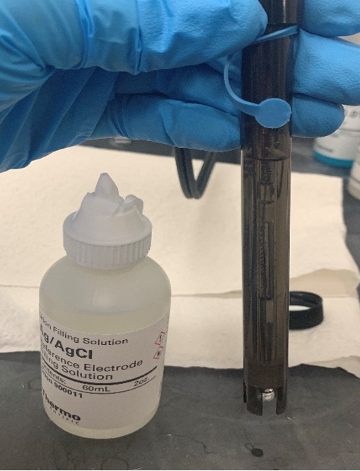

Protective Cap on Electrode Filling Hole

Reference Electrode Filling Solution should be at this level.

Electrode Filling Solution

Figure Electrode Filling Solution Level

1. Place the electrode in the holder and suspend in air for 5 minutes.
2. Slightly shake the electrode to remove any air bubbles.
3. Soak the electrode in pH electrode storage solution for 30 minutes minimum prior to using for a measurement.