**Contents**

STARTUP SEQUENCE 1

MEASUREMENT SEQUENCE 2

PRINTING/SAVING A REPORT 6

ENERGY CALIBRATION 7

STARTUP SEQUENCE

1. Turn on power to the entire workstation using the UPS.
2. Turn on XRF hardware by pressing the power button on the front panel. See Figure 1.

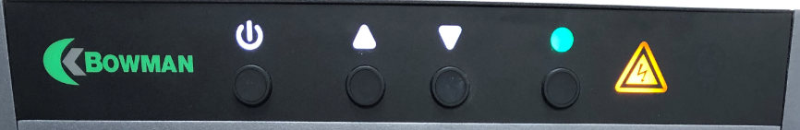

Power

Figure 1 XRF Controls – Power Button

NOTE: The hardware must be on before logging into the software. The software will immediately try to communicate with the hardware and will return an error if it does not see it ready.

1. Turn on the computer and monitor.
2. Open the XRF software by selecting the “Xralizer” icon on the computer desktop. See Figure 2.

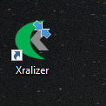

Figure 2 XRF Software Icon

1. Log in to the software – User “BASIC”, Password “12345”. See Figure 3.

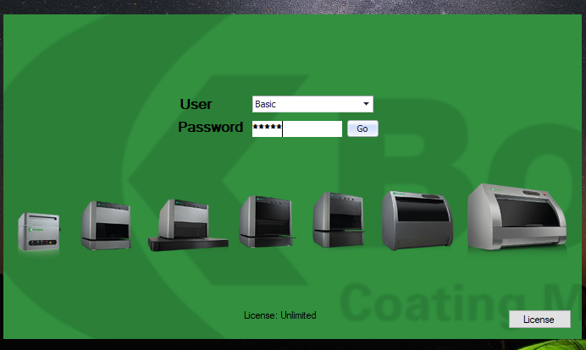

Figure 3 XRF Login Screen

1. Wait for the unit to finish initializing and until the field labelled “Special” (the detector temperature), at the bottom of the screen, has cooled to at least -45°C and is no longer highlighted. See Figure 4.

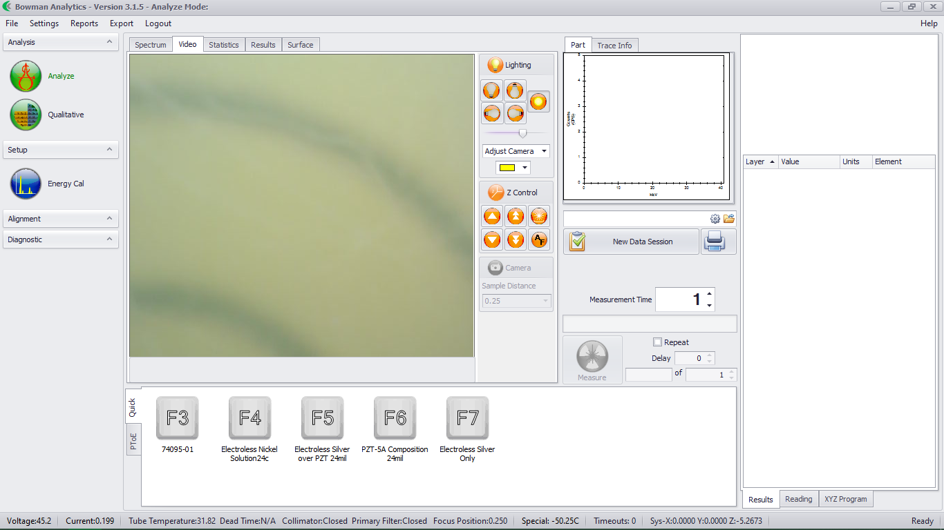

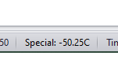

Figure 4 Detector Temperature Field

MEASUREMENT SEQUENCE



Analyze Icon

Program

Figure 5 XRF Measurement Screen

1. Select the “Analyze” icon at the top left side of the screen. See Figure 5.
2. Select the program, according to the item number, at the bottom of the screen. See Figure 5.
3. Open the door to the XRF, load the sample onto the tray, insert the tray into the XRF, locate the sample using the camera, then close the door. See Figure 6.

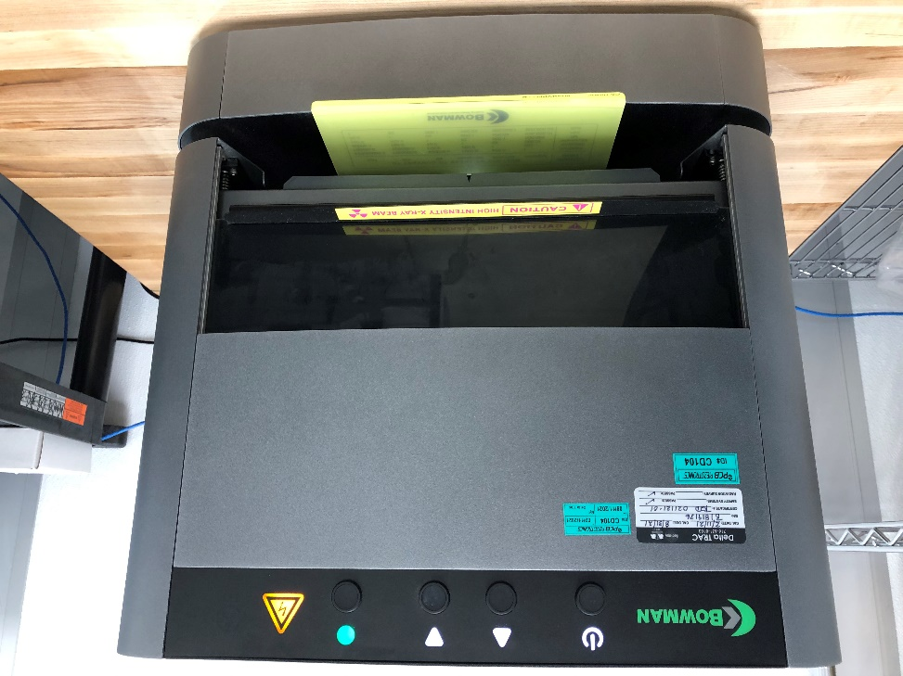

Sample Tray

XRF Door

Figure 6 XRF Door and Sample Loading

NOTE: When the part is centered on the bullseye and the tray is inserted so the arc line on the front of the tray lines up with the edge of the XRF, the part should be centered under the camera.

1. Adjust the lighting, using the icon cluster, if needed. See Figure 7.

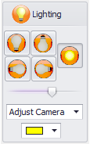

Figure 7 Lighting Controls

1. Begin a new data session by clicking the “New Data Session” button . See Figure 8.

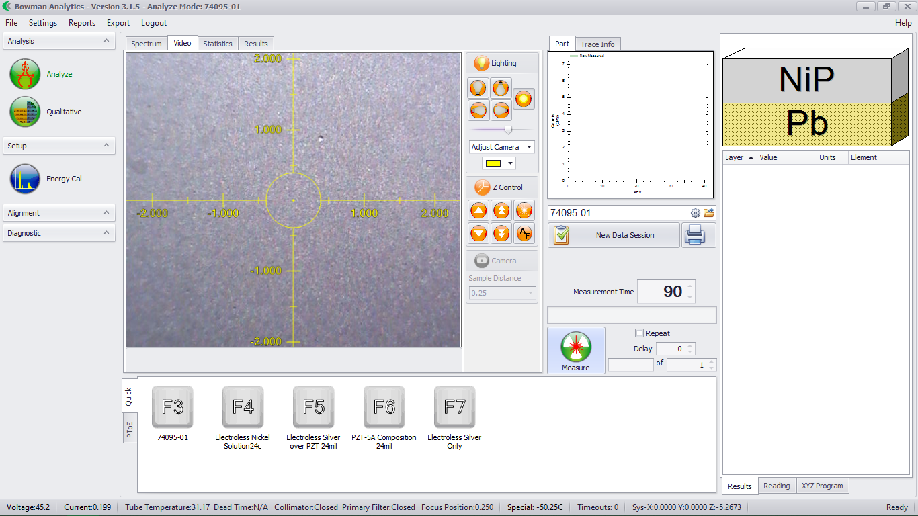

Measure

New Data Session

Figure 8 XRF Measurement Screen

1. Enter the Job Number, eg: CR12345. See Figure 9.

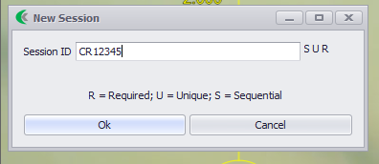

Figure 9 New Session Job Number Entry

1. Begin the measurement by clicking the Measure button 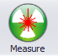.

NOTE: The XRF will Autofocus with each measurement. See Figure 10.

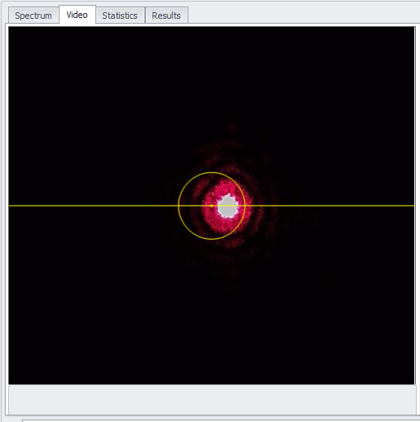

Figure 10 Video Screen During Autofocus

NOTE: While the measurement is counting down, the measure button  will change into a stop button 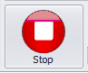. Be certain to wait until it changes back into the measure icon before opening the chamber door.

NOTE: Periodically, the XRF will require the user to perform Energy Calibration before a measurement can begin. A dialog box will appear on the screen and prompt you to perform this measurement. Follow the steps in the Energy Calibration section.

1. Once the measurement is complete, the results will be displayed in the top right window. See Figure 11.

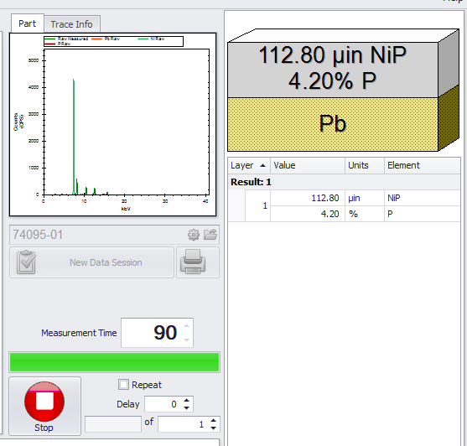

Results

Figure 11 Measurement Results

NOTE: Out of tolerance results will be indicated by red text and a triangle pointing up or down.

1. Remove the sample from the XRF and repeat the measurement for the remaining samples.

PRINTING/SAVING A REPORT

1. Once all of the required samples are measured for the specific job, click the Printer icon .
2. Under the File drop down, Click on Export. See Figure 12.

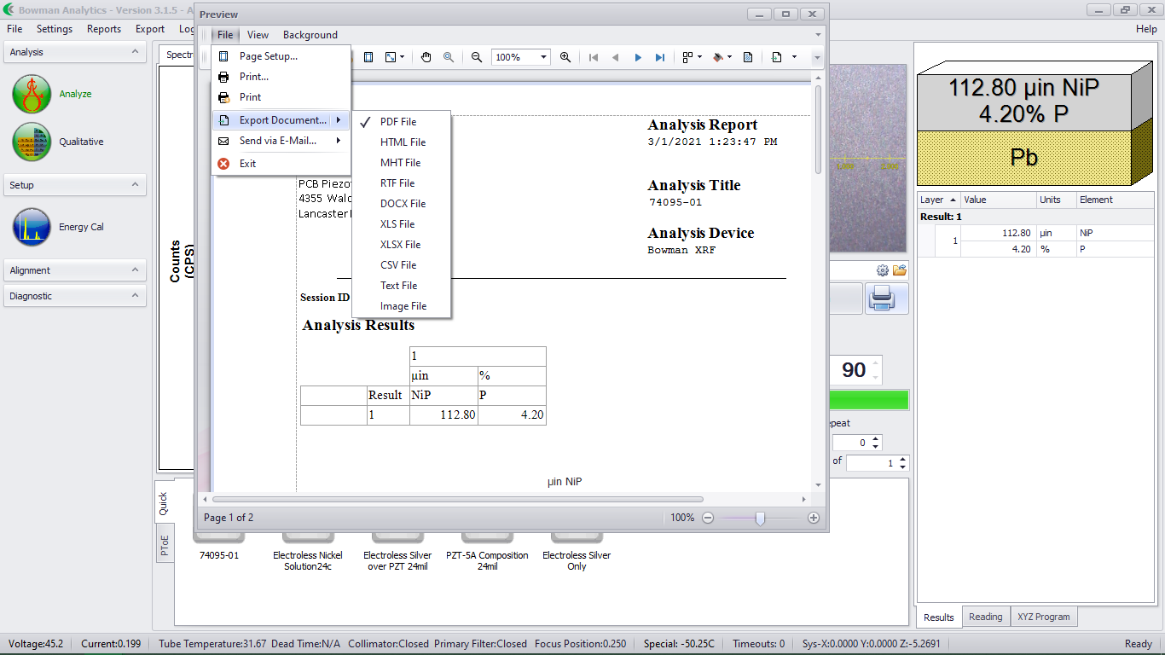

Printer

Figure 12 Saving a Report

1. Save the report to the appropriate directory listed on the router.

ENERGY CALIBRATION

1. Click on the Energy Cal icon  located at the top left of the screen. See Figure 13

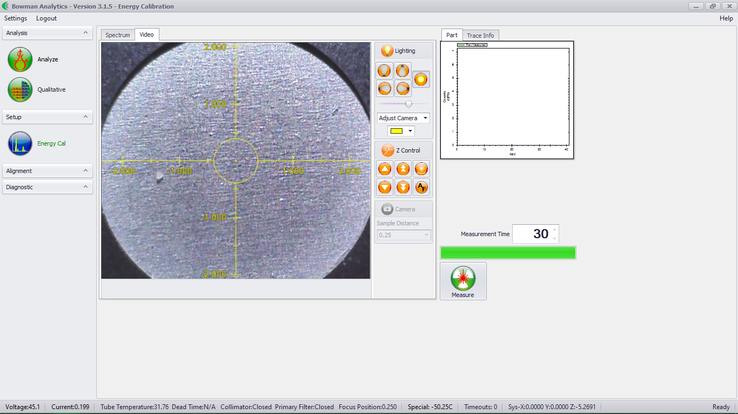

Energy Cal

Figure 13 Energy Cal Screen

1. Open the door to the XRF, place the Energy Cal standard onto the tray, insert the tray into the XRF, and locate the sample using the camera, then close the door. See Figure 14.

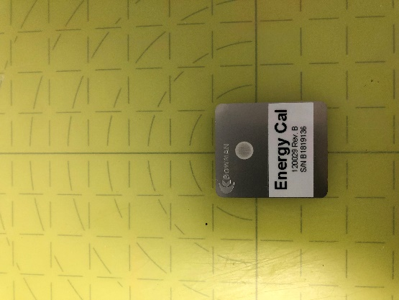

Figure 14 Energy Cal on Sample Tray

NOTE: When the sample is centered on the bullseye and the tray is inserted so the arc line on the front of the tray lines up with the edge of the XRF, the sample should be centered under the camera. See Figure 14.

1. Begin the calibration by clicking the Measure button .
2. After the instrument has calibrated, a screen will pop up indicating the energy calibration was successful or has failed. If the calibration has passed, measurements can following the Measurement Sequence section. If the calibration has failed, notify your Supervisor/Engineer/Lead.