**Contents**

1. Overview 2

1.1. Safety and Precautions 2

1.2. Introduction 3

1.3. Particle Extractor 3

2. General Procedure for Marking or Ablating Parts 4

3. Power Meter Test Procedure 6

4. Preventative Maintenance 7

# 

## Overview

## Safety and Precautions

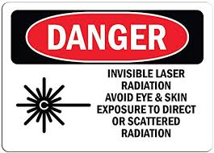

* + 1. The Trumpf Trumark 5000 utilizes a class IV Laser which can be very dangerous when used improperly or carelessly. It is crucially important to avoid any possible eye or skin exposure to either direct or scattered radiation.
    2. It is important to recognize that the most dangerous type of radiation emitted from this equipment is invisible to the human eye. For this reason, it is critical at all times to ensure safe use of the machine.
    3. The Trumpf Trumark 5000 features a protective housing that will not allow the marking laser to run while the automatic door is open.

#### The laser marker is a Class I workstation that does not allow access to hazardous levels of laser light during operation. Never disable or defeat the door safety switch or remove any of the guarding when the laser is running production.

* + - 1. There is a second ‘Trace’ laser that is used to trace the outline of the mark that can be run when the door is open. This trace laser is not dangerous and is commonly used while the door is open to ensure proper sizing and orientation of marking programs.
      2. Upon starting a program, the door will close and the laser head will move into position to mark. At this time, the laser will begin running. Although the door is closed and the safety glass serves as a safety barrier between the operator and the laser, it is not recommended to ‘stare’ at the laser while it is marking for long periods of time. Periodic glances to ensure proper marking is acceptable. Dangerous radiation (to eyes or skin) is NOT transmitted through the safety glass.

#### Hazardous gasses may be produced from the burning of plastics or metal coatings. In the case of deep marking/light engraving, hazardous metal vapors will be produced. For protection, the marker is equipped with an automatic ventilation unit that turns on any time a part is being marked.

## Introduction

* + 1. This Trumpf TruMark 5000 laser marker can be used to ablate or laser mark various materials and parts. Ablation is typically used to remove layers of materials in specific and precise geometries for a variety of reasons. Laser marking is typically used to permanently display information and logos on parts. This specific machine is largely automated, which makes the user experience relatively simple and straight-forward.
    2. Equipment Overview:

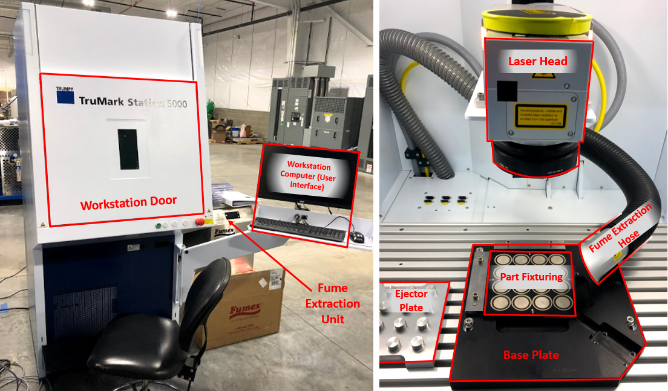

**Figure 1:** Equipment Overview with Essential Parts Labeled

## Particle Extractor

* + 1. The particle extractor located next to the ablation machine will be used at all times when crystals are being ablated. During the ablation process, the laser will create dust which can build up and obstruct proper ablation and also become airborne. This particle extractor has a hose located near the side of the marking field that is designed to remove the particles from the ablation field and machine enclosure. This hose and attachment are properly positioned, mounted and move with the laser head. It should never be re-located or removed.
    2. The particle extractor is programmed to automatically power on when the laser is running, and automatically power off when the laser is off for at least 15 seconds. For this reason, user interaction with the particle extractor (power on/off) is not needed.
    3. 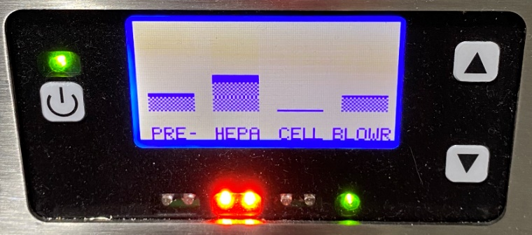While running the first job of the day only, check the fume extractor filter status. While the first program is running, review the screen on the fume extractor located behind the etcher for any red warning lights. If no red lights are apparent, continue ablating parts. If a red light is noticed (as shown on “HEPA” in Figure 2), contact a supervisor to ensure the filters get replaced in a timely manner.

**Figure 2:** Filter Warning Lights

## General Procedure for Marking or Ablating Parts

NOTE: These are general instructions only. For part-specific marking instructions, refer to the model-specific procedure called out on the part’s router.

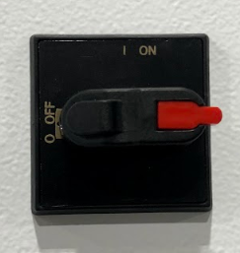

**Step 1:** **Power up Machine**

Power on the marker by turning the switch located on the right-hand side of the machine to the ‘On’ position. After switching the machine on, a series of pre-programmed startup processes will occur. This is fully automatic and takes approximately 1 minute:

* The machine will power on and the interior lights will turn on.
* The computer will automatically power on.
* TruTops Mark Program (the user interface) will open automatically on the computer screen.
* After TruTops Mark is open, the workstation door will automatically open.

**Figure 3:** Machine On/Off

There is no warm-up time required for this machine. After the machine goes through the startup procedure above, it is ready to run parts.

**Step 2: Load Parts to be Marked in Fixture or Corner**

**\*IMPORTANT\*** Wear **white** gloves at all times when loading and unloading or otherwise handling any parts.

Depending on the type of parts being marked or ablated, load the parts into the machine appropriately. Refer to part specific procedures called out in routers for detailed instructions.

**Step 3:** **Select Program Using Trutops Software**

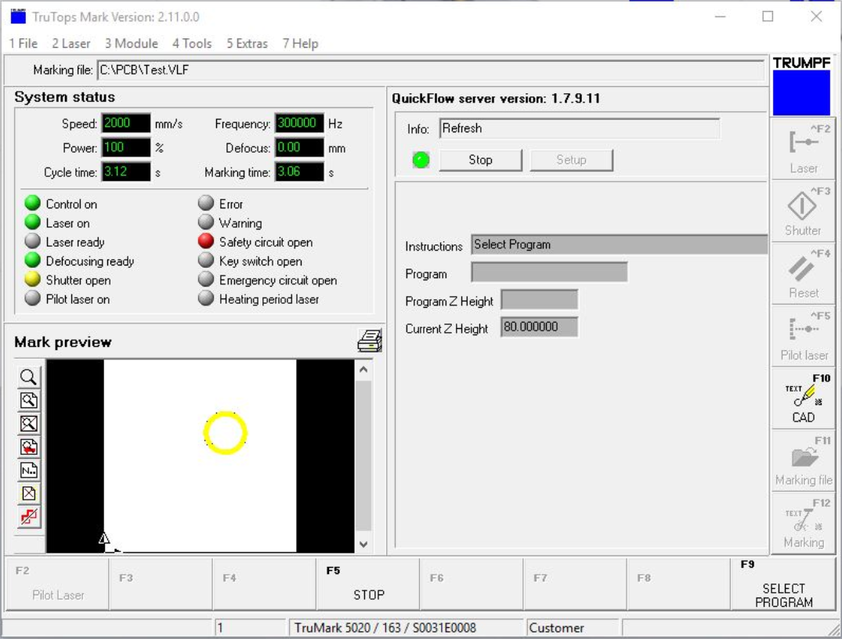

After the machine is powered on, Trutops software will automatically open on-screen as shown in Figure 4. Trutops is the user interface which will be used throughout the entirety of the marking process. Press the green button on the front of the machine to display the list of prgrams shown in Figure 5. Select the desired program from the list by double-clicking.

**To Change Between Programs:**

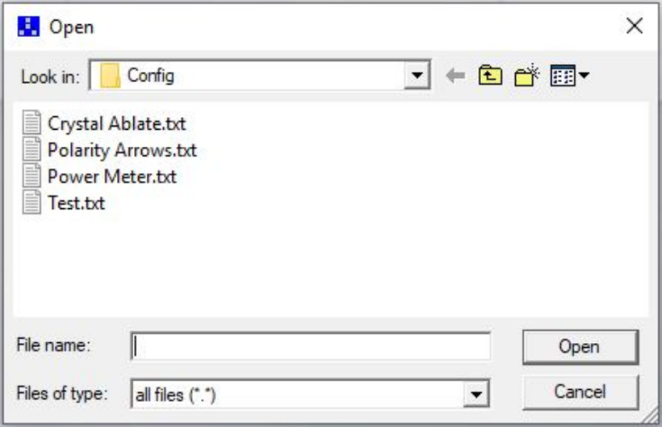To change from one program to another, press the “SELECT PROGRAM” button in the bottom right corner of TruTops, or F9 on the keyboard to display the program list. Select the desired program from the list by double-clicking.

**Figure 4:** Trutops User Interface

**Step 4: Mark Parts using TruTops Software**

With parts loaded and the correct program selected, press the green button the front of the machine. The door will close and the laser will begin marking the parts.

**Step 5: Unload Marked Parts and Load Next Job**

If more parts are being marked, unload the previously marked parts and load the next set. Press the green button on the front of the machine to begin marking.

**Figure 5:** Program List

**Step 6:** **Power Down Machine**

1. Close Trutops software by clicking on the X in the upper right corner.
2. Turn the key on the side of the machine to the “off” position. The interior light will shut off.
3. Manually close the door on the machine by sliding it to the closed position.
4. The machine is now powered down.

## Power Meter Test Procedure

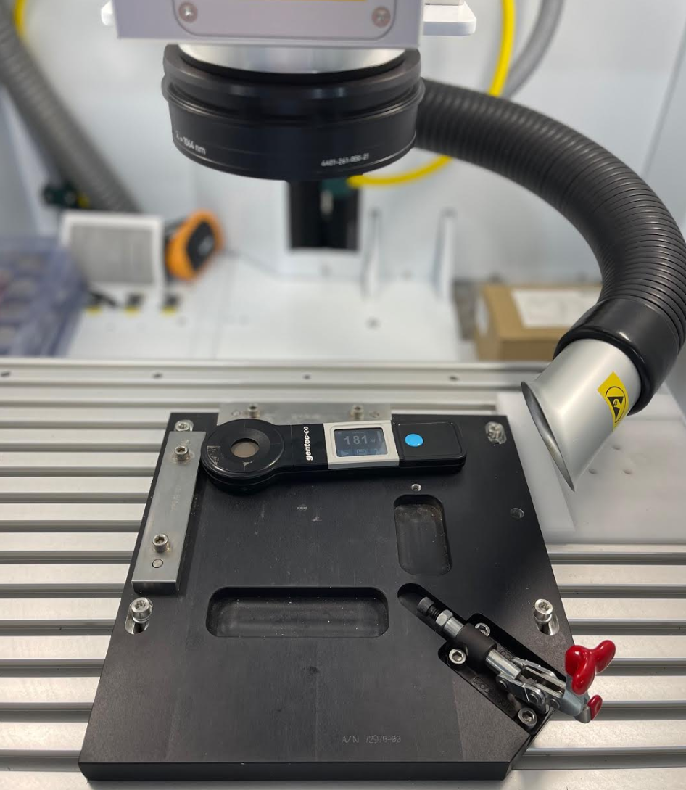 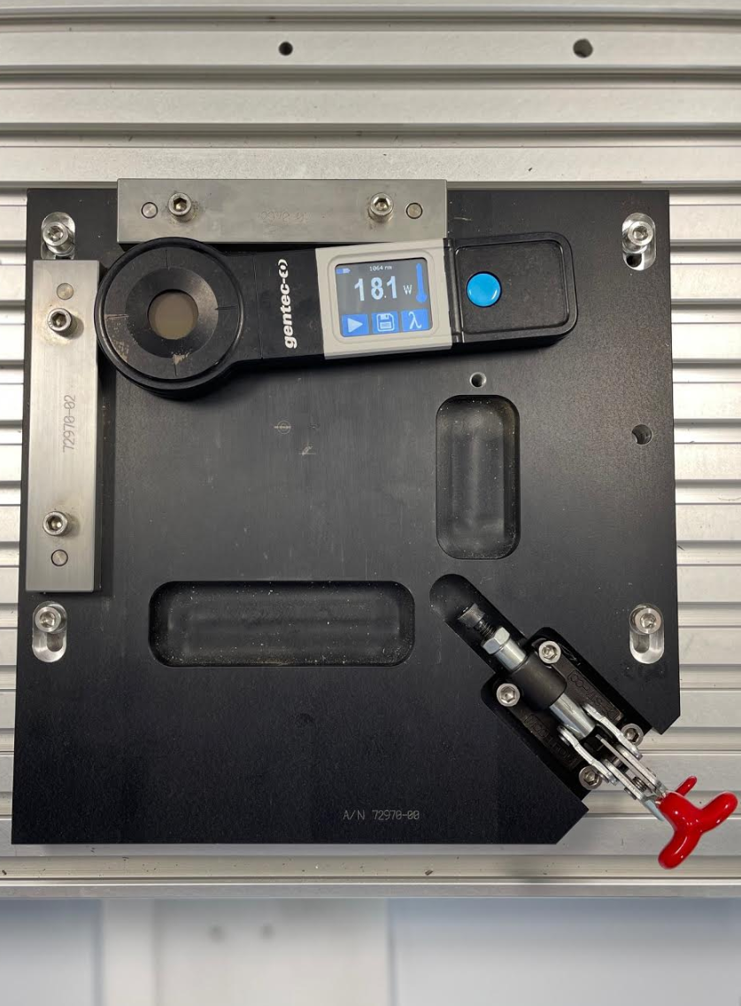

**Figure 7:** Power Meter in Corner

**Figure 6:** Power Meter Placement

**Step 1:** Follow the General Procedure above in Section 2 to power on the workstation and open TruTops Mark.

**Step 2:** Open “Power Meter” Program

**Step 3:** Remove power meter from storage case and place it in the corner of the base plate as shown above.

**Step 4:** Press the “play” button on the power meter screen. A series of dots will appear and this means that the power meter is searching for a reading from the laser.

**Step 5:** Press the green button to begin the power reading. The power meter will begin a 5 second countdown and display the power reading. The door will open after the program has been run.

**Step 6:** Record the power readingon the power verification sheet located in the sleeve on the workstation bench. If the recorded range is outside of the acceptable range stated on the sheet, contact a department supervisor or engineer before marking any parts.

**Step 7:** Power down machine following instructions in Section 2 Step 6 of the general procedure above.

## Preventative Maintenance

**NOTE:** For additional information regarding routine maintenance procedures, refer to the TMS5000 Maintenance PDF saved on the desktop of the machine.

The Trumpf TruMark 5000 workstation requires very little maintenance due to the fact that it uses a fiber laser which doesn’t require air or fluid to operate. Cleaning and filter replacements are the main preventative maintenance measures that will be required.

1. **Cleaning protective viewing window:** Clean the glass viewing window on both sides on an as-needed basis using a cotton cleaning cloth and soapy water. Dry the protective filter after cleaning with a paper towel.
2. **Lubricating the linear axes:** The guide rails and spindles of the linear z-axis must be cleaned as required and lubricated every 600 operating hours. Use PCB Part Number 100-9169-60 Shell GADUS S2 V220.

To grease the z-axis, remove the rear cover of the machine following the instructions beginning on page 7 of the TMS5000 Maintenance PDF. Apply grease to the spindle nuts and grease nipple shown in Figure 6 below.

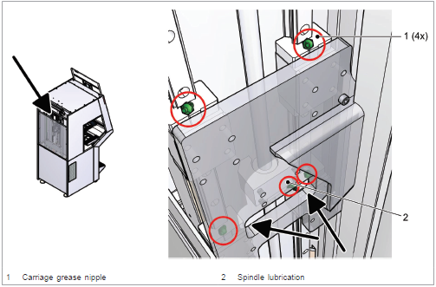

**Figure 8:** Location of grease application on z-axis of machine.

1. **Particle Extractor Filter:** Replace particle extractor filter when the monitoring system indicates a replacement filter is required.
2. **Marking Field:** Clean the marking field and machine enclosure as needed when it appears dirty with dust from marking. Use the vacuum and attachments located on the shelf under the workstation bench for cleaning.