**Contents**

PART A: NONDESTRUCTIVE TEST 1

PART B: DESTRUCTIVE TEST I 2

PART C: DESTRUCTIVE TEST II 3

APPENDIX: PART B TEST INTERPRETATION 5

APPENDIX: PART C TEST INTERPRETATION 6

PART A: NONDESTRUCTIVE TEST

1. Check that all hardware and supplies for the testing are available:

* Test Tape Semicro CHT-250, PCB PN 100-17227-60
* Tape Test Hold Fixture, PCB PN 74379-01
* Stereo Zoom Microscope

1. Place the crystal into the fixture and put the cover piece on as shown in Figure 1.

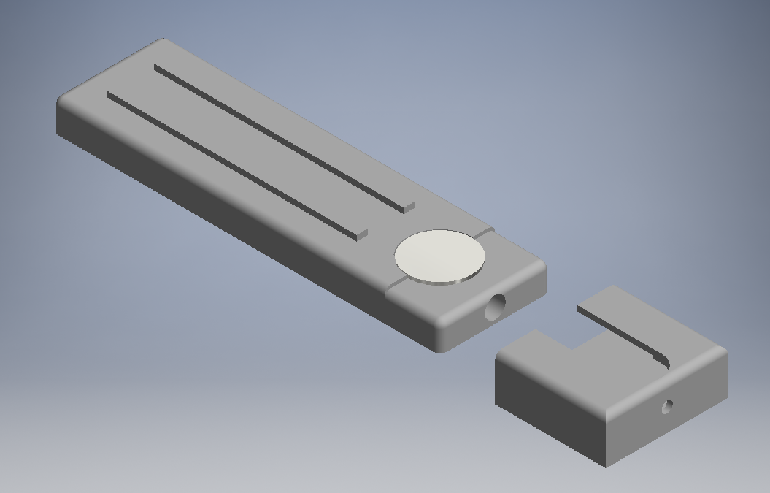

Slide on cover piece

Place crystal in fixture

Figure

1. Unwind and cut off approximately 3” of tape from the roll - pull it at a steady rate.
2. Center the cut piece of tape over the opening in the cover and burnish using a finger. Take care to ensure no wrinkles or air bubbles are trapped in the tape.
3. After applying the tape, remove the tape. Pull in a single smooth action, at an angle of 180° to the sample.
4. Inspect the crystal. Make sure plating has adhered to the crystal and is not removed by the tape. Use a zoom scope if necessary.

PART B: DESTRUCTIVE TEST I

1. Check that all hardware and supplies for the testing are available:

* Test Tape Semicro CHT-250, PCB PN 100-17227-60
* Tape Test Hold Fixture, PCB PN 74379-01
* Cutting Guide Fixture, PCB PN 74382-01
* Camel Hair Brush- PCB PN 270-0457-00
* Stereo Zoom Microscope
* Scalpel

1. Place the crystal into the fixture and put the cover piece on as shown in Figure 2.



Slide on cover piece

Place crystal in fixture

Figure

1. Place the cutting guide onto fixture as shown in Figure 3.

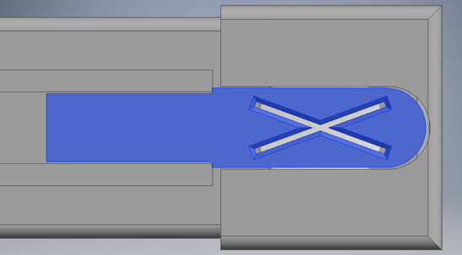

Figure

1. Using scalpel, scribe along the guides to cut through plating. Be sure to cut away from your hand holding the bulk of the fixture.

NOTE: This will leave as X pattern cut into the sample.

1. Remove the cutting guide. Lightly brush the sample to clear away detached plating bits.
2. Inspect the sample under the zoom scope, to verify that the plating is completely scored for both cuts.
3. Unwind and cut off approximately 3” of tape from the roll - pull it at a steady rate.
4. Center the cut piece of tape over the X and burnish using a finger. Take care to ensure no wrinkles or air bubbles are trapped in the tape.

NOTE: If needed, rub the tape firmly using the pencil eraser or a plastic burnish tool to ensure good adhesion between the tape and the sample.

1. 60 seconds after applying the tape, remove the tape. Pull in a single smooth action, at an angle of 180° to the sample.
2. Inspect the X cut using the zoom scope. Classify the adhesion against the lattice cuts using table in the appendix.

PART C: DESTRUCTIVE TEST II

1. Check that all hardware and supplies for the testing are available:

* Test Tape Semicro CHT-250, PCB PN 100-17227-60
* Tape Test Hold Fixture, PCB PN XXXXX-01
* Camel Hair Brush- PCB PN 270-0457-00
* Stereo Zoom Microscope
* Scalpel
* Elcometer 1542 Cross Hatch Adhesion Tester (See Figure 4)

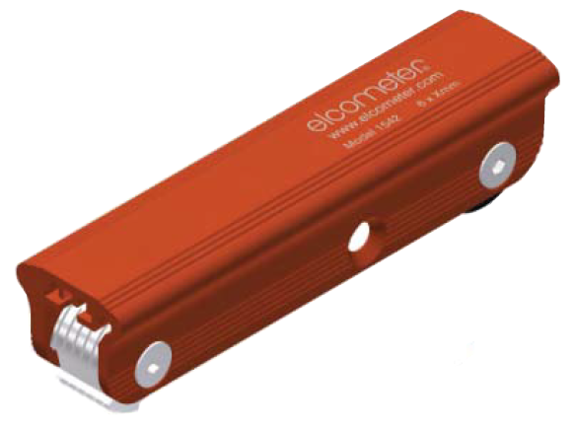

Figure

1. Place the cutting edge on the sample. Press down and gently pull the tester towards you once, to make a series of parallel cuts about 3/4” long.
2. Rotate the crystal 90 degrees.
3. Place the cutting edge on the sample. Press down and gently pull the tester towards you once, to make a series of parallel cuts about 3/4” long.

NOTE: This will leave a lattice pattern of cuts in the sample.

1. Lightly brush the sample to clear away detached plating bits.
2. Inspect the sample under the zoom scope, to verify that the plating is completely scored for all cuts.
3. Cut off an additional 3” of tape- pull it at a steady rate.
4. Center the cut piece of tape over the lattice and burnish using a finger. Take care to ensure no wrinkles or air bubbles are trapped in the tape.

NOTE: If needed, rub the tape firmly using the pencil eraser or a plastic burnish tool to ensure good adhesion between the tape and the sample.

1. 60 seconds after applying the tape, remove the tape. Pull in a single smooth action, at an angle of 180° to the sample.
2. Inspect the lattice cuts using the zoom scope. Classify the adhesion against the lattice cuts using table in the appendix.

APPENDIX: PART B TEST INTERPRETATION

|  |  |  |
| --- | --- | --- |
| Perfect | Edges Perfectly Smooth/No discernable difference between before and after tape application.  Continue Processing | Perfect |
| Acceptable | Detachment of plating at intersections of the cuts. A cross-cut area of not greater than 5% is affected.  Continue Processing | Acceptable2 |
| Unacceptable | Plating has flaked away along edges and/or intersections. A cross-cut area greater than 5% is removed.  Place plating lot on Engineering Hold | UNAcceptable |

APPENDIX: PART C TEST INTERPRETATION

|  |  |  |  |  |
| --- | --- | --- | --- | --- |
| **Example Appearance** | | **Description** | **ASTM Class** | **Action** |
| **Minimum Removal Maximum Removal** | |
| perfect | | Edges are completely smooth, no squares are detached. | 5B | Continue Processing |
| perfect | 4B | Detachment of plating at intersections of the cuts. A cross-cut area of not greater than 5% is affected. | 4B | Continue Processing |
| 4B | 3B | Plating has flaked away along edges and/or intersections. A cross-cut area greater than 5% but less than 15% is removed. | 3B | Plating lot on engineering hold |
| 3B | 2B | Plating has flaked away on edges and/or squares partly or wholly. A cross-cut area greater than 15% but less than 35% is removed. | 2B | Plating lot on engineering hold |
| 2B | 1B | Plating has flaked away on edges and/or squares partly or wholly. A cross-cut area greater than 35% but less than 65% is removed. | 1B | Plating lot on engineering hold |
| 1B | 0B | Worse than ASTM Class 1B (above) | 0B | Plating lot on engineering hold |