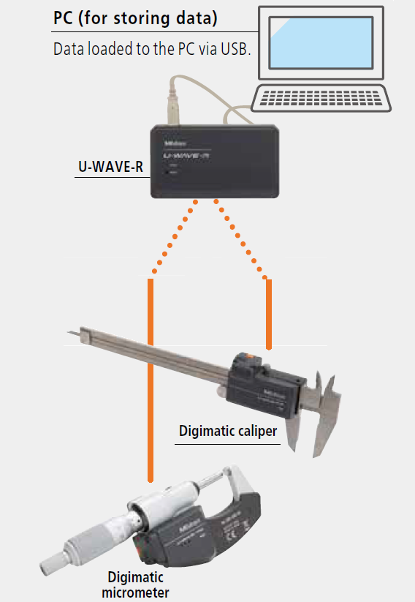

Required Software:

* U-WAVEPAK
* MS Excel or Word

U-WAVE TC Wireless Data Transmitter and Connection Unit

U-WAVE TM

Wireless Data Transmitter and Connection Unit

Wireless Data Receiver

Figure 1 – U-WAVE System

# Activate System

* + - 1. Click the Mitutoyo U-WAVEPAK icon (“M”) on the desktop or taskbar.



Figure 2

* + - 1. Click [Data I/F start] on the U-WAVEPAK menu screen.

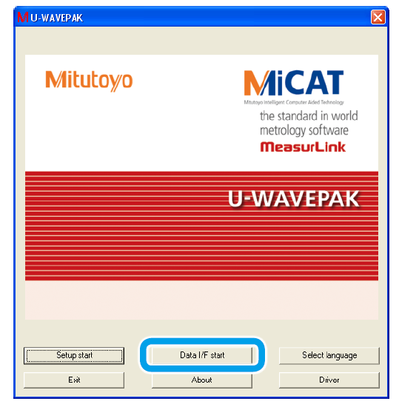

Figure 3

>> [U-WAVEPAK Data I/F] starts, and U-WAVEPAK icon (“M”) is displayed in the Windows taskbar.

U-WAVEPAK

activated

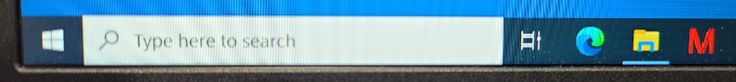

Figure 4

* + - 1. The system is ready for use.

# Collect Measurement Data

1. Open the desired data sheet (Excel spreadsheet shown below as an example).
2. Select the cell to import measurement data into.

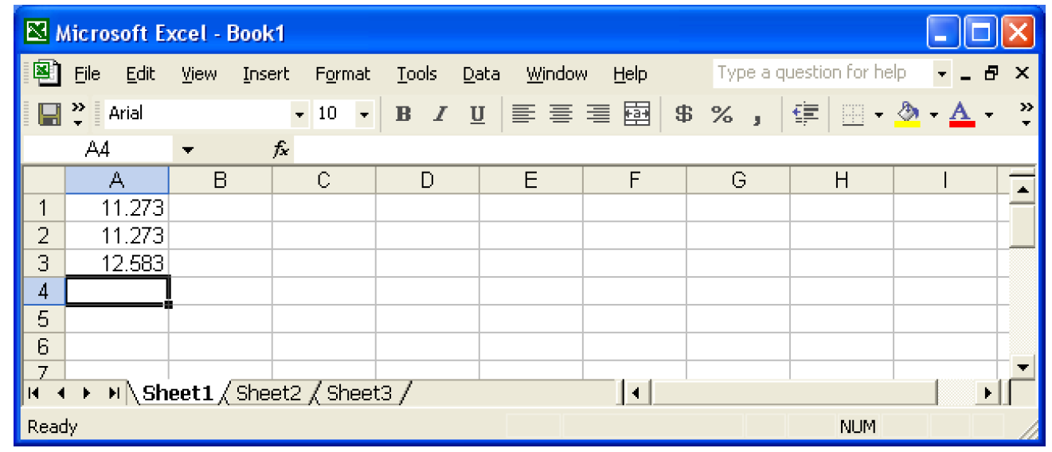

Figure 5

1. Measure part with SPC mics or calipers. With the Power (green LED) indicator of the U-WAVE receiver lit, press the [DATA] button on the U-WAVE transmitter (on SPC mics or calipers) to import the reading into the selected cell. Once the U-WAVE transmitter successfully communicates with the receiver, the LED indicator on the transmitter blinks in green.

NOTE: Be sure the correct cell is selected in the worksheet before measuring a part. It is also advisable to periodically save the data sheet to prevent loss of data in case of a sudden malfunction (power outage, network or computer problems, etc.).

# Exit System

1. Click the U-WAVEPAK icon (“M”) on the Windows taskbar after final measurement data has been imported and saved.
2. Click [Stop data I/F], and then click [Exit data I/F].

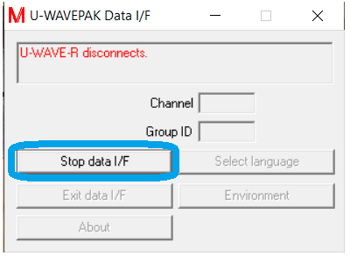 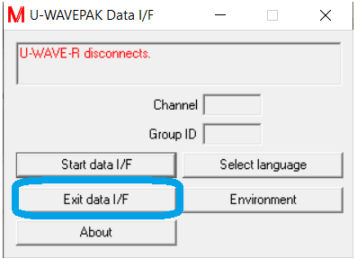

Figure 6

>> The U-WAVEPACK menu screen is displayed.

1. Click [Exit].

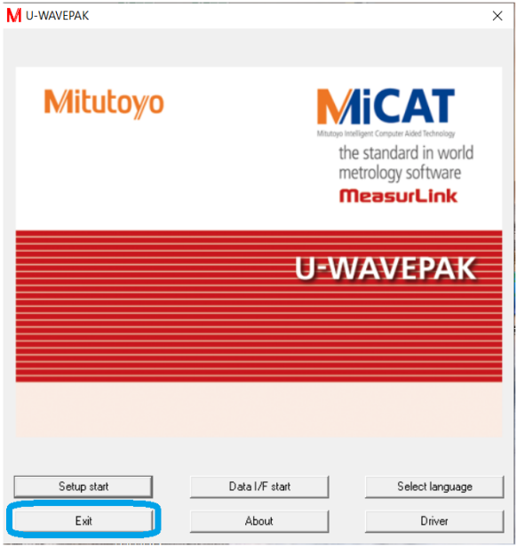

Figure 7

>> U-WAVEPAK exits.

**APPENDIX A - Install U-WAVE Software and Hardware**

1. **Install U-WAVE Receiver**

(Video instructions may be found here: <https://www.youtube.com/watch?v=WzDmZT_9KSc>)

1. To start, you need 4 things:
2. U-WAVE receiver
3. Supplied USB cable
4. Local computer
5. U-WAVEPAK software
6. Connect the supplied USB cable between the back of the receiver and USB port in the computer. Note, the power light on the receiver is not illuminated.

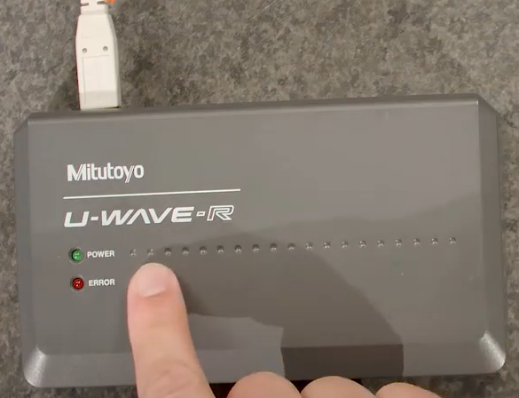

1. Load U-WavePak software from installation disc or from a pre-installed location on the computer or network directory (e.g. R:\Crystals\Mitutoyo U-Wave). Click on U-WavePak folder.

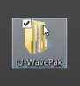

1. Click on Setup directory, then double-click on Setup.exe to begin installation.

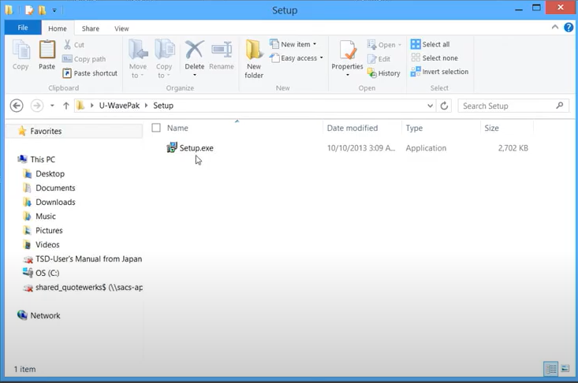

1. Select language, then click OK to accept.

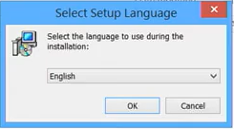

1. The installation welcome screen will appear. Click Next to continue.

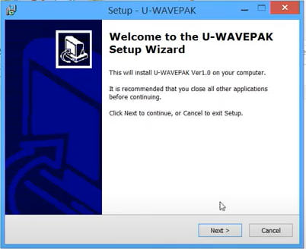

1. Accept license agreement and then click Next.

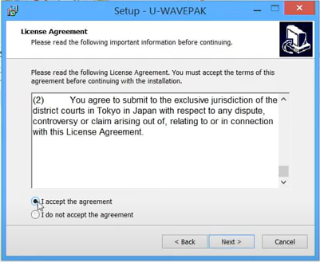

1. Indicate where software will be installed on computer. Location may be different from that shown in the following image.
2. Click Next.

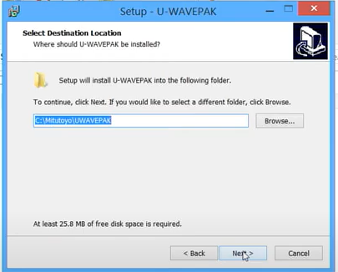

1. The Start Menu folder will display. Click Next to continue with the wizard.

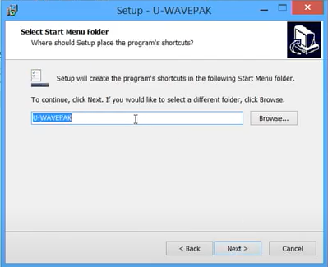

1. Check to create a desktop icon, then click Next to continue.

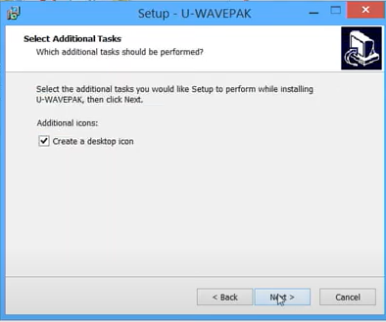

1. A summary of previous pages in the wizard will display.
2. Click Install to begin the installation.

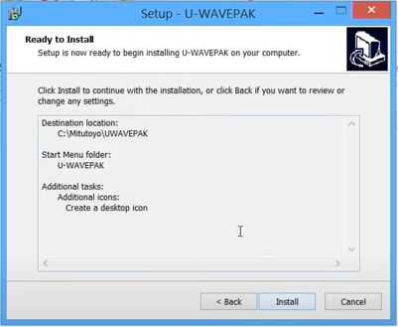

1. Once complete, click Finish to exit the installer.

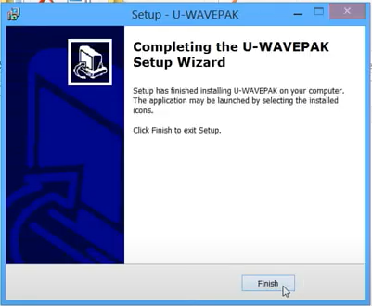

1. Note, the power light is still not illuminated.

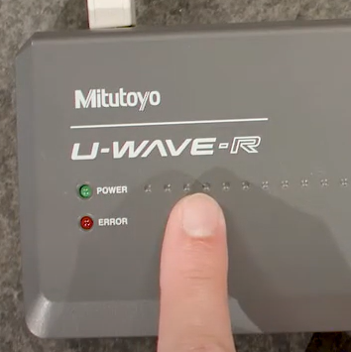

1. **Install Drivers for U-WAVE Receiver**
2. In the computer Control Panel, select Device Manager.

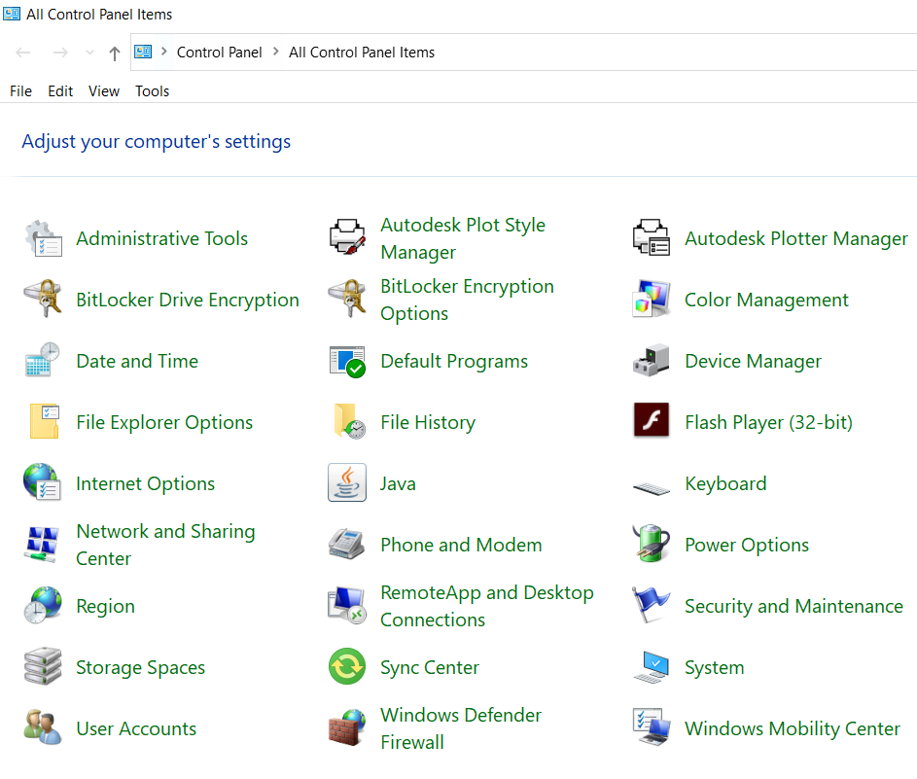

1. Two drivers will need to be installed. The first driver will be for the Mitutoyo U-WAVE found under the “Other devices” folder.

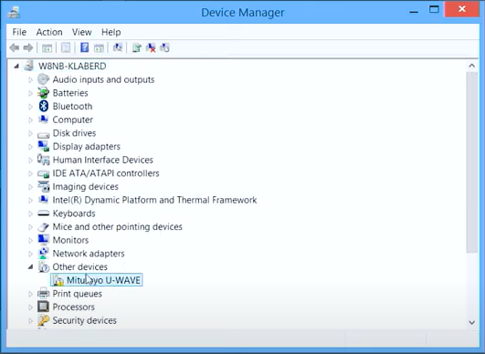

1. Right-click “Mitutoyo U-WAVE” and select Update Driver Software.

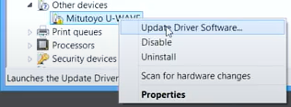

1. Select “Browse my computer for driver software”

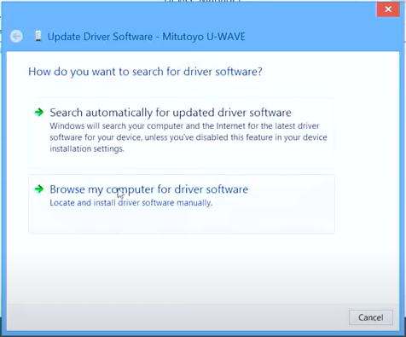

1. Browse to the folder that contains the driver software. This is the same folder U-WavePak is installed in.

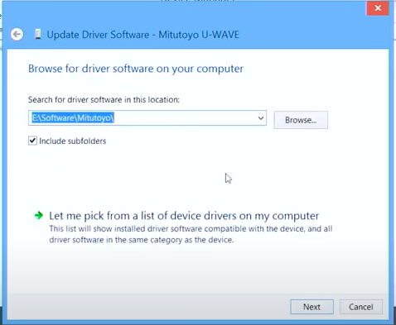

1. Click on UWAVEPAK folder, the click OK.

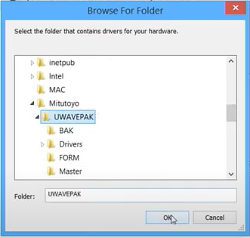

1. Click Next to continue.

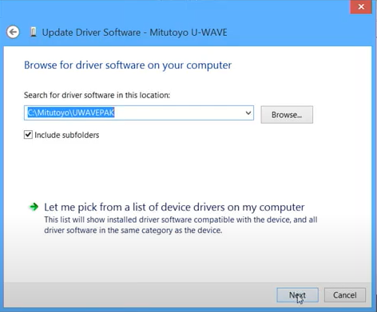

1. The drivers will install.

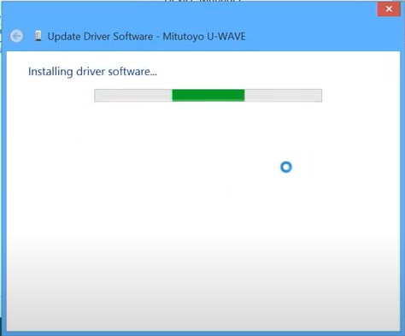

1. Once drivers are loaded, click Close to return to the Device Manager.

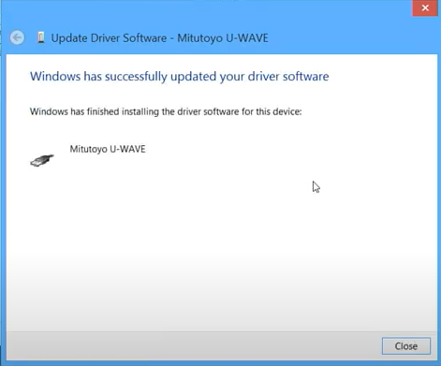

1. Notice the icon has changed next to the Mitutoyo U-WAVE device, which means the drivers were successfully loaded.

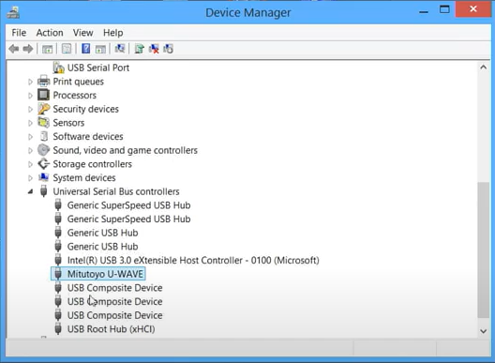

1. Install the second driver, which is for the USB Serial Port. Right-click USB Serial Port and select Update Driver Software.

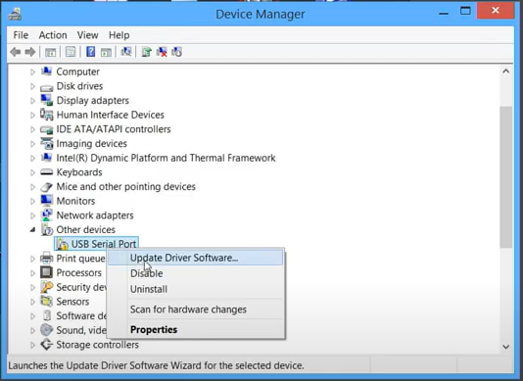

1. Select “Browse my computer for driver software”

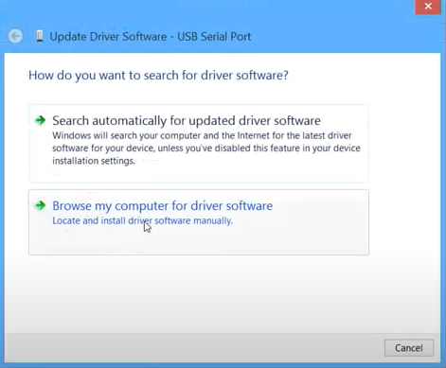

1. Notice the folder is still entered from the last driver installed. Click Next.

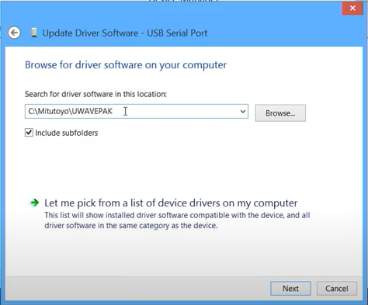

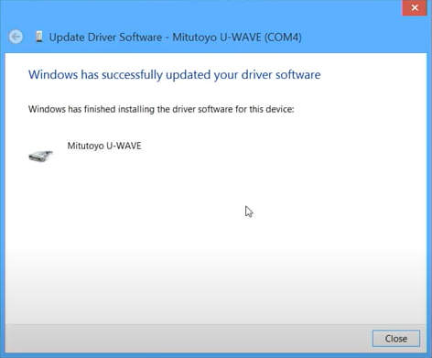

1. Click Close to return to Device Manager.
2. Notice icon has changed. Note, COM port may be different than what’s shown in image.

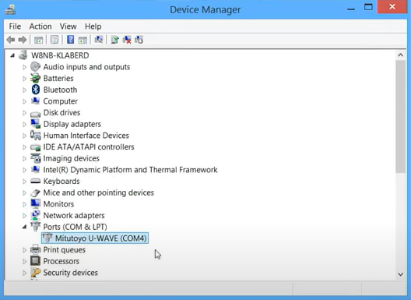

1. Close out of Device Manager.
2. For a new installation, lights on receiver will be begin blinking, alternating red and green. This indicates the receiver needs to be initialized.

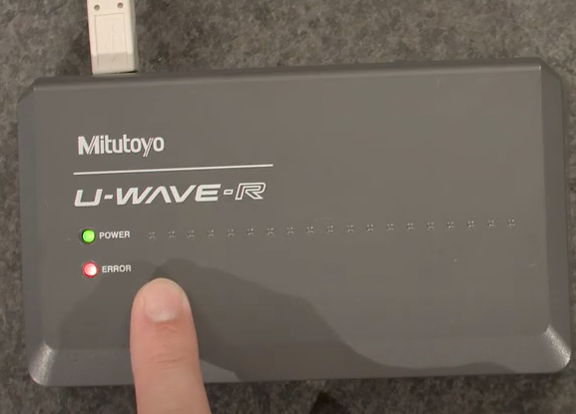

1. Launch U-WAVEPAK.



1. Click Setup start to begin setting up the receiver.

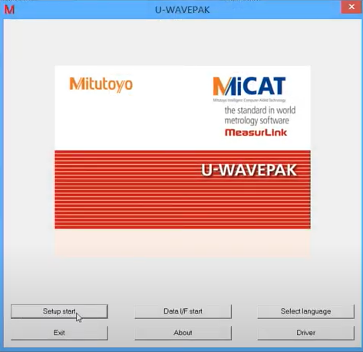

1. The following will display on a new installation to notify the receiver has not yet been initialized.
2. Click Yes.

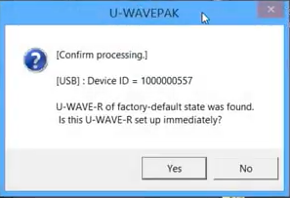

1. The default setting for the receiver will display. Unless a reason to change, click OK to continue.

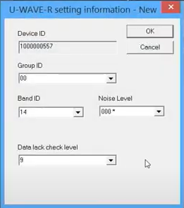

1. Press Yes to initialize the receiver.

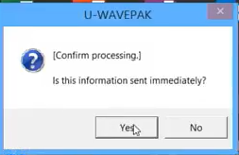

1. The settings from the previous screen ae now active.

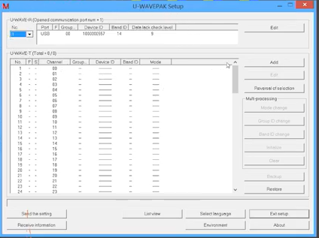

1. **Pair U-WAVE Transmitter and Receiver**

(Video instructions may be found at <https://www.youtube.com/watch?v=BNVLmyG4D5g>)

1. Note the device IDs on the side of the transmitter and the bottom of the receiver.

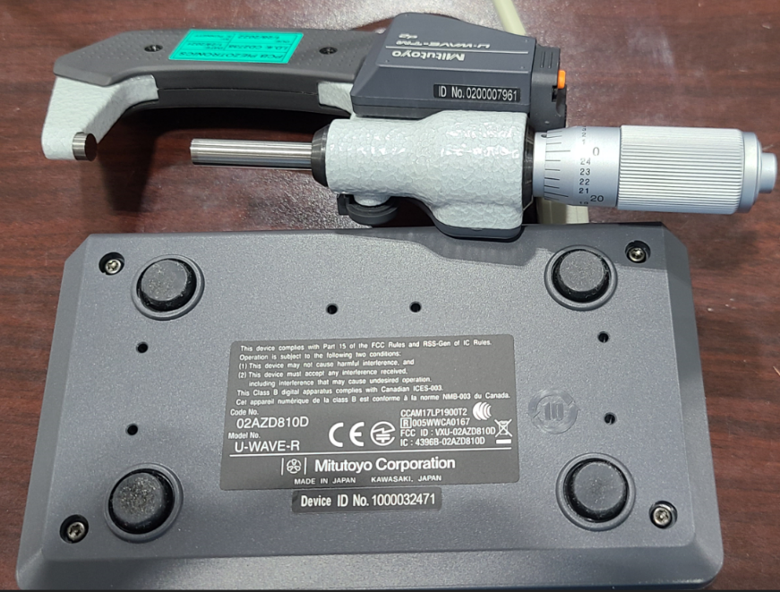

1. Launch U-WAVEPAK software.

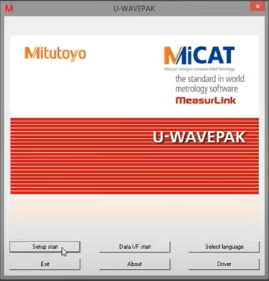

1. Click “Setup start” to begin pairing the transmitter to the receiver.

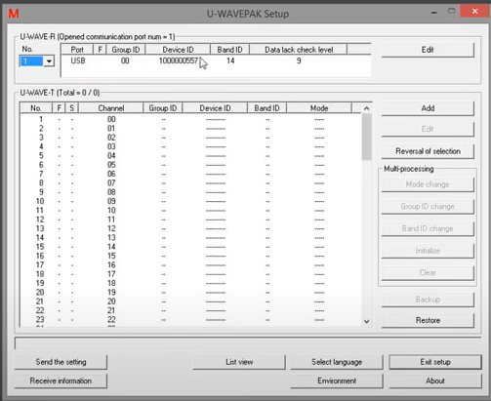

1. Note U-WAVE-R in top section shows the receiver currently plugged into the computer. U-WAVE-T section shows transmitters currently paired to the receiver. Note there are no paired transmitters in the image.
2. To add a transmitter, click the Add button.

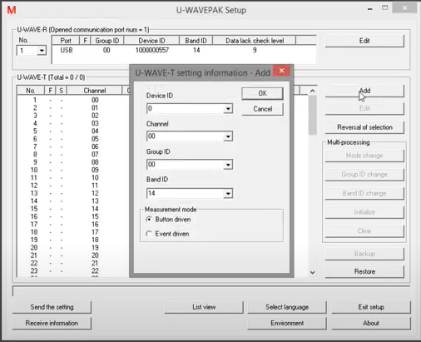

1. Enter the transmitter’s device ID.
2. Enter the desired channel. The default is the first available number. In this example, it’s “00”.
3. The Group ID and band ID are linked to the receiver. Do not change these settings.
4. Click OK to continue.

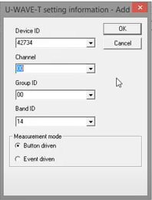

1. A confirmation screen will appear. This means the receiver is ready to receive data from the newly added transmitter for the first time.
2. Click “Yes”.

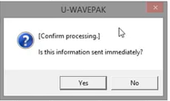

1. Make sure the measuring device (with transmitter) is ready to send data, and there is a reading on the device.

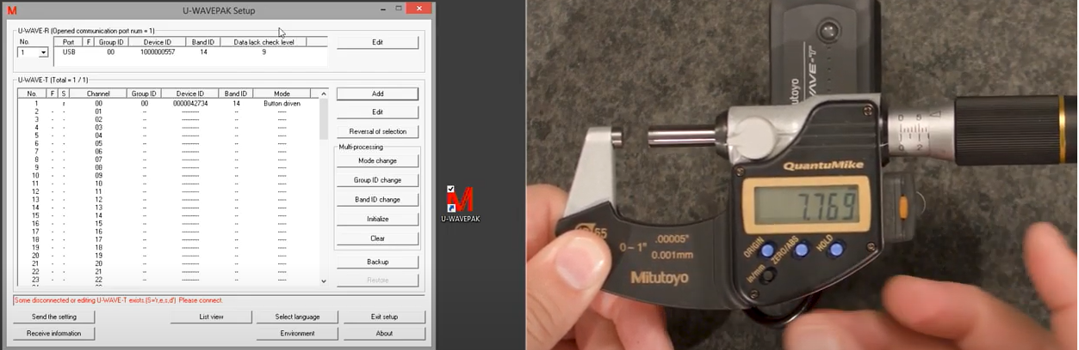

1. Press and hold the data send button on the transmitter for about 1 second. Notice the “r” in the S column has changed to a “c”, which means the gage is connected.

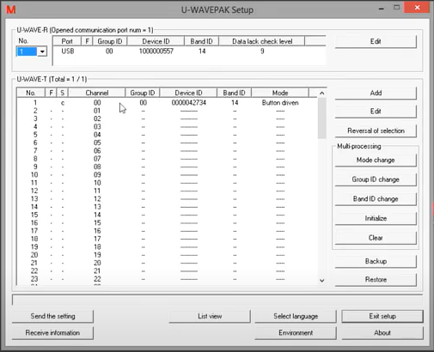

1. Press the data send button on the transmitter. Note on the bottom of the U-WAVE software that the data has been transferred.

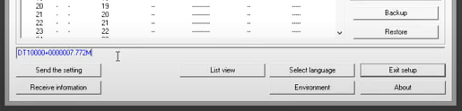

1. The transmitter is now connected and you can exit the U-WAVEPAK set-up.
2. Click Exit setup.

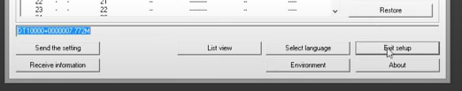

1. **Unpair U-WAVE Transmitter & Receiver**

(Video instructions may be found at <https://www.youtube.com/watch?v=K5VSMplDiIg>)