DD1014
Specification Entry Procedures for the Web

Purpose:
To process new and/or existing PCB specification sheets into the web database

Responsibilities:
Maintained by Drafting Department Supervisor or Delegated Representative
Carried out by Engineering Personnel

Associated Documents:
ISO 9001
PCB Quality System Manual
PCB Quality Assurance Manual

Procedure:
Entering a New Product

If an electronic “template” exists for the product, it should be entered electronically. To find out if a template exists for the product, contact drafting. If an electronic template does not exist for the product, use the traditional method of creating a specification sheet.

- Entering Electronic Specification
(See example following procedure)

The engineer should do the following.

a Obtain a document number from the drafting database. (DD02)
b Launch Internet Explorer then get onto PCB’s web site by typing in the following http://www.pcb.com/admin/products/login.asp

1st login screen
You will get a dialog box titled “ Enter Network Password” that will ask you to “Please type your user name and password.”
The user name is pcbedit
The password is 4overthere3
Note: Username and Password are case sensitive.

2nd login screen
You will get a 2nd login screen “Please login here!”
Type in your personnel username and password.
Note:
Your default login is your e-mail name (e.g., j doe). Lower case
Your default password is your three letter initials + your 3 number employee badge number (e.g., ABC123)
If this doesn’t work, please see Help Desk. If you need to change your Username and/or Password, see Help Desk. Depending on your access level, you will see different menus.

Begin entering the specifications directly into the database using the appropriate electronic template. If you do not know how to do this, see marketing or drafting. (see example )
c Print out the specification sheet.
d Check the specifications and add any verification numbers and notes.
e Get either the VP of Engineering, the Engineering Coordinator, or the Lead Engineer for approval of notes.
f Sign and date the specification in both the “Drawn” and “Engineer’ fields.
g Pass the specification onto the appropriate sales person for approval.

2) The sales approval person should do the following

a Check the specification sheet and sign and date in the “Sales” field
b Add a note to the specification if the product should not be released to the web.
Unless otherwise noted, All standard and stock products will be released.
Specials and/or OEM products shall not be released to the web.
c Pass the specification on to the appropriate final approval person

3) The final approval person should do the following.

a Check the specification sheet and sign and date in the “Approval” field.
b Return the specification to engineer
c Engineer forwards specification to General Drafting

4) Drafting should do the following

a Edit in the four approval signatures and dates into the database. This will approve the product.
b Sign off electronically in the 5th signoff field in the database. This will provide a record of who and when the product was released. This electronic “signature” will not show up on the specification sheet. It is only a historical record in the database.
c Release the product to the web (standard and stock products) unless otherwise noted on the specification sheet
d Scan the original document with signatures and notes for archive then file the original in the engineering file.

Entering an Existing Specification

1) Any model spec that is entered into the database Will be ECRed and assigned the next Revision letter. However, blanket ECR’s were issued to the various groups to start this process.
Even if the specification did not change, the overall “look” has been improved through consolidations of terms, consistent logos, adding more complete information, cleaning up of notes, etc.
Upon entering the new specifications, we are making several changes based on “global” ECR’s that are currently active. For example, adding the qualifying term for CE marked models and changing the supplied accessories from 1 to 3 seals on pressure sensors.

2) The person within the product group ENTERING the data ( either an engineer or a data entry person ) must obtain an up to date specification sheet with signatures from the drafting. They must also check with drafting to get the blanket ECN number and check to see if there are any other open ECR’s for the product. They will then:

- Update the REV Letter ( i.e., A to B, C to D, etc ) The revision letters will start with the letter
NR” and be incremented by one letter. The letters “I”, “O”, “Q”, “S”, “X” and “Z” will not be used as revision letters.
- Update the ECN number
- Enter the specifications into the database (with the new Rev letter and ECN number)
- Be sure to update any specs under ECR
- Leave the electronic signature (approval ) field blank.
- Check the data to verify that they have been entered correctly
- Print out the new specification sheet from the web and staple it to the original with the new sheet on top.
- Sign and date the “Drawn” field on the hard copy.
- Pass the specification on to the appropriate engineer as indicated by the signature on the original specification sheet. If that engineer is no longer available or not in the group the lead engineer will assign it to someone to review.

3) The engineer should do the following.
- Check the specifications and add notes as necessary. These may only be necessary if there have been some actual specifications changes made from an existing open ECR.
- Sign and date the specification in the “Engineer” field
- Pass the specification on to the appropriate sales person for approval.

  - The sales approval person should do the following.
- Check the specification sheet and sign and date in the “Sales” field.
- Add a note to the specification if the product should NOT be released to the web. All standard and stocked products will be released unless otherwise noted.
Specials and OEM products will not be released to the web.
- Pass the specification on to the appropriate person for final approval.

5) The final approval person should do the following.
- Check the specification sheet and sign and date in the “Approval” field.
- Pass the specification on to drafting.

6) Drafting should do the following.
- Edit in the four approval signatures and dates into the database. This will approve the product. At this point the electronic copy becomes the official copy of the specification.
- Sign off electronically in the 5th signoff field in the database. This will provide a record of who released the product. This electronic “signature” will mot show up on the specification sheets. It is only a historical record in the database.
- Release the product to the web (standard and stock products) unless otherwise noted on the specification sheet.
- Remove copies of the old specification from the network, including, Word document, and pdf’s
- Scan the original document with signatures and notes for archive, then return the original to the engineer for filing in the engineering project file.
- Notify marketing as to which products have been released to the web.

7) Marketing will remove the product pdf from the ftp site.

NOTE: If at any time in the approval process an error is found, the specification should be returned to the data entry person, the error corrected, the new specification printed out and the signature process started again

Blanket ECR’s

Blanket ECR’s will be used for converting Word specifications into electronic specs. The ECRs will be generated by drafting and will be written to “Convert Specs to Web Format” or similar statement. Blanket ECRs will be generated by product type or template, for example, Industrial ICP , Accelerometers or ICP, Pressure Sensors. These ECR’s will be closed out monthly and new ones opened. Thus the person entering data must check with drafting to get an up to date ECN number.

From the main navigation screen, select “new product” from the product drop down menu.

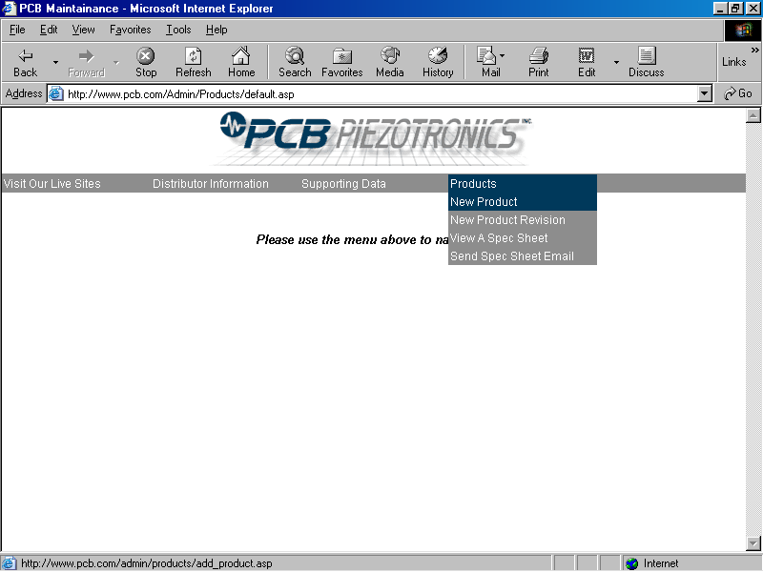

To view an official specification sheet, point to “Products” on the menu bar, then move cursor to “View a spec Sheet” and click.

On the “Search Products” page, type in the model number of the product you want to find. If left blank, it will find all the products but it will take longer. You can also put in a series number and find all of the products for a series (e.g. 601). Either a single model or multiple models will be displayed.

Pick a product on the menu and click on “View Specs”. A typical looking PCB / IMI specification sheet will be displayed in a separate browser window. If this product showed up on PCB’s web page as described in the procedure above, it should have signatures and dates entered in the lower right corner of the specification sheet. If it does, this is the up-to-date official record of the products and it will no longer be found on the drafting drive. In this case, this is the specification sheet that is current and should be sent to the customer.

If the product selected does not show up on PCB’s web page, then it will not have signatures in the lower right corner of the specification sheet. This is not yet the official specification sheet and it will be found on the drafting drive. If a customer needs a specification sheet for this model, you should get it of the drafting drive and send it as you normally would.

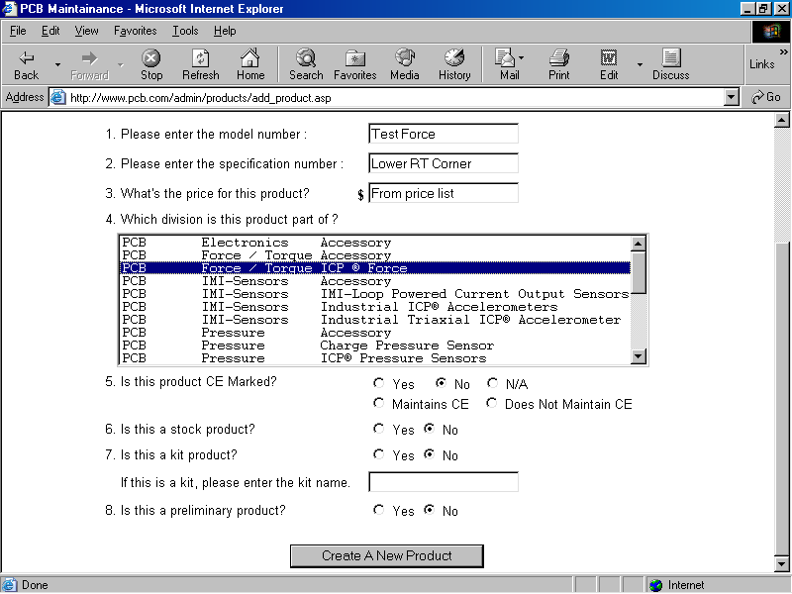

Enter questions 1 – 12 and select “Create A New Product”.

Note:

Number 2 - is the number in the lower right corner of a spec that is some times referred to as “spec number”.

Number 3 - is from the price list.

Number 4 - highlight the template for the product that you are working on.

Number 9 – this is if you are entering a completely new product for PCB. For example, a product that would go into the “What’s New” brochure.

Number 10 – This would indicate a product that has its own specifications and can also be used as an accessory. For example, an AC power supply that is an accessory to a line powered signal conditioner.

You will be taken to the Model Home Page:

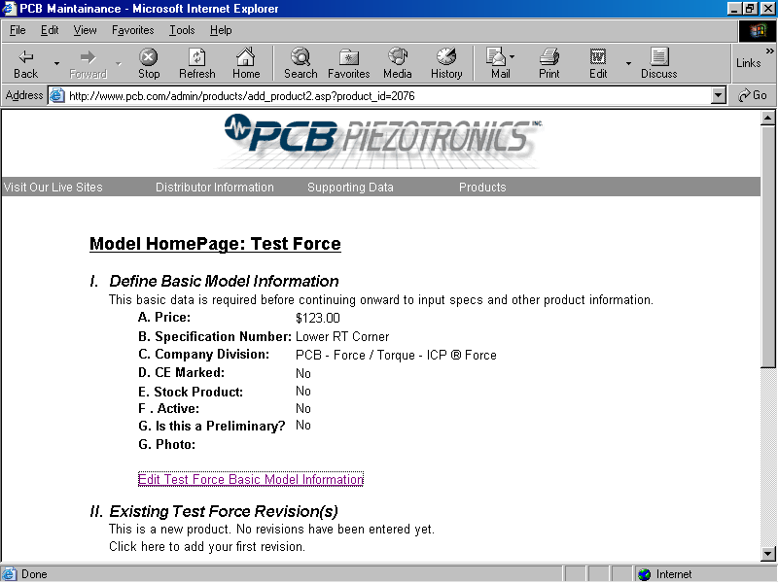

Section I – you can review and edit information that has been enter to this point. If you made a mistake, for example a type in the model number, you can select the above link [edit xxxx Basic Model Information] and the following window will appear. Otherwise scroll to the bottom of this page.

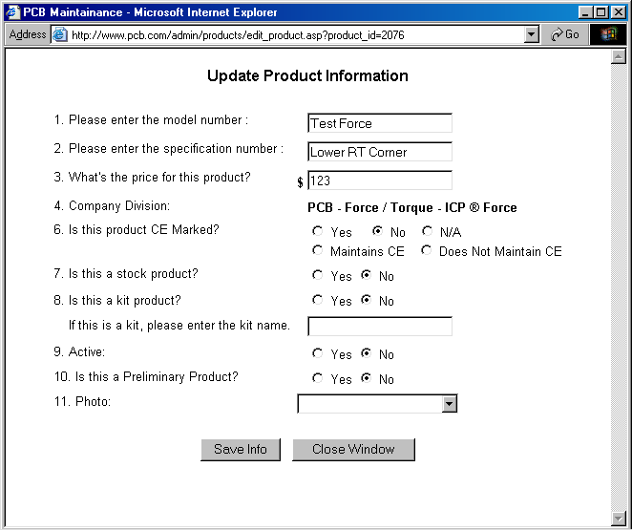

In section II you may already have a sensor listed that you can use as a base model, which means most of the information for the model that you are working on, will be pre-populated onto the template. To do this highlight the model and hit “Continue”. Or if you want to start with a blank template leave “lets begin from a clean…” highlighted and hit “Continue”.

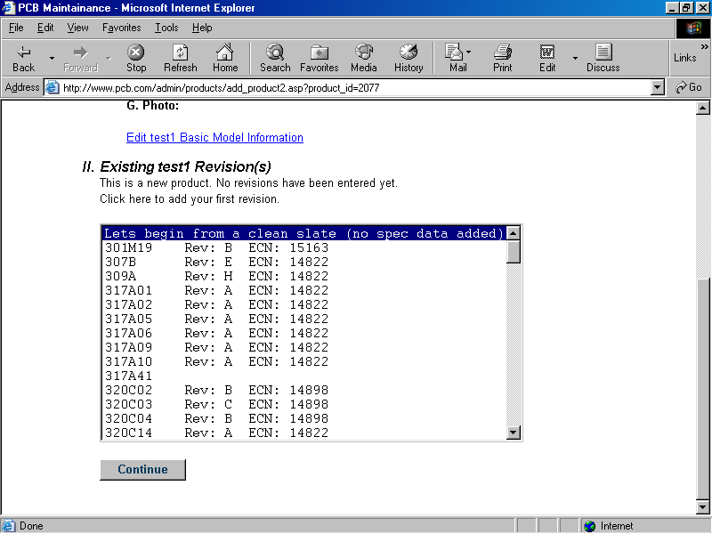

This is the ‘Revision Home Page’

On this page select “Edit Basic Product Information”. A window will open in which you should enter the required data. See below window, presently the only information that you will enter is Rev. number (one more then on current spec, excluding letters i, o, q, s, x, and z) and the ECN number obtained form drafting. If this is a new release enter NR with out a slash or dash.

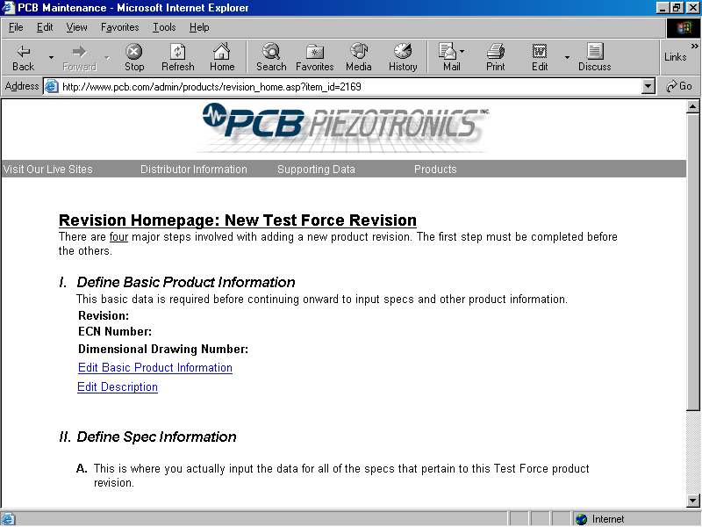

This is the [Edit Product Information] window
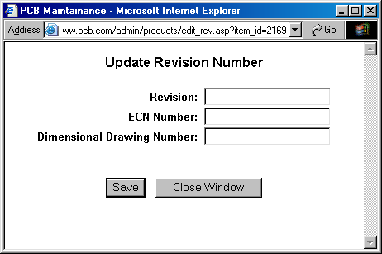

After saving the above window will close automatically and bring you back to the ‘Revision Home Page’ (RHP). Select “edit description” on the ‘RHP’

The following window will open. Enter the price list description (from the price list) into the price list section.

This is the [Edit Description Window]
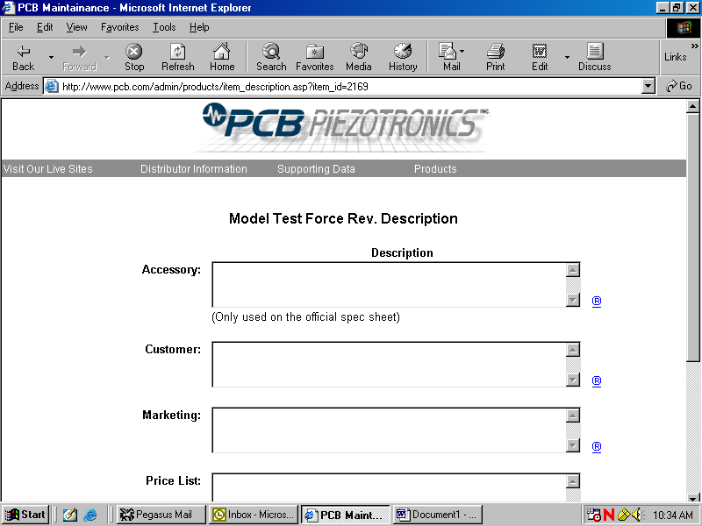

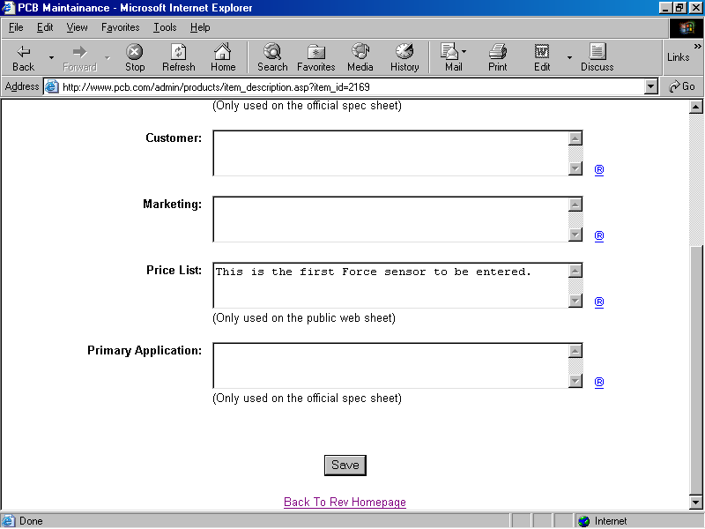

After entering the description and saving, the window will close and you will be returned to the ‘RHP’. page.

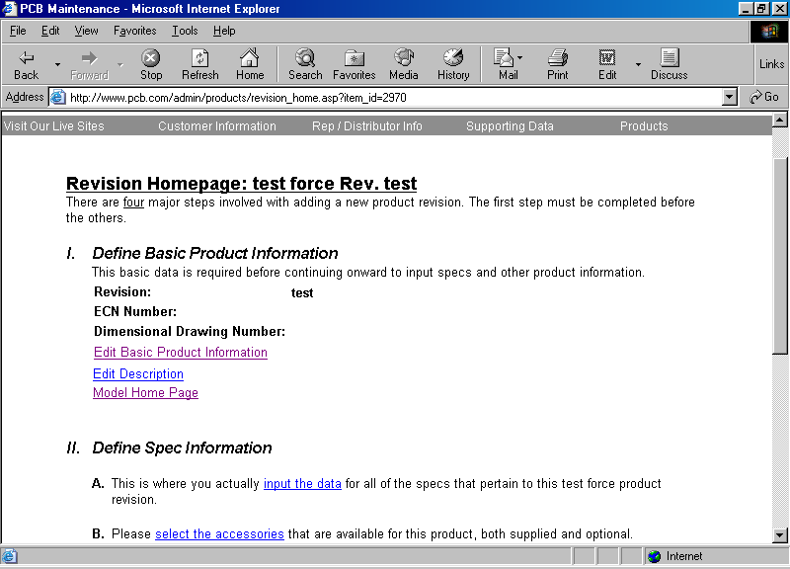

You will now notice that the ‘input the data’ link in part II-A is now highlighted. Select this link and the following ‘template” window will open.

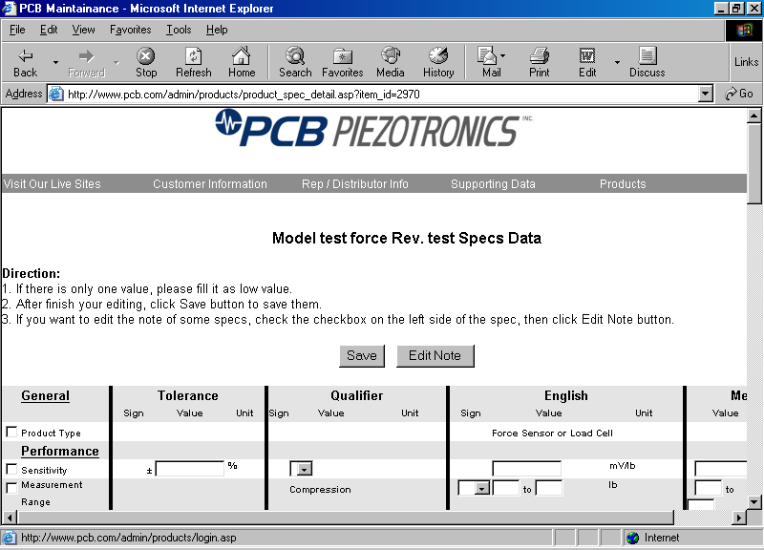

SOME NOTES on utilizing the template to enter data:

  - Never use commas “,”. If it is a comma for a decimal point then use a decimal point. If the number is greater than 999 enter the data with out commas such as 10000.
  - If the data field calls for a range but you only have one number enter that number into the first box.
  - Never enter “+” or “-“ for numeric values for data other than temperature related. Utilize the drop down signs for non-temp data. For temperature related date you can enter the “+” or “-“ sign in with the numeric value.
  - Never use a letter to denote a number, for 1K enter 1000.
  - Notes are hard-coded into the template but they can be edited.

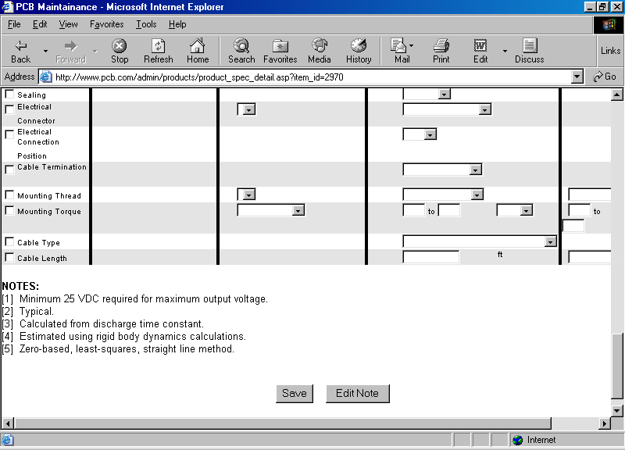

If you have to enter a note, check off the box on the left for the spec that needs a note added/deleted or edited. Then scroll to the bottom of the page and select “edit notes”. If you do not have to make changes to note hit “Save” and you will return to the “Revision Home Page”.

The following window will open to make the necessary changes to the notes. The window will close and send you back to the template when you hit “save”.

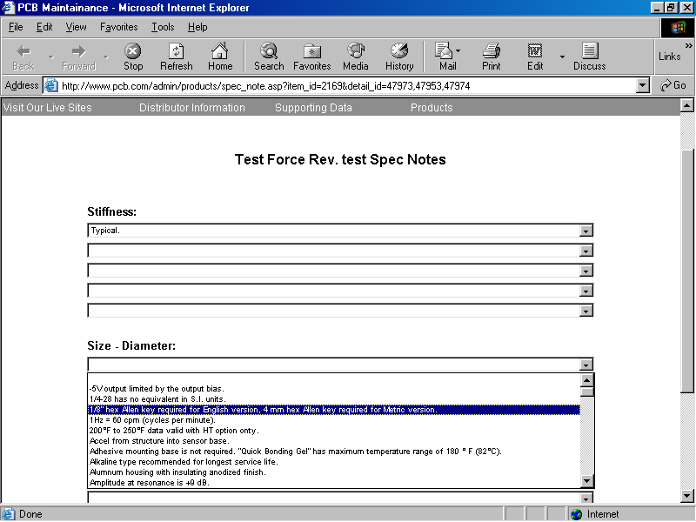

You will return to Revision Homepage “return to rev homepage” from the template page.

Under II B. on the RHP, select the link “select the accessories”.

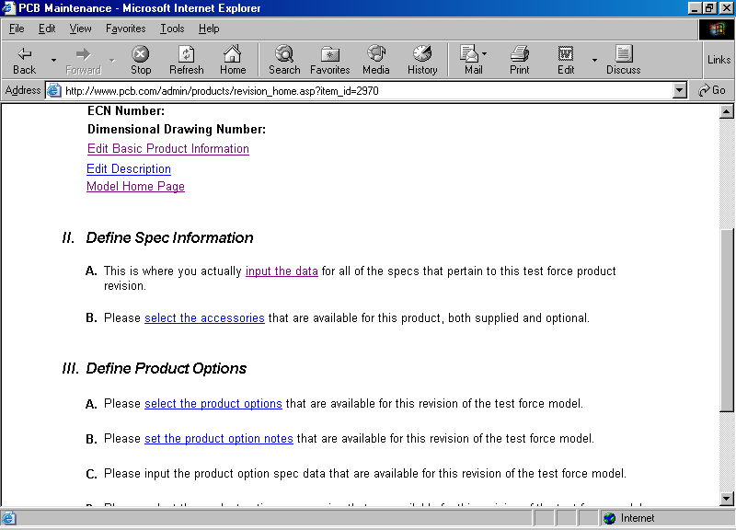

Select the accessories/s from the drop down list, indicate the quantity and if they are optional or supplied as standard. Return to RHP when completed with the accessories.

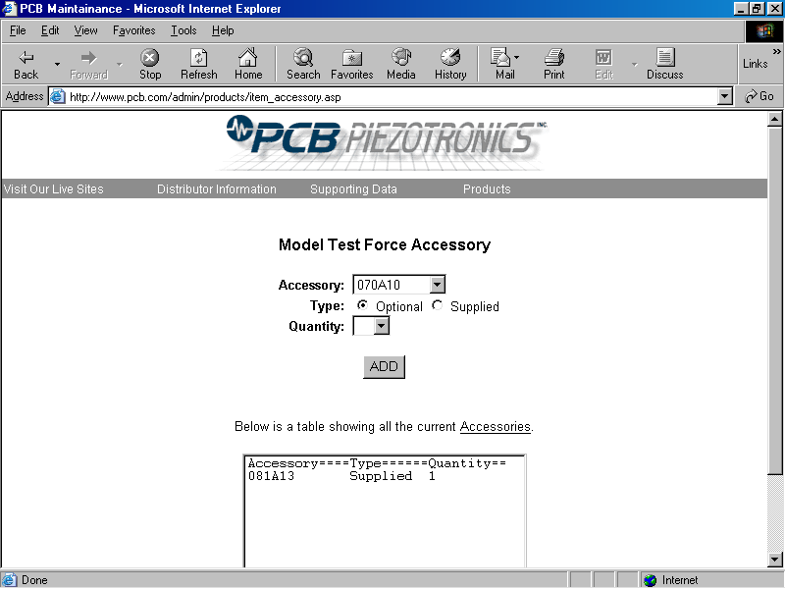
On the RHP click on the link in III A to select the options.
Select the options and return to rev homepage.

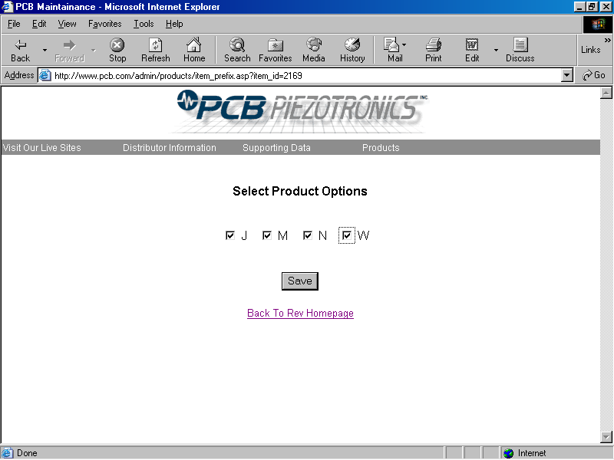

There are some notes that are tied to an option and other notes that are tied to a spec under an option. In III B click on “set the product option notes” to edit notes that are tied to an option, the following window will appear.

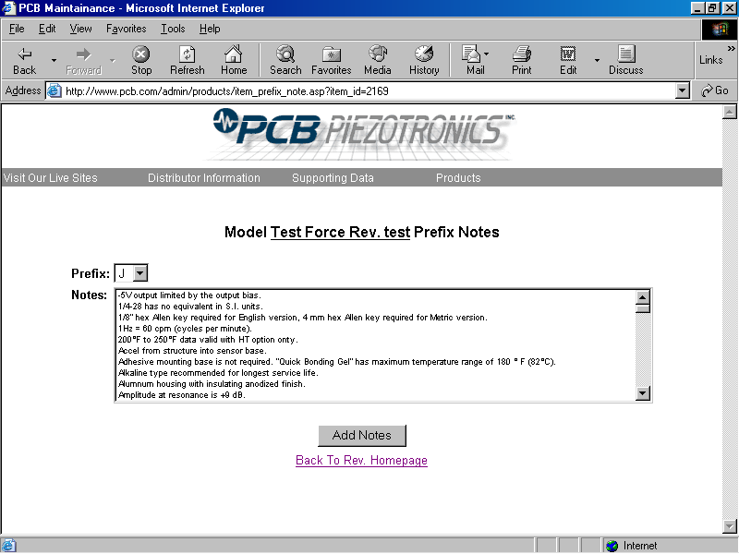

Back on the RHP you can click on “input the product option spec data” as part of III C which will allow you to enter the option data.

On this page you will enter specs for the option/s or edit the notes for the specs under an option.

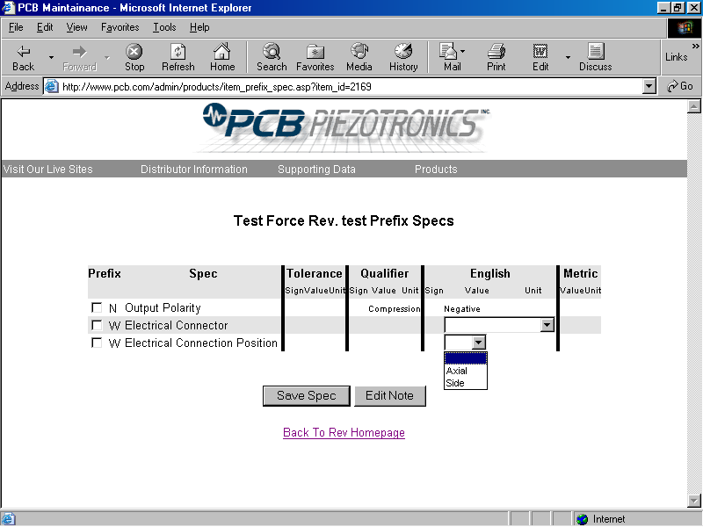

Back on the RHP you can click on “select the product option accessories” in III D.

Enter the accessories for the options noting if and accessory replaces one for the standard model.

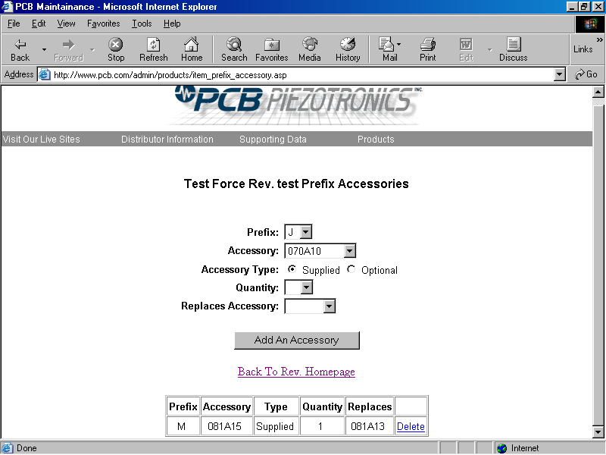

Select “View A Spec Sheet” in the drop down menu under ‘Products’ on the main menu navigation menu.

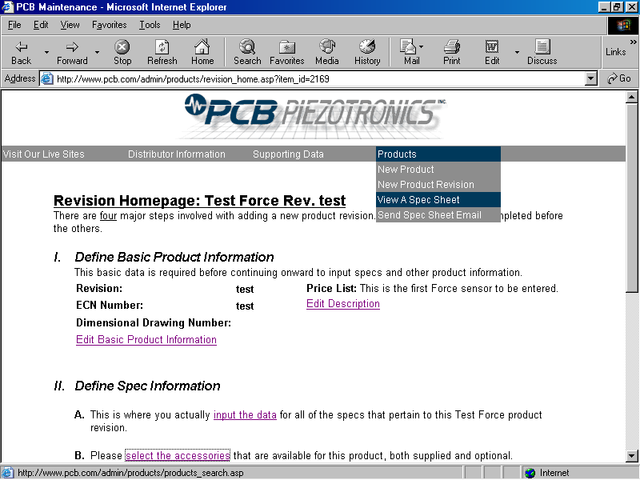

Enter the model number , check of “In-Process Modal Revisions” and hit search.

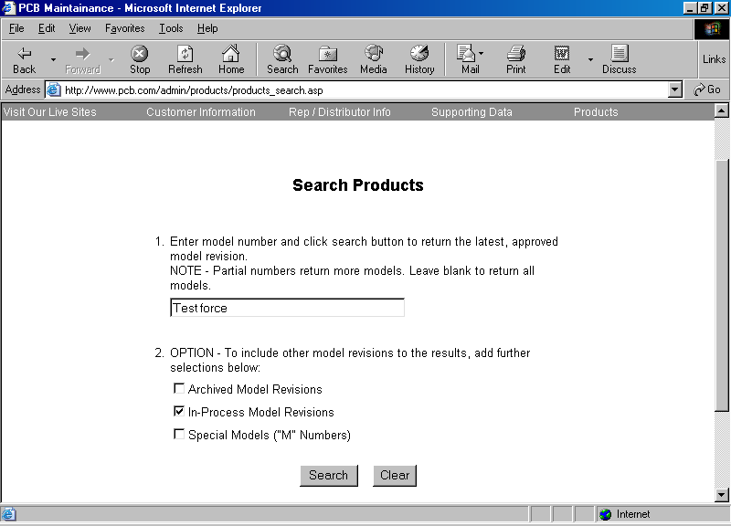

Select view a spec and another window will open with the spec sheet.

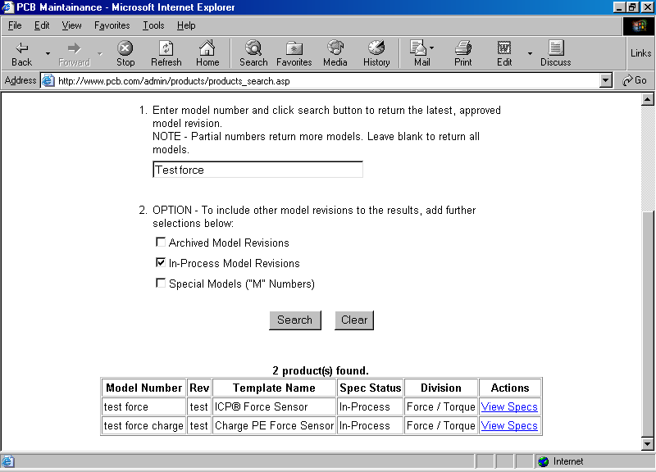

Print this page. You will have to change your print settings from portrait to landscape.

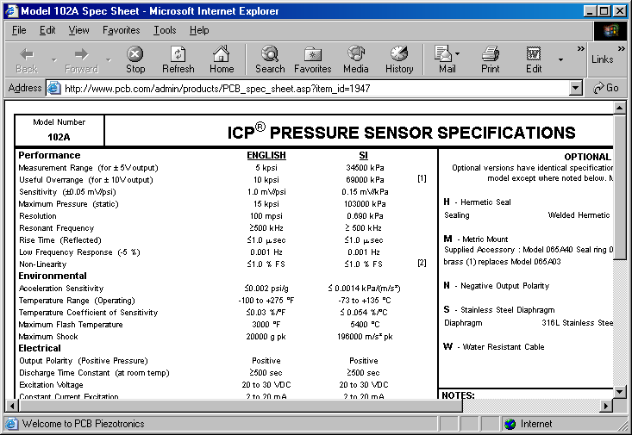

Referenced Documents:
DD02

Unusual Conditions:

