Bill of Materials (BOM) Structure: 1

Bill of Materials (BOM) Creation: 3

Routers / Operation Steps Structure: 5

Operation Notes: 7

Creating the Router / Operation Steps from Scratch: 11

Copying BOMs and/or Router / Operation Steps from an Existing Part: 15

New Product Development (NPD) Process: 17

Appendix A: Standard Hours by Work Center 18

# Bill of Materials (BOM) Structure:

A Bill of Materials is created by the engineer and maintained in the Business System Database (BSD). It generally consists of raw material, depending on complexity of the product.

The general structure is as follows:

ENG-5555-XX Part Number (used when the BOM requires special approval prior to modification)

Raw Materail Part Number

Fixture(s) (qty. = 0)

Special Tooling or Tooling Kit – Excluding tool sheet items (qty. = 0)

Outside process part numbers (see note 4 below)

Special Packaging Part Number(s)

The BOM is the list of required material to manufacture the part. It is critical that it be correct and all-inclusive. The BOM is also used in combination with the router and to cost the item.

If a certain item is to be used in the manufacturing process , then this item should be included on the BOM. A good example is a special collet used for a part run on a GT.

NOTES:

1. CE Certificates, Certificates of Conformance and other similar documentation, which are defined on a per order basis, do NOT get included on the BOM.
2. ENG-5555-01: The description states “DO NOT MODIFY WITHOUT ENG APPROVAL” – General Engineering Approval.
3. ENG-5555-02: The description states “Scheduled No Mods w/o Notified Body Approval” – ATEX/Explosive Atmosphere Scheduled items. “ATEX” or “EXPLOSIVE ATMOSPHERE” products, are manufactured and approved for use in potentially explosive environments and therefore cannot generate any electrical sparking or shorting. Changes to these products could impact certifications and therefore requires approval prior to any changes.
4. ENG-5555-03: The description states “Related No Mods w/o Authorized Approval” – ATEX/Explosive Atmosphere Related items. “ATEX” or “EXPLOSIVE ATMOSPHERE” products, are manufactured and approved for use in potentially explosive environments and therefore cannot generate any electrical sparking or shorting. Changes to these products could impact certifications and therefore requires approval prior to any changes.
5. ENG-5555-04: The description states “PROGRAM-NO MODS W/O CUSTOMER APPROVAL” – Program Models Only. “Program” products are manufactured for use in aerospace and/or defense or equivalent applications which are subject to customer specification and contractual requirements. Changes to this product must be approved to ensure the customer and contractual requirements are still being met.
6. ENG-5555-05: The description states “EXPORT LICENSE REQUIRED” – ITAR Models. “ITAR” product is product which is unique to a Military application (not COTS) and information related to such product which is restricted from distribution to any non-US citizen, including export out of the US.
7. ENG-5555-06: The description states “NO MODIFICATIONS W/O CUSTOMER APPROVAL” – “Customer Controlled” product is product that must meet the requirements of a customer specification. Changes to this product must be approved to ensure the customer requirements are still being met. Customer controlled item examples are Ono Sokki, GE, etc.
8. ENG-5555-07: The description states “EXPORT CONTROLLED INFORMATION” “Export Controlled Information” product is product and information related to such product which is restricted from distribution to any non-US citizen, including export out of the US. This product is similar to ITAR but carries more strict regulations about the distribution of such product and information.
9. Outside Services Process

When creating a new part number for an outside service, the part number should begin with the noted prefix below.

The new outside services part number must be structured in the BOM to the parent item that requires the outside service at the outside service operation. Also, the new prefixed part number must be created as a purchased part. For a complete list see EN1001 or the BSD.

BLxxxxx-xx – Blanks of Materials or Balancing

CLxxxxx-xx – Cleaning

DBxxxxx-xx – Deburr

ETxxxxx-xx – Engrave

EPxxxx-xx – Electroplate / Electropolish

GRxxxx-xx – Grinding

HCxxxxx-xx – Hard coat part per drawing

HTxxxxx-xx – Heat Treat per drawing

MDxxxx-xx – Molding

PCxxxxx-xx – Powder coat per drawing

PLxxxxx-xx – Plate (anodize) per part drawing or main assembly

PTxxxx-xx – Paint

RKxxxxx-xx – Rokide (ceramic coating)

SSxxxxx-xx – Silkscreen per drawing

TCxxxxx-xx – Turning per drawing

1. In an effort to insure the BOMs/Routers are accurate, the Production Department has a formal mechanism for providing feedback and tracking the errors. If Production finds an error, this is documented on an Material Disposition Report/Deviation Notice (also known as Waiver) Form (QA020) – See below for the Machine Shop defined process.

MDN/MDR Shop Process

* Machinist has an issue with parts run
* Machinist runs issue by Cell Leads. Lead decides if MDN/MDR form needs to be filled out
* Cell Lead – delivers program folder with MDN to engineering
* Engineering updates (new) Shop Quality Data Base.
* Engineering assigns MDN to appropriate Programmer
* Engineering stores program in file cabinet (tbd)
* Engineering delivers MDN to Programmer with due date assigned
* Engineering sets appropriate flags in Syteline – (RRR and or PRG)
* Programmer makes updates
* Programmer delivers to appropriate personnel to release the syteline flags
* MDN stays in program folder
* Next run – MDN and program go to cell for prove out and approvals
* Part gets ran
* If good – cell lead (initiator) approves
* Cell Lead turns MDN into engr
* Engineering updates the Quality Data Base

# Bill of Materials (BOM) Creation:

Generally a list of materials needs to be generated for each item. If you are creating a BOM for a new item, the items “Material Status” field on the “Controls” tab on the “Items” form in the BSD should have been set to “Slow Moving” by default upon item number creation. The MPS Flag on the “Planning” tab on the “Items” form will automatically be checked to prevent demand from showing in the ERP System.

If you are revising a BOM, check the “ECO” flag near the top of the “Items” form. This causes the material status field to change to “Slow Moving” to prevent planning from creating a job until the changes are complete. When the drawing is released, Drafting will check the “Design Release” flag on new items, or the “ECO” flag on revised Items when everything is released, to allow the ERP System to drive requirements. This will trigger these items with a family code beginning with SHOP to be set to slow moving with a reason code of RRR.

For new PMC customer items, when the BOM/Router has been approved, MS Engineering will check the “Design Release” flag. This will trigger these items with a family code beginning with SHOP to be set to slow moving with a reason code of RRR. Engineering will need to notify planning to set the item to active with a reason code of RRC and planning will need to review the planner code,etc. to ensure the information is correct.

The following procedure provides a basic outline for creating the list of materials.

1) Open the “Current Operations” form in the BSD:

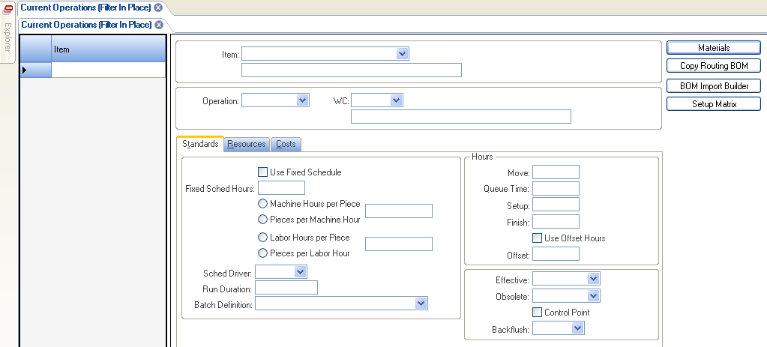

Screen Shot 1 (Blank Current Operations Form)

2) Enter the Part Number you want to add materials to in the “Item” field, then click the “Magnifying Glass” icon or hit F4 to retrieve the item from the database. Note: The item must already exist in the database in order for you to add materials to it. Refer to EN1006 for creating new items.

3) In the “Operation” field, enter “5” or “7”(or select from the pull-down menu where available).

**Note**: As a guideline, all materials and fixtures are issued in Operation 5 if picked from central inventory or Operation 7 for Machine Shop picked from Steel Stores; see 4 below for appropriate work centers.

**Note**: Material associated with outside services should be issued at the operation where the service is performed.

4) In the “WC” (work center) field, enter the appropriate inventory work center [e.g., DIC01 (central inventory), DIC02 (HCD inventory), DIC03 (Micro inventory), MS1090 (Steel Store), or HIC01 (Halifax central inventory)], depending on who will issue the material for the job. [Additional IC (inventory control) work centers may be added over time.] Select appropriate WC from pull-down menu.

5) Click the “Save” icon.

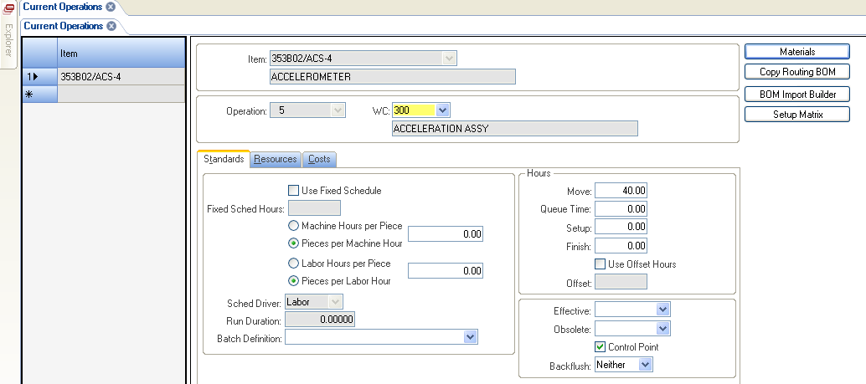

Screen Shot 2 (Populated Current Operations Form)

6) Click the “Materials” button to open the linked “Current Materials” form.

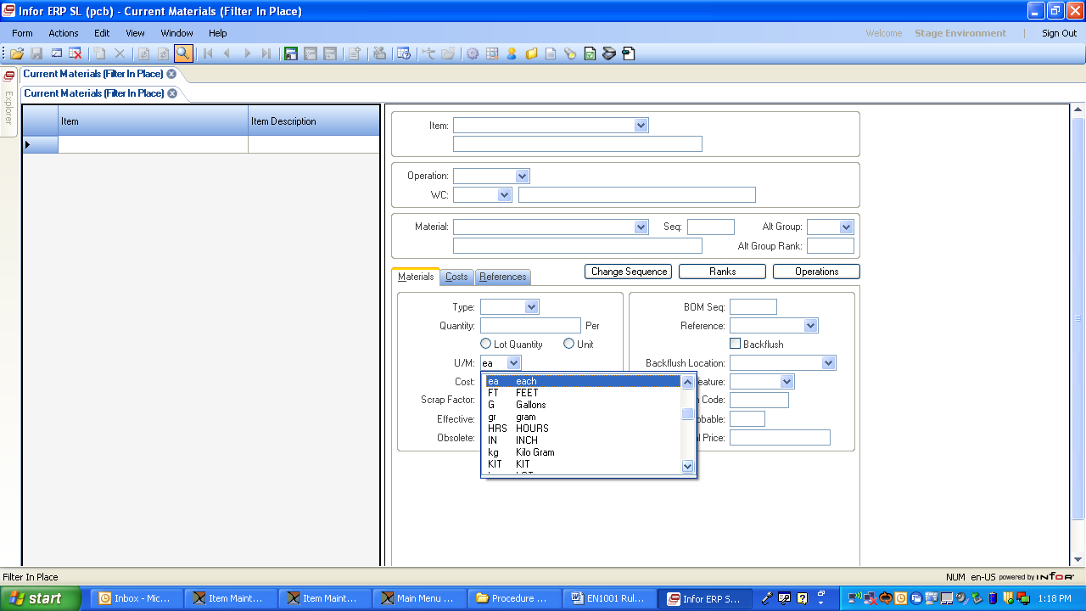

Screen Shot 3 (Current Materials Form with U/M Pull-down Menu)

7) In the “Material” field, enter the part number of material (or select using the pull-down menu; use a partial number to limit search). **Note**: The item must already exist in the database in order for you to add it to the BOM.

8) The “Type” field on the “Materials” tab will default from the items form, do not change.

9) In the “Quantity” field on the “Materials” tab, enter the quantity required. (For consumable expense items, such as solder, ribbon wire or epoxy, as well as fixtures and documentation, enter “0”.)

1. Under the “Quantity” field on the “Materials” tab, be sure the “Unit” or “Lot Quantity” option is selected, based on the following types of material:

* If **Unit** is selected, the system multiplies the “Quantity” field value by the released quantity of the job to derive the actual quantity needed.
* If **Lot Quantity** is selected, the system considers the value entered into the “Quantity” field as the actual quantity needed regardless of job size.

**\*Note:** Outside Services fall under the **“Other”** material type, quantity per defaults to per lot. Quantity per may need to be changed to per unit based on purchasing contract.

1. The “U/M” field defaults to the value entered on the “Items” form for the specific item number being used as material.Normally, the “U/M” field is not changed unless there is a significant difference between the stocking U/M and the usage U/M. To use an alternate U/M, select from the pull-down menu.

**Note:** If changing the U/M from the default, make sure that a unit of measure conversion exists that is applicable for the conversion you want.

**Note**: There are special circumstances for unit of measure. For pre-measured items such as tubing, wire and cable, a unit of measure of piece (PC) should be selected. These items should not be identified with a unit of measure of each (ea) because supply chain could interpret (ea) as feet.

1. Repeat this series of steps until all of the materials have been entered.

This completes the initial creation of the BOM.

# Routers / Operation Steps Structure:

A PMC router is created by a manufacturing engineer and maintained in the Business System Database (BSD). It consists of a simplified set of operations required to manufacture the part.

1. The general structure is as follows:

Operation 5 or 7

* For routers that have material issued from a central inventory location, set as follows:
* Select appropriate DIC or HIC work center
* Check “Use Fixed Schedule” box

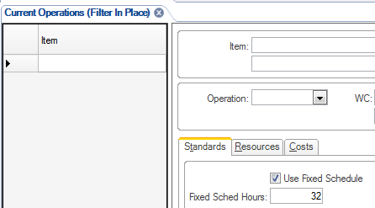

* Fixed Schedule Hours = 32
* Move Hours = 0
* For routers that have material issued from Steel Store location, set:
* Select MS1090 as the work center
* Check “Use Fixed Schedule” box
* Fixed Schedule Hours = 16
* Move Hours = 0
* When required, apply Special “Do Not Change” Codes. See note 2 in Bill of Materials (BOM) Structure section.
* When updating the router, add a note (see example below) to the first operation on the router (OP 5 or OP 7) with an explanation of update include DIN if applicable.

Example:

****************************************************************************************************

OFFICE USE ONLY:

10/2/13 - MOVE FROM BND TO STAR SR-32J - SLM

*****************************************************************************************************

Operation 9

If horizontal bandsaw operation required after steel stores, use operation 9 and add note below.

CUT ________ SLUGS ___________ LONG

INT: _________________ DATE: _________________ QTY: _______________

Appropriate slug dimension(s) should be determined and entered.

Operation 10

* Add operations as process changes work center, recommend incrementing by 10 for each operation.

NOTE: Do NOT add OP 800 or any other operation for Departmental Acceptance. This is no longer used.

Operation 998 – Work center should always be MSRWK for machine shop rework.

**Note**: For Operation 998 8 hours of move time should be added to this operation to account for stocking; no other times should be added to this operation.

1. Move Time, Set-Up Time and Control Points must be reviewed for each operation. This is explained later in this procedure in the Creating the Router / Operation Steps from Scratch: section.
2. When machine shop parts are sent to the outside vendor for processing, the following operations must be added to the router: The inspection operation is required before and after the outside processing operation.

a) MS1082 – Inspection. This work center indicates the part must be routed through inspection department to have any required data entered into our QCS system. Notes under this operation shall include the following

INSPECTION:

OPERATOR____________DATE_____________

MOVE QTY_____________NOTES____________________________________

1. “MS9999”. This work center indicates that the part is sent out for processing. (Examples include anodized sensors and plated machine parts.) Notes under this operation shall include the following:

DELIVER JOB TO APPROPRIATE STAGING AREA

SEND OUT *<INDICATE OUTSIDE PROCESS PERFORMED>* (e.g., SEND OUT FOR ANODIZING)

ITEM IS EXPORT CONTROLLED INFORMATION, PRINT OUT LG146 AND ENSURE THAT IT IS PACKAGED WITH THE ITEM(S) SUCH THAT IT IS VISIBLE BEFORE THE ITEM (only include on items that are Export Controlled Information (ENG-5555-07))

INT:________DATE:________QTY:________

Select the “Use Fixed Schedule” box on the “Standards” tab on the “Current Operations” form and enter the vendor lead-time in fixed-schedule hours. **Note**: The Outside Processing work center is set up as a 24/7 shift. This is a BSD requirement which allows the operaiton to be schedule properly. The vendor lead-time may come from a quote or conversation with the vendor. If the lead-time is unknown, enter a default value of “336”, which is equivalent to 2 weeks. The outside operation material (PL12345-01, HC12345-01, etc.) must be entered in the respective outside operation to track the service cost and schedule properly.

c) MS1082 – Inspection. This work center indicates the part must be routed through inspection department to have any required data entered into our QCS system. Notes under this operation shall include the following

INSPECTION:

OPERATOR____________DATE_____________

MOVE QTY_____________NOTES____________________________________

1. If Deburr is required on a router, a Miraclean operation must be created before and after the deburr operation unless otherwise specified.
2. If Lapping is required on a router, an inspection operation must be created before and after the lapping operation unless otherwise specified.
3. If Lapping is required with a set fixture size, notify the planner to set the order modifiers to reflect the fixture quantity.
4. For items that require Lot Traceability (for aerospace programs or ATEX requirements) you must select the “Lot Track” option on the “Controls” tab on the “Items” form in the BSD as called out in EN1006.
5. Key Product Characteristics- KPCs (designated by the symbol: KPC or the old critical inspection symbol: ) that are contained in a step of the router need to be defined and always entered into the SPC Program. Reference QAM 7.3 and DD01 for definition and application of KPCs. Needs to be verified
6. Key (Process) Control Characteristics- KCCs (designated by the symbol: KCC) also need to be identified and an additional control added to the router and/or PMS (Planned Maintenance System) for these items. Reference QAM 7.3 and DD01 for definition and application of KCCs. Needs to be verified

Each Work Center needs to have an area for sign off by the operator. If multiple operations happen at the work center, then a sign off for each operation needs to be available. The INT:_____DATE:____QTY:_____ can be added in the notes section.

# Operation Notes:

Add Operation Notes to appropriate operations as required. Reference notes are stated below.

1. Operations such as grind, etch, fabricate, heat treat:

XXXXXXXXX PER PRINT

INT. __________________ DATE: _________________ QTY. ___________

1. Assembly notes:

STEEL STORES: RECEIVE IN - AFFIX LOT STICKERS

DELIVER PAPERWORK TO MS OFFICE

INT: _________________ DATE: _________________ QTY: _______________

MS OFFICE:

LOG OUT

SCAN

INT: _________________ DATE: _________________ QTY: _______________

1. Beryllium Copper notes:

**\*\*\*Any item using Beryllium Copper MUST have this note included at ALL operations\*\*\***

**************************************** ****************************************

FOLLOW BERYLLIUM COPPER SAFE HANDLING PRACTICES

SAFE HANDLING PRACTICES:

1) MUST ONLY PICK OR SCRAPE TO DEBURR

2) DO NOT USE COMPRESSED AIR TO CLEAN PARTS OR WORK SURFACE.

3) VACUUM ANY DEBRIS WITH HEPA VACUUM FROM OFFICE

4) CLEAN WORKING SURFACES WITH ALCOHOL & THROW OUT WIPES

**************************************** ****************************************

**************************************** ****************************************

1. Deburr notes:

DEBURR

INT. _____________ DATE: ______________ QTY. ___________

1. Deliver to MS office notes:

*** DELIVER TO MACHINE SHOP OFFICE UNDER OP 998 ***

1. Inspection Notes:

INSPECTION

OPERATOR _________ DATE: _____________

MOVE QTY. _________ NOTES: _________________________________________

1. Lapping notes:

UPDATED ___________________ (UNPROVEN)

LAPPING FIXTURE ________________________

QTY/FIX:__________________________

AREA: ______________ WEIGHT: _______________ FIX:__________________

TIMES FLIPPED: ______________ CYCLE TIME:_______________

INT: _________________ DATE: _________________ QTY: _______________

1. Machining notes:

MACHINE AS PER PRINT / SETUP SHEET

INT: _________________ DATE: _________________ QTY: _______________

1. Miraclean Notes:

CLEAN USING PROGRAM #1

DO NOT OVERSTACK PARTS IN BASKET

INT: _________________ DATE: _________________ QTY: _______________

1. Op 998 notes (for internal PMC delivery):

LOG OUT

UNPOSTED JOB TRANSACTIONS SCREEN

MOVE TRANSACTION TO RECIEVE INTO STOCK

CLOSE OPERATION, DO NOT CLOSE JOB

MISC ISSUE TO ENG

DELIVER TO XXXXXXXXXXXXXXXXXXXXX.

SCAN

INT: _________________ DATE: _________________ QTY: _______________

1. Plate stack op 998 notes:

STEEL STORES: RECEIVE IN - AFFIX LOT STICKERS

DELIVER PAPERWORK TO MS OFFICE

INT: _________________ DATE: _________________ QTY: _______________

MS OFFICE:

LOG OUT

SCAN

INT: _________________ DATE: _________________ QTY: _______________

1. Plate stack pre-op 998 notes:

DELIVER TO STEEL STORES

DO NOT SEND TO LOGISTICS

1. Polishing notes:

UPDATED ______________________ (UNPROVEN)

POLISH PER PRINT USING SAME FIXTURE AS LAPPING OPERATION.

INT: _________________ DATE: _________________ QTY: _______________

1. Saw notes:

CUT ________ SLUGS ___________ LONG

INT: _________________ DATE: _________________ QTY: _______________

1. Steel stores notes:

ISSUE MATERIAL

INT: _____________ DATE: _________________ QTY: _______________

1. Vacuum bake notes:

CLEAN USING PROGRAM #1 AND TA1061 PROCESS H

USE PYREX CONTAINERS FOR VAC BAKE

ONLY ONE LAYER OF PARTS IN PYREX BEAKER FOR EZ-CLEAN:

INT. ________________ DATE: ______________ QTY. ______________

1. Zygo notes:

ATTACH FLATNESS AND SURFACE ROUGHNESS

OPERATOR_____________DATE_____________

MOVE QTY_____________NOTES_____________________________________

# Creating the Router / Operation Steps from Scratch:

A router can be created from scratch or copied from a similar design by entering information using the following steps.

1. Open the “Current Operations” form in the BSD and enter the item you are creating the router for. Click the “Create New Object” icon to enter a new operation step.

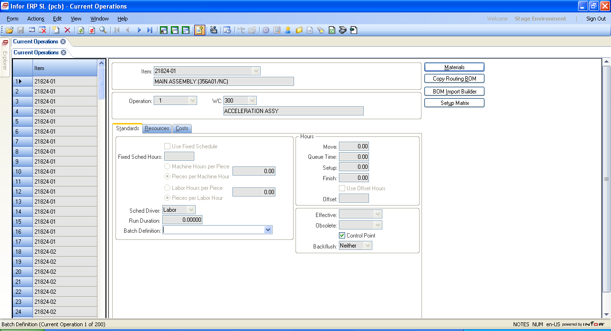

Create New Object Icon

Note Icon

Screen Shot 5 (Location of Create New Object Icon on Current Operations Form)

1. Enter “7” in the “Operation” field (or select “7” from the pull-down menu where available).
2. In the “WC” field, select from the pull-down menu the work center where the work will be performed.
3. Fixed Scheduled Hours are used for outside operations, steel stores and miraclean. See note 5 in the Routers / Operation Steps Structure: for outside operations detail.
4. If entering an Operation Step that contains labor, selected the desired cost rate as “Pieces per Labor Hour (PPLH)”. Enter the number in the field provided

**Note**: Use caution when selecting LHP vs. PPLH, for a wrong entry could significantly alter the true cost on this product.

**Note**: For PS0003, Etching work center, set Pieces per Labor Hour” (PPLH) to 35 PPLH per Etch .  If more than one etching requirement at the same operation, divide by the number of discrete etches per part and enter the resulting value into the pieces per labor hour field.

1. Enter “Move” time as appropriate for all non-touch times.Move time is used to schedule time for movement between the previous operation and the current operation in the routing. See Appendix A

**Note**: Move time for all work centers will default to 0 hrs.

**Note**: Engineering should change the move time if they know the time is different than 0 hrs per Appendix A

**Note**: Use a maximum of 8 hours of move time per day.

Examples:

104 epoxy with 12 hour cure would use 8 hours of move time.

100 hours of temperature cycle testing would use 34 hours of move time:

(100 hour ÷ 24 hours/day × 8 hours) = 33.33 hours rounded to 34 hours

1. Queue Time: Should not be used.
2. Set Up Time:Typically used only for CNC Equipment.

**Note**: When using set up time, make sure the appropriate lot size is set.

1. Control Points flag is preset in the work centers parameter. In General, all work centers should be left at their default settings. The Control Point flag being checked indicates that a transaction is required at that operation.
2. Default backflush is preset in the work center settings. Backflush “Neither” indicates labor tracking is required at this operation. Backflush “Both” indicates labor tracking will not be performed.
3. Click on the “Note” icon to add the specific details associated with each operation step. This is the information that the associates will follow when performing a process (See Operaiton Notes section for samples) and needs to include the associates signoff area: “Int:__________Date:_____________Qty:___________”.

**Note:** Leave a blank line between the last note and the associates sign off area to allow sufficient room for employee stamps.

1. After entering all of the necessary information, click the “Save” icon to save the data for that operation.
2. Repeat this series of steps to add operations as the part moves from work center to work center. See note 2 below when you get to the last step.
3. Machine shop specific

NOTES:

1. All routers should end with Operation 998.

The following settings should be used for Operation 998:

WC = MachineShop Rework MSRWK

Engineering is responsible to change the move hours for operation 998 from 0 hr to 8 hr**.** .

1. To print the router open the “Item Current Routing Report” form:

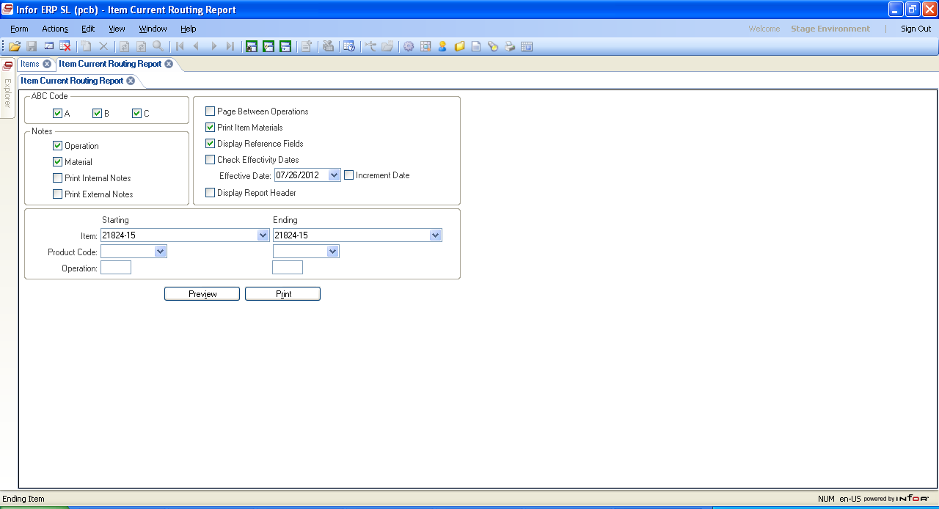

Screen Shot 6 (Item Current Routing Report Form)

1. ABC Code: Leave as default.
2. Check the Notes box for the type of notes you want to print :
   1. Operation – Notes attached to the router operation.
   2. Material – Notes attached to the material.
   3. Internal – Notes attached to the items with the internal flag checked.
   4. External – Notes attached to the items with the interal flag not checked.
3. Page Between Operations: Normally not checked.
4. Print Item Materials: Check to have current material printed with operations.
5. Display Reference Fields: Check to display bubble numbers associated with material.
6. Effectivity Dates: Used to remove obsolete material and/or operations by date.
7. Display Report Header: Recommended to leave unchecked.
8. Enter starting and ending range for one or all of the following – recommend using item only.
   1. Item: Enter starting and ending range of items to be displayed.
   2. Product Code: To display current routing report by product code range. – Leave blank
   3. Operation: Display only the operation(s) from the entered Items or Product Code.

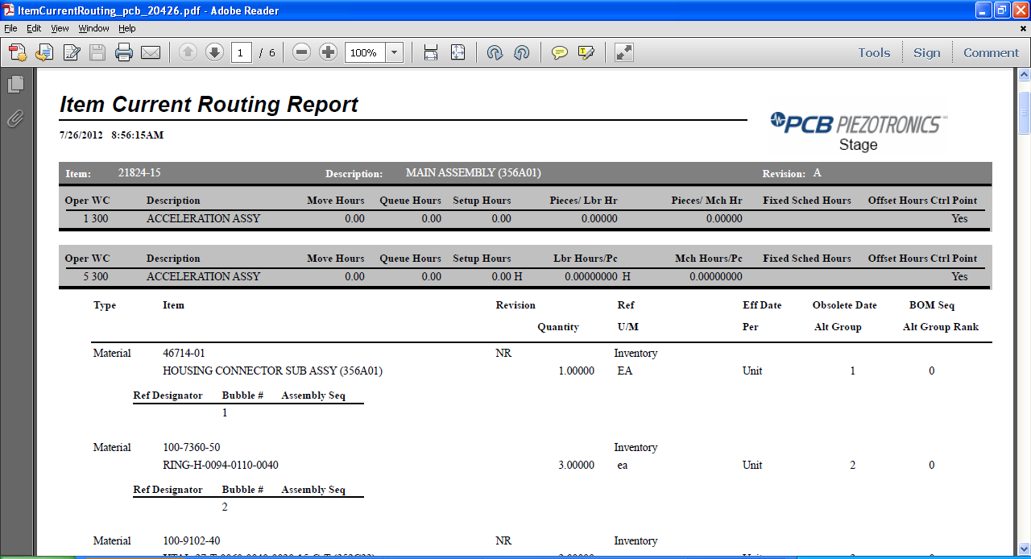

Screen Shot 7 (Item Current Routing Report Preview)

**Note**: If you click “Preview” and the report does not open in Adobe Reader, your Adobe Reader Internet Settings need to be changed. In Adobe Reader, select Edit > Preferences to open the Preferences dialog, then select the “Internet” category and “Uncheck” the “Display PDF in browser” checkbox.

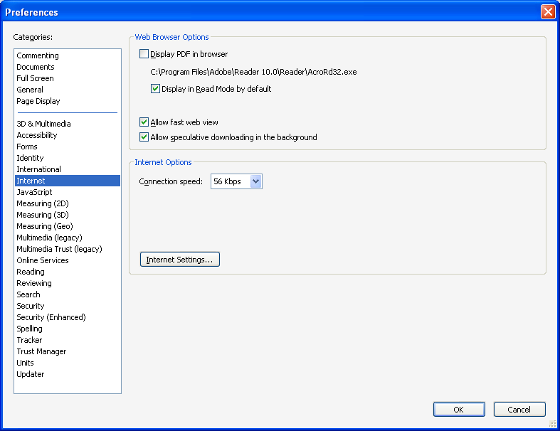

Screen Shot 8 (Adobe Reader Internet Settings; NOTE: contact IT help desk to additional assistance)

# Copying BOMs and/or Router / Operation Steps from an Existing Part:

When a new BOM or Router is being created and it closely resembles an existing BOM or Router, the simplest approach is to copy the existing information to the new part. Then the materials or notes in each operation can easily be modified.

Note: Special care must be taken to prevent overwriting existing data. Verify that the BOM and Router do not exist for the “copy to” item.

1. Open the “Copy Routing BOM” form:

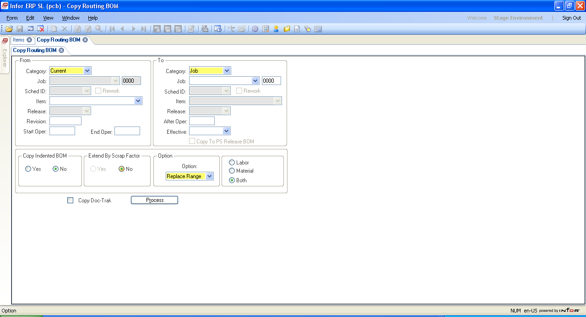

Screen Shot 9 (Copy Routing BOM Form)

1. In the “From” fields:
   1. “Category”: Select one category:
      * “Current”: Copy from a current Router and BOM.
      * “Job”: Copy from an existing Job Router and BOM.
      * “Actual Job”: Same as “Job” but includes any added material or operations added after the job was released.
      * “Estimate Job”, “PS Item” and “PS Release” are not used.
   2. “Job”: Enter job number if “Job” or “Actual Job” is selected as the category.
   3. “Item”: Enter Item number when “Current” is selected as the category. Auto populated for all other categories.
   4. “Revision”: Automatically populated.
   5. “Start Op” and “End Op”: Enter beginning and ending operations you want to copy. Used to limit portion of router to be copied.
2. In the “To” field:
   1. “Category”: Select one category:
      * “Job”: Copy to an existing Job Router and BOM.
      * “Current”: to copy to an items current Router and BOM.
      * “Job”: Enter job number if “Job” is selected as the category.
      * “Item”: Enter Item number when “Current” is selected as the category. Auto populated for all other categories.
      * “After Oper”: Enter operation number to insert copied router and BOM when inserting and not replacing.
3. The “Copy indented BOM” field should be left at its default of “No”.
4. The “Extend By Scrap Factor” field should be left at its default of “No”.
5. In the “Option” field, select one option:
   * + “Insert Range”: Adds new operations and material to existing operations. New operations will follow the operation entered in the “After Oper” field above.
     + “Replace Range”: Overwrites existing operations with the same numbers as the starting and ending operations entered above. If there are operations outside of the specified range, they will remain.
     + “Delete All”: Removes all existing operations and replaces them with operations from the source Router and BOM.
6. “Labor”, “Material”, “Both”: Select one option:
   * + “Labor”: Copies only existing operations entered above.
     + “Material”: Copies only material from the operations entered above.
     + “Both”: Copies both operations and material from the operations entered above.
7. “Copy Doc-Trak”: Check to have any Doc-Trak information copied.

Note: Normally the “Copy Doc-Trak” option is not checked because Doc-Trak components are attached to the BOM components. However, it should be used to Doc-Trak phantom assembly BOMs.

1. After copying, be sure to go back to the item you copied information to and make the necessary modifications to the new BOM and/or Router.

# New Product Development (NPD) Process:

1. Engineering monitors design review folder for new parts
2. Engineering determines if new item is fixture or part
3. Fixtures:
   1. Make/buy – Decision usually based on Load or need date
      1. If make
         1. Create routing
         2. Inform Buyer and appropriate engineer if new material or other special service needed
         3. Inform production via NPD log if programs required
         4. Update cost for gut check
         5. “Print” routing to check for errors
      2. If buy: inform Buyer/Planner to set to purchased
4. Part via NPD
   1. Decide if eng cell or Production – based on capability of engineering cell
   2. If production, discuss, when necessary, appropriate workcenter with programmers/planners/production control
   3. Create routing
   4. Inform Buyer/appropriate engineer if new material or other special service needed – Using EN1006
   5. Advise planner to review and update planner code and order modifiers as needed
   6. Inform production via NPD log if machine programs required – this includes the initial set up of tooling through ATC – Programming is usually short lead-time approx. 1 day or less – it is initial tooling that is the delay.
   7. Update cost for gut check
   8. “Print” routing to check for errors
5. Part via ECO – ECO is brought over for signature – ECO flag should be set – router / BOM is update per marked up print – drafting releasing the drawing and unchecked ECO’s – when ECO is uncheck for items with a family code shop*, set to slow moving reason code RRR.
   1. Discuss, when necessary, appropriate workcenter
   2. Modify routing to reflect production routing
   3. Add note to reflect DIN, etc. to first OP
   4. Inform Buyer/appropriate engineer if new material or other special service needed
   5. Inform production via NPD log if programs required
   6. Advise planner to review and update planner code and order modifiers as needed
   7. Update cost for gut check
   8. “Print” routing to check for errors

# Appendix A: Standard Hours by Work Center (note new hours by work center, effective Rev C)

|  |  |  |  |
| --- | --- | --- | --- |
| Work Center | Work Center Description | Fixed Schedule Hours | Move Hours |
| MS1004 | BNC-20T |  | 16 hours |
| MS1005 | BND-34S (2 Machines) |  | 16 hours |
| MS1011 | TOOLROOM |  | 24 hours |
| MS1012 | CONQUEST GT (4 MACHINES) |  | 40 hours |
| MS1013 | LAPMASTER 12 |  | 32 hours |
| MS1014 | MIRACLEAN | .25 | 16 hours |
| MS1015 | FABRICATION |  | 16 hours |
| MS1016 | CITIZEN L20 1 & 2 |  | 16 hours |
| MS1021 | ARBURG |  | 40 hours |
| MS1023 | VMC-800 (2 Machine-1&3) |  | 16 hours |
| MS1024 | E-42 EURO |  | 16 hours |
| MS1026 | WIRE EDM AQ325L, AQ300, AQ360LX |  | 16 hours |
| MS1027 | DEBURR |  | 40 hours |
| MS1028 | MECHANICAL POLISHING |  | 16 hours |
| MS1030 | CELL 1 BND-7 |  | 16 hours |
| MS1031 | ENG LATHES-OKUMA/TM6/QT'S/MANUAL |  | 24 hours |
| MS1034 | ENG MILL-AJV-25/VM2/MANUAL |  | 24 hours |
| MS1035 | ENG CELL DEBURR |  | 40 hours |
| MS1039 | HEAT TREAT |  | 16 hours |
| MS1040 | LAPMASTER 15 |  | 32 hours |
| MS1041 | Mechan. Polish PR-2 |  | 16 hours |
| MS1042 | LAPPING PR-1 |  | 32 hours |
| MS1043 | Mechan. Polish PR-1 |  | 16 hours |
| MS1044 | ZYGO INSPECTION |  | 16 hours |
| MS1045 | TUMBLE |  | 16 hours |
| MS1048 | CELL 1 ROBO 1 |  | 32 hours |
| MS1049 | CELL 1 ROBO 2 |  | 32 hours |
| MS1050 | CELL 1 ROBO 3 |  | 32 hours |
| MS1051 | CELL 1 ROBO 4 |  | 32 hours |
| MS1053 | VACUUM BAKE |  | 16 hours |
| MS1055 | LAPPING PR-2 |  | 32 hours |
| MS1056 | GT #1 |  | 16 hours |
| MS1061 | STAR #1 SR20 1 |  | 16 hours |
| MS1063 | OKUMA 4VA VM #2 |  | 16 hours |
| MS1064 | ENG OKUMA 4VA VM #3 |  | 16 hours |
| MS1065 | MAKINO A55E HM |  | 16 hours |
| MS1069 | OKUMA CADET |  | 16 hours |
| MS1070 | CITIZEN B12 LATHE |  | 16 hours |
| MS1071 | CITIZEN B20 LATHE |  | 16 hours |
| MS1072 | CITIZEN L20 #3 LATHE |  | 16 hours |
| MS1073 | CITIZEN M20 LATHE |  | 16 hours |
| MS1074 | CITIZEN M16 LATHE |  | 16 hours |
| MS1078 | ELECTRO-CHEM DBR |  | 40 hours |
| MS1080 | FMS FLEX MACH SYS |  | 16 hours |
| MS1082 | INSPECTION |  | 16 hours |
| MS1086 | MAKINO A55D HM |  | 16 hours |
| MS1090 | STEEL STORES | 16 hours |  |
| MS1103 | NAK-TOME-2  300 LATHE |  | 16 hours |
| MS1104 | SURFACE GRINDER |  | 16 hours |
| MS1106 | SUPER KIA TURN SKT25 |  | 16 hours |
| MS1107 | SQT-15 LATHE #1 and 4 |  | 16 hours |
| MS1109 | SQT-18 LATHE #3 |  | 16 hours |
| MS1111 | STAR #2 SR-20R |  | 16 hours |
| MS1112 | NAK-TOME-1 SLANT 4 |  | 16 hours |
| MS1132 | STAR #3 SR-32J |  | 16 hours |
| MS1133 | VMC-800 #2 for Boxes |  | 16 hours |
| MS1134 | STAR SW-20 |  | 16 hours |
| MS1135 | MAKINO F5 |  | 32 hours |
| MS1137 | FLEX-BEAM TURNING CENTER-NAKAMURA TOME |  | 16 hours |
| MS1138 | FLEX-BEAM FINISH MACHINE-MAKINO A51 |  | 16 hours |
| MS1141 | FLEX-BEAM WASH |  | 16 hours |
| MS1142 | A71 MAKINO |  | 16 hours |
| MS1143 | Hurco VMX 30i |  | 16 hours |
| MS1144 | PS105 |  | 16 hours |
| MS9001 | HORIZONTAL BAND SAW |  | 16 hours |