Table of Contents

**Procedure:** 1

**1. Searching for Existing Part (Figure 1)** 1

**2. (Engineer) Obtaining a Number for Parts with a PCB Drawing:** 3

**3. (Engineer) Obtaining a Number for Parts without a PCB Drawing: (Figures 4 & 5)** 3

**4. (Engineer) Entering the New Part Number into the BSD:** 4

**5. (Engineer) Critical Storage Inventory Location** 13

# Procedure:

Warning: It is easy to accidentally change fields in the Business System Database (BSD). This is especially true for the Item description field because it is the default field selected when the “Items” form opens onscreen. When closing the “Items” form or moving to another record, you will be prompted to save the record; make sure the information is correct prior to saving.

# Searching for Existing Part (Figure 1)

## Before obtaining any new numbers, you should search the BSD to determine if the item you need already exists (see following steps).

Magnify Glass

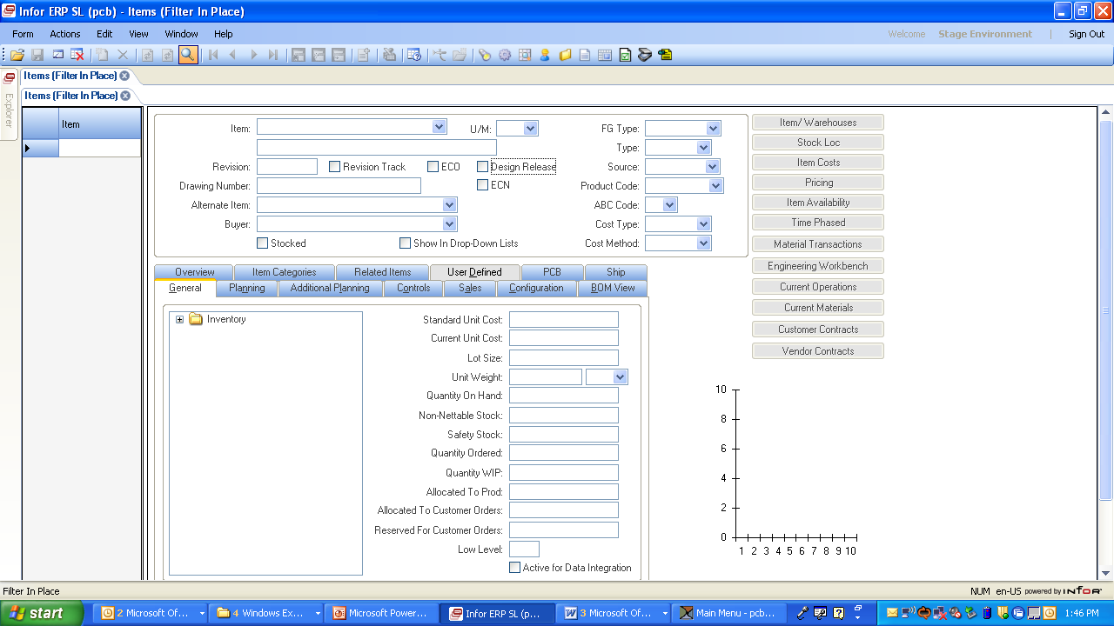

Figure (1) Items Form, Blank Data

Magnify Glass

## Select Form > Items from pull down menu.

## In “Items” form, enter information in fields to return similar items.

### Note: Filter in description field uses: “Cap*”.

### Note: “*” is a wildcard; it can be placed before and/or after text.

### Note: You can filter on multiple fields to better refine the search.

### Note: Search result is limited to 1st 200 records found.

## Select magnify glass. (Figure 2)

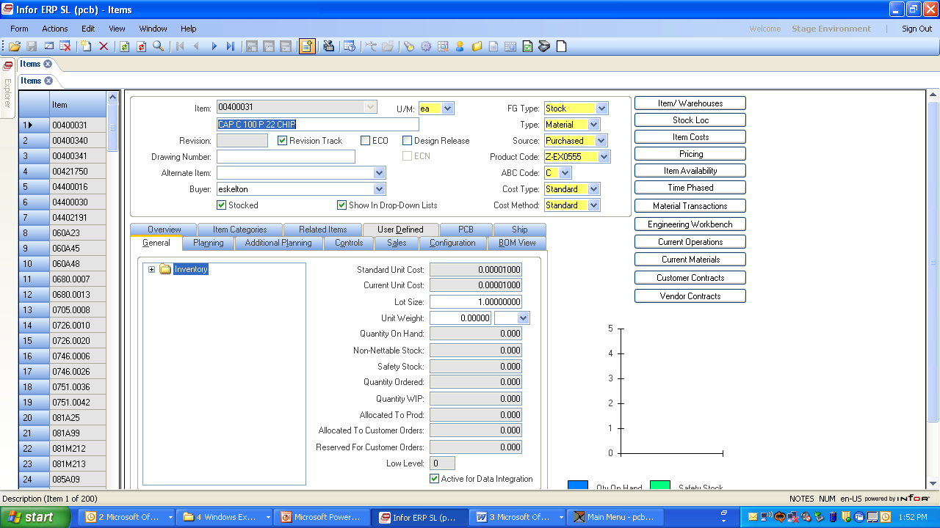

1st 200 Records were returned

Searched on “Cap*”

Figure (2) Items Form, Search Results

## Scroll through items on left hand side of screen to see if item already exists. (Figure 3)

### NOTE: Using “Grid View (Ctrl 2)” is a useful tool; you can sort by double clicking on headers (e.g., Description).

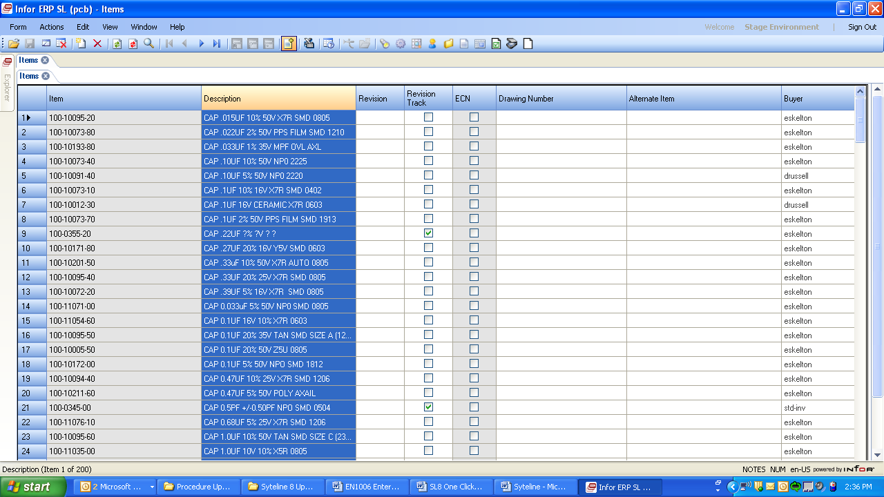

Figure (3) Grid View

# (Engineer) Obtaining a Number for Parts with a PCB Drawing:

## To obtain a new part number that has a PCB drawing number associated with it, see Drafting Procedure DD1045 “Retrieving/Closing/ Reviewing Document Numbers and ECO Numbers” to obtain the number from the Drafting ACCESS Database. To create new drawings see DD1046 “Drawing Creation”.

# (Engineer) Obtaining a Number for Parts without a PCB Drawing: (Figures 4 & 5)

## To obtain a new part number that does not require any drawings, enter the Business System Database (BSD).

## Use the “DataView” form, filter in place for; “PCB Last 100- Items Global”. Select “Launch” button to display a list of recent purchased items added to the BSD. Use the last PCB part number taken out and increment this number by 10 to obtain the new part number. (Examples: If 100-8093-30 is the last number taken, then the new number will be 100-8093-40. If 100-8093-90 is the last number taken, then the new number will be 100-8094-00.

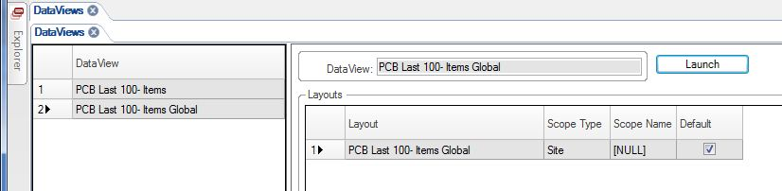

Select PCB Last 100-Items Global

Select Launch

Figure (4) Data Views

Use Last Number at Top of List

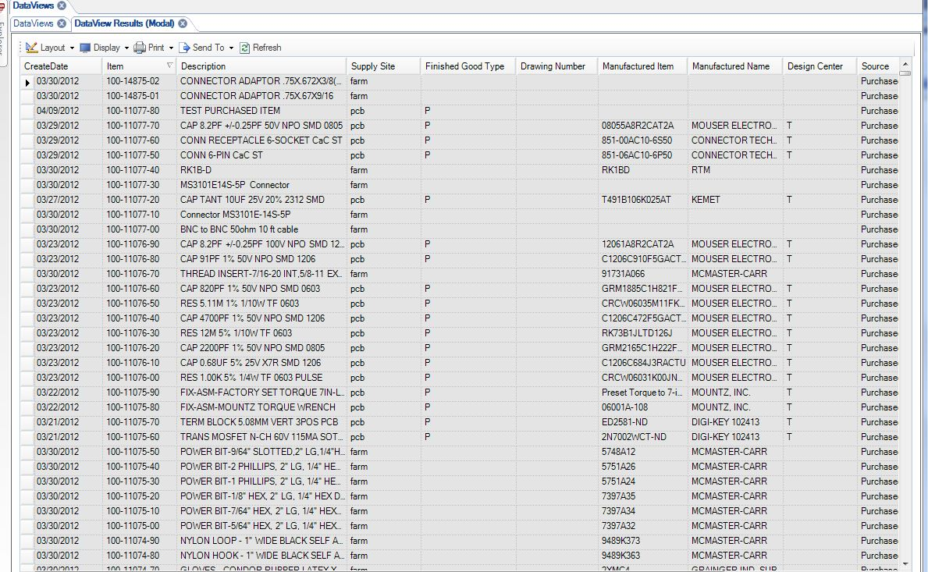

Figure (5) DataView Results, Grid Mode

# (Engineer) Entering the New Part Number into the BSD:

## All parts to be ordered need to be entered into the BSD prior to ordering.

NOTE: If item to be ordered is any type of chemical or chemical compound, (for example, but not limited to, adhesives, epoxies, solvents, solders, lubricants, braze pastes, paint, cleaners, etc.) STOP. Follow the Approval and Control of Chemical Materials Process, PE05.

## Enter the “ITEMS” form in the BSD and enter “CTRL-N” to add a new item or select Actions > “ADD NEW” from pull down menu.

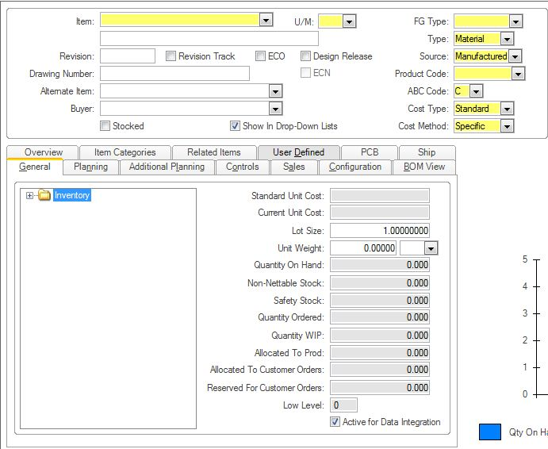

. Figure (6) Items Form Data Entry Fields – General Tab

## Enter data in the appropriate fields as instructed below. NOTE: Fields with a yellow background are required before saving the new item.

## General Tab

### When the “Items” form opens onscreen, the “General Tab” will be in view.

### In the **“Item”** field, enter the new Part Number.

### In the **“U/M”** field, select the unit of measure. The unit of measure should match the typical unit of measure specified on the BOM. For cables, wire, heat shrink and similar items, the U/M should be FT or MTR. When using precut pieces of items such as tubing, wire, or cable, the U/M should be PCS and not EA to prevent confusion with older cable item U/M of EA. The search icon will display available codes. Unit of Measure is important because it will affect future item costing. Once a Job or PO is taken out on the item, U/M can no longer be changed.

### In the [unlabeled] **“description”** field, enter descriptive text. Where applicable, EN1055 (Syteline Descriptions Users Guide), which are located on TCS **(**Suggestions for new templates are welcomed if one does not already exist.) Accurate descriptions are critical for Engineering to be able to look up items in the future. Whenever possible, new sub-assemblies descriptions should contain the model where they are used. New special model numbers do not need to be added to existing sub-assemblies descriptions.

### In the **“Revision”** field**,** enter the revision number of the item being entered. Engineering drawings use the engineer’s initials and a number, like EJV1 (when/if it is revised to EJV2, Drafting will update this field). Drafting drawings follow DD1053. Leave this field blank for purchased parts.

### ”Revision Track”— do not check it. It is used during the BOM / Router creation process EN1001, and/or the ECO process DD02.

### “Design Release” – send a “Design Request” email to Drafting for items that do not have a PCB drawing number after completing the part number entry to have this box checked. If this box is not checked, demand will not be created automatically.

### “Stocked” – check the box for all items before adding to any bom. If the flag is not set, the references on jobs will be in-correct.

### For parts with a PCB drawing, enter the drawing number in the **“Drawing Number”** field.

### The **“FG Type”** will default to Special. **DO NOT CHANGE IT**. There is a process to have items set to stock or standard and should be followed separately from item entry..

### Select the appropriate type of part from the **“Type”** drop down menu. (Note: All items consumed in the manufacture of a product or sub-assembly are “Materials” (direct material). PCB does not use the “Tool” designation. “Fixtures” are used as required by each design. Documentation is considered “Other”.)

#### Fixture **“Type”** should be set to material.

### Enter the source of the material from the **“Source”** drop down menu**.** Note: Select “Purchased” for those items procured from an outside vendor as well as all items classified as Z-DOCUMENT. Select “Manufactured” for those parts made in-house.

### In the **“Product Code”** drop down menu, select from the available product codes. Note: Once this is created and Saved for the first time it could create accounting problems if it is changed after this point. This should not be changed except by an authorized person. (Reference TA1070 for more detailed listing.)

#### Typical Product codes begin with a prefix and end with the group number (XXXX): (This is the Tech Center list and the cells within each Tech Center. Pull down menu shows all available options including the prefix.)

0XXX Finished goods (Generally entered by Sales)

SAXXXX Sub-Assemblies

MSXXXX Machine Shop Parts

RMXXXX Purchased Parts

Z-XXXX Expensed items are either bulked out or the cost is accounted for in overhead (e.g. documents, epoxies, hardware, etc.) are usually zero quantity on bom.

#### Typical “Z” items (see product code pull down menu for full list of codes):

Z- CHEMICAL – Chemicals used e.g., alcohol (Must follow process map PE05 and TA07 for documentation, control, and training. Be sure any new adhesive is added to TA014 (Adhesives list) and TA074 (Epoxy Cure Times))

Z- CH1500 – Chemicals used by crystal group (Must follow process map PE05 and TA07 for documentation, control, and training Be sure any new adhesive is added to TA014 (Adhesives list) and TA074 (Epoxy Cure Times))

Z- DOCUMENT – documents e.g., drawings, manuals

Z- EPOXY – epoxies used (Must follow process map PE05 and TA07 for documentation, control, and training. Be sure any new adhesive is added to TA014 (Adhesives list) and TA074 (Epoxy Cure Times))

Z- ESD – ESD items, e.g., wrist straps

Z- EX (+ PRODUCT GROUP CODE NUMBER) – items used, e.g., solder, foam, trim cap

Z- HD (+ PRODUCT GROUP CODE NUMBER) – Hardware used, e.g., screws, nuts

Z- MAINT – Items used by the Maintenance department, e.g., paper towels

Z- OS (+ PRODUCT GROUP CODE NUMBER) – items sent outside for processing

Z- SHIPPING – shipping items

Z- TF (+ PRODUCT GROUP CODE NUMBER) – tools and fixtures

### The “**ABC Code**” field will default to “C” for new items, do not change.

### The “**Cost Type**” field will default to “Standard”, do not change. Other Sites such as NYS, FARM, PROVO will default to Actual and should not be changed.

### In the **“Cost Method**” drop down menu, select “Standard”. Ignore prompts about rolling cost because these are addressed by Planning in a later process.

### If the part is a model, main assembly or sub-assembly, the “Revision Track” flag should be turned on by authorized persons after the materials and operation steps have been added. (Reference EN1001 Creation of BOMs / Router Procedure for more information.)

## Planning Tab

### Next move to the “Planning Tab” of the “Items” form

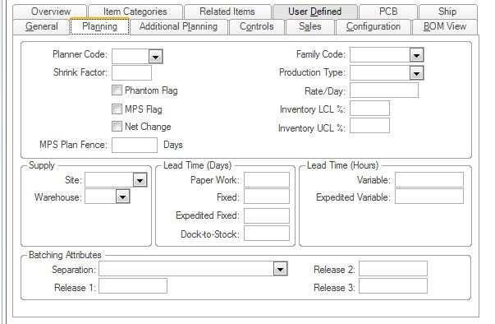

Figure (7) Items Form Data Entry Fields – Planning Tab

### In the “**Planner Code”** field, select the planner code specific to your group. **It is important that a Planner Code be entered for EVERY item entered in the system.** The appropriate Planner Codes are: (Reference TA1070 for a more detailed listing.)

NMS - New machine shop part

NCS – New Components & Services Part (Crystal, HCD part, etc.)

NPI – New purchased parts

188 – PRE Products

288 - FTQ Products

388 – SVS Products

588 - IMI Products

788 - GEP Products

888 – Cable Products

ENG – Fixtures

900 – KON (Specials Shack Products)

910 – KON Product

988 – AME Products (NPD & CIP)

### For Models, Main Assemblies and Sub-Assemblies, enter the estimated yield in the **“Shrink Factor”** field, if known. (Example: If the product has an estimated yield of 80%, then enter 0.20 in this field.)

### Work with Production/Planning to determine whether or not it is appropriate to check the **“Phantom Flag”**. (Normally, this is set only for sub-assemblies which are built as part of the upper assembly and immediately consumed. Doctrak the detail BoMs when using subassemblies to assist production with bom item numbers in procedures.)

## Controls Tab

### Next move to the “Controls Tab” of the “Items” form.

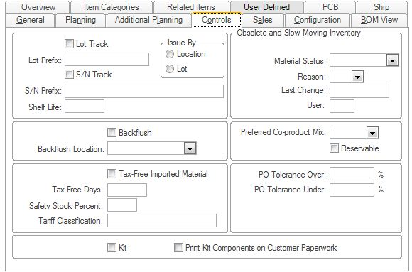

Figure (8) Items Form Data Entry Fields – Controls Tab

### Check the “**Lot Track**” box in the PCB configuration (Depew Site) for Items that need to be identified in subsets for traceability in inventory and as they move through the process of being incorporated into higher level builds. The engineer has the discretion to set a **new** Item to Lot Tracked regardless of where the Item resides in the product build (i.e. component, subassembly, main assembly or top model).

#### The following Items MUST have the Lot Track box checked in the PCB Configuration.

##### Crystals (XTALS).

##### Amplifiers.

##### Element Assemblies.

##### Connectors and Connector Assemblies.

##### Items that have a shelf life (including but not limited to epoxy and solder).

###### In addition to checking the Lot Track box, the products shelf life (in days) must be added to the **Shelf Life** field (also located on the Controls Tab)

#### If an Item is used to build a Program, Aerospace or ATEX model ensure you know if the Item needs to be Lot Tracked. Ask the Project Manager if there is a question.

### Check the “Issue By Lot” when the “lot Track” box is checked. Syteline will use the available lot numbers to issue items to jobs using alphanumeric sorting.

### Check the “**S/N Track**” box for all serialized items (Models and main assemblies when built to that level). An Item cannot be both Serial Tracked and Lot Tracked. If an Item needs to be Serial Tracked do not check the Lot Track box.

### Check the **“Backflush**” box for all Accessories.

## PCB Tab

### Next move to the “PCB Tab” of the “Items” form.

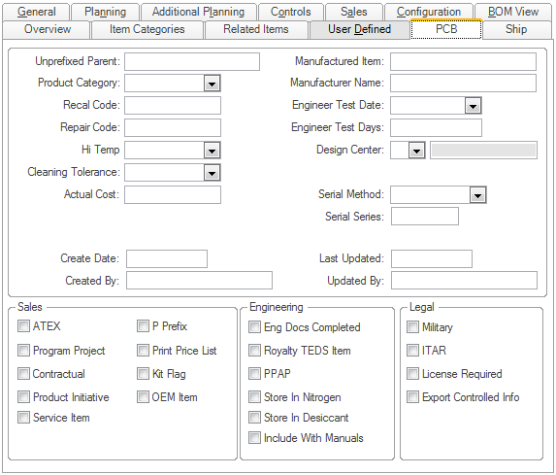

Figure (9) Items Form Data Entry Fields – PCB Tab – PART A

#### Unprefixed Parent: Not Used for components or assemblies (Leave blank.)

#### Manufactured Item: Enter manufacturer’s part number for purchased items requiring source control

#### Manufacturer Name: Enter manufacturer’s name for purchased items requiring source control

#### Recal Code: Used by Sales

#### Repair Code: Used by Sales

#### Design Center: Select appropriate design center.

##### Use the Design Center that applies to the end market where known and “Specials Shack” for all others. Only use Larson Davis, L&T, or Accumetrics for products designed in the respective location.

#### ROHS Status: This field is being replaced by a similar field on the Items Certification Form. See RA01 RoHS process Map and RA1001 for an explanation of the RoHS codes.

#### Engineer Test Date: For stock and program models, enter date to pull first unit for performance verification testing.

#### Engineer Test: Enter number of days before repeating performance verification testing.

#### Hi Temp: Only used by LD. (All other sites leave blank.)

#### Cleaning Tolerance: Only used by LD. (All other sites leave blank.)

#### Actual Cost: Calculated field by Syteline (no entry required).

#### Serial Method: Series. This field is only used for items that require serial numbers.

#### Serial Series: Enter the model number or series number to be used for serial numbers. Do not include the prefix when entering the model number. For series, only enter the base series without revision letter or prefix (e.g., 208 or 356).

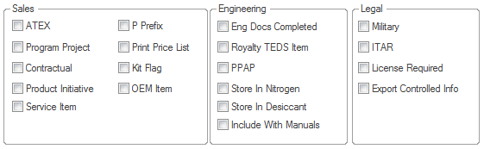

Figure (10) Items Form Data Entry Fields – PCB Tab - PART B

#### ATEX: For “ATEX” / Explosive Atmosphere Products. Check the “ATEX” box for the following items:

##### Any model with ATEX/IEC approval.

##### Components including any critical component used in an ATEX approved model. Critical components are defined as piezoelectric materials, discoidal capacitors, and feedback capacitors as well as amplifiers and their components. These items will have either the “Related” or the “Scheduled” stamp on their associated documents.

*Related* – critical components or BOMs.

*Scheduled* – Documents that are controlled by the Approval Agency such as CSA or ATEX. These documents we call “Approval” to distinguish them from their similar internal counterparts. General Etching, General Assembly, General schematics or amplifier, and General Crystal drawings are common examples.

Note #1: For purchased parts including parts that are critical components, this flag should be used to indicate on the PO that a certificate of conformance in accordance with EN 45014 is required (Note: EN 45014 is not a PCB controlled document, refer to quality standards library).

Note #2: For purchased parts, this flag will trigger incoming inspection to assign a product lot number.

Note #3: When a new model is entered the flag must be checked; an automatic monthly e-mail summary is sent to insure the model is on our current EC-Certificate Schedule as well as to include the model in our QC database for tracking.

Note #4: Documents cannot be both Related and Scheduled; they must be one or the other or neither.

#### Export Controlled Information: Check for items only used on controlled models that contain “Export Controlled Information.” Example: This includes any top model as well as its components that are exclusive to this model. If components are used on other models which are not designated as Export Controlled Information then the item does not need to have the “Export Controlled Information” box checked.

#### ITAR: Check for items only used on ITAR controlled models. Example: This includes any top model as well as its components that are exclusive to this model. If components are used on other models not ITAR controlled then the item does not need to have the “ITAR” box checked.

#### Military: Check for items that are used in a Military application.

#### Program Project: (See also DD1053 for document control for Programs.)

##### Check the “Program Project” box for the following items:

##### Any model, main assembly and sub-assembly BOM as defined by the customer or Program Manager, has an ENG-5555-04 line item, and has achieved Final Design Review acceptance. (See EN1001 for proper application of line item.)

##### Any model, main assembly, sub assembly or single component drawing, procedure, and specification that is used on a Program Project that has achieved Final Design Review acceptance, and has a stamp on the drawing/document. (See DD1053 for proper application of stamp.)

##### Typically the flag, line item, and the stamp should be executed at Final Design Review to avoid wasted work and to ensure that it is done properly.

##### Typically the flag is not checked for routers or procedures.

##### Typically the flag is not checked for fixtures and other indirect material required to build the product.

##### Setting the Program flag for purchased items will trigger purchasing to indicate on the PO that a certificate of conformance in accordance with EN45014 is required. Note: EN 45014 is not a PCB controlled document, refer to quality standards library.

#### All Program models that have P.M.A. through F. A. A. are listed and controlled on the PMA Model No. Registry List EN024. (Reference EN1022 PMA Procedure.)Customer Controlled: Check the “Customer Controlled” box for the following items:

##### Any model, main assembly and sub-assembly BOM as defined by the customer or Sale Representative, has an ENG-5555-06 line item, and has achieved Final Design Review acceptance. (See EN1001 for proper application of line item.)

##### Any model, main assembly, sub assembly or single component drawing, procedure, and specification that is used on a Customer Controlled Project that has achieved Final Design Review acceptance, and has a stamp on the drawing/document. (See DD1053 for proper application of stamp.)

#### Contractual: Checked by Sales.

#### Service Item: Checked by Sales.

#### P-Prefix: Checked by Sales.

#### Print Price List: Checked by Sales.

#### Kit Flag: Identifies items shipped as a kit (contains multiple finished good models).

#### OEM Item: Checked by Sales.

#### Engineering Docs Completed: Checked by drafting when formal documentation is released.

#### Royalty TEDS Item: Checked for finished goods containing ICP and TEDS.

#### PPAP

##### Item needs to be qualified before it can be used in a product. (See PAPP process map PD04.)

#### Store in Nitro: If component needs to be stored in Nitrogen to prevent oxidation and to prevent moisture absorption. (See EN027 for items that are stored in Nitrogen.) If only moisture absorption is a concern, the “store in desiccant” flag should be checked.

#### Store in Desiccant: If component needs to be stored in dry conditions to prevent moisture absorption from ambient humidity. Items with this flag may be stored in desiccant or Nitrogen.

#### Include With Manuals: Do Not Use, not yet implemented.

#### License Required: For items that require an Export License, but don’t fall under ITAR. Dictated by Sales. Consult with Export Manager or Legal Dept. to determine if unique subcomponents require this box to be checked when used on License Required products.

## Click the **“Save”** icon () to save the record and add it to the BSD, or click the **“Undo”** icon ()to discard the record.

# (Engineer) Critical Storage Inventory Location

## If item to be ordered requires any type of critical storage, to preserve the item upon arrival, or to insure safety (i.e. kept frozen, placed in fire cabinet), an inventory location must be assigned before the item is ordered.

### Email the Inventory Coordinator and request that the new item be assigned to the correct inventory location before the first order is placed.

### Once a response is received, verify that the correct location has been set by entering the “ITEMS” form in the BSD. On the ‘General” tab, expand the inventory folders and make sure the first location shown is the correct location.

## Product without critical storage requirements do not require a pre-defined inventory location. Dry box and nitrogen storage requires are not considered “critical”.



Click + To Expand Folder View

Figure (10) Verify Inventory Location is Set