Table of Contents

1 Connector selection 2

1.1 Connector design 2

1.1.1 Socket Design 2

1.1.2 Pin Design 6

1.1.3 Coupling Nut Design 10

1.2 Finish Specifications: 11

1.2.1 Plating Dimensions: 11

1.2.2 Anodizing per Mil-A-8625, Type II, Class2 (then list color IE Black) 11

1.3 Finishing (Anodizing, Hardcoating, Plating) on threaded parts. 12

1.3.1 Thread Dimensions 12

1.4 Hermetic connector 13

1.4.1 Shell / Pin Material Selection 13

1.4.2 Glass wetting / Glass meniscus 14

1.4.3 Shell design 15

1.4.4 Hermetic pin design 16

1.4.5 Glass Preform design. 17

1.4.6 Fixture design 19

1.4.7 Top cap design 21

1.4.8 Finishing 23

2 High temperature connectors. 26

2.1 High temperature glasses 27

2.2 High temperature connector design guidelines 27

2.2.1 Glass Design 27

2.2.2 Metal Design 29

2.2.3 Socket and pin design 30

2.2.4 Housing, cover, header design 34

2.2.5 Fixturing 38

2.3 Processing 44

2.3.1 Cleaning and surface preparation 44

2.3.2 Firing 45

2.3.3 Finishing 45

2.3.4 Welding 47

# Connector selection

**Low temperature connector design guidelines for connectors used from -100- 500°F are described in section 1. The attached link can be used to filter for material, contact design and dimensions.** [**HCD Connectors for EN1058.xlsx**](HCD%20Connectors%20for%20EN1058.xlsx)

**High temperature connectors that can be used from-65 to 500° and or to 900°F are described in Section 2.**

## Connector design

### Socket Design

(Reference Figure 1)

1. The uncrimped socket ID should be a clearance fit (approx .002”) on the pin OD to eliminate binding between the diameters. The socket ID should have a lead in chamfer to aide proper alignment with the pin.
2. Slots are added to the socket to allow it to be crimped to an interference fit on the pin.
3. The slot depth should be sized such that it is equal to or greater than the pin engagement length to eliminate binding between the socket and pin.
4. Dual slot tapered crimp design (Reference Figure 1)
5. The preferred method for slot design is a dual slot “tapered crimp”. In this design, the socket is crimped slightly (~.050) away from the pin insertion side using a fixture. This leaves a tapered area on the pin insertion side to aide proper alignment. Special fixtures are required for the dual slot design (reference P/N 46638 (live tooling crimp fixture, 38691 Manual crimp fixture), and the drawing should specify what fixture to use to crimp the socket.

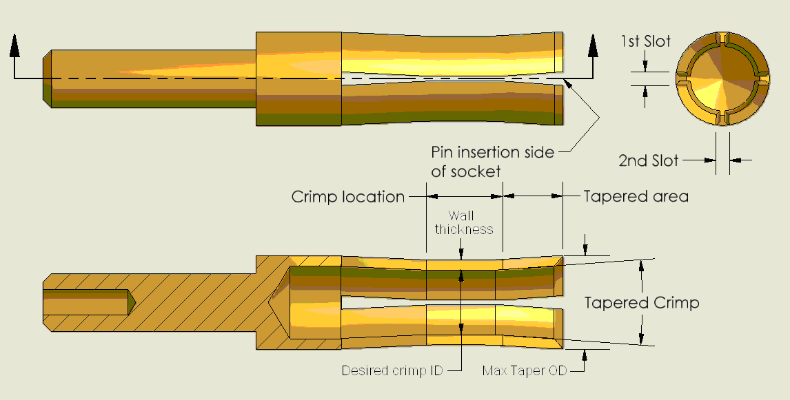

Figure 1: Dual slot “tapered crimp” design (21000 Socket)

1. Tapered socket crimp fixture (Reference Figure 1and Figure 2)
2. Fixtures to create the tapered crimp on sockets consist of a crimper, which compresses the socket; and a swager which spreads the mouth of the socket open, creating the taper. Ideally, the fixtures will mount in the live tooling within the lathe, and be used during the machining process to eliminate manual crimping operations.
3. The swage tip has a tapered point to spread the tapered area of the socket. It is threaded so that it can be adjusted in and out to contol the crimp taper angle and max taper OD.
4. The crimper has a lead in angle to aid socket insertion. The crimper ID can be determined by the desired OD of the socket after crimping (desired crimp ID + 2 * socket wall thickness). The Socket OD stop is the hard stop which will not allow the socket max taper OD to exceed the desired value.

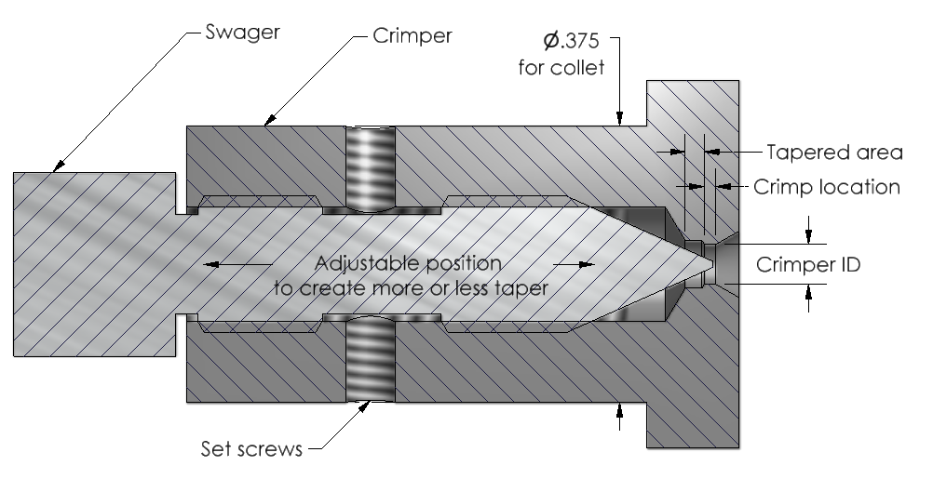

Figure 2: Live tooling crimp fixture (P/N 46638)

1. Single slot “bump” crimp design (ReferenceFigure 3)
2. Traditionally, a single slot “bump crimped” design has been used. In this design, the pin insertion side of the socket is pinched closed by bumping it with the blunt end of the cutting tool. For this design, the drawing should specify “CRIMP SLOTTED END CLOSED.”

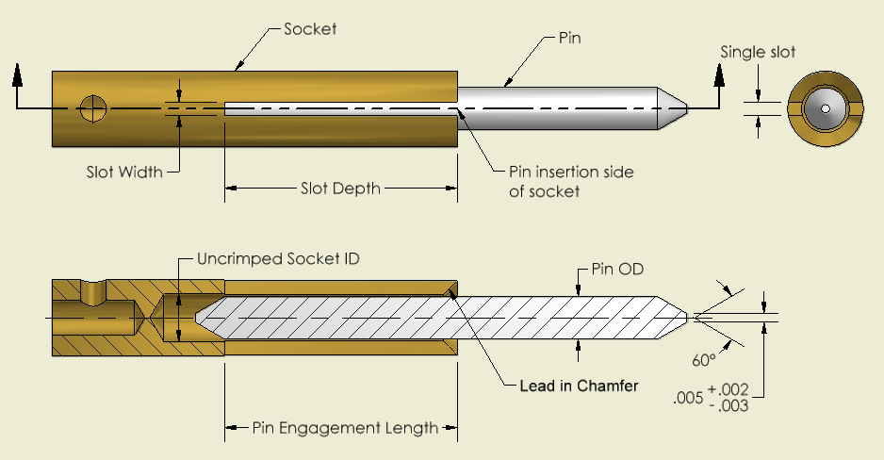

Figure 3: Single slot “bump crimped” design (39908 Socket & 37901 Pin)

1. Winked Sockets and Slot Width (ReferenceFigure 4)
2. The slot width must be sized such that there is an interference fit between the socket and pin after crimping to assure proper contact between the socket and pin. To assure an interference fit with a tolerance stack up, the maximum socket ID minus the minimum slot width must be less than the minimum pin OD.
3. Winked sockets (an off-center crimp condition) can cause misalignment and/or a no fit conditions between a pin and socket when combined with a large slot width. The slot width and tolerance should be minimized to reduce the effects of a winked socket.
4. Tapered crimped design is preffered over the single slot design because it eliminates the possibility for winked sockets, and it maintains contact force onto the pin. The single slot design has a tendency to loose retention force over time which has lead to intermitted connections during use.

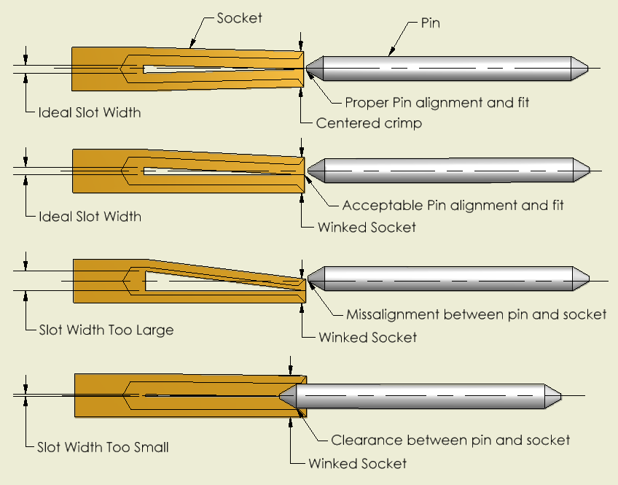

Figure 4: Winked socket & Slot Width Examples

1. To assure sufficient contact between the pin and socket, all socket drawings should specify “MINIMUM RETENTION FORCE OF XXXX ON ØMIN PIN WITH MAX FINISH”, where “ØMIN” pin is equal to the minimum diameter of the mating pin, and “XXXX” is determined by the chart below and the diameter of the pin (derived from MIL-C-39029)

|  |  |  |  |  |  |  |
| --- | --- | --- | --- | --- | --- | --- |
| The chart below is based on MIL-C-39029 & SAE AS39029. Values in **BLUE** are PCB determined values. | | | | | | |
| Engagement End Size (Per  MIL-C-39029 &  SAE AS39029) | Models | Desc. | Pin Ø (Engagement End Ø) | Minimum Separation force (oz) | Maximum Separation force (oz) | Max Test pin Diameter   +.0000 / -.0002 |
| 0000 |  |  | .500±.001 | 15 |  | 0.501 |
| 0 |  |  | .357±.001 | 15 |  | 0.358 |
| 4 |  |  | .225±.001 | 10 |  | 0.226 |
| 8 |  |  | .142±.001 | 5 |  | 0.143 |
| 10 |  |  | .125±.001 | 4 |  | 0.126 |
| 12 |  |  | .094±.001 | 3 |  | 0.095 |
| 16 |  |  | .0625±.0010 | 2 |  | 0.0635 |
| 20 |  |  | .040±.001 | 0.7 |  | 0.041 |
|  | **AG** | **5-44 coax** | **0.0345±.0005** | **1.5** | **24** | **0.0340** |
|  | **PSHS15, 1397** | **10-32 Coax** | **0.0310±.0005** | **3** | **24** | **0.0300** |
| 23 |  |  | .0270±.0005 | 0.5 |  | 0.0275 |
|  | **AY** | **1/4-28 4-pin** | **0.0245±.0005** | **1** | **8** | **0.0240** |
| 28 | **EH** | **8-36 4-pin** | **.0150±.0005** | **0.5** | **4.5** | **0.0145** |
|  | **EK** | **3-56 COAX** | **.014±.001** |  |  | **0.013** |

### Pin Design

(ReferenceFigure 5)

1. The pin should have a chamfer to aide proper alignment with the connector. Traditionally a 60° chamfer with a starting diameter of Ø.005” +.002/-.003 has been used, as shown inFigure 1. The ideal method for pin engagement is the “bullet nose”, construction of this configuration on a Ø.600 pin is shown inFigure 5.

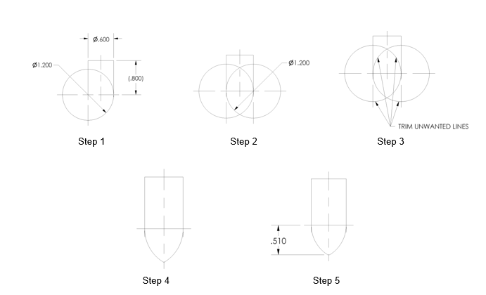

Figure 5: Bullet Nose Pin Example

1. Pins with solder holes should have a vent hole to release flux gasses, & allow proper solder flow. Suggested vent hole diameter should be between ½ and ¾ the diameter of the solder hole diameter. (ReferenceFigure 6and Figure 7)

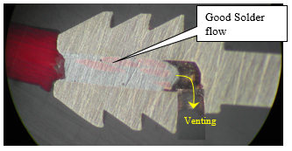

Figure 6: Vented Solder hole

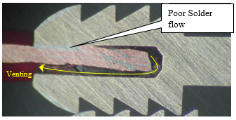

Figure 7: Non vented solder hole

1. Front Isolator
2. Front Isolator is used to isolate the socket(s) from the shell and hold the sockets in the proper position.

ReferenceFigure 8:

1. The thru hole (on the pin insertion side) should be a slip fit (.000 to .001” gap) with the pin and have a lead in chamfer to aide proper alignment between the pin and socket.
2. The counterbore (socket side) should be sized such that it is a slip fit (.000 to .001” gap) with the socket.

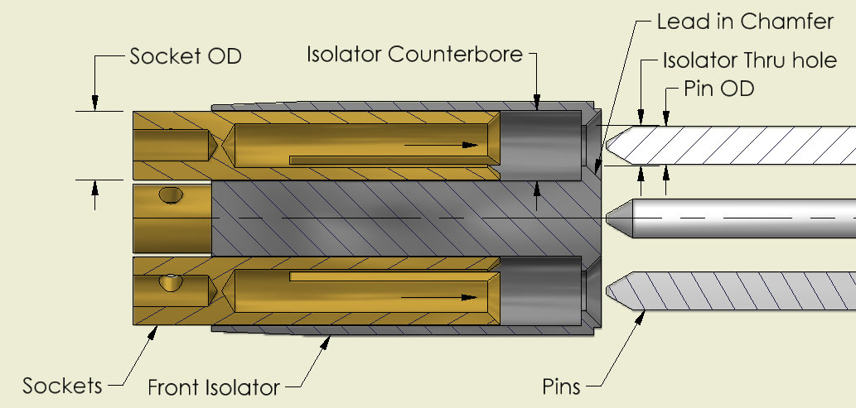

Figure 8: 36504 Front Isolator, 39908 Sockets & 37901 Pins

ReferenceFigure 9:

1. The counterbore depth should be sized such that there is a gap (approx .001”) between socket and bottom of the counterbore to eliminate binding. A flat bottom hole is recommended as the positive stop for the socket to maximize pin engagement. A drill point is acceptable, but will create a larger gap between the bottom of the hole and face of the socket, and reduce pin engagement.
2. The molded isololator must have a minmum wall thickness of .006” to prevent void problems during molding.

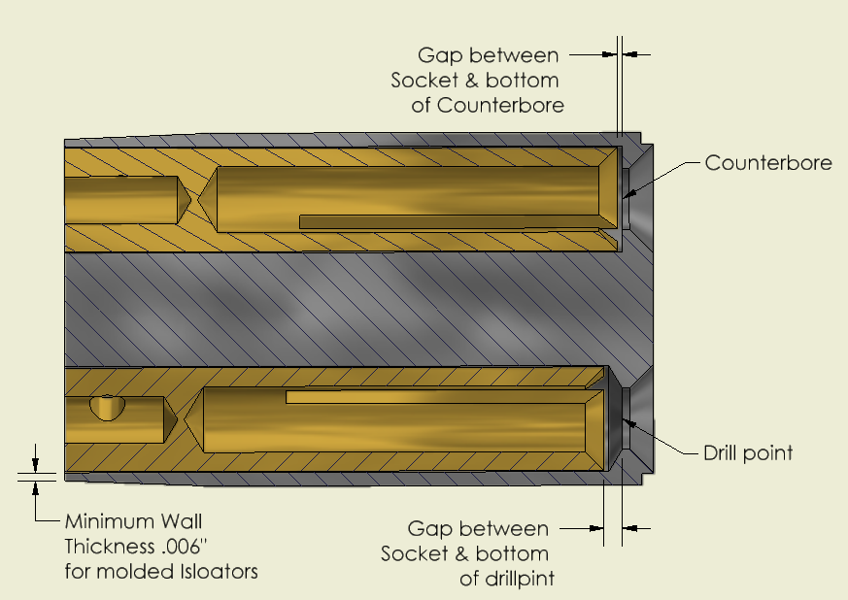

Figure 9: 36504 Front Isolator, 39908 Sockets

ReferenceFigure 10:

1. A keyway on the OD of the isolator is one method used to maintain radial alignment with the connector shell, isolator, and the mating connector. A slip fit (.000 to .001” gap) is recommended for this purpose.
2. The key radius should be designed to bottom out with the key way pocket in the backshell so the isolator and backshell are properly aligned. A larger radius is desired on the key to assure there is no radial interference, causing the isolator not to seat properly.

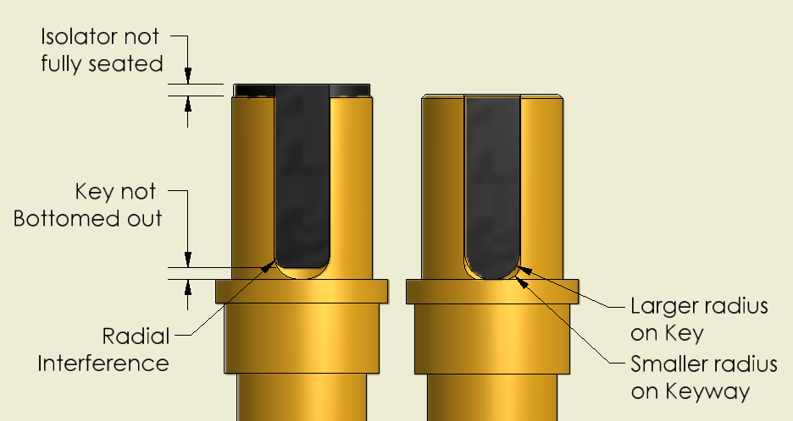

Figure 10: 36504 Front Isolator & 23914 Backshell

ReferenceFigure 11:

1. Rear Isolator is used to isolate the socket from backshell, and hold the socket in place during mating pin insertion.
2. A counterbore on back of the connector shell is one method used as a positive stop for the internal connector components. A counterbore on the front of the connector shell is one method to secure the connector components in place.

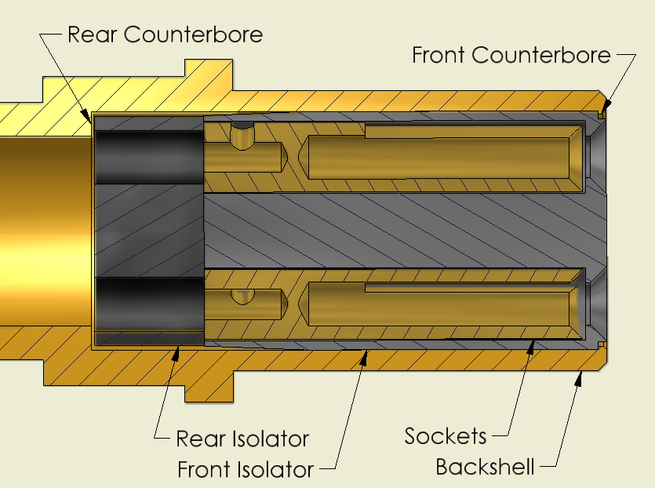

Figure 11: 36504 Front Isolator, 37980 Rear Isolator, 23914 Backshell, & 39908 Sockets

### Coupling Nut Design

Reference Figure 12

1. Couterbore Coupling nut design is assemblied onto back shell from cable side.
2. Design coupling nut with sufficient clearance to the back shell to prevent binding after crimping of back shell.

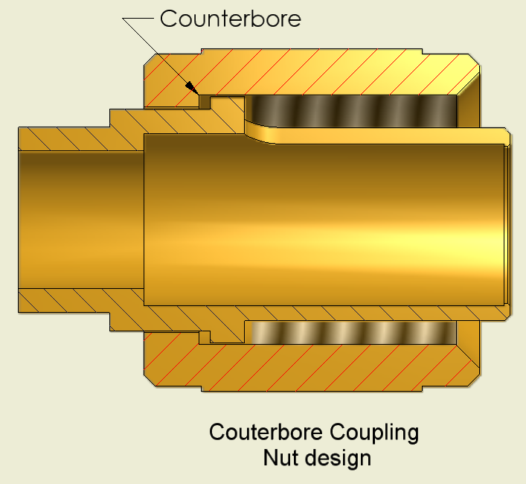

Figure 12: 23911 Coupling nut & 23914 Backshell

ReferenceFigure 13:

1. Crimped, “Swedged” Coupling Nut Design is assembled onto back shell from front side and crimped (swedged) into a groove on backshell using a fixture.
2. A Fixture must be designed to Crimp “swedge” the nut onto the backshell. Fixtures should not allow over crimping, which will cause the coupling nut to bind on the backshell.
3. To control the swedging location and avoid distortion of the coupling nut, which can cause binding, the wall thickness of the swedged area must be thinner than the length of the swedged area.

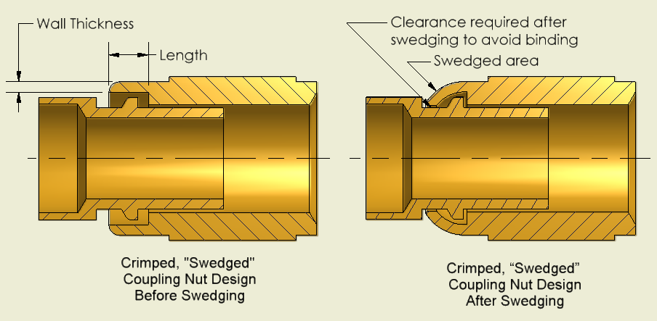

Figure 13: 11655 Backshell & 11656 coupling nut

## Finish Specifications:

### Plating Dimensions:

1. All plating dimensions must specify “Total plating thickness XXXX”-XXXX”

### Anodizing per Mil-A-8625, Type II, Class2 (then list color IE Black)

1. Class 1 indicates clear
2. Class 2 indicates to be colored, and must specify a color.
3. Hardcoating or Hard Anodize. Hardcoating per: Mil-A-8625, Type III, Class X .0010-.0015 Thick.
4. Class 1 indicates clear
5. Class 2 indicates to be colored, and must specify a color.
6. Use gold plating only if required by the customer or program. Gold Plating per: MIL-G-45204, TYPE II, GRADE C, CLASS 1 (.00005 MIN), OVER NICKEL PLATE PER SAE AMS-QQ-N-290, Class 2, Grade G (.0002 Min). Total plating thickness .0003-.0005”.
7. Note: The conclusions from a 2014 6-Sigma project R:\Six Sigma\Six Sigma Projects\2014 - Gold Plating Connector Pins indicate that, after extensive salt fog tests, gold plating of pins as defined in 1.2.2.D above provides no significant benefit to performance and when graded for visual defects the gold plated samples consistently scored worse than those with nickel plating only.
8. Sulfamate Nickel plating (melting point ~1455°C) per SAE AMS-QQ-N-290 CLASS 2, GRADE G (.0002 Min). Total plating thickness .0003-.0005”. This is the plating that is typically applied to hermetic connector pins prior to the glass sealing process.
9. Electroless Nickel plating (melting point ~890°C): NICKEL PLATE PER MIL-C-2607 (.0002 Min),   
   CLASS 1. Total plating thickness .0003-.0005”.

## Finishing (Anodizing, Hardcoating, Plating) on threaded parts.

(ReferenceFigure 14)

### Thread Dimensions

1. Threads on finished parts must include a preplate dimension and a post plate dimension, labeled with:

“*thread specification* } AFTER PLATING”

“P.D. Ø*.xxxx* - Ø*.xxxx* } BEFORE PLATING”

1. The suggested P.D. (prior to plating) can be determined with the equation below. Reference the pitch diameter calculator (EN046) located in TCS.

**Minimum P.D. Maximum P.D.**

Internal threads: **ØSPECIAL(Min)=ØSTD(Min)+2*(ΔMax/SIN(α/2)) ØSPECIAL(Max)=ØSTD(Max)+2*(ΔMin/SIN(α/2))**

External threads: **ØSPECIAL(Min)=ØSTD(Min)-2*(ΔMin /SIN(α/2)) ØSPECIAL(Max)=ØSTD(Max)-2*(ΔMax/SIN(α/2))**

Where: ØSPECIAL(Min/Max) is the suggested Max/Min (preplate) pitch diameter;

Ø2Min/Max is the desired Max/Min (post plate) pitch diameter;

Δ Min/Max is the Max/Min *anodizing/hardcoating/plating* buildup;

α is the angle of the thread (60°) (Note: SIN(α/2)=0.5 when α=60°).

Note: Buildup of hardcoating thickness must be divided by two, as hardcoat is 50% imbedded into the material.

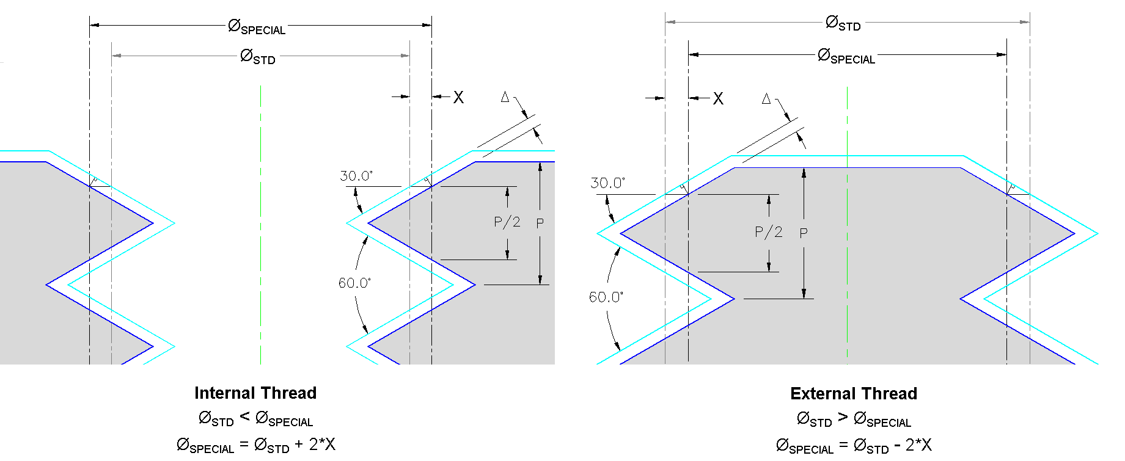

Figure 14: Reference for Thread Dimensions

## Hermetic connector

### Shell / Pin Material Selection

1. Shell, pin, and glass material must be selected based on the Coefficient of Thermal Expansion (CTE) of the material.
2. Compression Seals (desired): CTE of Shell > CTE of Glass ≥ CTE of Pin
3. Matched Seals: CTE of Shell = CTE of Pin = CTE of Glass (or very close)
4. Mismatched Seals (won’t work): CTE of Shell > CTE of Pin > CTE of Glass
5. Typical PCB hermetic seal material combinations (and CTE) are:

Table 1: Hermetic Seal Material Combinations

|  |  |  |  |  |  |
| --- | --- | --- | --- | --- | --- |
| **Shell** | | **Glass (or equiv.)** | | **Pin** | |
| **Material** | **(TCE /°C) x10-6** | **Material (or equiv.)** | **(TCE /°C) x10-6** | **Material** | **(TCE /°C) x10-6** |
| Titanium [Ti6Al4V] | 10.5 | 7056/S-8250 | 5.4 | Kovar | 5 |
| Titanium [Ti6Al4V] | 10.5 | S-8072 (CaBAl12) | 6.2 | Kovar | 5 |
| 304LSS | 17.3 | 9013/S-8061 | 8.9 | 52 Alloy | 9.5 |
| 304L SS | 17.3 | 9013/S-8061 | 8.9 | 430 SS | 11.2 |
| 316L SS | 16.2 | 9013/S-8061 | 8.9 | 52 Alloy | 9.5 |

1. Note: Elan 88 and MRG54 are vendor designations for equivalents to Corning 7056 and Schott 8250. Elan 13 and AB89 are vendor designations of equavalents to Corning 9013 and Schott 8061. The Dash number associated with Elan glass numbers, such as 13-603 indicate glass color.
2. Note: 430 SS retains more spring than 52 Alloy, and is a better choice for sockets. 430SS is difficult to solder to, 430 F can’t be substituted for 430SS because of increased solderability issues.
3. Note: New connectors should be tested within the range which they are intended to be used. Usable temperature range for connectors can be limited by type of CTE of components, glass properties, and IR requirments.

Reference Figure 15A and Figure 15B

### Glass wetting / Glass meniscus

1. Wetting refers to how a liquid is deposited on a solid substrate. A concave meniscus is desired to maximize glass seals area. The best method to obtain proper wetting is by using manufacturing practices & techniques such as the thermal sealing profile, oven dew point, oven gasses, part preparation, etc.
2. Historically, PCB has had more difficulty obtaining proper glass wetting on Titanium than other materials. For this reason, Zero clearance top caps (see top cap design) or glass stops (see shell design) have been used on Titanium connectors to force wetting. These designs are not ideal, but have been used in the past.

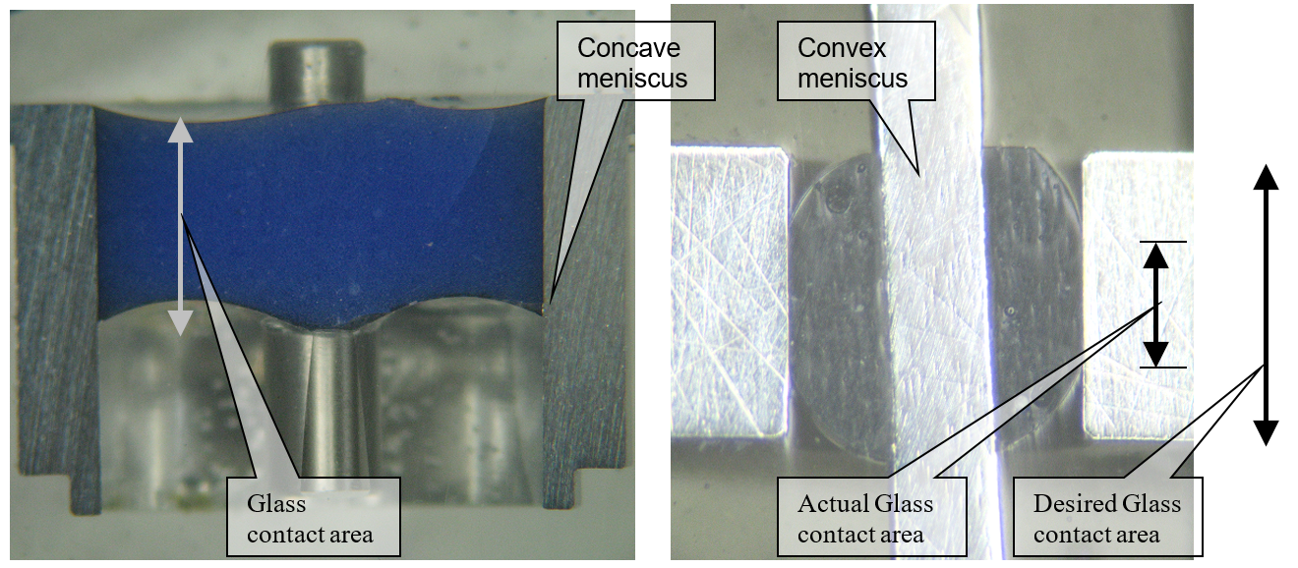

Figure 15A:Proper wetting (SS Shell) Figure 15B: Poor wetting (Ti shell)

### Shell design

1. The surface finish of glass sealing areas should be a 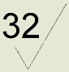or better. The area must be free from burrs, chips, and foreign debris. Uneven surfaces will cause stress risers and/or bubbles to form in the sealing area, which can cause leaks and/or cracking.
2. Titanium
3. Welded areas of titanium connectors may be machined to virgin material after sealing to remove scale. The shell must have .003” (minimum) of extra material in areas that will be machined off later in the process for welding. Advancements in the titanium glass sealing have reduced or eliminated the need to machine titanium after firing in most cases where the weld area has not been in direct contact with carbon fixturing. Most titanium connectors that are now designed with S-8072 (CaBAl 12) glass preforms require no machining after firing and are designed with final metal dimensions.
   * Extra material when required should be kept to a minimum, as excess machining can crack the glass seal and cause seal failure.
   * The finished assembly drawing of parts that get machined after firing must call out the finished dimensions of the connector. Each rework dimension must have a machine surface symbol, 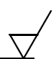
4. Threaded areas of titanium connector shells fired at tempertures over 1000oC must specify a presealing pitch diameter “P.D. Ø .xxxx - .xxxx” to account for .000 to .0012 of oxidation growth. These values can be calculated using the formulas for “suggested P.D. (prior to plating)” in the “Finishing on Threaded Parts” section (above) or by using the formulas below:

Min Special P.D. Max Special P.D.

Internal Threads:=Min Std P.D.+.0006” =Max Std P.D.

External Threads:=Min Std P.D. =Max St P.D.-.0006”

1. Glass stops
   * Historically, glass stops have been used on some titanuim connectors to force proper wetting. During sealing, the molten glass is forced against the glass stops from the weight of the top plate. As discussed in glass wetting section, this method is not ideal. Titanium connectors with S-8072 (CaBAl 12) glass require no top caps. No need for forced wetting.
2. SS 304L
3. For items chemically cleaned and brightened: Threaded areas of Stainless Steel connectors must specify a presealing pitch diameter “P.D. Ø .xxxx - .xxxx” to account for .0000 to .0012 of material removal during descale & chemical brightening. These values can be calculated using the formulas for “suggested P.D. (prior to plating)” in the “Finishing on Threaded Parts” section (above) or by using the formulas below:

Min Special P.D. Max Special P.D.

Internal Threads: =Min Std P.D. =Max Std P.D. -.0006”

External Threads: =Min Std P.D.+.0006 =Max St P.D.

1. For items not chemically cleaned or brightened: The oxidation growth on SS 304L threads is < P.D.Ø 0.0005” and does not need to be accounted for when calculating the presealing pitch diameter.
2. Inconel and Haynes 242
3. When designing the presealing pitch diameter, “P.D. Ø .xxxx - .xxxx”, of threaded areas on Inconel and Haynes 242 connectors, reference Table 2 and account for oxidation growth.

Table 2: Pitch Diameter and Functional Size Oxide Buidup on Threads

|  |  |  |  |  |
| --- | --- | --- | --- | --- |
| **Material:** | Inconel 600 | 304L SS | Haynes 242 | Inconel 718 |
| **P.D. Avg. Growth after Preoxidation (in.)** | 0.00016 | 0.00000 | 0.00011 | 0.00025 |
| **P.D. Functional Size Avg. Growth after Preox (in.)** | 0.00034 | 0.00006 | 0.00034 | 0.00055 |
| **P.D. Avg. Growth after Final Fire (in.)** | 0.00017 | 0.00002 | 0.00019 | 0.00026 |
| **P.D. Functional Size Avg. Growth after Final Fire (in.)** | 0.00038 | 0.00035 | 0.00072 | 0.00054 |

### Hermetic pin design

Refer to “Connector Pin Design” (above).

1. Pins used in connectors may be Nickel sulfamate plated per QQ-N-290 (.0002-.0004) before sealing to promote solderability.

Reference Figure 16

1. To avoid glass cracks, pins with center holes (for soldering, or a mating connector) must be solid in the glass sealing area.

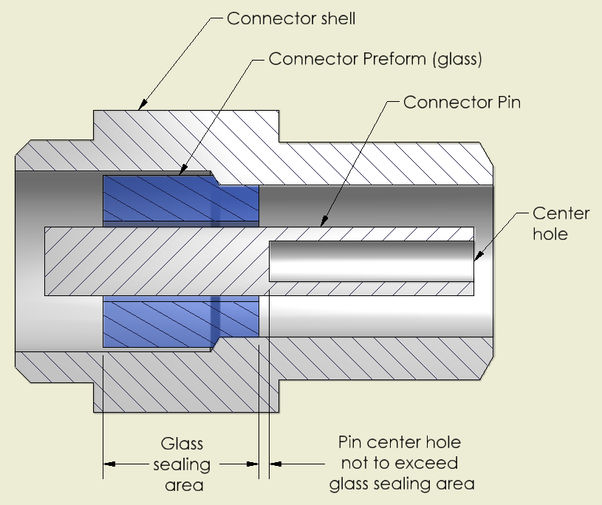

Figure 16: 250-3734-01 Shell, 7824 Preform, & 250-3194-01 Pin

### Glass Preform design.

Reference Figure 17

1. Multi-seal connectors (one preform per pin) have stronger mechanical strength, but require a larger connector shell to meet the design requirements (shell OD should be approx 15 times the pin OD).
2. The preform OD (ØD) should be 2.5 times larger than the pin OD (Ød).
3. The distance between adjacent pins or the shell (A) should be greater than or equal to the preform OD (ØD).
4. The preform thickness (T) should be approximately equal to the preform OD (ØD).

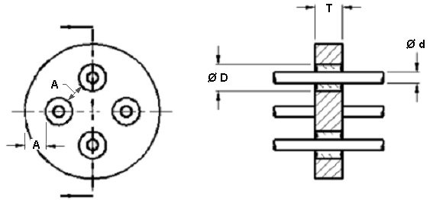

Figure 17: Multi-seal connectors

Reference Figure 18

1. Multi-pin connector (one perform per multiple pins) have better electrical resistance between pins, and can use a smaller connector shell to meet the design requirement (shell OD should be approx 12 times the pin OD).
2. The distance between adjacent pins or the shell (A) should be greater than or equal to the preform OD (ØD).
3. The preform thickness (T) should be greater than 1/3 of the preform OD (ØD).

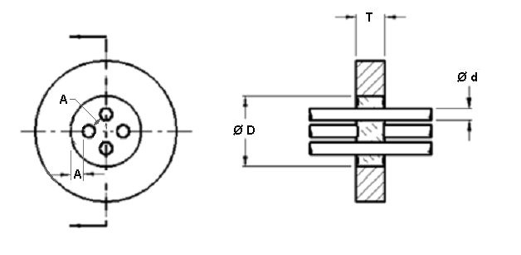

Figure 18: Multi-pin connector

1. The preform should be sized such that there is a .001” gap between the maximum preform OD and the Minimum Shell ID, and a .001” gap between the minimum perform ID and the maximum pin OD.
2. The preform weight should be determined based on 95±2% of the desired volume. Drawing notes may read as follows:

WEIGHT: GLASS TO FILL Ø *shell ID* X *preform height (ref)* LONG LESS *number of pins* PINS Ø *pin OD.*

FORMULA: WEIGHT (95% FILL): 95% X CAVITY VOLUME (cc) X DENSITY OF GLASS (mgs/cc) = WEIGHT (mgs±2%); WHERE CAVITY VOLUME IS *cavity volume* (CC).

GLASS DENSITY MUST BE SUPPLIED WITH EACH SHIPMENT.

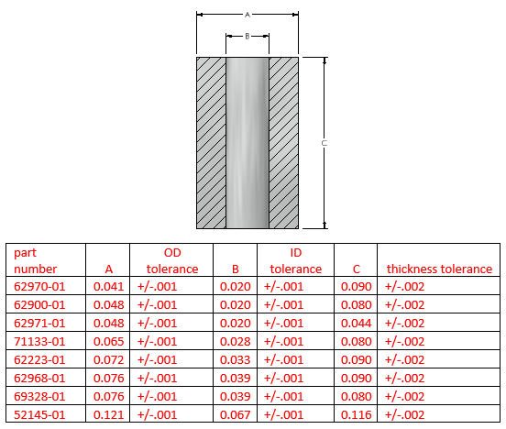

Figure 19: Standard CaBAl Preform Sizes

### Fixture design

1. A burning fixture is used to hold the assembly in place and set pin height during sealing (required for all assemblies).

Reference Figure 20

1. Fixtures that accept pins should be sized with a clearance between the pin OD and fixture ID, as specified below.

Pins Nominal clearance Minimum clearance

1-2 .0010 .0005

3-6 .0015 .0010

7-9 .0020 .0015

1. Fixtures must be made from L56 carbon or equivalent (or a material that will not react with the glass or metal) so that the glass does not stick to the fixture. The fixtures must be fired prior to use, using the same thermal profile that will be used while sealing the glass to burn off any forign debris.
2. Post type fixtures have a post or pedestal which holds the glass into place during firing. These fixtures have a .003” nominal clearance (.001” minimum clearance) between the OD and the shell ID.

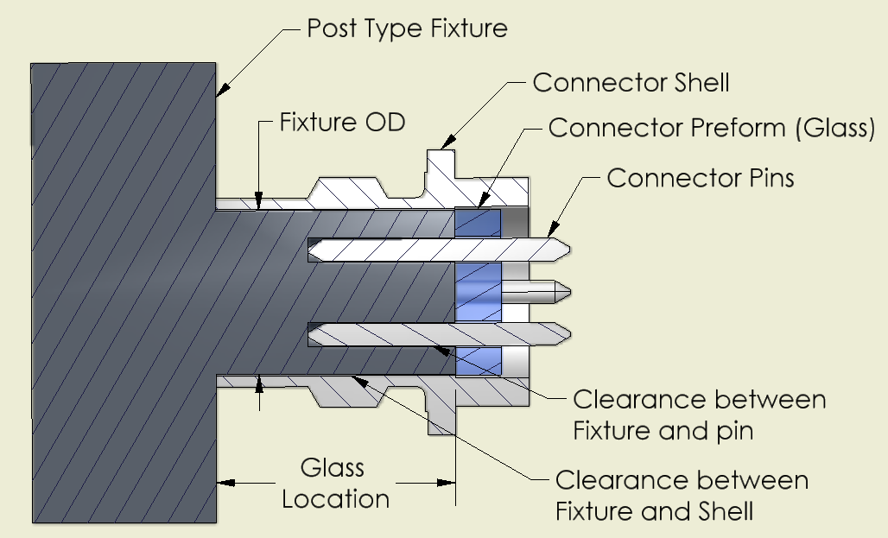

Figure 20: Post type Fixture 7885 for 22300 Connector.

Reference Figure 21

1. Recessed fixtures where the connector sits in a pocket should have a clearance based on coefficient of thermal expansion (CTE) of connector material at peak furnace temperature.

TEpart = (ΔT x CTE x Part OD)

Example of 304L connector:

ΔT = 1850-75 = 1775 °F, CTE 304L = 9.6 x 10-6 in/in/°F,

Part OD = .338

TEpart = .0057”

Hole diameter = .338 +.0057 = .3437

1. If carbon adheres to connector, an undercut can be added to eliminate carbon diffusion into connector which causes poor welds.

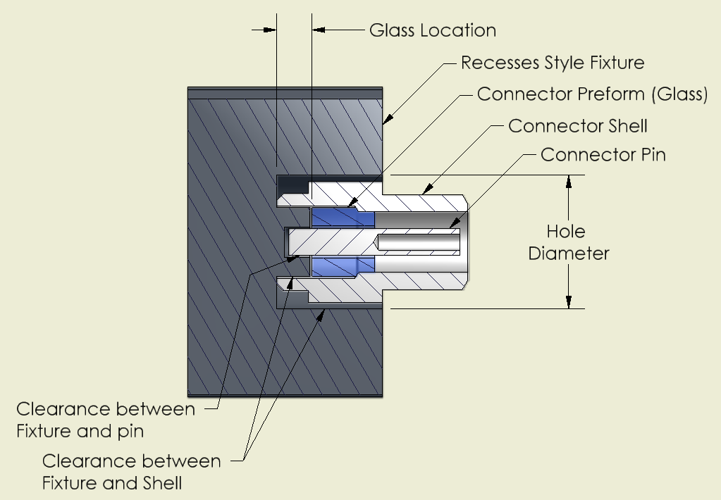

Figure 21: Recessed type Fixture 42790 for PSHS18 Connector.

### Top cap design

1. A top cap is used to hold the pin in the proper position during firing.
2. Top caps must be made from L56 carbon or equivalent (or a material that will not react with the glass or metal). 17-4 Stainless steel, or other materials with low coeffeiceint of thermal expansion are also acceptable. The Top cap must be heat treated prior to use, using the same thermal profile that will be used while sealing the glass to burn off any forign debris.

ReferencesFigure 21and Figure 22

1. Top caps should have a .005” nominal clearance (.003” minimum clearance) between the maximum top cap OD and the shell ID.
2. Top caps should be designed with a flange that is larger than the shell OD, so that the shell supports the weight of the top cap & plate rather than the glass. The flange also aides top cap removal after firing and its diameter should be 150% the connector’s rim, and it’s thickness should be 75% the diameter of the connector rim.

1. Top cap with clearance:
2. It is desired for top caps to have a .020 to .030 clearnace from the glass. If 17-4 Stainless steel (or another material that will react to the glass) is used, a top cap with clearance must be used.

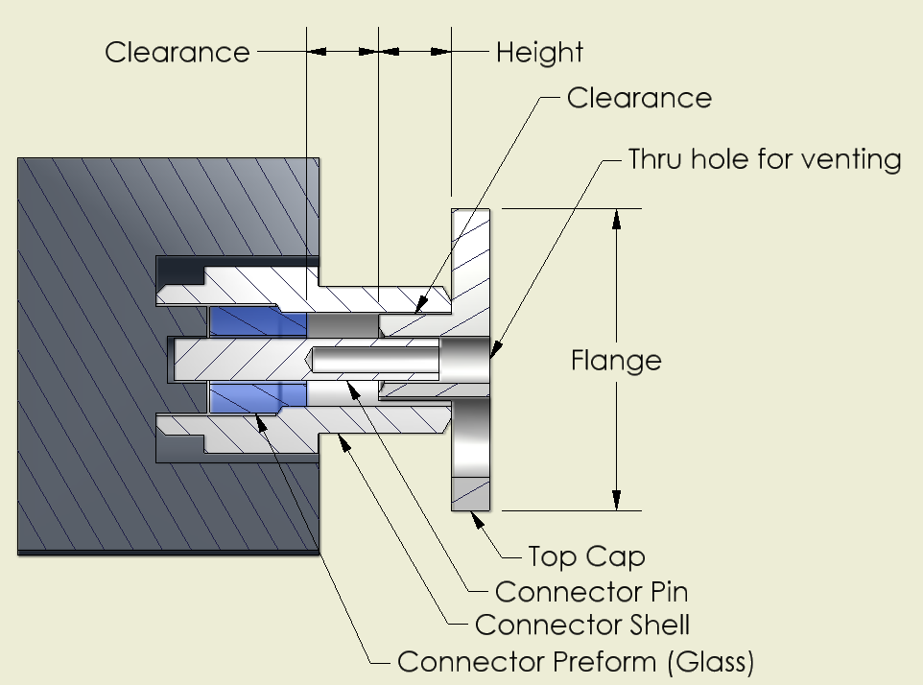

Figure 22: PSHS18 connector & 27171 Top Cap

Reference Figure 23

1. Zero clearance Top cap:
2. Historically, zero clearance top caps have been used on some Titanium connectors to force wetting, (conceptually the same as glass stop design discussed above). As discussed in section 1.4.2, Glass wetting / Glass meniscus, this method is not ideal.
3. Zero clearance top caps must be made from L56 Carbon (or equivalent) so that the glass does not stick to the fixture.
4. Top caps that accept pins should be sized with a clearance between the pin OD and top cap ID, as specified below. Top Cap pin holes should be **blind holes** to reduce furnace atmosphere exposure and Nickel plating oxidation on the pins, enhancing solderability. An index thru hole should be made to identify pin array orientation on multi-pin connectors during connector/fixture assembly. It is best for this index hole to be the same size as the pin holes (for ease of machining), and be outside of the connector rim.

Pins Nominal clearance Minimum clearance

1-2 .0010 .0005

3-6 .0015 .0010

7-9 .0020 .0015

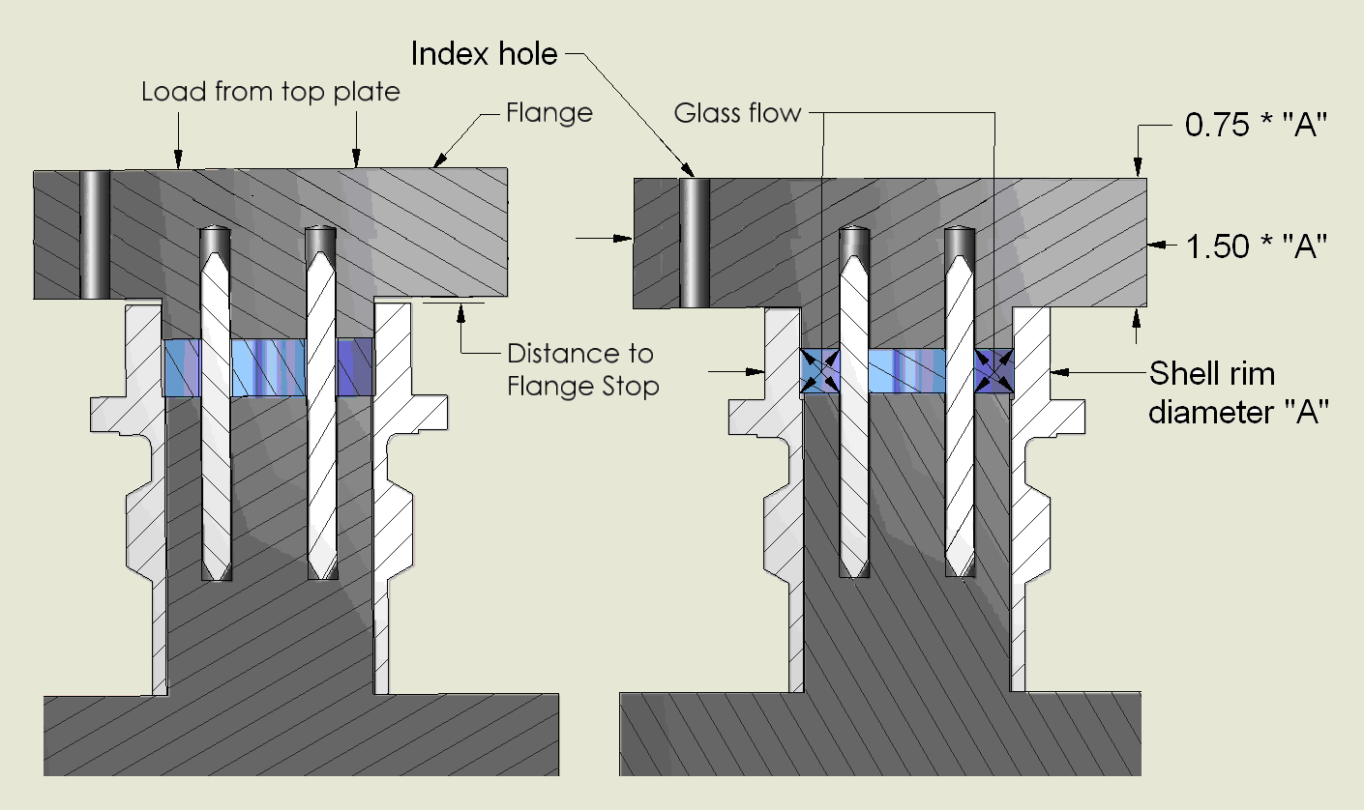

Figure 23: Zero clearance top cap 22303 for 22300 Connector.

### Finishing

1. Finished assemblies with a stainless steel shell must be descaled to remove oxide from the firing process. Assembly drawings must specify; “FINISHED ASSEMBLY TO BE DESCALED AND CHEMICALLY BRIGHTENED”.
2. If gold plating is required (all DC connectors), it must be applied after sealing. Gold plating should be per MIL-G-45204, Type II, Grade C, Class 1 (.00005 min).
3. Insulation Resistance
4. Insulation resistance between the pin and the shell is usually tested, and will be the default if not specified on the drawing. Pin to pin IR testing, and it’s ratings, should be called out on the drawing. Test voltages should only be 50, 100, 250 and 500 volts DC. RMS IR testing cannot be performed and should not be called out on the drawing. Typically IR rating is 5.0 Gohm tested at 500 VDC. Connectors used in charge sensors or any high temp application should have 1 Teraohm IR tested at 50 VDC. Mini 2 and higher pin connectors should be tested at 100 volts DC.
5. Note: To improve IR, a silicone protectant is applied to the glass. on the outside of the connector to make the glass hydrophobic (water resistant), and keep moisture off of the glass.
6. Table 3 shows experimental data from an insulation resistance test performed on connectors at varying temperatures. The connectors were tested in a CWF 1300 Carbolite Oven using a megohmeter with a test voltage of 500VDC. The connector IR was immeasurably high up until 200oF (400oF for Ceraflux). The IR data is plotted in Figure 24 and Figure 25.

Table 3: Connector IR Profiling Data

|  |  |  |  |  |  |  |  |  |  |  |  |  |  |
| --- | --- | --- | --- | --- | --- | --- | --- | --- | --- | --- | --- | --- | --- |
|  |  |  | 21oC (70oF) | | | 66oC (150oF) | | 121oC (250oF) | | 204oC (400oF) | | 260oC (500oF) | |
| Part # | Shell Material & Glass | # Pins | Avg. Pin to Shell IR (GΩ) | Avg. Pin to Pin IR (GΩ) | Avg. Pin to Shell IR (GΩ) | | Avg. Pin to Pin IR (GΩ) | Avg. Pin to Shell IR (GΩ) | Avg. Pin to Pin IR (GΩ) | Avg. Pin to Shell IR (GΩ) | Avg. Pin to Pin IR (GΩ) | Avg. Pin to Shell IR (GΩ) | Avg. Pin to Pin IR (GΩ) |
| 64007-01 | Ti Cabal | 1 | 3377.5 | N/A | 3751 | | N/A | 990.8 | N/A | 85.3 | N/A | 11.8 | N/A |
| 67603-01 | SS Cabal | 1 | 5333.3 | N/A | 12000 | | N/A | 2533.3 | N/A | 260 | N/A | 95 | N/A |
| 1516-01 | SS 9013 | 1 | 18333 | N/A | 833.6 | | N/A | 560 | N/A | 2.4 | N/A | 0.15 | N/A |
| 54147-01 | Ceraflux | 1 | 2533.3 | N/A | 4000 | | N/A | 4066.7 | N/A | 1450 | N/A | 64.7 | N/A |
| 1397-01 | Ti Borosilicate | 1 | 10000 | N/A | 4333 | | N/A | 86.1 | N/A | 0.66 | N/A | 0.06 | N/A |
| 63372-01 | Ti Borosilicate | 4 | 6433.3 | 4400 | 9167 | | 8000 | 555 | 933.3 | 3.2 | 5.4 | 0.27 | 0.44 |
| 9557-01 | SS 9013 | 2 | 20000 | N/A | 20000 | | N/A | 1053.3 | N/A | 3.96 | N/A | 0.21 | N/A |
| 5775-01 | SS 9013 | 4 | 16667 | 16000 | 20000 | | 16667 | 1650 | 1700 | 7.55 | 11.2 | 0.55 | 0.67 |
| 7764-01 | SS 9013 | 3 | 795 | N/A | 11233 | | N/A | 408.3 | N/A | 1.52 | N/A | 0.11 | N/A |
| 12786-01 | SS 9013 | 3 | 456.5 | N/A | 3390 | | N/A | 457.5 | N/A | 1.98 | N/A | 0.13 | N/A |
| 22220-01 | SS 9013 | 5 | 266.7 | 277.5 | 5578 | | 1550 | 581.7 | 542.5 | 3.5 | 6 | 0.2 | 0.36 |
| 8895-01 | Ti 7056 | 4 | 591.7 | 430 | 2533 | | 1510 | 130 | 202.5 | 0.85 | 1.43 | 0.08 | 0.13 |
| 13185-01 | SS 9013 | 2 | 5243.3 | N/A | 16000 | | N/A | 986.7 | N/A | 2.22 | N/A | 1.13 | N/A |
| 24777-01 | Ti S8016 | 2 | 203.3 | N/A | 3400 | | N/A | 333.3 | N/A | 3.98 | N/A | 0.45 | N/A |
| PSHS18 | Ti Borosilicate | 1 | 206.7 | N/A | 3067 | | N/A | 196.7 | N/A | 1.16 | N/A | 0.11 | N/A |
| 37890-01 | SS 9013 | 1 | 97.3 | N/A | 950 | | N/A | 380 | N/A | 5.8 | N/A | 0.35 | N/A |
| 37404-01 | Ti Borosilicate | 9 | 14.1 | 22.2 | 281.7 | | 206 | 161.7 | 188 | 1.61 | 1.9 | 0.13 | 0.18 |
| 49885-01 | SS 13-603 | 2 | 94 | 127.8 | 4283 | | 3333 | 1200 | 2200 | 4.75 | 6.07 | 0.26 | 0.35 |
|  |  |  |  |  |  | |  |  |  |  |  |  |  |

|  |  |  |  |  |  |  |  |  |  |  |  |  |  |  |  |
| --- | --- | --- | --- | --- | --- | --- | --- | --- | --- | --- | --- | --- | --- | --- | --- |
|  | |  | 316oC (600oF) | | 371oC (700oF) | | 427oC (800oF) | | | 482oC (900oF) | | | 510oC (950oF) | | |
| Part # | Shell Material & Glass | # Pins | Avg. Pin to Shell IR (GΩ) | Avg. Pin to Pin IR (GΩ) | Avg. Pin to Shell IR (GΩ) | Avg. Pin to Pin IR (GΩ) | Avg. Pin to Shell IR (GΩ) | Avg. Pin to Pin IR (GΩ) | Avg. Pin to Shell IR (GΩ) | | Avg. Pin to Pin IR (GΩ) | Avg. Pin to Shell IR (GΩ) | | Avg. Pin to Pin IR (GΩ) |
| 67603-01 | SS Cabal | 1 | 7.23 | N/A | 1.72 | N/A | 0.71 | N/A | 0.35 | | N/A | 0.38 | | N/A |
| 54147-01 | Ceraflux | 1 | 4.5 | N/A | 0.8 | N/A | 0.16 | N/A | 0.06 | | N/A | 0.03 | | N/A |

Figure 24: IR v. Temperature

Figure 25: IR v. Temperature for 10-32 Connectors

# High temperature connectors.

**High temperature connectors are for use from -65 to 500F in the stainless steel designs and to 900°F in the inconel designs. These connectors will be more expensive than the low temperature connectors so this should be considered when incorporating them in a design. (The following general guidelines apply to most headers and connectors designed for use at high temperature). The attached link can be used to filter the current models.** [**HTC Connectors for EN1058.xlsx**](HTC%20Connectors%20for%20EN1058.xlsx)

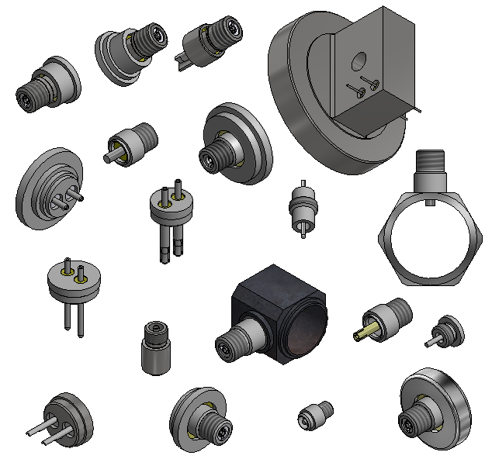

## High temperature glasses

We currently use two high temperature glasses to make compression seals. Electrical properties are critical in high temperature connector designs and are listed below for the various glasses.

Table 4: high temp glass characteristics

|  |  |  |  |  |  |
| --- | --- | --- | --- | --- | --- |
| **High temp glasses** | compositions | Firing temperature | Insulation resistance at room temp  In 10-32 configuration | Insulation resistance at 900F  In 10-32 configuration | Insulation resistance at 950F[1]  In 10-32 configuration |
| **Viox** | Barium aluminosilicate glass  TCE 8.4+/-1.2 x10-6/°C | ~1200°C in air | >1T ohm | 10gigohms | 5 gigohms |
| **Ceraflux** | Lead bisilicate glass  TCE 7.1 x10-6/°C | ~835°C in air | >1T ohm | 50 to 75 megohms  [2] | 30 megohms |

[1] can be used at 950°F but resistance is lower as noted

[2] Insulation resistance for the Ceraflux glass in the thinner walled 40832-01 and the 42237-01 size is >20megohms at 900°F.

[www.viox.com](http://www.viox.com) V16709

[www.hammondlead.com](http://www.hammondlead.com) Ceraflux

## High temperature connector design guidelines

### Glass Design

1. If possible, to reduce cost and lead time, design the connector/header around standard glass preform sizes listed in Figure 26 and Figure 27.

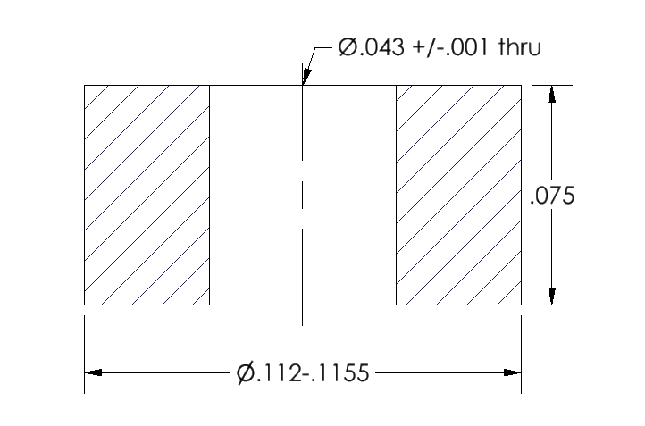

Figure 26: standard 29810-03 Viox preform size

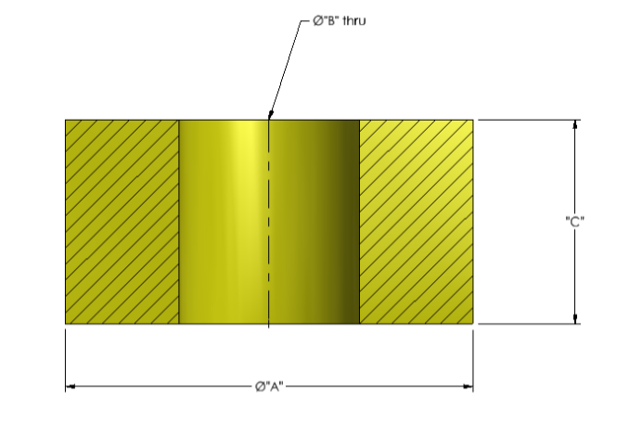

|  |  |  |  |  |  |  |
| --- | --- | --- | --- | --- | --- | --- |
| part number | A | OD tolerance | B | ID tolerance | C | thickness tolerance |
| 60590-01 | 0.090 | +/-.002 | 0.023 | +/-.002 | 0.075 | +/-.005 |
| 52989-01 | 0.0905 | +/-.001 | 0.038 | +/-.002 | 0.075 | +/-.005 |
| 56932-01 | 0.091 | +/-.002 | 0.044 | +/-.002 | 0.097 | +/-.003 |
| 50829-01 | 0.093 | +/-.0015 | 0.034 | +/-.001 | 0.080 | +/-.005 |
| 62255-01 | 0.122 | +/-.002 | 0.066 | +/-.002 | 0.075 | +/-.005 |
| 48393-01 | 0.1485 | +/-.002 | 0.066 | +/-.002 | 0.08 | +/-.01 |
| 62256-01 | 0.211 | +/-.002 | 0.165 | +/-.001 | 0.075 | +/-.005 |
| 62487-01 | 0.227 | +/-.001 | 0.165 | +/-.001 | 0.075 | +/-.005 |
| 40832-01 | 0.300 | +/-.0025 | 0.223 | +/-.0025 | 0.075 | +/-.002 |

Figure 27:standard Ceraflux preform sizes

1. Low temperature glass performs described in section 1.4.1 and 1.4.5, are purchased to size. Ceraflux and Viox used in all of the high temperature glass to metal seals, are purchased as glass frits. Organic binder is added and they are pressed into final shape with a punch and die set. Some with very thin walls are pressed into blanks and machined to size by Ceramics. A minimum wall thickness of .020” is desired for machinability.
2. The current standard preforms are designed around a .020”, .030”, .040” or .060” pin or socket. See section 2.2.3 and Figure 31 andFigure 32***.***
3. If designing a double isolated connector it is best to align the level of the outer glass with the inner glass as closely as the design allows as shown inFigure 28.

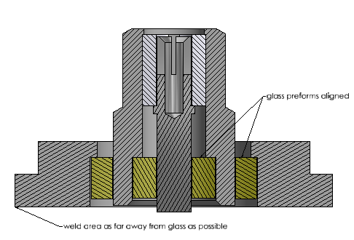

Figure 28: Example of preform alignment and weld area location.

### Metal Design

1. Always allow a minimum of .001” oxide growth on all metal surfaces when designing metal tolerances around standard glass performs. SeeFigure 29for an example of this.

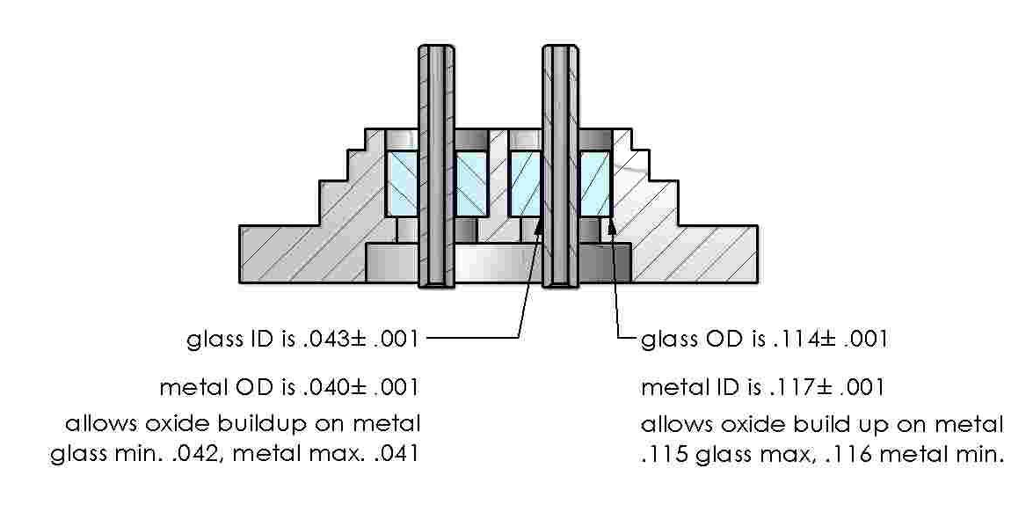

Figure 29: metal tolerancing to allow for oxide build up

1. While it is ideal for the outer most metal to have the largest thermal expansion coefficient decreasing to the center pin, other considerations may overrule this, such as weldability.
2. In a double isolated connector it is critical that the outer piece of metal has excellent welding characteristics. 304L is the preferred material for connectors used in the 500°F range. INCONEL alloy 718[1] is preferred for 900°F for its “outstanding weldability including resistance to post weld cracking”.[2]
3. INCONEL alloy X750 is the preferred high temperature material for high temperature sockets. “Its excellent relaxation resistance is useful for high-temperature springs and bolts.” [3]
4. Haynes 242 is the preferred metal for the inner housing on double isolated connectors. It’s lower thermal expansion characteristics make it ideal to created a compression seal.

### Socket and pin design

1. INCONEL alloy X750 is the preferred material for high temperature sockets.
2. The design guidelines noted in section 1.1.1 are an excellent reference.
3. It is important to keep the socket slots and ID well away from the glass seal area to eliminate that as a stress point, to reduce glass cracking. The pin or socket design in the glass seal area shall be solid material or tubing. The wall thickness should be constant. No external or internal features should be located in the glass seal area to reduce uneven stress. *See*Figure 30***.***

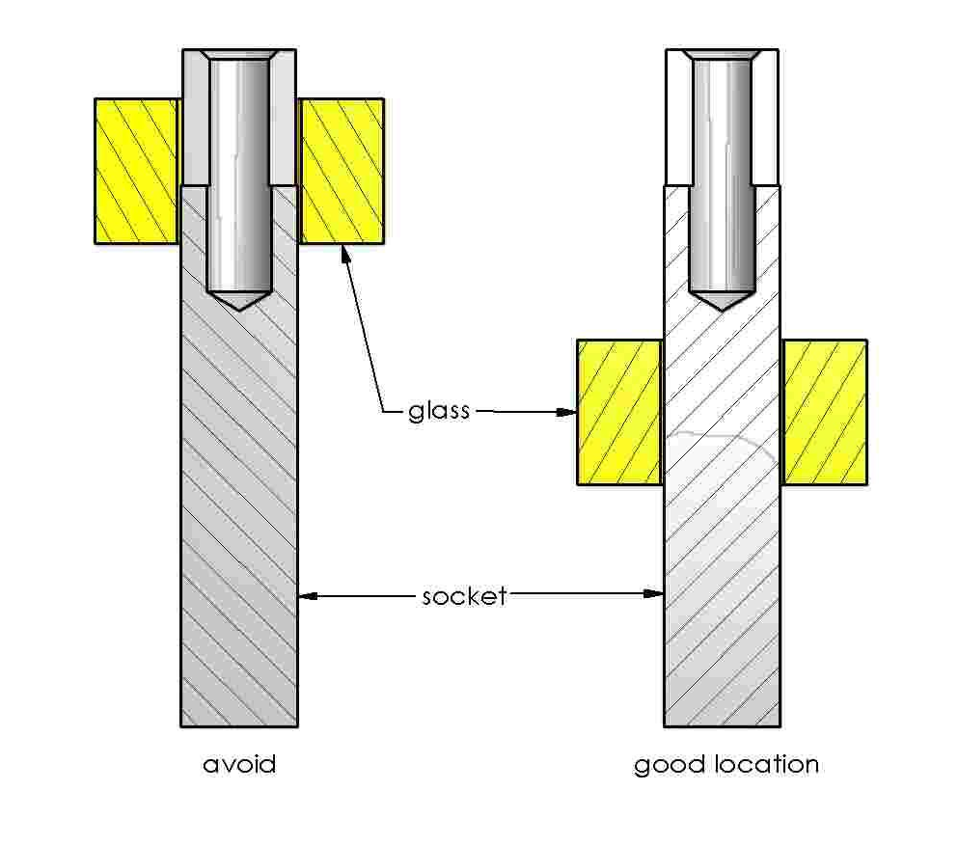

Figure 30: glass preform location

1. Current standard pin and socket OD’s are ~.010, .030”, .040” and .060”. See Figure 31and Figure 32for examples.

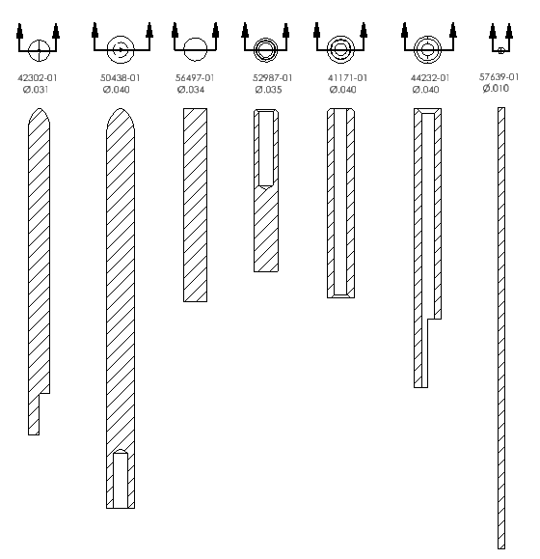

Figure 31: Example of current standard pins

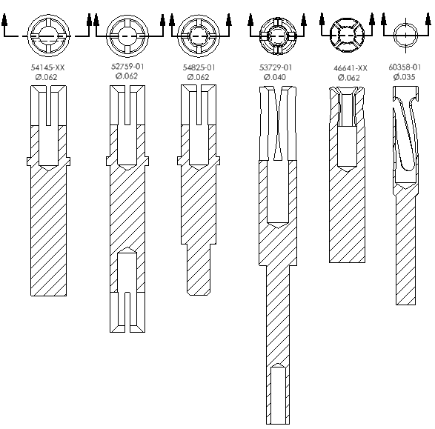

Figure 32: Examples of current standard pins and sockets

1. Early designs had the alumina retaining ring in contact with the glass preform. In firing, the glass melts onto the alumina to keep it in place. When the connector is taken to high temperatures in welding and in use, the difference in expansion between the alumina and glass can cause the connector to leak. To eliminate this, the socket can be designed with a ledge that holds the retaining ring in position but separates it from the glass during and after sealing. Sapphire is the preferred material for retaining rings as it is stronger, cheaper and has higher IR before and after processing. SeeFigure 33.

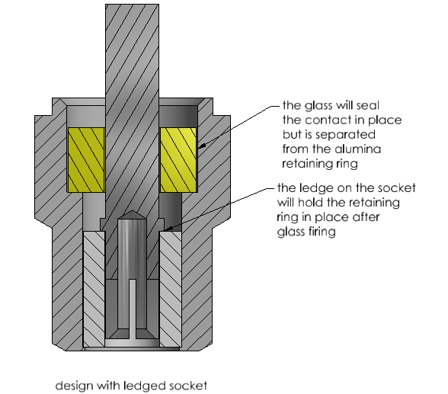

Figure 33: ledged socket separating glass and retaining ring

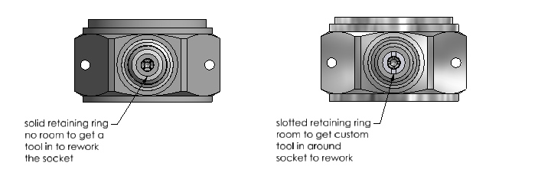

Figure 34: slotted retaining ring allowing field reworkable socket

### Housing, cover, header design

1. For a single isolated design for use at 900°F, INCONEL alloy 718 or INCONEL alloy 600 are used with an INCONEL alloy X750 socket or pin.
2. For a double isolated design, the outer cover will be INCONEL alloy 718 if used at 900°F.
3. INCONEL alloys can also be used at 500°F but it is also possible to use stainless steel.
4. Again the cover materials are chosen for their welding characteristics rather than fitting into the thermal coefficient of expansion (TCE) model for compression seals. Haynes 242 is now the preferred metal for the inner housings in double isolated connectors. It has a lower thermal expansion coefficient than the outer INCONEL 718 or 316L stainless steel, which helps create the desired compression seal. Inconel 600 was previously used but can cause circumferential cracks that may cause problems in later processes, welding, assembling and high temperature soaks. As noted in the Welding section Inconel 600 changes metal grain size in firing and can cause problems in welding.

|  |
| --- |
|  |
| Table 5: metal combinations for high temp glass to metal seals   |  |  |  |  |  | | --- | --- | --- | --- | --- | | Cover (TCE/°C) | Glass (TCE/°C) | Housing (TCE/°C) | Glass (TCE/°C) | Pin/socket  (TCE/°C) | | INCONEL 718 (12.96 x 10-6) | Ceraflux  (7.1 x 10-6) | INCONEL 600  (13.32 x 10-6 ) | Ceraflux  (7.1 x 10-6) | INCONEL X750  (12.6 x 10-6) | | 304L stainless steel  (17.28 x 10-6) | Ceraflux  (7.1 x 10-6) | 316 stainless steel  (16.02 x 10-6) | Ceraflux  (7.1 x 10-6) | INCONEL X750  (12.6 x 10-6) | |  |  | INCONEL 600  (13.32 x 10-6 ) | Ceraflux  (7.1 x 10-6) | INCONEL X750  (12.6 x 10-6) | |  |  | INCONEL 718  (12.96 x 10-6) | Ceraflux  (7.1 x 10-6) | INCONEL X750  (12.6 x 10-6) | | INCONEL 718 (12.96 x 10-6) | Ceraflux  (7.1 x 10-6) | HAYNES 242  (10.8 x 10-6) | Ceraflux  (7.1 x 10-6) | INCONEL X750  (12.6 x 10-6) | | 316L stainless steel  (15.9 x 10-6) | Ceraflux  (7.1 x 10-6) | HAYNES 242  (10.8 x 10-6) | Ceraflux  (7.1 x 10-6) | INCONEL X750  (12.6 x 10-6) | |  |  | INCONEL 718  (12.96 x 10-6) | Viox  (8.4 x 10-6) | INCONEL X750  (12.6 x 10-6) | |  |  | INCONEL 600  (13.32 x 10-6 ) | Viox  (8.4 x 10-6) | INCONEL X750  (12.6 x 10-6) | |  |  | 304L stainless steel  (17.28 x 10-6) | Ceraflux  (7.1 x 10-6) | INCONEL X750  (12.6 x 10-6) | |

1. Following similar guidelines to the socket design it is best to have the wall thickness of both the housing and cover as consistent as possible in the glass seal area to reduce stress. This will not always be possible but should be held to the minimum required for the product design.
2. Figure 35is an example of a design that was improved by changing the bolt circle from .125 to .140. You can see that the original design had a very narrow (.008”) metal wall between the two preforms. The OD could not be changed but by increasing the bolt circle to .140 an even metal wall thickness was achieved which reduced the uneven stresses. Very small hairline cracks in the glass along the .008” center were eliminated by adjusting this design.

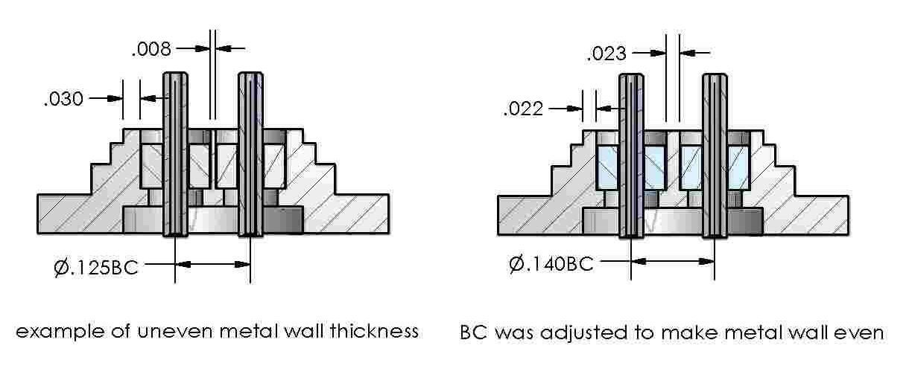

Figure 35: metal design adjustment to reduce uneven stresses

1. A ledge to hold the glass preforms will be designed into the housing and/or cover. This is required as unlike the connectors described in section 1.4, the tooling does not hold the glass in place during firing. The ledge should be 0.030”. Why this is preferred is shown inFigure 37. Examples of ledges can be seen in Figure 33, Figure 35, Figure 36, Figure 37 and Figure 38.
2. In double isolated connector designs, design the metal to have both glass preforms aligned, (seeFigure 36) and incorporate both the ledged socket separating the glass and retaining ring. This is optimum to reduce the stress both in the fired connector and through the later welding processes. The slotted retaining ring allows for the socket to be recrimped if needed.

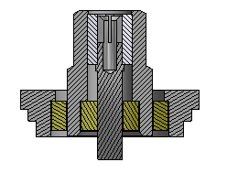

Figure 36

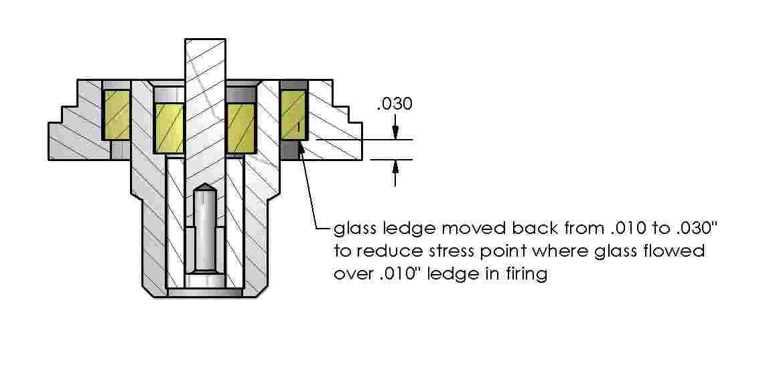

Figure 37: example of increased glass ledge to reduce stress point

1. Figure 37shows an earlier design change where the glass ledge was increased. In firing, the glass flows and in this particular design, circumferential cracking occurred where the glass flowed over the 0.010” ledge. While circumferential cracking in itself is not a cause for rejection, it can be a source for additional cracking in later operations such as machining and welding. Moving the ledge back, reduced the stress in this area and the benefits at that time offset the negative of having one perform slightly higher than the other, and has since been corrected to have the glass lined up as shown inFigure 36.

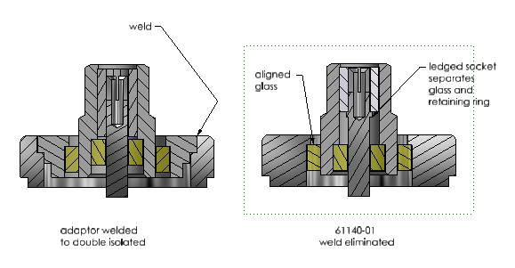

Figure 38

1. Another improvement was to combine what was originally two pieces of metal to one, eliminating a weld that creates additional thermal and mechanical stress. The 47061-01 was originally welded to the 47060-01 adaptor before being welded into the transducer. The outer metal was redesigned to be one piece to eliminate one of the welds. SeeFigure 38.

### Fixturing

1. Materials
2. Ceraflux glass
   * Tooling for Ceraflux glass designs should be made from INCONEL alloy 600, but 310 or 316 stainless steel can also be used. It is important to specifically not use graphite with this glass. The reaction between the glass and graphite causes a discolored, contaminated, cold seal. See Figure 39for a tooling design example.

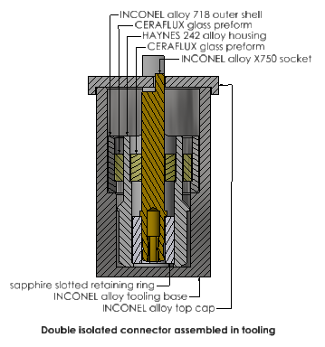

Figure 39: Tooling for Ceraflux double isolated connector fired at 835oC in air

1. Viox glass
   * Tooling for Viox glass designs should be made from graphite (carbon grade L56 or equivalent).
   * In addition an outer base and cover made from INCONEL alloy 600 are required for the Viox designs. The INCONEL alloy cover and base will reduce the graphite loss in firing and should be designed to completely cover the graphite. See Figure 40for a tooling design example.

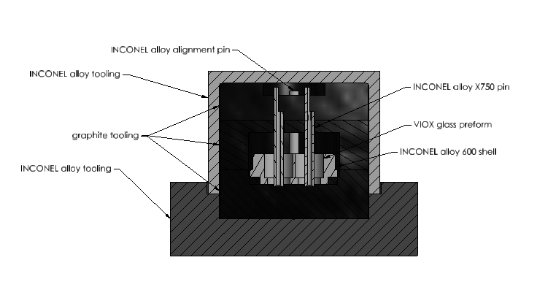

Figure 40: example of Viox glass, graphite tooling and INCONEL alloy cover

* + INCONEL alloy 600 can be used in place of the graphite in locations that have to retain very tight tolerances while holding very little of the pin depth but there must be some graphite tooling in the fixture design to create the atmosphere needed for Viox firing. See Figure 41***.*** See the notes below in the Welding section but if possible keep the graphite tooling away from weld areas on the connector. It has been proven to cause problems in welding, even after machining.

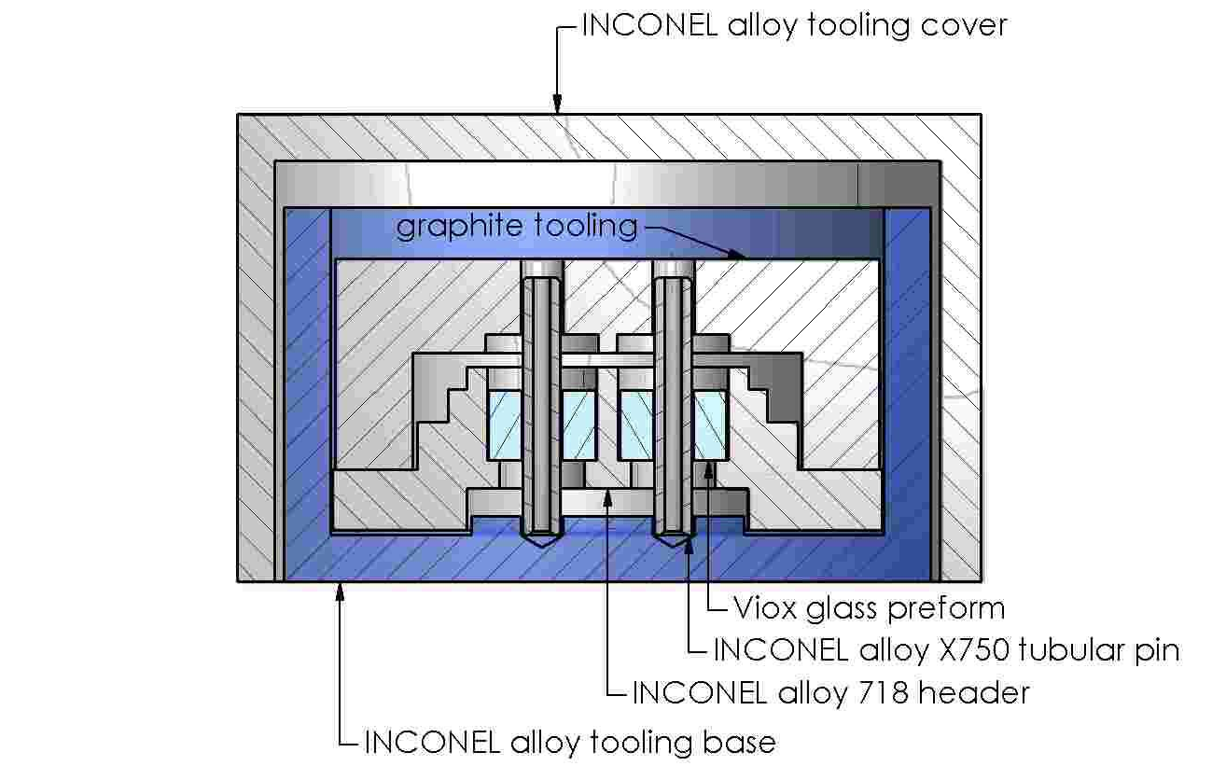

Figure 41: Tooling for Viox glass header fired at 1200-1250o in air

1. Tooling design
2. Determine the most critical dimension defining the relationship between the metal parts.
3. If it is important to hold this dimension to a tight tolerance, to control this most effectively, design the connector to be fired with that dimension in the down position as seen in Figure 39, Figure 40 and Figure 41.
4. To minimize tolerance buildup, let your tooling control the metal relationship by dimensioning it like Figure 42*.* This design will avoid tolerance buildup from the multiple metal parts tolerances as well as the tooling tolerances and it is possible to hold the pin height theoretically to +/- .002”.

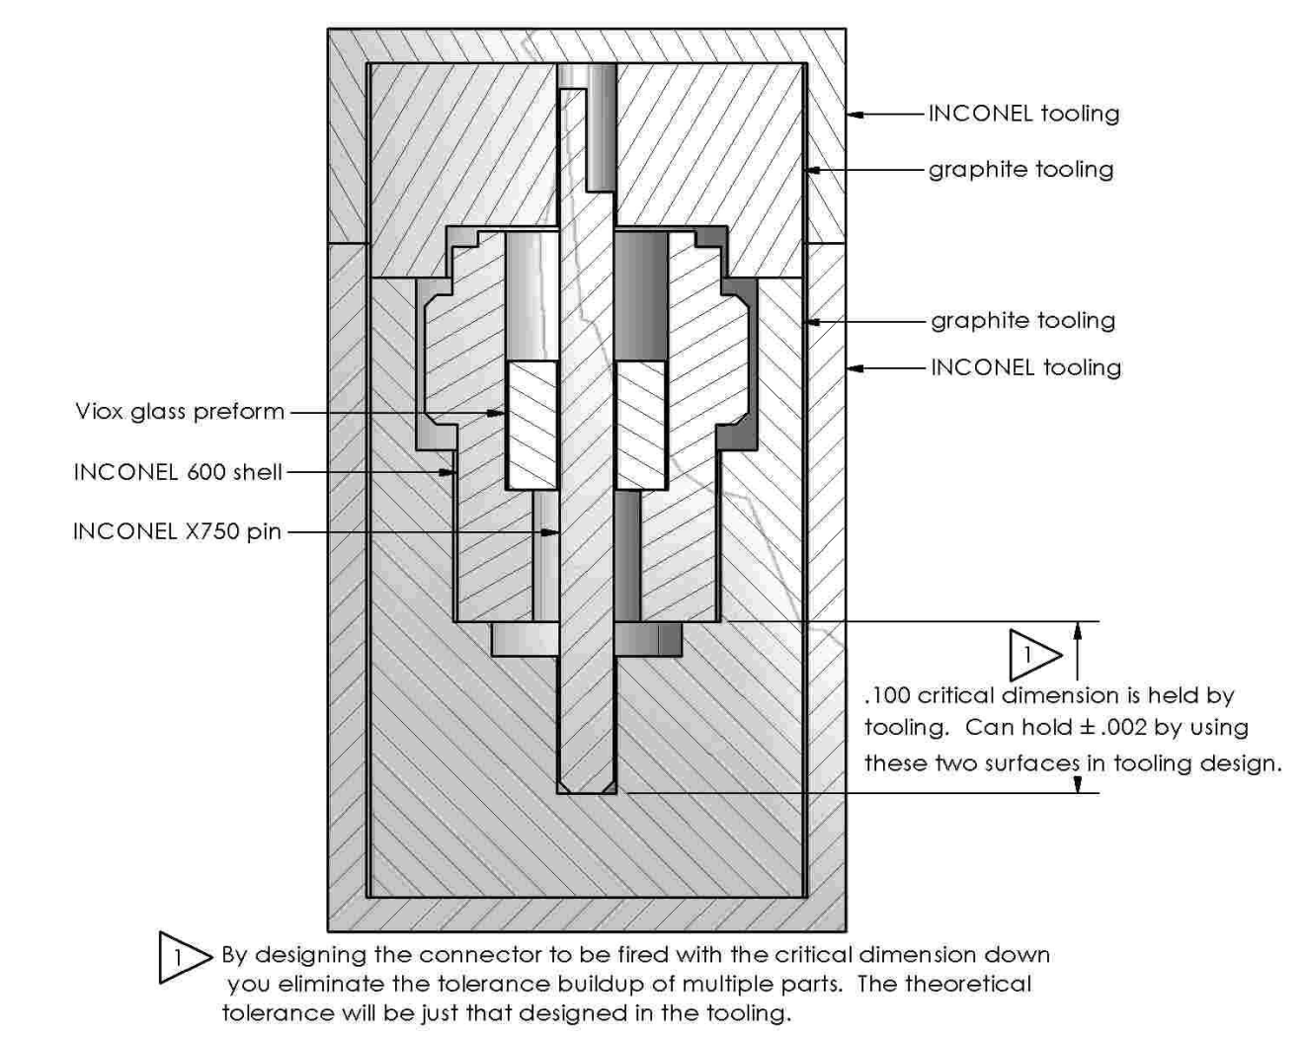

Figure 42: tooling and glass position designed for tight tolerance

1. Figure 43shows what can happen to create a tolerance buildup of +/-.017” and should only be used when this is acceptable to the process.

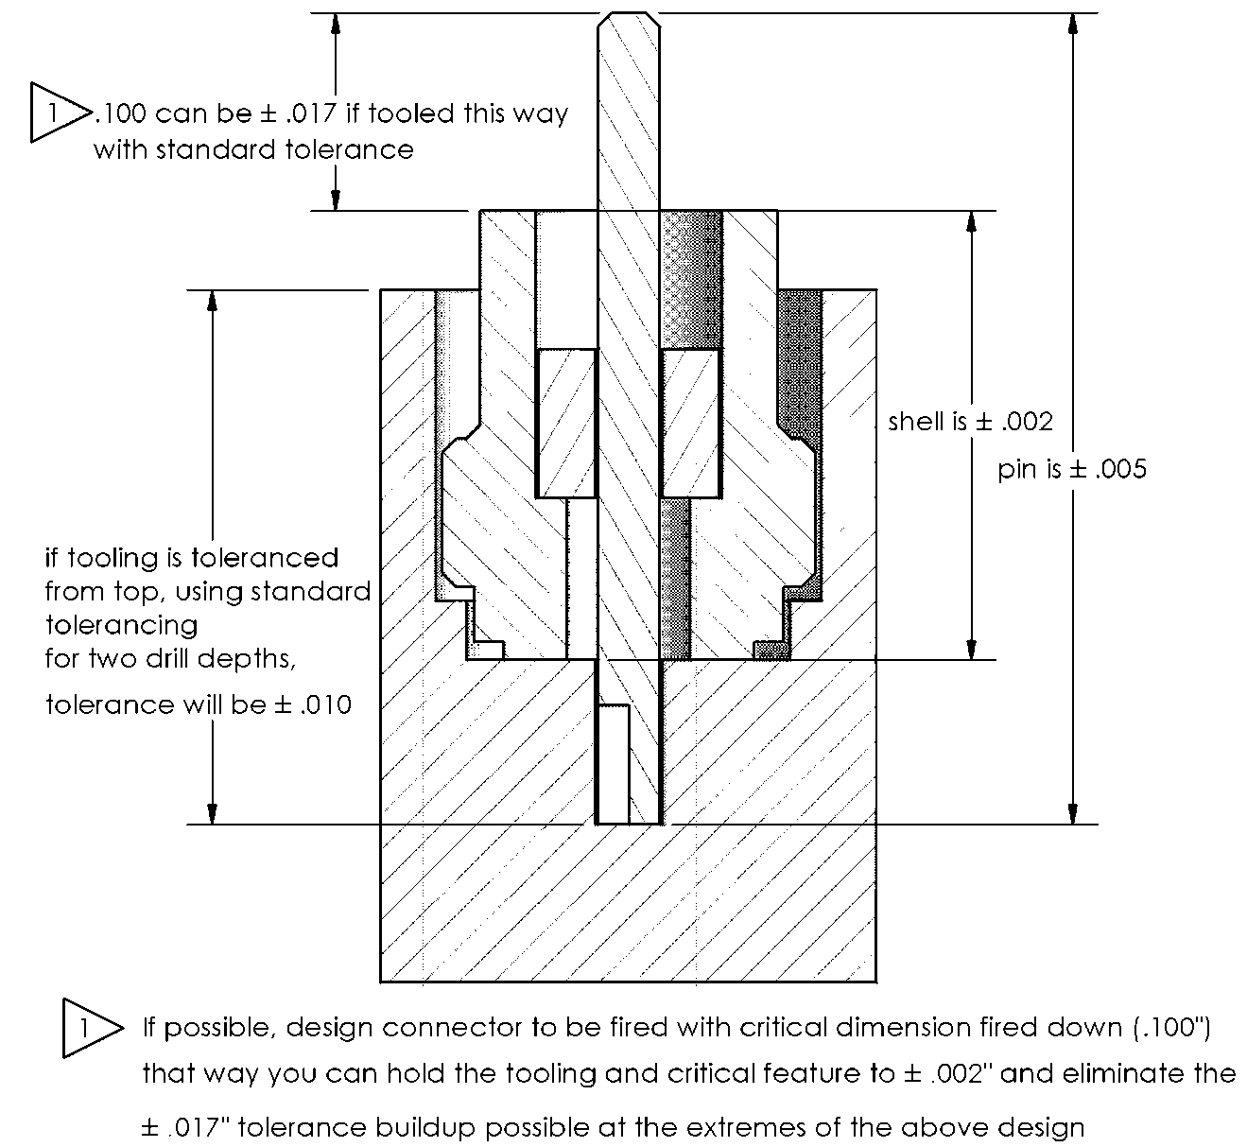

Figure 43: Tooling design to avoid if tight tolerances are required.

1. In your ID tolerance design, always assume a minimum of 0.001” oxide buildup on all metal surfaces, both the tooling and connector metal, from preoxidation. In your OD tolerance design, reference Table 6 for average preoxidation growth of various materials. If the connector material is not listed in the table, assume a minimum of 0.001” oxide buildup. See Figure 44for an example of tolerancing for this clearance.

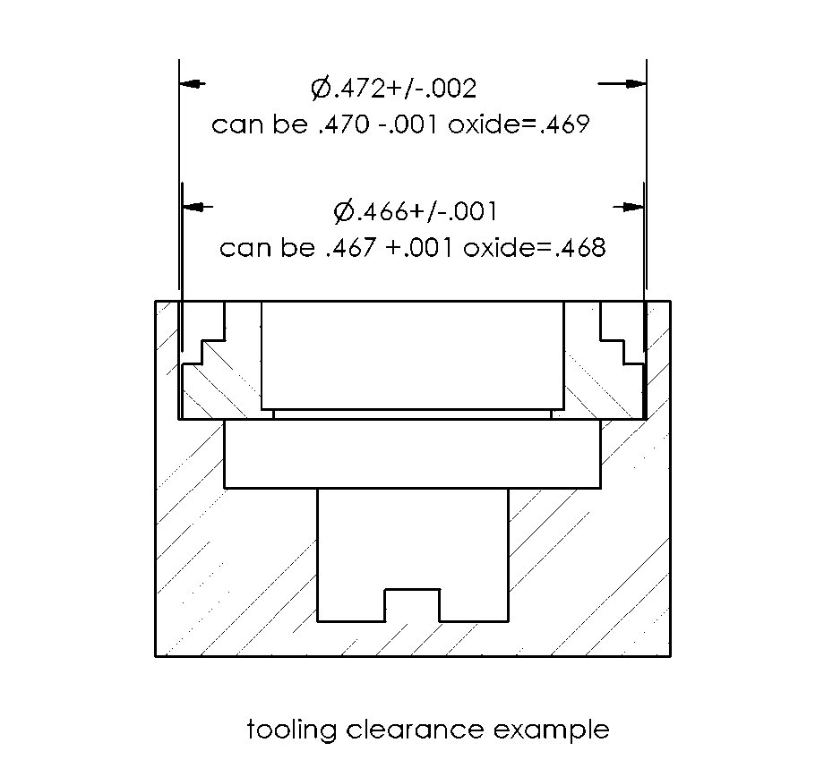

Figure 44: metal, tooling clearance for oxide growth

Table 6: High Temp Oxide Buildup on OD

|  |  |  |  |  |  |
| --- | --- | --- | --- | --- | --- |
| **Material:** | Inconel 600 | 304L SS | Haynes 242 | Inconel 718 | Inconel X750 |
| **OD Avg. Growth after Preoxidation (in.)** | 0.00006 | 0.00002 | 0.00008 | 0.00033 | 0.00017 |
| **OD Avg. Growth after Final Fire (in.)** | 0.00019 | 0.00016 | 0.00021 | 0.00035 | 0.00019 |

1. Design a recessed area below the glass seal areas. The glass flows in firing and this will avoid the glass sealing to the tooling. See Figure 39, Figure 40 and Figure 41***.***
2. When designing the top cap, tool to the pin OD and if not possible to use the connector metal ID or OD, tool to the ID or OD of the fixture base. SeeFigure 39for an example of this.
3. In general use a .020” wall minimum for both graphite and INCONEL alloys. The INCONEL alloy tooling will retain heat after firing so use the minimum amount of metal in the tooling design to facilitate the quickest, yet most even cooling.

## Processing

### Cleaning and surface preparation

1. Both the Ceraflux and Viox create a chemical bond with the metal oxide surfaces they are in contact with in firing. Cleaning and surface preparation are important steps in achieving a hermetic seal.
2. Sandblasting
3. Sandblasting roughens up the metal surface and creates more surface area for the glass to bond to. The glass to metal seal surfaces are sandblasted on the double isolated Ceraflux connectors to improve adhesion and glass seal strength.
4. Although this would help adhesion on the Viox designs also, we have seen bubbles created at the glass metal interface during firing which may contribute to lower hermeticity. Sandblasting is not recommended at this time for the Viox glass to metal seals.
5. Cleaning
6. It is very important to have a consistent oxide on the glass sealing surfaces. To achieve this, the metal parts must be clean before they are preoxidized in the furnace. This applies to both both Ceraflux and Viox designs.
7. Degreasing removes machining oils and can be performed in a vapor degreaser, or ultrasonic cleaner (current chemical used is Lenium).
8. A soap bath removes dirt and salts (from human hands among other sources) and this is performed either with Miraclean in the machine shop or Microclean in an ultrasonic cleaner.
9. A thorough rinsing in Deionized water is required after soap.
10. An additional passivation step with a nitric acid bath can be done which will remove any free iron on the surface from metal machining steps. The nitric acid passivation also creates a passive surface on the metal.
11. A thorough rinse is required after this passivation step.
12. CR1045 and CR1050 include specifics concerning these cleaning processes.
13. Preoxidation
14. An oxide is grown on the metal surfaces before firing. Individual times and temperatures vary and will be noted on each part’s router. For example, metal for a Ceraflux connector design is preoxidized at 850°C for 3 minutes in air.

### Firing

1. Currently both the Ceraflux and Viox connectors are fired in air in a box furnace.
2. Actual firing times and temperatures will be customized to glass batches and product designs.
3. In general the Ceraflux connectors are fired at 835°C for 8 minutes.
4. The Viox connectors are fired between 1200° and 1250°C for approximately 10-15 minutes.
5. In addition to the times varying with glass batch and design, this may also vary with volume of parts fired at one time.

### Finishing

1. Sandblasting is the preferred oxide removal procedure at this time for areas that are spot welded (tubular pins fired with Viox glass). The oxide created in Ceraflux firing does not create any electrical barriers and can be welded through so sandblasting is not necessary. Viox creates a much thicker oxide so sandblasting is required. For weld areas on Viox glass headers, the current available method to remove the oxides created during firing, is machining. .005”-.006” is the amount of metal recommended to be added to the “before machining” metal design in all welded areas.
2. Machining and welding create both mechanical and thermal stresses on the glass to metal seal connector being processed. If at all possible, keep the areas to be machined and welded to a minimum and as far away from the glass seal area as possible.
3. In some designs the machining step as well as welding step of the process can be performed before glass is fired in place. Figure 45Is an example of this. The 10-32 housing is welded into the hex. The glass is then fired into this subassembly, eliminating multiple stress creation steps.

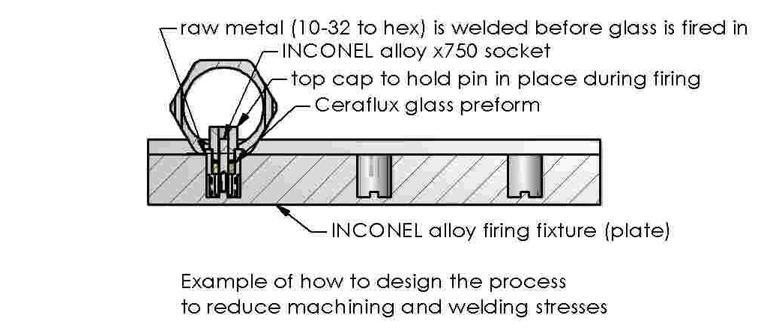

Figure 45: Hex weld firing example

1. After machining, it is critical to clean the surfaces to prevent problems in welding. HCD1001 describes the degreasing procedure performed in the HCD degreaser to accomplish this.
2. Because machining creates stress on the connector, it is recommended that helium leak testing be performed after the machining step. In helium leak testing, fixturing is required to seal the part outside of the largest glass OD. Custom fixturing may need to be designed to accomplish this.
3. Parts that have a vent hole will not require leak testing.
4. To remove the vacuum grease used in leak testing, the parts are degreased per HCD1001 or CR1047.

### Welding

1. As mentioned above, welding creates both mechanical and thermal stresses on connectors. Ideally the weld area will be designed to be as far away from the glass seal area as possible.
2. In addition, copper heat sinks are recommended to be used whenever possible, to draw the heat created from welding away from the glass seal area. The copper heat sink can perform a dual function in holding the part in place for welding and contacting the metal part that will be welded. The heat sink design should eliminate any need for pressure on any metal separated from the welded metal, by glass. SeeFigure 46for an example of this.

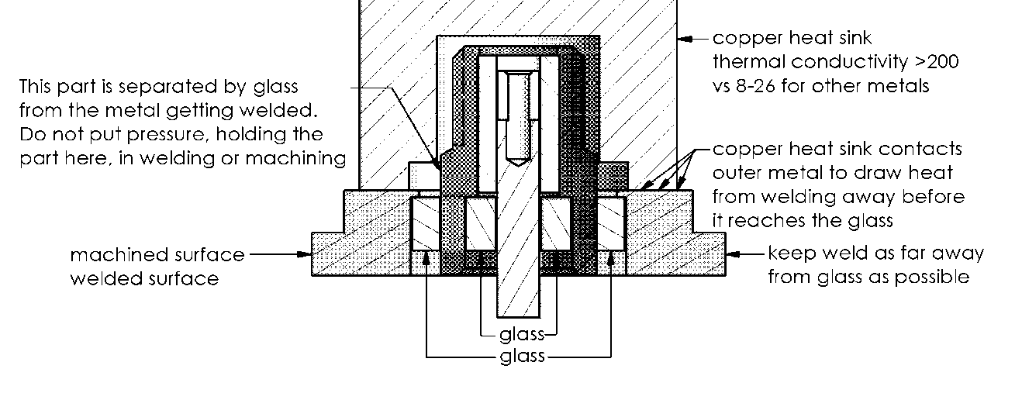

Figure 46: Recommended copper heat sink contact area to be used in welding.

1. If at all possible in the tooling design, keep contact with the graphite tooling away from the weld areas of the part.
2. The metal grain size changes when 600 inconel is fired at high temperatures so if possible avoid using 600 inconel.

1. INCONEL is a trademark of the Special Metals Corporation group of companies.
2. [www.specialmetals.com/products/inconelalloy718.php](http://www.specialmetals.com/products/inconelalloy718.php)
3. [www.specialmetals.com/products/inconelalloyx750.php](http://www.specialmetals.com/products/inconelalloyx750.php)