|  |  |  |  |  |  |
| --- | --- | --- | --- | --- | --- |
| Revision History | | | | | |
| Rev.  Level | Reason for Revision | Date of  Revision | Initiator | Revision  Approval | Revision  Approval |
| NR | New Release | 02-22-13 |  |  | J. Higbee |
| A | Better gain tests / clean-up | 10-15-13 | J. Higbee |  | J. Higbee |
| B | Add 22851-01 | 12-9-13 | J. Higbee |  | J. Higbee |
| C | Add section 4.7 on EEPROM Testing and add 58575-01 | 3-27-14 | J. Higbee |  | J. Higbee |
| D | Add testing specs for 1790-03 | 10-8-14 | H. Krupp |  | J. Higbee |
| E | Added 23910 family | 12-17-18 | J. Higbee |  | J. Higbee |
|  |  |  |  |  |  |

**Table Of Contents**

1 General Information 2

1.1 Types of Assemblies Covered By This Procedure 2

2 General Setup Diagrams 2

2.1 General Setup For ICP® Assemblies 2

2.2 General Setup For 3-Wire Assemblies 3

3 Special Test Fixture Requirements 3

3.1 Control of Insulation and Strays 3

4 Definitions of Test Categories 3

4.1 Temperature Cycling 3

4.2 Bias Testing 4

4.3 Gain Testing 4

4.4 Input Resistance Test 4

4.5 Temperature Testing 4

4.6 Frequency Response 5

4.7 1-Wire EEPROM Memory Test (TEDS) 5

5 Specification Requirements By Item Number: 8

# General Information

## Types of Assemblies Covered By This Procedure

### There are four types of assemblies covered by this document. ICP® Voltage, ICP® Charge, 3-Wire Voltage, and 3-Wire Charge. The table of specification requirements at the end of the document identifies each item’s assembly type with ICP-V, ICP-C, 3wr-V, or 3wr-C. There is also a category of ‘Special’ for some assemblies that are not amplifiers.

### There is a difference in test setup between ICP assemblies and 3-wire assemblies. The differences are noted in the setup diagrams below.

# General Setup Diagrams

## General Setup For ICP® Assemblies

### Each ICP® assembly shall be powered with a compatible ICP® power supply set to 2mA current supply. When connecting an ICP® assembly to the test setup, the ICP® power supply connects to the output lead. The readout equipment also connects to the output lead. See figure #1 below.

ICP® power supply or 2mA constant current

Readout

(Scope, DMM, DAQ input, etc.)

ICP® Type

Assembly

Function

Generator or DAQ output

Output

Coupling

Capacitor

Input

Ground

FIGURE #1 – ICP® Assembly Setup

### Note: Powering ICP® Assemblies with a standard power supply will result in damage to the assembly. The output circuitry will attempt to sink as much current from the supply as possible, and will suffer almost immediate thermal damage. Always use an ICP® supply or a constant current source approved by PCB engineering.

## General Setup For 3-Wire Assemblies

### Each 3-Wire assembly shall be powered with a DC power supply set within 5% of the supply value listed in the specification table at the end of this document. See figure #2 below.

Input

Coupling

Capacitor

Readout

(Scope, DMM, DAQ input, etc.)

3-Wire Type

Assembly

DC power supply

Function

Generator or DAQ output

Ground

Output

Power

FIGURE #2 – 3-Wire Assembly Setup

# Special Test Fixture Requirements

## Control of Insulation and Strays

### Most of the assemblies that PCB uses contain very high impedance inputs that require special consideration when designing test fixtures. The fixture must maintain insulation resistance levels that are at least ten times as large as the input resistor value found in the assembly. Typically, standard FR4 board will not comply, and ceramics or plastics must be used. Also note that any relays or switches will affect this insulation.

### In cases where temperature testing is required, the materials used must maintain the required insulation at the highest temperature used during testing.

### Stray capacitance can lead to large errors in measurements of certain assemblies. Whenever possible, the fixture should add less than two picofarads of stray capacitance.

# Definitions of Test Categories

## Temperature Cycling

### If an assembly requires temperature cycling, this should occur before any testing is performed. The assemblies shall be cycled 10 times from -65°F to +250°F. The dwell times at temperature shall be 5 minutes. The transition between temperature extremes shall happen as quickly as the oven will allow. The goal is to stress the wirebonds and overcoat such that any marginal units fail at first test.

## Bias Testing

### Apply power to the assembly, and allow the output to settle to a stable bias point. When the change in DC voltage over a one second period is less than 1% of the voltage at the beginning of the period, the assembly is considered to be settled. Measure and record this DC voltage and label as "bias". The result must be within the minimum and maximum voltages on the assemblies specification sheet. Perform this test with the input capacitor switched in but no input signal present.

## Gain Testing

### Type ICP-V or 3WR-V Assemblies (See Table in Section 5 for Type)

#### To test AC coupled gain on voltage amplifier assemblies, the system must be profiled with a specified input coupling capacitor. This is because these amplifiers are highly sensitive to input capacitance. Ten pieces of known good assemblies are run on the system, and the gain is averaged to obtain a system average gain. Subsequent tests are referenced to this value.

#### For voltage amplifiers, test the AC gain of the assembly both with and without a coupling capacitor (value specified in Section 5 Table). The result without the coupling capacitor must fall within the specified values. The result with the coupling capacitor must fall within 4% of the system average gain as obtained above. Use a 100Hz sine wave for gain testing unless otherwise noted on the job paperwork. Gain should be tested and recorded to at least three significant digits.

### Type ICP-C or 3WR-C Assemblies (See Table in Section 5 for Type)

#### When testing AC gain on charge amplifiers, the input coupling capacitor is called out in the specification table at the end of this document. The value of the input capacitor must be 1% tolerance or better.

#### Test the AC gain of the assembly with the specified input coupling capacitor. The measured gain must fall within the min and max shown in the table. Use a 100Hz sine wave for gain testing unless otherwise noted on the documentation. Gain should be tested and recorded to at least three significant digits.

## Input Resistance Test

### On all units where the input resistor values are greater than or equal to 6e10 ohms, the Input resistor value must be 100% tested. On assemblies with Input resistor values lower than 6e10, the Input resistor value shall be tested on two random pieces of each lot. This testing may be done on the resistors before use in the circuit if probe equipment is available, otherwise the completed assembly is to be tested. If testing the complete assembly, connect an electrometer between input and ground leads. Use a 1volt test source. The measured values shall be recorded.

## Temperature Testing

### Assemblies listed as voltage amps on the spec sheet may need to have the output DC bias level tested at the maximum operating temperature. Assemblies should be soaked for a minimum of 30 minutes before bias is measured. Measure and record bias at temperature per the requirements in the bias testing section except no input capacitor is required. The input lead on the assembly shall be left floating.

### To account for expected circuit behavior at elevated temperature, the minimum acceptable bias at maximum temperature is 1volt lower than the room temperature specification.

### Assemblies listed as charge amps on the spec sheet may need to have output DC bias level tested at maximum operating temperature if the Input resistor value is above 1e9 ohms. ICP versions must also be tested at both a 2mA current setting and a 8mA current setting while at temperature. Bias must not vary by more than 2% between these current settings. Assemblies should be soaked for a minimum of 40 minutes before bias is measured. Measure and record bias per the requirements in the bias testing section except no input capacitor is required. The input lead on the assembly shall be left floating.

## Frequency Response

### Frequency response shall be tested at the maximum output amplitude of the assembly under test. The low frequency starting point shall be 10Hz, and the reference point shall be 100Hz. Test for either the -5% or -3dB point, or both, depending on the entries in the table at the end of this document. Frequency resposnse is to be tested with the coupling capacitor in place.

## 1-Wire EEPROM Memory Test (TEDS)

### The purpose of this test is to perform a preliminary check on the EEPROM chip to insure that it can perform read and write operations. The EEPROM is used to store TEDS information. TEDS stands for Transducer Electronic Data Sheet, and is a defined format (IEEE-1451.4) for storing sensor calibration data.

### The equipment listed below is used during this test. The cable, software, and the USB adapter will be supplied by PCB. PCB will not supply the computer. It will be necessary to to adapt the cable connector (10-32 coaxial) to the suppliers test jig. Alternatively, the supplier may design a cable with an RJ-11 connector that plugs directly to the 1-wire USB adapter.

#### Computer equipped with TEDS software (PCB #EE224)

#### Test cable (PCB #009M86)

Maxim 1-Wire USB Adapter (Maxim #DS9490R)

### Plug USB adapter into any USB port. Connect test cable or custom cable to USB adapter. Start the program called “1-Wire Memory Chip Test”. Once the UUT is connected, click the ‘Start Test’ button at the bottom of the program window.

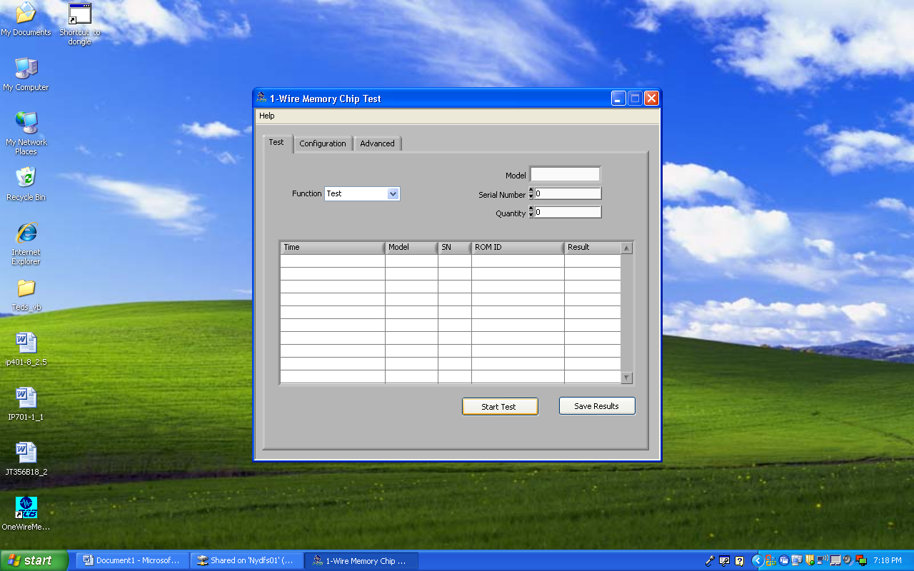

Click To Start Test

A pop-up window will appear asking if documentation is correct. Simply click ‘Yes’ in response. This software is capable of writing calibration info to the EEPROM once it is in a sensor. In this preliminary test case, there is no information necessary.

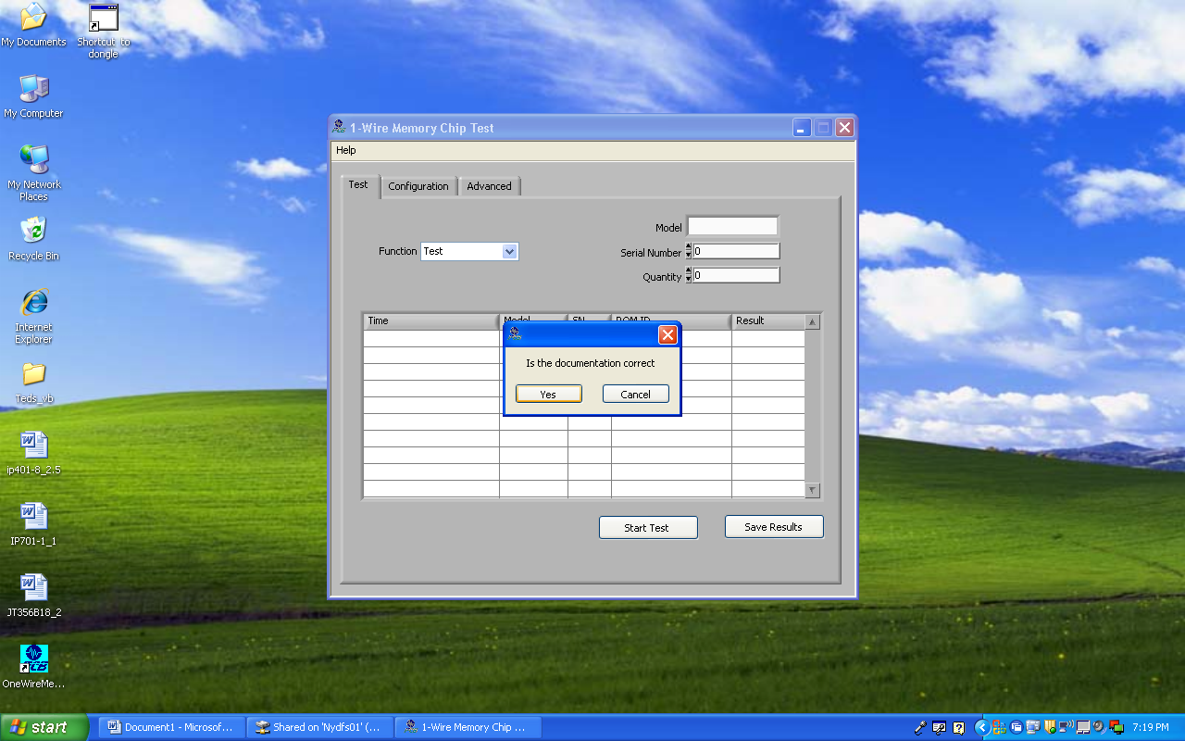

Click ‘Yes’

The test will run. If the UUT passes, a pop-up window will show ‘Passed!’. Connect to the next UUT, then click ‘Next Unit’. Another Pop-up will ask if the Results Table should be cleared. Click ‘OK’. This returns to the main screen where the ‘Start Test’ button can be pressed again.

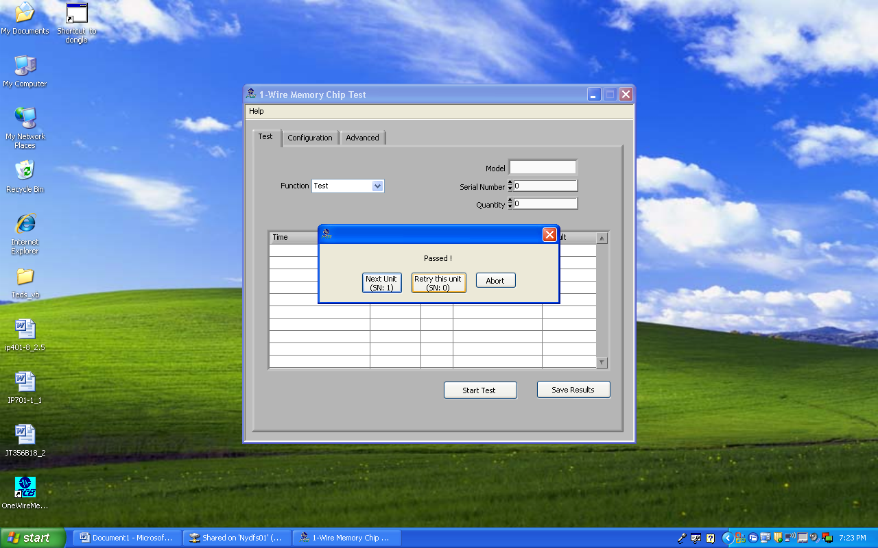 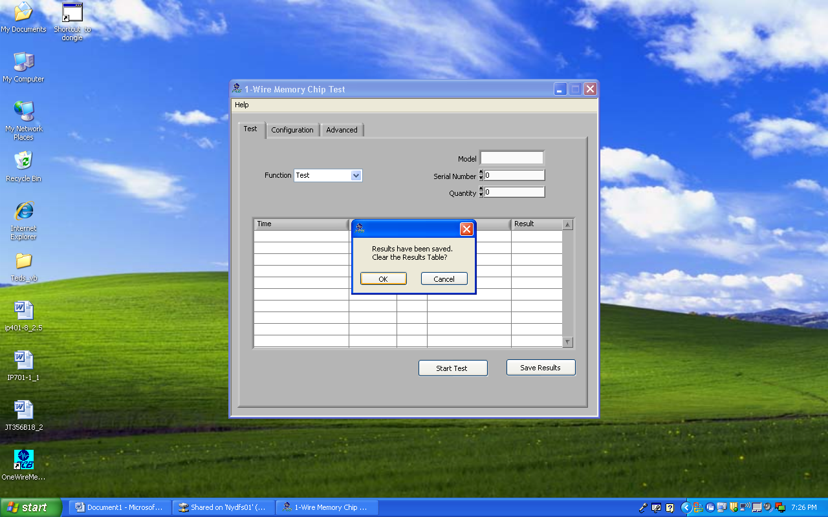

# Specification Requirements By Item Number:

|  |  |  |  |  |  |  |  |  |  |  |  |  |  |  |  |
| --- | --- | --- | --- | --- | --- | --- | --- | --- | --- | --- | --- | --- | --- | --- | --- |
| Assembly | Amplifier Type per 1.1.1 | Power Supply Per Sec. 2 | Bias Min (V) per 4.2 | Bias Max (V) per 4.2 | Gain Min per 4.3 | Gain Max per 4.3 | Temp. Cycle per 4.1 | Coupling Capacitor per 4.3 | Input Resistor Min per 4.4 | Input Resistor Max per 4.4 | Temperature Test (°C) per 4.5 | Filter Testing per 4.6 | L.P. -5% Point per 4.6 | L.P. -3dB Point per 4.6 | Test EEPROM Per 4.7 |
| 24297-01-209-100 | 3Wr-C | 5.0 | 2.452 | 2.55 | 3.06 | 3.55 | No | 330pF | 1.6e+09 | 2.4e+09 | N/A | N/A | N/A | N/A | No |
| 40604-01 | ICP-C | ICP | 8.00 | 12.00 | 3.822 | 3.978 | No | 390pF | 1.6e+09 | 2.4e+09 | N/A | N/A | N/A | N/A | No |
| 22852-01 | 3Wr-C | -24V | -8.25 | -8.80 | 11.76 | 12.24 | No | 1800pF | N/A | N/A | N/A | N/A | N/A | N/A | No |
| 22852-02 | 3Wr-C | -24V | -8.25 | -8.80 | 3.15 | 3.28 | No | 1800pF | N/A | N/A | N/A | N/A | N/A | N/A | No |
| 22851-01 | ICP-C | ICP | 9.75 | 10.25 | 1.45 | 1.57 | No | 1800pF | N/A | N/A | N/A | N/A | N/A | N/A | No |
| 58575-01 | Special | N/A | N/A | N/A | N/A | N/A | No | N/A | N/A | N/A | N/A | N/A | N/A | N/A | **YES** |
| 1790-03 | ICP-V | ICP | 8 | 14 | .715 | .755 | No | 8 pF | 7.5e+10 | 1.25e11 | N/A | N/A | N/A | N/A | No |
| 23910-01-209 | ICP-V | ICP | 8.2 | 11.8 | 1.90 | 2.15 | YES | 8 pF | 1.6e+09 | 2.4e+09 | 325°C | N/A | N/A | N/A | No |
| 23910-01-309 | ICP-V | ICP | 8.2 | 11.8 | 1.90 | 2.15 | YES | 8 pF | 2.4e+09 | 3.6e+09 | 325°C | N/A | N/A | N/A | No |
|  |  |  |  |  |  |  |  |  |  |  |  |  |  |  |  |
|  |  |  |  |  |  |  |  |  |  |  |  |  |  |  |  |
|  |  |  |  |  |  |  |  |  |  |  |  |  |  |  |  |
|  |  |  |  |  |  |  |  |  |  |  |  |  |  |  |  |
|  |  |  |  |  |  |  |  |  |  |  |  |  |  |  |  |
|  |  |  |  |  |  |  |  |  |  |  |  |  |  |  |  |
|  |  |  |  |  |  |  |  |  |  |  |  |  |  |  |  |
|  |  |  |  |  |  |  |  |  |  |  |  |  |  |  |  |
|  |  |  |  |  |  |  |  |  |  |  |  |  |  |  |  |
|  |  |  |  |  |  |  |  |  |  |  |  |  |  |  |  |
|  |  |  |  |  |  |  |  |  |  |  |  |  |  |  |  |
|  |  |  |  |  |  |  |  |  |  |  |  |  |  |  |  |
|  |  |  |  |  |  |  |  |  |  |  |  |  |  |  |  |
|  |  |  |  |  |  |  |  |  |  |  |  |  |  |  |  |
|  |  |  |  |  |  |  |  |  |  |  |  |  |  |  |  |
|  |  |  |  |  |  |  |  |  |  |  |  |  |  |  |  |