Purpose 1

Related Documents 1

Responsible 1

Rules 1

No Standard Exists 1

Gross Error 2

Upon Release at Rev NR 3

Upon Being Copied into the NC Site via the PCB BOM Router Copy Utility 4

How to Perform an Out-of-Cycle Cost Roll 6

# Purpose

To document when an out-of-cycle cost roll is performed and include instructions on how the cost roll is performed.

# Related Documents

None

# Responsible

Approved by: Controller

Maintained by: Senior Accountant

# Rules

1. Cost roll will be performed prior to the initial purchase or manufacture of an item.

Note: A purchase order/job order cannot be released without a corresponding purchased/manufactured standard cost.

1. A standard cost roll will be performed when any new model is released to production (i.e. assigned a letter value revision – e.g. Rev A).
2. An out-of-cycle cost roll is performed under the following conditions:

# No Standard Exists

**To establish the initial standard cost of an item:**

1. Purchased Item
   1. Each Buyer is responsible for populating the current unit cost of an item and sending an email to the “Planners” contact group, requesting a cost roll be performed.
      1. If QOH = zero, Planning performs the cost roll as per the steps at the end of this procedure.
      2. If QOH $≠$ zero, the email is forwarded to the “Costing” contact group for processing.
         1. The Sr. Cost Analyst shall calculate the impact to inventory and roll cost.
            1. If inventory impact is greater than $2K, an email will be sent to the “Finance Department” contact group, notifying them of the revaluation.
2. Manufactured Item
   1. If a Planner attempts to release a job and receives the following message, “Not one Standard Cost exists for Item that has [Item: xxxxxx-xxx]”, the Planner will review the QOH.
      1. If QOH = zero, Planning performs the cost roll as per the steps at the end of this procedure.
      2. If QOH $≠$ zero, the email is forwarded to the “Costing” contact group for processing.
         1. The Sr. Cost Analyst shall calculate the impact to inventory and roll cost.
            1. If inventory impact is greater than $2K, an email will be sent to the “Finance Department” contact group, notifying them of the revaluation.

# Gross Error

**To correct a gross error in unit cost resulting from an incorrect labor duration specified on router (e.g. Pcs/Labor Hour entered as Labor Hours/Piece) or an incorrect lot size:**

Note: Only an Engineering Manager can request a cost roll be performed to correct a gross error in unit cost.

1. The Engineering Manager will send an email to the “Costing” contact group requesting a cost roll be performed. The subject line of the email should read: “Request to Perform Out-of Cycle Cost Roll – Gross Error in Unit Cost.”
2. The Sr. Cost Analyst will determine the number of items impacted by the request.
   * + 1. Generally, if the number of items impacted is less than 250, the Sr. Cost Analyst will calculate the overall Inventory impact, perform all the required cost rolls, and notify the Engineering Manager that the task has been completed.
          1. If inventory impact is greater than $2K, the Engineering Manager will send an email to the “Finance Department” contact group, notifying them of the revaluation.
   1. If the number of items impacted is greater than 250, the Sr. Cost Analyst shall contact Finance to discuss the level of effort involved to complete the request. Finance will decide if the cost roll is warranted.
      * + 1. If the decision is made to roll cost, the Sr. Cost Analyst will calculate the overall Inventory impact, perform all the required cost rolls, and notify the requestor that the task has been completed.
3. If inventory impact is greater than $2K, the Engineering Manager will send an email to the “Finance Department” contact group, notifying them of the revaluation.
   * + - 1. If the decision is made to not roll cost, the Sr. Cost Analyst will notify the requestor (and CC Finance) that the request to roll cost has been denied.

**To correct a gross error in unit cost resulting from a lower level component not having an accurate current cost at time of initial cost roll:**

Note: Only an Engineering Manager can request a cost roll be performed to correct a gross error in unit cost.

1. The Engineering Manager will send an email to the “Costing” contact group requesting a cost roll be performed. The subject line of the email should read: “Request to Perform Out-of Cycle Cost Roll – Gross Error in Unit Cost”
2. The Sr. Cost Analyst will determine the number of items impacted by the request.
   * + 1. Generally, if the number of items impacted is less than 250, the Sr. Cost Analyst will calculate the overall Inventory impact, perform all the required cost rolls, and notify the requestor that the task has been completed.
          1. If inventory impact is greater than $2K, an email will be sent to the “Finance Department” contact group, notifying them of the revaluation.
       2. If the number of items impacted is greater than 250, the Sr. Cost Analyst will contact Finance to discuss the level of effort involved to complete the request. Finance will decide if the cost roll is warranted.
          1. If the decision is made to roll cost, the Sr. Cost Analyst will calculate the overall Inventory impact, perform all the required cost rolls, and notify the requestor that the task has been completed.
3. If inventory impact is greater than $2K, an email will be sent to the “Finance Department” contact group, notifying them of the revaluation.
   * + - 1. If the decision is made to not roll cost, the Sr. Cost Analyst will notify the requestor (and CC Finance) that the request to roll cost has been denied.

# Upon Release at Rev NR

Each day the Sr. Cost Analyst will review the items released the previous day (in the PCB site).

Generate a Daily Report

Note: This section will need to be updated after the IT request to create a dataview is completed

* 1. Open the form titled “Audit Log.”
  2. In the column titled “Log Description” enter “Items.”
  3. In the column titled “Message Description” enter “item.revision”.
  4. In the Column titled “New Value” enter “<>null”.
  5. In the column titled “Date/Time,” enter the previous work day in the following format: mm/dd/yyyy.
  6. Run query. This query will return a list of all items that had their revision updated in Syteline during previous work day.
  7. Export data to Excel and save file in the following format: yyyy/mm/dd – New Item Release

Note: Where yyyy/mm/dd, enter the date that appears in the column titled “Date/Time.”

* 1. In the column titled “New Value,” filter on all Engineering Revs (i.e. revisions that end in a numeric value – e.g. BAM1) and delete these items.
  2. Compare the values contained in the columns titled “Old Value” and “New Value.” If both values contain letter values (e.g. Old Value = A; New Value = B), then these items were updated, not released. These items do not require a cost roll and should be removed from the spreadsheet.
  3. In the column titled “New Value,” look for any entries with the text “FARM.” Delete these items.
  4. Add the following columns to the spreadsheet: “Product Code,” “Low Level Code,” “Source,” & “Rev.”
  5. Open the form titled “Items”.
  6. Copy/paste the items that appear in the column titled “Primary Key” (in your spreadsheet) into the Item field of the Items form.
  7. Using the data displayed, populate the “Product Code,” “Low Level Code,” “Source” and “Rev” in the spreadsheet created above.

1. Filter/Parse/Sort Data
2. Verify that the revision letter that appears in the coumn titled “New Value” and Rev are identical. Remove any items where these fields do not match.
3. Remove any items where the Product Code starts with “Z-DOC.”
4. Sort data by Low Level Code (Highest to Lowest).

Note: Should you encounter items with a low level code = 21 do not proceed! Send an email to the “Planning” contact group with the subject line “Urgent! – Action Required – Items exist in pcb site with LLC = 21”. These items will need the cost rolled the following business day.

1. Execute Cost Roll as per the steps at the end of this procedure.

Perform a cost roll on each item that appears in the column titled ”Primary Key.”

Note: Items with the highest level low level code must be rolled first.

1. Validate Cost Roll
2. The Sr. Cost Analyst shall verify the cost on each model level is within 7% of the previously estimated cost.
   * + 1. For NPD items, the product cost should match the “long form” cost estimate, previously created.
       2. For Specials, the product cost should be ~50% of the price of the item currently on order. If not, the Sr. Cost Analyst should contact the Sales person listed on CO to determine what cost margin was applied to the item on order.
3. If the Sr. Cost Analyst determines the cost roll does not fall within acceptable limits, they will investigate the issue and re-roll cost.

# Upon Being Copied into the NC Site via the PCB BOM Router Copy Utility

Note: Except where noted, this section is completed by NC Planning.

Once items are copied into the NC site, the product structure (e.g. BOM) is reviewed by NC Planning. The review occurs from the lowest level component and continues up the product structure (i.e. components, followed by sub-assemblies, followed by model level P/Ns).

A sourcing decision must be made for each new item. (In this usage “new” means the first time an item appears in the NC site.)

**To determine the source of a new item:**

* + - 1. Purchased Components

1. Items Purchased in NY
2. The Items Source is set to Transferred (in NC) during the BOM Copy Process.  The Standard Unit Cost (from NY) is entered as the Current Unit Cost (in NC).
3. If QOH = zero, NC Planning performs the cost roll (in NC) as per the steps at the end of this procedure guide.
4. If QOH $≠$ zero, the email is forwarded to the “Costing” contact group for processing.
5. The Sr. Cost Analyst will calculate the impact to inventory and roll cost (in NC).
   * + 1. If inventory impact is greater than $2K, an email will be sent to the “Finance Department” contact group, notifying them of the revaluation.
6. Items Purchased in NC
7. The Items Source is set to Purchased (in NC). The Current Unit Cost is populated (in NC) by Purchasing.
8. If QOH = zero, NC Planning performs the cost roll (in NC) as per the steps at the end of this procedure.
9. If QOH $≠$ zero, the email is forwarded to the “Costing” contact group for processing.
10. The Sr. Cost Analyst will calculate the impact to inventory and roll cost (in NC).
    * + 1. If inventory impact is greater than $2K, an email will be sent to the “Finance Department” contact group, notifying them of the revaluation.
11. The Items Source is set to Transferred (in NY). The Standard Unit Cost (from NC) is populated in the Current Unit Cost (in NY).
12. If QOH = zero, NC Planning performs the cost roll (in NY) as per the steps at the end of this procedure.
13. If QOH zero, the email is forwarded to the “Costing” contact group for processing.
14. The Sr. Cost Analyst will calculate the impact to inventory and roll cost (in NY)
    * + 1. If inventory impact is greater than $2K, the Sr. Cost Analyst will send an email to the “Finance Department” contact group, notifying them of the revaluation.
        2. Manufactured Sub-Assemblies
15. Items Manufactured in NY

The Items Source is set to Transferred (in NC) during the BOM Copy Process.  The Standard Unit Cost (from NY) is entered as the Current Unit Cost (in NC)

* + - 1. If QOH = zero, NC Planning performs the cost roll (in NC) as per the steps at the end of this procedure.
      2. If QOH zero, the email is forwarded to the “Costing” contact group for processing.

The Sr. Cost Analyst will calculate the impact to inventory and roll cost (in NC).

1. If inventory impact is greater than $2K, an email will be sent to the “Finance Department” contact group, notifying them of the revaluation.
2. Items Manufactured in NC

Note: As noted above, manufactured items must have their source changed and their cost rolled in a specific sequence (the highest low-level code items must be processed first).

1. The Items Source is set to Manufactured (in NC).
   * + 1. If QOH = zero, NC Planning performs the cost roll (in NC) as per the steps at the end of this procedure.
       2. If QOH zero, the email is forwarded to the “Costing” contact group for processing.
2. The Sr. Cost Analyst will calculate the impact to inventory and roll cost (in NC).

If inventory impact is greater than $2K, an email will be sent to the “Finance Department” contact group, notifying them of the revaluation.

1. The Items Source is set to Transferred (in NY). The Standard Unit Cost (from NC) is populated in the Current Unit Cost (in NY).

If QOH = zero, NC Planning performs the cost roll (in NY) as per the steps at the end of this procedure.

If QOH zero, the email is forwarded to the “Costing” contact group for processing.

1. The Sr. Cost Analyst will calculate the impact to inventory and roll cost (in NY)
2. If inventory impact is greater than $2K, an email will be sent to the “Finance Department” contact group, notifying them of the revaluation.

**To verify that the cost roll performed on the items copied into NC was executed correctly:**

* + - 1. Generate Daily Report

Note: This report is generated in the pcb site. This section will need to be updated after the IT request to create a dataview is completed.

* + - * 1. Open the form titled “Audit Log”.
  1. In the Column titled “New Value” enter “T”.
  2. In the Column titled “Date/Time,” enter the previous work day. In the Column titled “Message Description,” enter “item.p_m_t_code”.
  3. Run Query. This query will return a list of all the items which had their source changed to transferred the previous day.
  4. Export data to Excel and save file in the following format: yyyy/mm/dd – Items Copied into NC.

Note: Where yyyy/mm/dd, enter the date that appears in the column titled Date/Time”.

* 1. Add the following columns to the spreadsheet: “Source,” “Product Code” and “Low Level Code.”
  2. Open the form titled “Items.”
  3. Copy/paste the items that appear in the column titled “Primary Key” (in your spreadsheet) into the Item field of the Items form.
  4. Using the data displayed, populate the “Source,” “Product Code” and “Low Level Code” in the spreadsheet created above.

1. Filter / Parse / Sort Data:
2. Verify that the Source of of each item still appears as “Transferred.” Remove any items where these fields do not match.
   * 1. Remove any items where the Product Code does not start with “0”
     2. Sort data by Low Level Code (Highest to Lowest).

Note: Should you encounter items with a low level code = 21 do not proceed! Send an email to the “Planning” contact group with the subject line “Urgent! – Action Required – Items exist in pcb site with LCC = 21”. These items will need the cost rolled the following business day.

1. Validate Cost Roll
   1. The Sr. Cost Analyst shall log in the NC site and verify that Current Cost and Standard Cost of each model level is within 7% of each other.
      1. If the Sr. Cost Analyst determines the cost roll does not fall within acceptable limits they will investigate the issue and re-roll cost.
      2. If the Sr. Cost Analyst determines the cost roll falls within acceptable limits they will record the Standard Cost (in NC) in the spreadsheet created above.
   2. The Sr. Cost Analyst shall log in the NY site and verify that Standard Cost in NC and the Standard Cost in NY are identical.
      1. If not, the Sr. Cost Analyst will adjust the cost and re-roll.

# How to Perform an Out-of-Cycle Cost Roll

Prior to executing a PCB Cost Roll, the item needs to be reviewed to see if there is a current unit cost and/or inventory on hand.

* + - 1. Open the “Items” form, and enter the material to be rolled in the “Item” field. Click on “Find.”

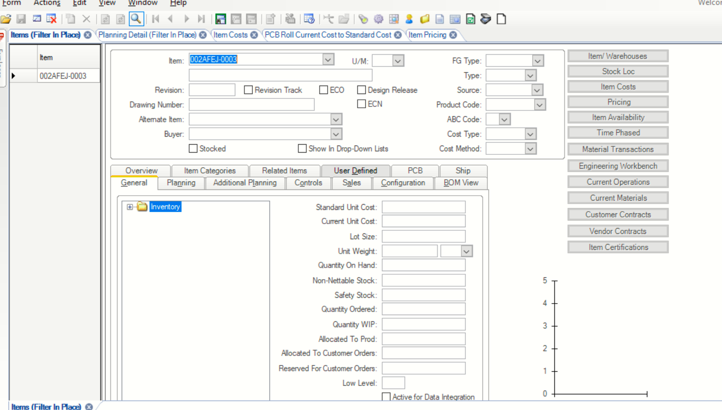

* + - 1. Check to see if there is any quantity on hand.
         1. If yes, STOP. Refer the material to Finance so they can complete the cost roll.
         2. If no, continue to step “c.”
      2. Check to see if there is a cost entered in the “Current Unit Cost” field.
         1. If yes, continue to step “d.”
         2. If no, return the cost roll request to the requestor and ask them to populate the “Current Unit Cost” field.
      3. Open the “PCB Roll Current Cost to Standard” form in Syteline.

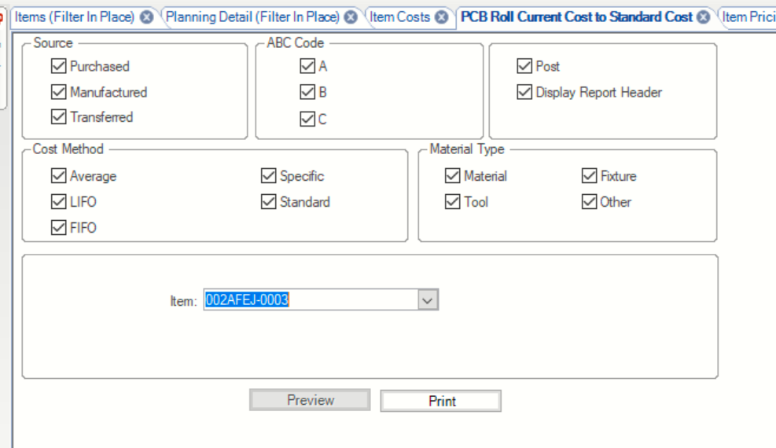

* + - 1. Enter the item to be cost rolled in the “Item” field.
      2. Check the “Post” box.
      3. Click on “Print.”
      4. The message “Report Submitted” will appear. Click on OK.

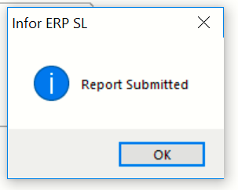

* + - 1. Return to the “Items” form. Click on the “Refresh” icon. The “Standard Unit Cost” field should now be populated.