**Table of Contents:**

**Overview ……………………………………………………………………………..….……. Page 2**

**Alarm System…………………………………………………………………………………. Page 2**

**Evacuation…………………………………………………………………………………….. Page 2**

**Medical Emergency………………………………………………………………………….. Page 3**

**Training………………………………………………………………………………………… Page 4**

**Fire Prevention and Maintenance………………………………………………………… Page 4**

**Emergency Shutdown Procedures………………………………………………………. Page 5**

**Power Outage………………………………………………………………………………… Page 5**

**Chemical Spill………………………………………………………………………………… Page 6**

**Active Shooter……………………………………………………………………………….. Page 6**

**Contact Information………………………………………………………………………… Page 8**

**Severe Weather and Natural Disasters…………………………………………………. Page 9**

**Appendix A – Staging Areas……………………………………………………………… Page 10**

**Appendix B – Site Maps……………………………………………………………………. Page 11**

**Appendix C – AED Protocols………………………………………………………..……. Page 15**

**Appendix D - Quick Reference Guide - Hazardous Wastes present at PCB**

**Piezotronics Facility; 3395, 3425 Walden Ave, Depew............................... Page 18**

**3395 Walden Ave Hazardous Waste……………………………………………………... Page 19**

**3425 Walden Ave Hazardous Waste……………………………………………………… Page 20**

**Overview**

This procedure is designed to ensure that proper up-front planning has been done to provide a safe evacuation of the PCB Piezotronics-Depew facility for all employees and visitors in the event of an emergency. These emergency conditions include, but are not limited to, hazardous chemical spills, fire/smoke, earthquake, flood/water, outside emergencies and power hazards. In addition, this procedure will cover preventative measures to reduce the chances of the aforementioned events, as well as providing directions for medical emergencies.

**Alarm System**

An alarm system is maintained throughout the building for activation in the event of an emergency. This system is primarily designed to handle fire and intrusion emergencies, although intrusion emergencies are outside the scope of this document.

Activation of the fire alarm is accomplished through the use of the alarm keypad or any of the fire pulls which are located at each entrance. Activation may also take place through a number of fire sensors located throughout the buildings. Activation will result in a horn strobe able to be heard throughout the facilities.

In the event of an activated alarm evacuation will take place per the Evacuation section of this procedure. In this case, the alarm system automatically notifies the alarm company who will attempt to verify the nature of the alarm with the Safety Officer or designee. If no contact is made, or in case of a verified emergency, the alarm company will notify Depew’s Emergency Response Services (e.g., Fire, Ambulance). The Safety Officer or designee will attempt to determine the source of the alarm without compromising their own safety.

The alarm system shall be tested annually. These tests will be immediately preceded by a general page and performed prior to 8:00 AM, after 6:00 PM, or on the weekend.

**Evacuation**

All departments shall have posted route maps showing the shortest route of evacuation and department staging locations. In the event of the activation of the alarm system, employees should immediately, and orderly, proceed to the nearest exit and staging area via the posted escape route.

Personnel Accountability During An Evacuation

Staging Area Coordinators (SAC’s) have been assigned to specific department areas to ensure that all PCB employees are accounted for after an evacuation (Appendix A – Staging Areas). Each area has a specific exit and backup exit if blocked due to the emergency itself (Appendix B – Site Map). The SAC will take the evacuation kit located at the exit to the respective staging area during an evacuation. The Atrium receptionist will take the visitor sign-in log so all non-employees may also be accounted for (e.g., visitors, contractors, vendors). Prior to exiting the building, the Safety Officer and department supervisors will ensure a safe and orderly exit for employees by checking restrooms, mailroom, training rooms, conference rooms and cafeterias within their areas of responsibility. Once the SAC arrives at their designated staging area, it is their responsibility to ensure that all employees are accounted for, and to note employees that should be at another staging area. These employees will be asked to go to their assigned staging area and check in with the SAC assigned to that area. If this is not practical or could compromise the employee’s safety, the employee(s) should remain at the staging area and the SAC assigned to that area will notify the other SAC’s via the use of a walkie-talkie.

The SAC will notify the Safety Officer, or designee, as soon as possible regarding the status of the employees in their respective staging area, including any employee that did not arrive at their designated staging area. The Safety Officer has the responsibility to communicate this information to the local responding agency incident commander at the scene to ensure that appropriate action will be taken. Employees should remain at their staging area during the entire evacuation period, unless otherwise directed by the SAC.

The SAC’s will instruct employees to return to the building once the “All Clear” signal has been received from the Safety Officer or designee. All employees should return to their work areas promptly.

Evacuation kits will be inspected on a monthly basis by the Maintenance Department. Included in this inspection will be a battery test of the walkie-talkie as well as stocking the boxes with backup batteries. This will be logged in the Preventative Maintenance Database.

# 

# **Medical Emergency**

Although PCB endeavors to maintain a safe and incident free workplace, it is important to be prepared for all types of medical emergencies. All work-related incidents are to be reported to a supervisor who will ensure that the Incident Report (PE043) is completed no later than the next business day. This paperwork must include corrective/preventative actions to ensure that similar incidents do not reoccur. In addition, this paperwork will be reviewed by the Safety Committee monthly in order to monitor and ensure that effective corrective actions have been implemented.

Attempt first aid only if trained and qualified. PCB employees with First Aid/CPR/AED training will be listed on the Medical Emergencies Contact list as Emergency Responders. This list will be updated on an annual (or as needed) basis by Human Resources and posted on company bulletin boards throughout the buildings, as well as on the Company’s Intranet site – MyPCB. These specially trained employees have volunteered to assist with first aid situations and can be contacted directly or through one of the following methods:

1. Medical Emergency – A medical emergency is one that requires calling 911 for emergency medical assistance (e.g., unconsciousness, chest pain, amputation). If you find yourself in a medical emergency situation please remain calm and follow these directions:

1. Do not move the victim unless their current location is deemed unsafe.
2. Call 911. Indicate the nature of the emergency (e.g., laceration, unconsciousness) and the location of the emergency (e.g., address, building). Do not hang up until the 911 operator has all the information needed.
3. Notify Emergency Responders via the phone paging system by announcing Code Blue and location of injured person (e.g., Code Blue - IMI). Dial 701 for Main Building; 702 for Machining Center; 703 for All Depew; 704 for Farmington; 706 for Utah.
4. The Atrium receptionist will automatically be notified via the phone system that a 911 call has been placed and the extension from which it was made. The Atrium receptionist will then attempt to call the extension in order to obtain further information regarding the emergency and location of the injured person.
5. If not already done, the Atrium receptionist will use the phone paging system to alert Emergency Responders to the injured person’s location by announcing Code Blue and location.
6. If the use of an Automatic External Defibrillator is required the responders will follow the protocol in Appendix C of this User Guide.
7. The supervisor that is in the area and/or Emergency Responder(s) will designate PCB personnel to go to the facility entrance nearest the injured person’s location in order to await the medical response unit(s) and direct them to the victim.
8. The HR Department will attempt to reach the employee’s emergency contact person
9. Medical Non-Emergency – A medical non-emergency is one that requires medical assistance, but not a 911 call (e.g., small cut, nausea) . In these situations please follow this procedure:
10. Notify Emergency Responders by contacting them directly or via the phone paging system by announcing Code Blue and location of injured person. Dial 701 for Main Building; 702 for Machining Center.
11. If the situation warrants further medical attention, employees may be seen at Immediate Care (Cheektowaga) or St. Joseph’s Hospital (Cheektowaga).
12. Note: If the Emergency Responder determines that a medical emergency exists then 911 will be called and the procedure for Medical Emergencies will be followed (as referenced above).

First Aid equipment is maintained at the following locations and is indicated on the evacuation maps posted throughout the facility:

Location Equipment

1) Front Cafeteria First Aid Cabinet / Trauma Bag (bag near Chiller)

2) North Coffee Area First Aid Cabinet / AED (AED near Chiller)

3) South Coffee Area First Aid Cabinet / Trauma Bag / AED

4) Endevco First Aid Cabinet

5) Engineering First Aid Cabinet

5) PMC Cafeteria Entrance First Aid Cabinet

6) PMC Southwest Employee Entrance First Aid Cabinet

7) PMC Outside of Offices Trauma Bag / AED

8) HCD First Aid Cabinet / Trauma Bag / AED

9) Crystals Center – Employee Entrance First Aid Cabinet / Trauma Bag / AED

10) Crystals Center – Cafeteria First Aid Cabinet

11) Crystals Center – Powder Room First Aid Cabinet

The Safety Committee is responsible for ensuring that the above equipment is properly stocked, maintained and inspected. Only currently certified Emergency Responders are authorized to use Trauma Bags and AED’s.

**Training**

All new employees will receive training on this procedure during their New Hire Department Orientation (PE025). In addition, annual retraining on this procedure is mandatory for all employees.

All employees with specific safety functions (e.g. SAC’s, Emergency Responders, Supervisors) will receive additional training to ensure that they fully understand their roles and responsibilities.

**Fire Prevention and Maintenance**

In order for PCB to properly conduct its business, it is necessary to use and store a number of flammable and/or hazardous materials in our manufacturing facilities. Examples of such materials include, but are not limited to: Greases, Solvents, Cleaners, Paints, and Alcohol.

It is the departmental supervisor’s responsibility to ensure that all such materials are stored correctly. All Class 1A flammable liquids shall be stored according to the following guidelines:

* Original DOT-approved shipping container – 60 gallons maximum
* Safety Can – Two (2) gallons maximum
* Metal (other than DOT drums) – One (1) gallon maximum
* Glass or approved plastic – One (1) pint maximum

In addition, all departments shall be cleaned and cleared of flammable and combustible trash on a daily schedule, which shall be removed from the building by the Maintenance Department. All exits, fire pull boxes, first aid equipment, and fire extinguishers must be kept clear of any obstructions.

Fire suppression equipment, including fire extinguishers, shall be maintained at various locations throughout the building and indicated on evacuation maps posted throughout the facility. The Maintenance Team Leader or designee is responsible for ensuring that authorized personnel service this equipment annually.

In addition, designated supervisors and Maintenance employees will receive annual training in the proper use and operation of fire extinguishers. When fire is discovered, depending on the severity:

* Activate the nearest fire alarm (see staging area map)
* If the fire alarm is not available or working, notify personnel about the fire emergency and/or evacuation by paging system

Fight the fire **ONLY** if*:*

* The Fire Department has been notified.
* The fire is small and is not spreading to other areas.
* Escaping the area is possible by backing up to the nearest exit.
* The fire extinguisher is in working condition
* You have been properly trained to use a fire extinguisher.

Upon being notified about the fire emergency, employees must follow the Evacuation portion of this procedure*.*

**Emergency Shutdown Procedures**

In the case of a fire, the Maintenance Department will attempt to shut off the main utilities to the facilities, including natural gas and electrical power, provided that it is safe to do so. Other energy sources may be turned off as needed.

**Power Outage**

In the event of a power outage, PCB has an emergency standby power generator. It automatically starts in the event of a power failure and will continue to run until there is 20 minutes of uninterrupted utility power. The power generator supports the I.T. department, telephone system, logistics department, alarm system, access system and sales bullpen. All outlets covered by the emergency generator are identified with a white label with green lettering stating “Emergency Power”. If a power outage lasts more than 10 minutes in work areas not supported by the generator then supervisors must fill out form TA114, the Power Outage Contingency Plan Checklist.

Emergency lighting will be active for 15 minutes. During this time employees are asked to close up their work stations and make their way to the nearest exit doors where they will await further instructions.

In the Precision Machining Center the generator supports network access, the phone system and alarm systems.

**Chemical Spill**

*When a Large Chemical Spill has occurred:*

* Immediately notify the area Supervisor, Safety Officer, Human Resources, and/or Maintenance.
* Contain the spill with available equipment (e.g., pads, booms, absorbent powder, etc.).
* Secure the area to prevent other personnel from entering.
* Do not attempt to clean the spill unless trained to do so.
* Deal with the spill in accordance with the instructions described in the SDS, while wearing proper PPE.
* Attend to injured personnel and follow the Medical Emergency portion of this procedure.
* Contact Environmental Service Group at (716)695-6720 during normal business hours, or (716)983-0783 or (716)946-2227 after business hours, for spill cleanup. If the spilled chemical presents an acute hazard (flammable, highly corrosive, etc), contact the Fire Department.
* Evacuate building as necessary by following the evacuation portion of this procedure.

*When a Small Chemical Spill has occurred:*

* Immediately notify the area Supervisor, Safety Officer, Human Resources, and/or Maintenance.
* Contain the spill with available equipment (e.g., pads, booms, absorbent powder, etc.).
* Secure the area to prevent other personnel from entering.
* Do not attempt to clean the spill unless trained to do so.
* Deal with the spill in accordance with the instructions described in the SDS, while wearing proper PPE.
* Attend to injured personnel and follow the Medical Emergency portion of this procedure.

**Active Shooter**

An Active Shooter is an individual actively engaged in killing or attempting to kill people in a confined and populated area; in most cases, active shooters use firearms(s) and there is no pattern or method to their selection of victims.

Active shooter situations are unpredictable and evolve quickly. Typically, the immediate deployment of law enforcement is required to stop the shooting and mitigate harm to victims.



Because active shooter situations are often over within 10 to 15 minutes, before law enforcement arrives on the scene, individuals must be prepared both mentally and physically to deal with an active shooter situation. At PCB we are calling any type of workplace violence “Code Orange” and employees will hear these words over the loudspeaker in the event there is a workplace violence situation.

**Good practices for coping with an active shooter situation:**

* Be aware of your environment and any possible dangers
* Take note of the two nearest exits in any facility you visit
* If you are in an office, stay there and secure the door
* If you are in a hallway, get into a room and secure the door
* As a last resort, attempt to take the active shooter down. When the shooter is at close range and you cannot flee, your chance of survival is much greater if you try to incapacitate him/her.

**CALL 911 WHEN IT IS SAFE TO DO SO!**

**HOW TO RESPOND WHEN AN ACTIVE SHOOTER IS IN YOUR VICINITY**

Quickly determine the most reasonable way to protect your own life. Remember that students and visitors are likely to follow the lead of employees and managers during an active shooter situation.

1. **Evacuate.** If there is an accessible escape path, attempt to evacuate the premises. Be sure to:

* Have an escape route and plan in mind and meet in your assigned Staging Area
* Evacuate regardless of whether others agree to follow
* Leave your belongings behind
* Help others escape, if possible
* Prevent individuals from entering an area where the active shooter may be
* Keep your hands visible
* Follow the instructions of any police officers
* Do not attempt to move wounded people
* Call 911 when you are safe

1. **Hide out.** If evacuation is not possible, find a place to hide where the active shooter is less likely to find you. Your hiding place should:

* Be out of the active shooter’s view
* Provide protection if shots are fired in your direction (i.e., an office with a closed and locked door)
* Do not trap yourself or restrict your options for movement
* To prevent an active shooter from entering your hiding place:
* Lock the door
* Blockade the door with heavy furniture

**If the active shooter is nearby**:

* Lock the door
* Silence your cell phone and/or pager
* Turn off any source of noise (i.e., radios, televisions)
* Hide behind large items (i.e., cabinets, desks)
* Remain quiet

**If evacuation and hiding out are not possible**:

* Remain calm
* Dial 911, if possible, to alert police to the active shooter’s location
* If you cannot speak, leave the line open and allow the dispatcher to listen

1. **Take action against the active shooter.** As a last resort, and only when your life is in imminent danger, attempt to disrupt and/or incapacitate the active shooter by:

* Acting as aggressively as possible against him/her
* Throwing items and improvising weapons
* Yelling
* Committing to your actions

**HOW TO RESPOND WHEN LAW ENFORCEMENT ARRIVES**

Law enforcement’s purpose is to stop the active shooter as soon as possible. Officers will proceed directly to the area in which the last shots were heard.

* Officers usually arrive in teams of four (4)
* Officers may wear regular patrol uniforms or external bulletproof vests, Kevlar helmets, and other tactical equipment
* Officers may be armed with rifles, shotguns, handguns
* Officers may use pepper spray or tear gas to control the situation
* Officers may shout commands, and may push individuals to the ground for their safety

**How to react when law enforcement arrives**:

* Remain calm and follow officers’ instructions
* Put down any items in your hands (i.e., bags, jackets)
* Immediately raise hands and spread fingers
* Keep hands visible at all times
* Avoid making quick movements toward officers such as holding on to them for safety
* Avoid pointing, screaming and/or yelling
* Do not stop to ask officers for help or direction when evacuating, just proceed in the direction from which officers are entering the premises

**Information to provide to law enforcement or 911 operator**:

* Location of the active shooter
* Number of shooters, if more than one
* Physical description of shooter/s
* Number and type of weapons held by the shooter/s
* Number of potential victims at the location

**Notes**: The first officers to arrive to the scene will not stop to help injured persons. Expect rescue teams comprised of additional officers and emergency medical personnel to follow the initial officers. These rescue teams will treat and remove any injured persons. They may also call upon able-bodied individuals to assist in removing the wounded from the premises.

Once you have reached a safe location or an assembly point, you will likely be held in that area by law enforcement until the situation is under control, and all witnesses have been identified and questioned. Do not leave until law enforcement authorities have instructed you to do so.

**Contact Information**

For more information regarding this procedure please contact:

* Roger Achkar, Safety Officer, (716) 684-0002, ext. 2215 or (716) 491-7594
* Stephanie Haller, Safety Chair, (716) 684-0002, ext. 2739
* Julia Culkin-Jacobia, VP of HR, (716) 684-0002, ext. 2673

**Severe Weather and Natural Disasters**

Tornado***:***

* When a warning is issued by sirens or other means, seek inside shelter. Consider the following:
  + Small interior rooms on the lowest floor and without windows,
  + Hallways on the lowest floor away from doors and windows, and
  + Rooms constructed with reinforced concrete, brick, or block with no windows.
* Stay away from outside walls and windows.
* Use arms to protect head and neck.
* Remain sheltered until the tornado threat is announced to be over.

Earthquake***:***

* Stay calm and await instructions from the Safety Officer, Human Resources, or other designated official.
* Keep away from overhead fixtures, windows, filing cabinets, and electrical power.
* Follow the evacuation portion of this procedure if evacuation is necessary.

Flood**:**

*If indoors:*

* Be ready to evacuate as directed by the designated official.
* Follow the evacuation portion of this procedure if evacuation is necessary.

*If outdoors:*

* Climb to high ground and stay there.
* Avoid walking or driving through flood water.
* If car stalls, abandon it immediately and climb to a higher ground.

Blizzard:

*If indoors*:

* Stay calm and await instructions from the designated official.
* Stay indoors.
* If there is no heat:
  + Close off unneeded rooms or areas.
  + Stuff towels or rags in cracks under doors.
  + Cover any windows at night.
* Eat and drink. Food provides the body with energy and heat. Fluids prevent dehydration.
* Wear layers of loose-fitting, light-weight, warm clothing, if available.

*If outdoors*:

* Find a dry shelter. Cover all exposed parts of the body.
* If shelter is not available:
  + Prepare a lean-to, wind break, or snow cave for protection from the wind.
  + Build a fire for heat and to attract attention. Place rocks around the fire to absorb and reflect heat.
  + Do not eat snow. It will lower your body temperature. Melt it first.

*If stranded in a car or truck*:

* Stay in the vehicle!
* Run the motor about ten minutes each hour. Open the windows a little for fresh air to avoid carbon monoxide poisoning. Make sure the exhaust pipe is not blocked.
* Make yourself visible to rescuers.
  + Turn on the dome light at night when running the engine.
  + Tie a colored cloth to your antenna or door.
  + Raise the hood after the snow stops falling.
* Exercise to keep blood circulating and to keep warm.

**APPENDIX A**

**STAGING AREAS**

|  |  |  |
| --- | --- | --- |
| **Staging Area** | **Staging Area Coordinator** | **Department Areas** |
| **# 1** | Production Manager |  |
| Pressure/Force Production Manager | Microelectronics |
|  | Pressure/Force |
|  |  |
| **# 2** | ACCELS/SVS Production Manager  IMI Production Manager | Accelerometers |
| Training Cell Supervisor | Final Inspection |
| Value Stream Ops. | Operations |
|  |  |
| **#3** | Customer Service Supervisor | Front Office IT |
| Service Manager | Marketing |
| IT/CIO | Sales |
| **#4** | Accounting Supervisor | Accounting Legal |
| Cables Supervisor | Administration Logistics |
| CSR Supervisor | Bull Pen / Customer Service Mail Room |
| HR | Cables Microphones |
| Logistics Supervisor | Engine Sensor OPS MT |
|  | GEP QA Receiving Inspection |
|  | Human Resources Welding/Etching |
|  |  |
| **#5** |  | AME Level II Team |
| Engineering Coordinator | Drafting Maintenance |
|  | Engineering Purchasing/Inventory |
| Purchasing Manager | Engineering Test Quality Assurance (QA) |
| Value Stream Ops. | Flex Beam Repairs |
|  | HCD Building Xerox |
|  |  |
|  |  |
| **#6 (2 boxes)** | Machining Center Supervisors, Entrance | All Machining Center Personnel |
| **#7** | Production Manager | Crystals |

**APPENDIX B - SITE MAPS**

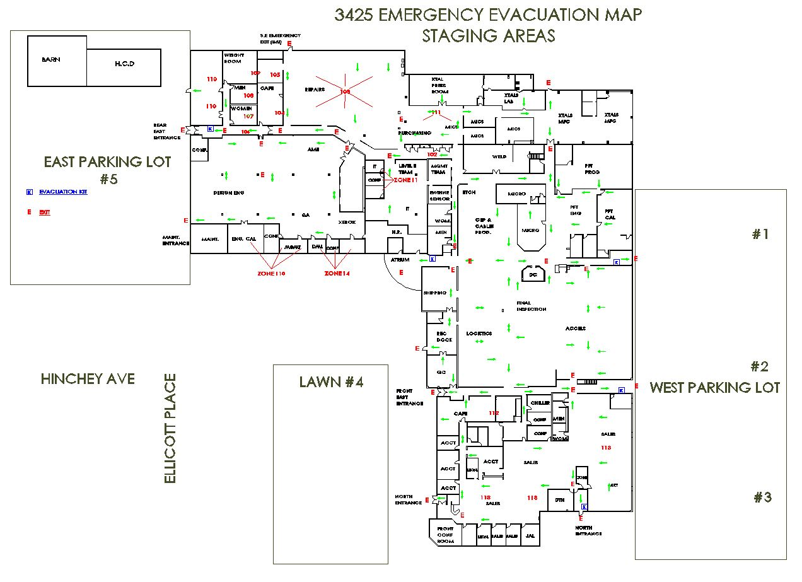

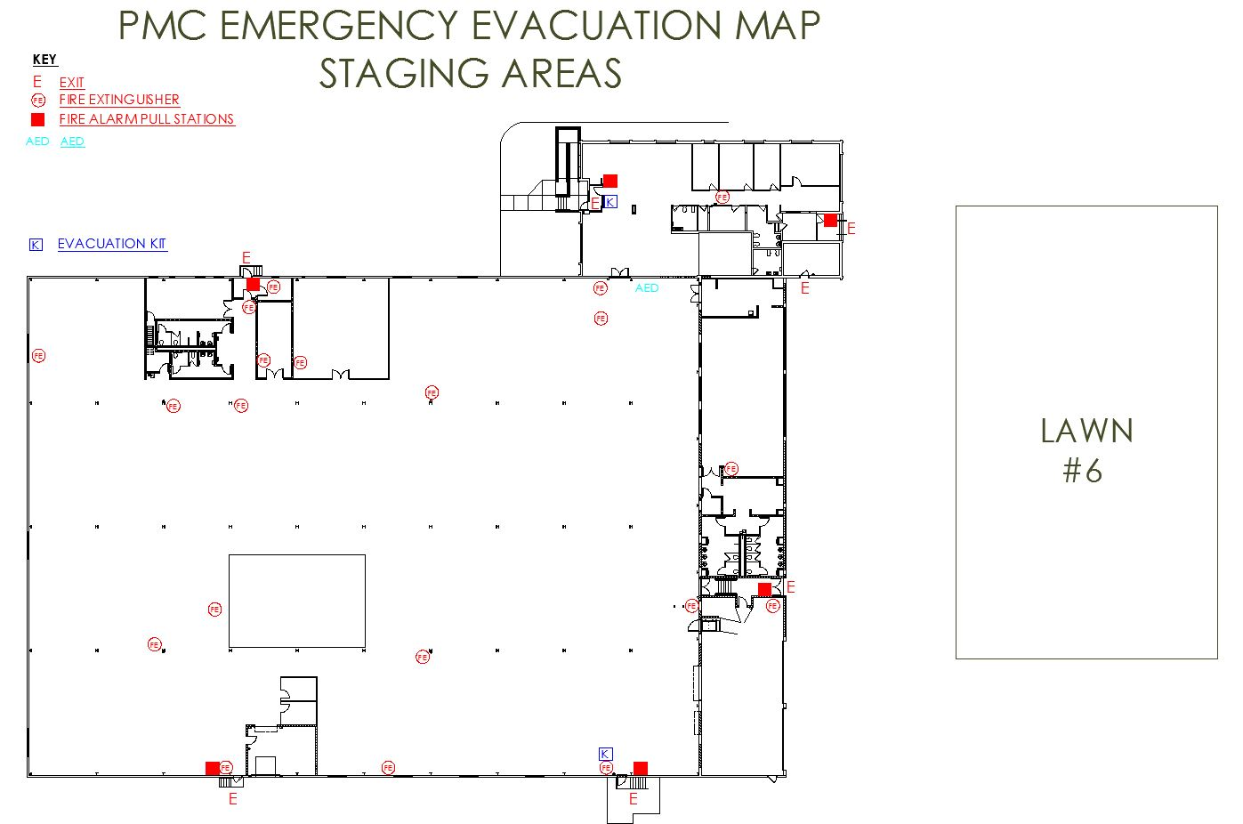

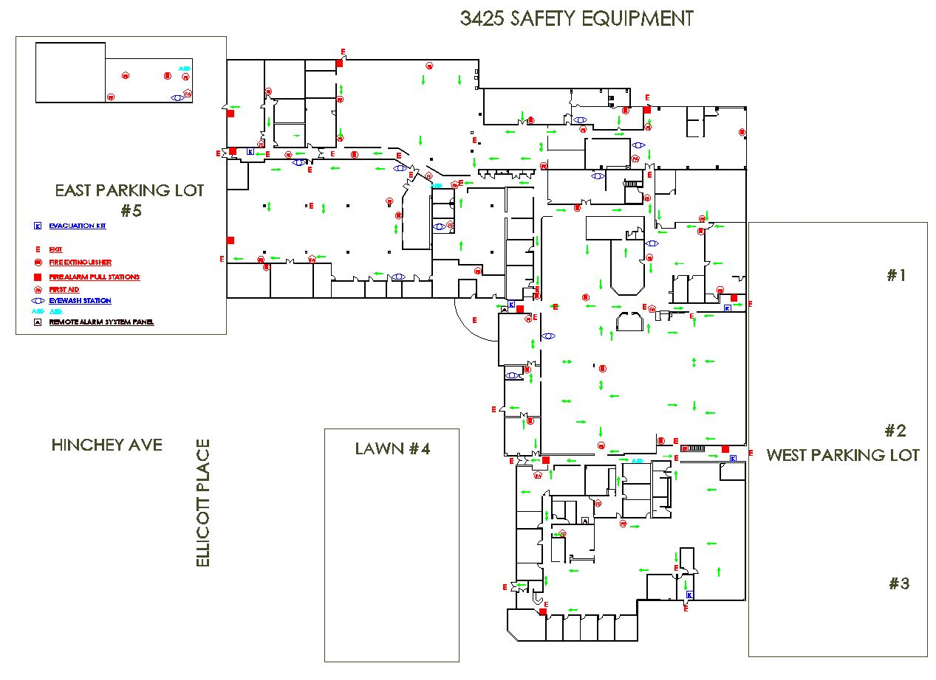

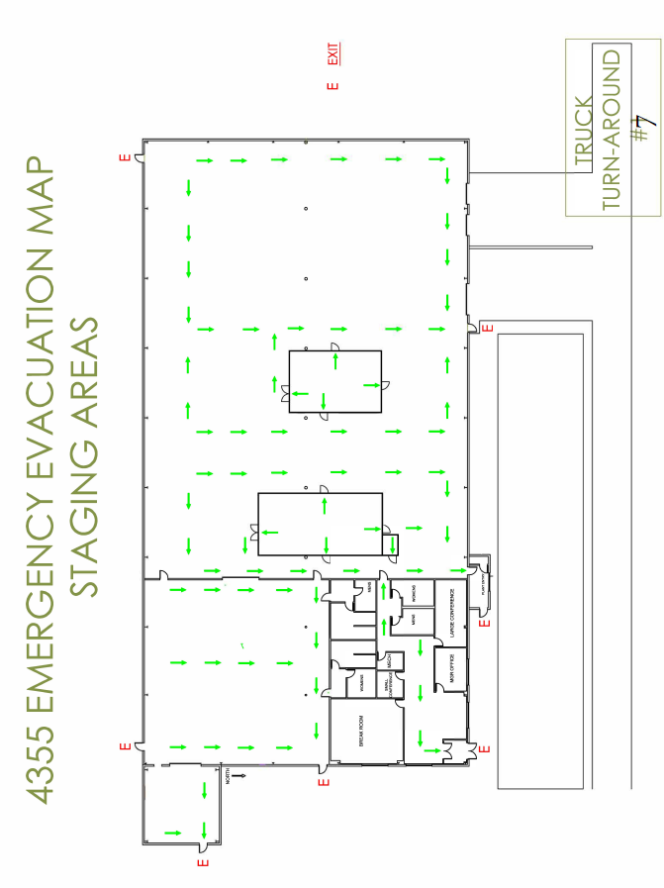

**APPENDIX C**

**AED PROTOCOLS**

In order to be eligible to use an AED on an appropriate patient, authorized individuals will:

* Meet the training requirements set forth in these policy and procedures
* Pass competency-based written and skills recognition examinations
* Comply with the requirements set forth in these policies and procedures. Failure to comply with these requirements shall result in the suspension of the individual’s authorization.

The authorization period for a trained responder will stay in effect as long as they adhere to the program guidelines.

Authorization shall be rescinded in the event of termination of the individual’s association with the company.

While the Public Access Defibrillator law allows AED to be applied to patients by individuals who have not been trained in CPR and AED, the law also requires organizations with AEDs to have authorized individuals. As an organization, we request that only authorized individuals use the AED unless there is no other alternative.

# **Internal Emergency Response System**

Type of Medical Emergency:

*Sudden Cardiac Arrest* – Follow Instructions for AED use.

*Other Medical Emergencies* – Responder should provide only the patient care that is consistent with their training.

The first person on the scene:

1. Will initiate the Chain of Survival by calling out for help with a medical emergency. The person at the desk will call 911 and delegate someone to go outside to escort the paramedics to the scene. The AED and other medical supplies are to be brought to the patient. If trained, the responder will initiate CPR until the AED arrives.

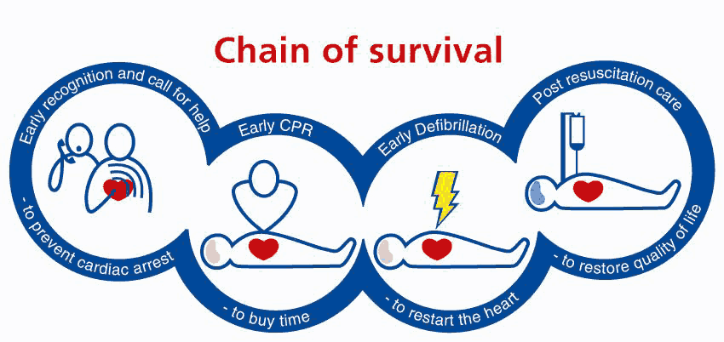

Initial protocol for the unconscious victim is as follows:

1. Upon arrival, assess the scene safety; use universal precautions
2. Assess patient for unresponsiveness
3. Assess breathing
4. Assess signs of circulation
5. If warranted, perform CPR until the AED arrives

**Determine if patient is:**

Unconscious Not Breathing No Signs of Circulation

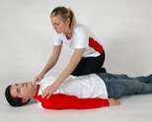  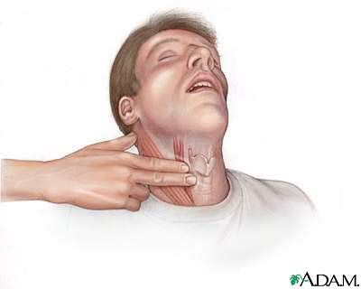

**\*Apply the AED if:**

**Unconscious, not breathing, and no signs of circulation**

**Begin AED treatment**:

1. Turn on AED and follow the prompts
2. Shave chest with disposable razor if needed. Discard razor in a safe manner. Wipe chest if it is wet.
3. Apply defibrillation pads. Make sure the AED pads are placed in the proper location and that they make good skin contact with the chest. **Do not place AED pads over the nipple**, **medication patches or implanted devices**.
4. Clear the patient area and deliver a shock to the patient when advised by the AED. Administer additional shocks as prompted by the AED until the AED advises no shock or a series of three consecutive shocks has been delivered.
5. When advised by the AED, check the patient’s airway breathing and signs of circulation, and initiate CPR if signs are absent.
6. Continue to follow AED prompts and perform CPR until EMS takes over

**When EMS Arrives:**

1. Authorized individual working on the patient should document and communicate important information to the EMS provider such as:
   1. Patient’s name
   2. Time patient was found
   3. Initial and current condition of the victim
2. Assist as requested by EMS personnel

**Post-use Procedure**:

1. Complete documentation of the sudden cardiac arrest event no more than 24 hours following the event (Incident Report, AED Use Report, etc.)
2. Give all documentation to the program coordinator
3. Program coordinator will contact the AED vendor to download event data from AED. Do not remove the battery.
4. Coordinator will assure that documentation is sent to the Medical Director as soon as possible and no later than one week from the date of the event
5. Program coordinator or designee should conduct emergency incident debriefing as needed
6. Replace any used inventory
7. Inspect the exterior and connector for dirt or contamination.

**APPENDIX D**

**Quick Reference Guide - Hazardous Wastes present at PCB Piezotronics Facility;**

**3395, 3425 Walden Ave, Depew**

|  |  |  |  |  |
| --- | --- | --- | --- | --- |
| Item | Material | Hazard | Approx. Quantity | Location |
| 1 | Isopropyl Alcohol | Ignitable spent solvent | 6 x 55 gal | Shipping/Receiving Dock 3395,3425 |
| 2 | Lead Oxide | Spent machining coolant with Lead, toxic | 4 x 55 gal | Southwest corner of 3425 |
| 3 | Nitrohydrochloric acid | Corrosive acid | 2 x 55 gal | Southeast out-building 3425 |
| 4 | Potassium hydroxide | Caustic solution | 1 x 55 gal | Southeast out-building 3425 |
| 5 | Methanol/Acetone/Toluene | Mixed ignitable spent solvents | 1 x 55 gal | Shipping/Receiving Dock |
| 6 | Hydrochloric acid | Corrosive acid | 1 x 55 gal | Southeast out-building 3425 |
| 7 | Nitric Acid | Corrosive acid | 1 x 30 gal | Southwest corner of 3425 |
| 8 | Potassium Cyanide | Poisonous spent plating solution | 2 gal | Southwest corner of 3425 |
| 9 | Hydrofluoric acid | Very toxic, corrosive acid | 1 gal | Southwest corner of 3425 |

1. Facility has fire alarm system that rings off site
2. Facility Safety Officer: Roger Achkar (716)491-7594 cell
3. Safety Data Sheets attached (for external copies only).
4. Facility maps attached.

