1.0 Purpose: 1

2.0 Responsibilities: 1

3.0 Affected Department / Product Group / Support Group: 1

4.0 Associated Documents: 1

5.0 Definitions: 1

6.0 Start Up: 2

7.0 Set Up Weld Strength Test 4

8.0 Procedure: 6

# Purpose:

To detail the steps for using the GE Schmidt spot-welding press to weld the key into various connector shells.

# Responsibilities:

The Production Supervisor and/or the HCD Engineer are responsible for maintaining this procedure.

The Production Supervisor and Bench Technicians are responsible for this procedure being carried out effectively.

# Affected Department / Product Group / Support Group:

HCD

# Associated Documents:

HC001

# Definitions:

**Mandrel**: Tooling post attached to the welding machine on which components are placed for alignment prior to welding.

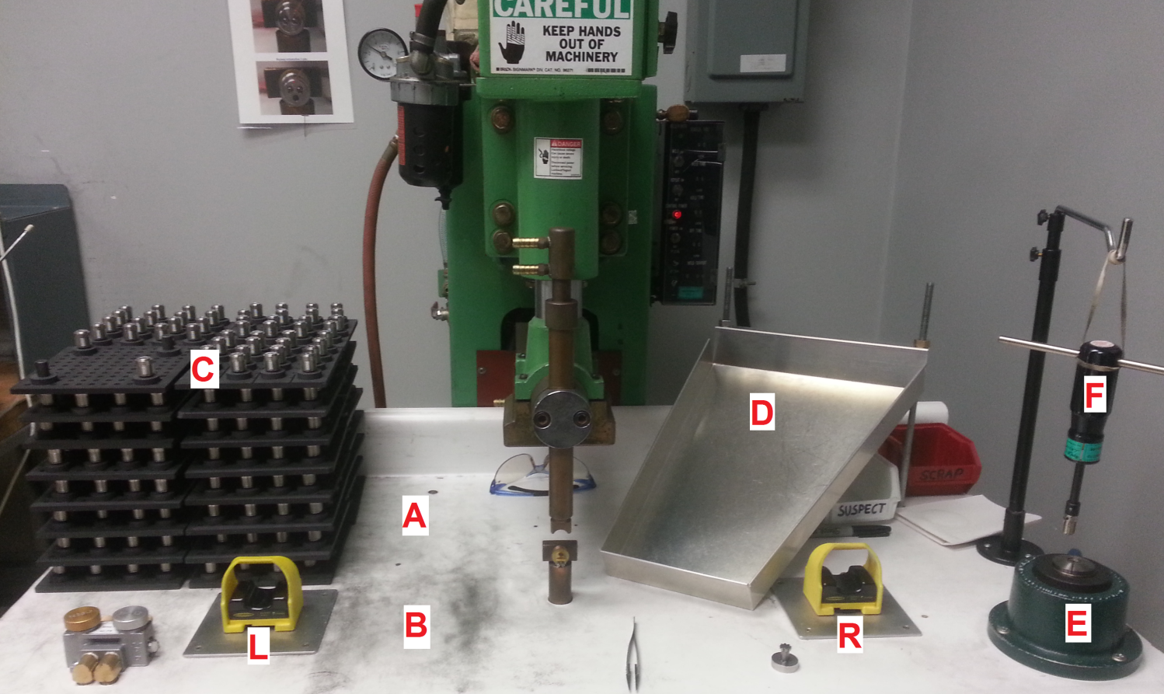

Figure 1: Spotweld bench showing location:

A: Place for stacked empty fixtures

B: Place for fixture currently being loaded

C: Stacked Loaded Fixtures

D: Tray for cleaned shells waiting for welding

E: Collet Vice

F: Torque-limiting screwdriver

L and R: Optical touch buttons

# Start Up:

## Check parts against the job paperwork to assure correctness.

* 1. Ensure that the torque-limiting screwdriver (or equivalent) is still within calibration date.

## Have all shells, keys to be welded, fixtures, etc. at the workstation before you start spot welding the job and keep them in their respective locations.

## Check that you have all firing fixtures ready with all keyways on fixtures properly aligned for easy placement of the completed spot welded sub-assembly; the key slot should be facing the wall behind the spot welder.

## Turn on the welder by using the power toggle switch; it is located on the lower left of the control panel, above the fuses. See Figure 2.

## NOTE: Spot welds vary due to material size variances and power fluctuations. The following parameters are a starting point to operate the spot welder. Destructive testing with torque gage is done to ensure proper weld strength. Settings should only be adjusted by engineering or supervisor to pass the test.

**NOTE:** Welder starting settings:

***only to be adjusted by engineering or supervisor***:

* Squeeze Time – 40
* Weld Time – 05
* Hold Time – 55
* Off Time – 00
* Weld Current – 6
* Repeat – Off

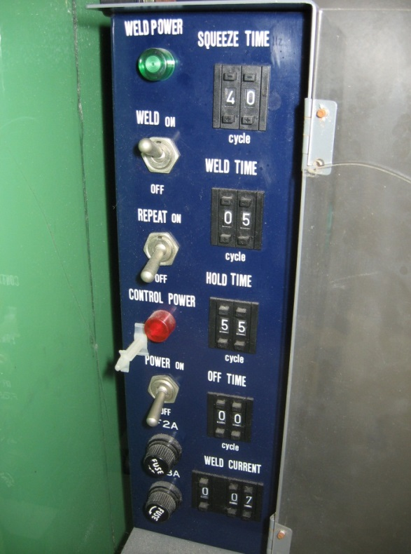

POWER toggle switch

Figure 2: Welder Control Panel

# Set Up Weld Strength Test

## Ensure that the torque wrench is still within calibration date.

## Weld 1 (one) subassembly piece for the job, see section 8 for details.

## Place this first subassembly in the vise, see Figure 3.

## Place brown socket adapter (or 57575-00 based equivalent) onto connector, see Figure 4.

|  |  |
| --- | --- |
| Figure 3: Connector placed initially in vise | HCDwelder 006  Figure 4: Hex adapter on connector |

## Set the PROTO model J6177F (or equivalent) dial torque wrench to 0 (zero) on the 100 in-Lb scale if necessary. Reset the memory needle to 0 on the outermost number line by turning counter clockwise.

## Attach the 19 mm socket to the square drive of the gage.

## Connect the socket to the hex adapter and apply clockwise torque to the connector until the key snaps (weld breaks), see Figure 5.

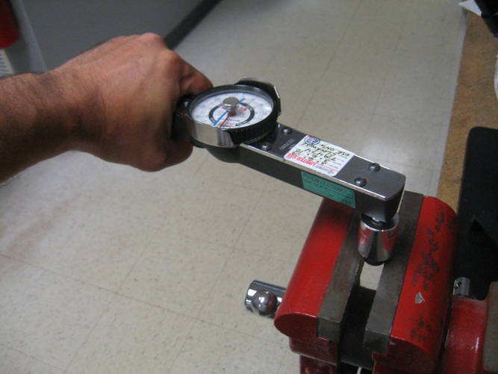

Figure 5: Torque gage testing connector weld

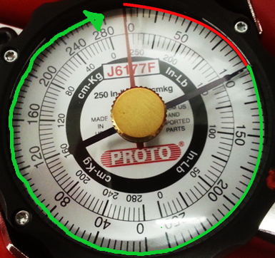

**Figure 6: Torque gage dial from testing connector weld with: red gauge needle set to 0 on the in-Lb scale; black memory needle showing 100 in-Lb result (passing). Black needle needs to be rest to zero before next test. Highlighted red zone indicates failure, highlighted green zone indicates passing.**

## Read dial; reading should have pushed the memory needle PAST 100 in-lb.

## Document the result of torque testing on HC001. At this point, this part is considered scrapped for destructive testing (511) and should be disposed of properly.

## If the black memory needle is below the 100 in-lb mark the weld is a failure, see Figure 6.

## Steps 7.1–7.10 will need to be repeated for each day that the job is being worked on.

## If failure occurs, stop welding and alert your supervisor or engineering.

# Procedure:

## Place key, tab side up, into mandrel, see Figure 7.

*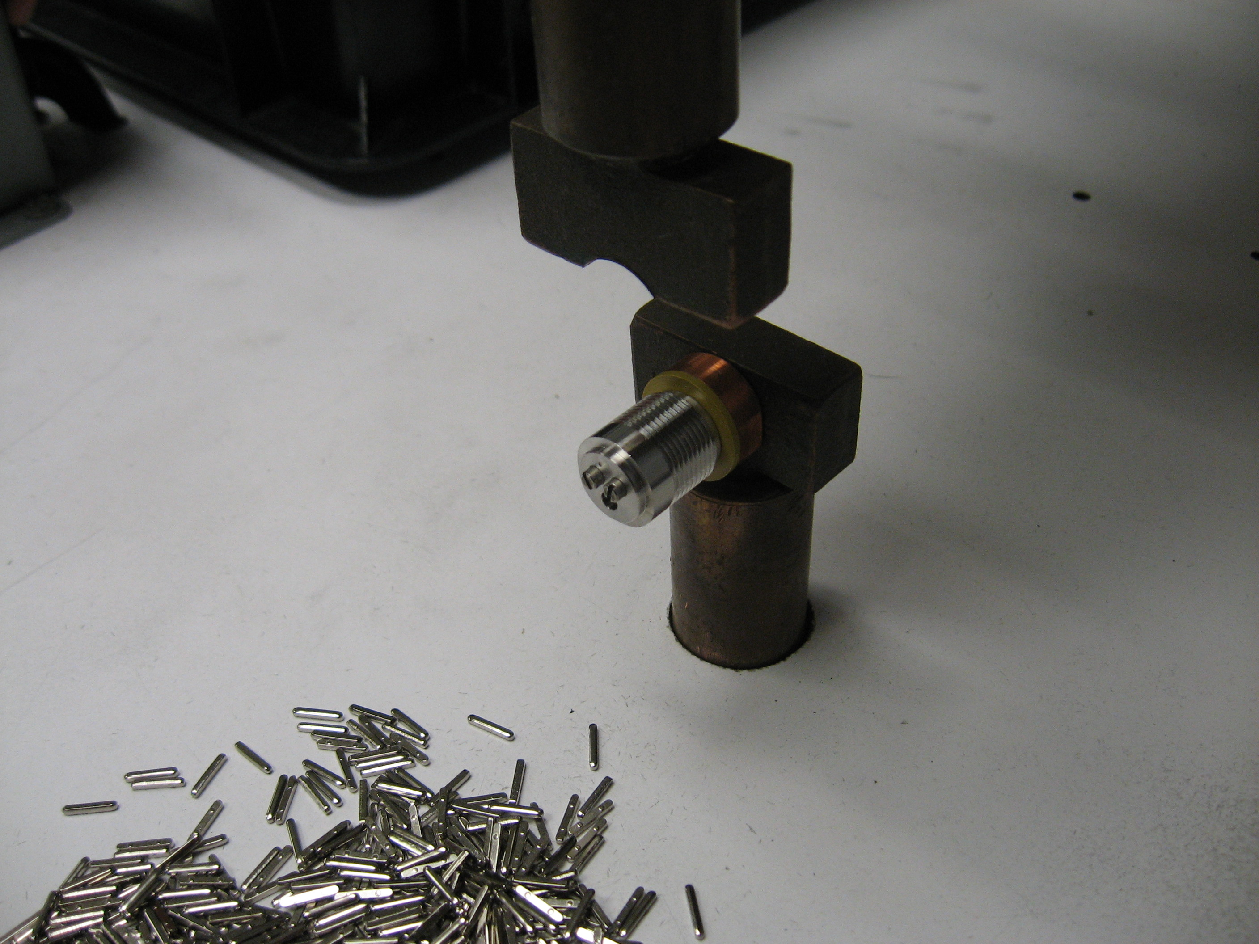

Tab side of key

Figure 7: Example Keys

## Slide shell over mandrel, making sure that marking dimple on the shell is always up, see Figure 8.

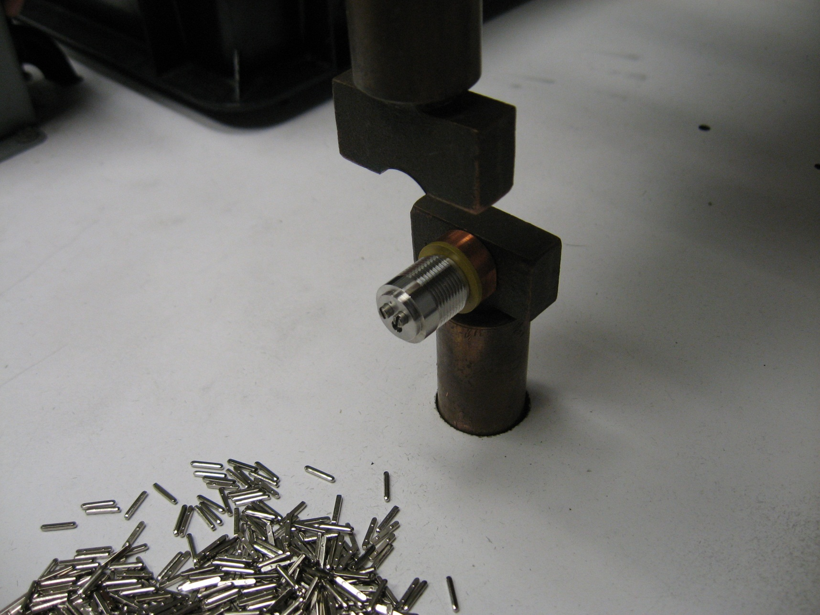

Dimple

Figure 8: Shell shown on mandrel

## Activate welder by activating the Optical Touch Buttons, maintain hands in the buttons until cycle is complete.

## Remove sub-assembly from mandrel after weld cycle is complete and put it directly onto fixture 60963-01 to check for proper alignment and location, see Figure 9 and Figure 10. This checks whether or not the key is straight to the shell. If you cannot get the subassembly to go completely on or if the fit is tight, stop and alert your supervisor or engineering.

## With the subassembly still on fixture 60963-01 rotate the part at least a quarter of a turn in either direction, see Figure 11. This checks whether or not the key is located the proper distance from the edge of the shell. If you cannot get the subassembly to rotate while pressed all the way to the bottom of the fixture, if you can feel any resistance to rotating the subassembly, or if you hear a clicking sound as you rotate the part, stop and alert your supervisor or engineering.

|  |  |  |
| --- | --- | --- |
| Keyway slots  Figure 9: Fixture 60963-01 | Figure 10: Subassembly on fixture: testing key alignment | Figure 11: Subassembly on fixture: testing key location |

## Remove sub-assembly from fixture 60963-01 when test is complete and place onto appropriate firing fixturing. Repeat steps 8.1 thru 8.5 until you have a welded sub-assembly for every fixture locations for the sub-assembly fixture plate. Continue onto 8.7 with the final part for each plate.

## At the end of each plate, clamp the final subassembly into the collet fixture (60593-00 or equivalent) with the collet closer and test the spot weld strength by torqueing to 100 inch pounds force (in-Lb) with the Mountz preset torque-limiting screwdriver (or equivalent) equipped with the 57878-00 adaptor (or equivalent). This checks that the spot-weld is remaining consistent and in specification. If one of the spot welds fails (the key falls off the shell), immediately stop making spot welds. Alert your supervisor or engineering and 100% test all of the parts on the last plate with the torque-limiting screwdriver.

## If any in-process adjustments are performed by engineering or supervisor, such as when an in process test fails in step, repeat steps 7.1–7.12.

## If job is not completed within one day, repeat steps 7.1–7.13.

## Move completed sub-assembly fixture plate to location C see (Figure 1), trays should not be stacked over 8 plates high. Replace with an empty sub-assembly fixture plate from location A. Repeat steps 8.1 thru 8.10 until you have processed all the parts on the job.