# Purpose

To provide instructions for technicians in the process and procedures necessary for sandblasting. For high temperature connectors sandblasting is performed on the metal of double isolated connectors and on oxidized connector pins.

# Responsibilities

## Connector manufacturing engineers are responsible for maintaining this procedure.

## The Production Supervisor, bench technicians, team leaders and/or lead persons are responsible for this procedure being carried out

# Affected Department/Product Group

Connector department

# Safety Precautions

## Eye Protection

## Sandblasting produces the potential for damage to the eyes. As such, eye protection is required for entrance to and utilization of the sandblast area.

## Electrical Hazards

## The sandblaster station as well as vacuum system can reach potentially lethal voltage levels.

# Equipment and materials

Micro Abrasive Blaster

Work Chamber

106A nozzle

Compressed Air

Shop Vac

Accubrade-27 abrasive powder, blend#1, 27 micron

Safety glasses

Nitrile Gloves

Petri dishes or equivalent

Magnifying light

Dust collector

# Preparation

## Vacuum Chamber

## In addition to High Temp connector metal, multiple products, made from multiple metals, are processed in the microblaster. To reduce the amount of contamination from the other metals it is a good idea to vacuum out the sand from the chamber.

### Open the chamber by lifting the glass cover and unlocking the front face.

### Unclip the shorting wire and remove the nozzle and hose assembly through the side of the chamber.

### Lift the metal mesh base out of the chamber.

### Vacuum all the interior surfaces including around the light and inside the front openings.

### Replace the metal mesh base and reattach the shorting clip.

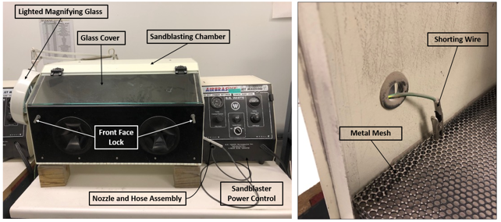

Figure 1: Sandblaster (Left) and Interior Mesh and Shorting Wire of the Sandblaster (Right)

## Nozzle Setup

## The goal of sandblasting the high temp metal is to roughen up the glass seal surfaces as evenly as possible. Using a 106A nozzle, which has a larger opening, facilitates this best. A smaller tip can cause deeper cuts in the metal resulting in an uneven surface finish.

### Unscrew and remove current nozzle tip. Set aside.

### Secure 106A tip to the nozzle.

## Turn on Sandblaster

## **NOTE: Make sure the dust collector is turned on before turning the sandblaster on. It is located on the far wall.**

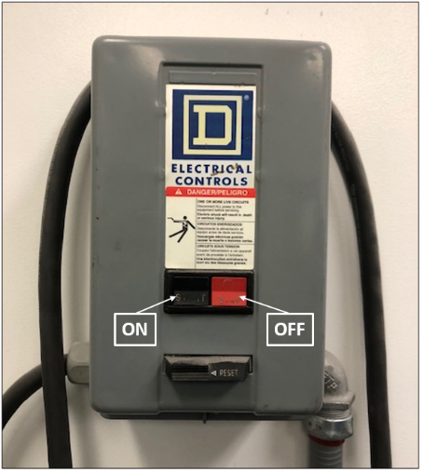

Figure 2: Dust Collector Power Controls

### Turn on the chamber light as well as the magnifying light.

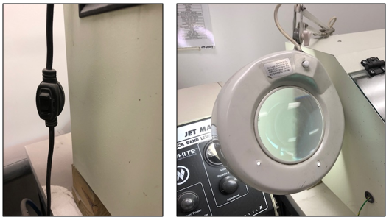

Figure 3: Power Button for Chamber Light (Left) and Magnifying Light (Right)

### Turn on the sandblaster power. No pressure adjustments should ever need to be made.

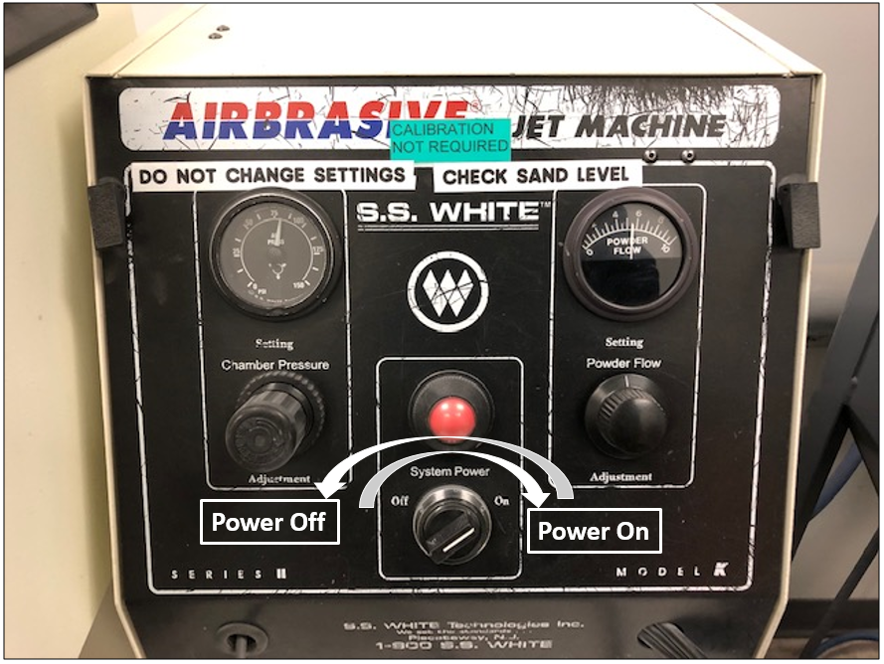

Figure 4: Sandblaster Power Control

### The sandblaster is controlled with a foot pedal. Locate the pedal and place it in a comfortable position for your foot control.

# Procedure

## High temp connector metal surfaces

### Remove one metal part from the job at a time. Hold the part with one hand in an area that is not to be sandblasted. The highlights in Figure 5 show the glass seal surfaces. The OD and/or ID of each component must be sandblasted on this surface.

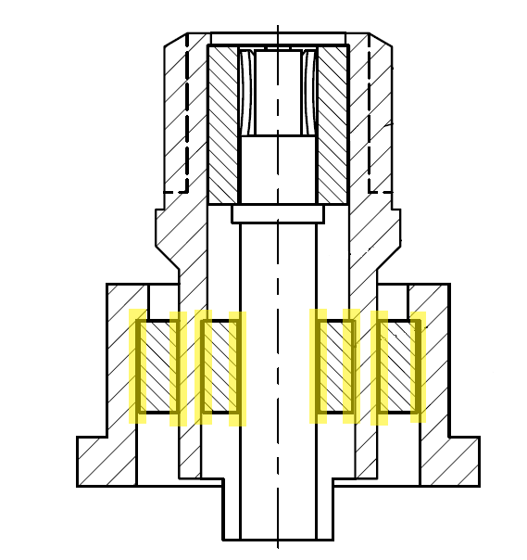

Figure 5: Highlighted areas represent where the metal will seal to glass and must be sandblasted for double isolated connectors.

### Aim the nozzle away from the part and begin pressing the foot pedal.

### NOTE: Often the sand will come out with a burst and then start to flow evenly.

### While still pressing the foot pedal, bring the nozzle in position, with the part approximately 1-2” away from the surface. Evenly sandblast the glass seal surface rotating the part as you sand.

### NOTE: For outer surfaces a 90 to 45 degree angle is best. For inner surfaces a 45 to 30 degree angle is best.

### Remove your foot from the foot pedal to stop the flow.

### Look at the surface you sandblasted by removing the part from the chamber and inspecting it under the magnifying light.

### NOTE: The goal is an even matte looking surface in the glass seal area. The best surfaces are achieved with a once around sand blast but it is acceptable to go back and sandblast an area that was missed.

### NOTE: Over sandblasting can create gouges and remove too much metal which is not only unnecessary but will have a negative effect on the glass seal.

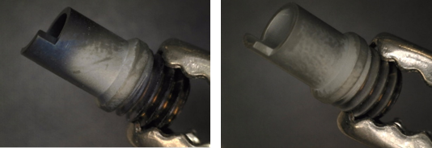

Figure 6: Example of bad (left) and good (right) sandblasted parts.

### Continue sandblasting one piece at a time.

### When you have sandblasted all the parts turn off the magnifying light, chamber light and sandblast power.

### Remove the 106A nozzle and replace it with the original nozzle tip. If last in the room, turn off the dust collector.

### The compressed air nozzle is located to the right of the sandblaster. Pick up each piece you have sandblasted and blow off the excess sand from the surfaces with compressed air.

## Viox glass pins

## The goal is to sandblast the pins, removing the heavy metal oxide formed when firing at >1200oC. Removing the oxide allows for successful welding. It is important not to sandblast the glass so a Teflon sheet mask is used (P/N: 100-9606-70).

### Insert the pins through the Teflon.

### Use tweezers to push the mask as far down against the glass as possible.

### NOTE: Make sure the hole in the Teflon mask is just large enough for the pins. The glass could get sandblasted if there are any cuts or excess holes in the mask.

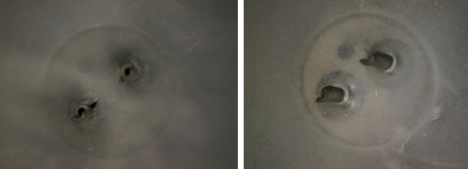

Figure 7: Example of a bad (left) and good (right) Teflon mask

### Hold the sheet with multiple pins exposed at an angle so you will be sandblasting the pin away from the Teflon.

### Aim the nozzle away from the part and begin pressing the foot pedal.

### NOTE: Often the sand will come out with a burst and then start to flow evenly.

### While still pressing the foot pedal, bring the nozzle in position, with the part approximately 1-2” way from the surface, and sandblast the entire OD of the pin rotating the pin as well as moving the nozzle.

### NOTE: It is often harder to sandblast the OD between the two pins so you may have to relocate the sheet in your hand to achieve this.

### Remove your foot from the foot pedal to stop the flow in between adjustments.

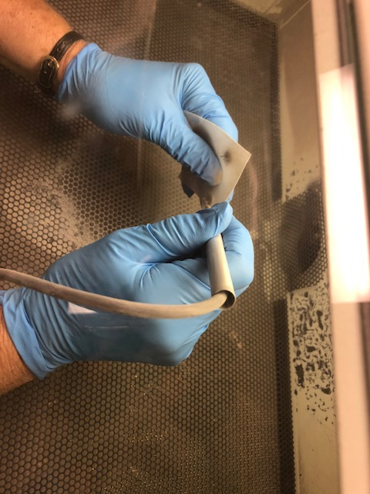

Figure 8: Sandblasting Pins

### Look at the surface you sandblasted by removing the sheet from the chamber and inspecting it under the magnifying light.

### Continue sandblasting one sheet of parts at a time.

### When you have sandblasted all the parts turn off the magnifying light, chamber light and sandblast power.

### The compressed air nozzle is located to the right of the sandblaster. Pick up each sheet you have sandblasted and blow off the excess sand from the surfaces with compressed air.

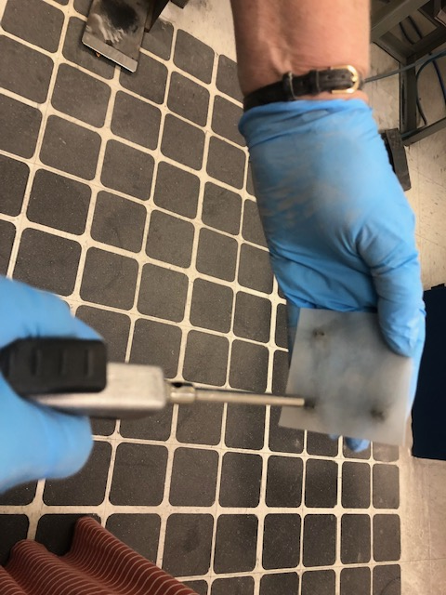

Figure 9: Blowing Pins Off

### Remove the connectors from the Teflon masks and again blow off each part as sand may have gotten through the Teflon mask.

# Clean Up

## Equipment

### When you have sandblasted all the parts, turn off the magnifying light, chamber light and sandblast power. If last in the room, turn off the dust collector.