This procedure is set up by firstly describing ESD controlled areas, followed by bullets of the general rules in the controlled ESD areas and lastly describing the detail of the equipment and procedure to maintain these rules.

# Reference Documents

### QA1040 ESD Control System Testing Requirements

### TA079 Wrist and Heel Strap Log Sheet

### TA1085 Amp Handling and Preparation

### TA1074 Foreign Object Debris Prevention

### TA1247 5S Work Benches

### TA129 Preflight Checklist

# ESD controlled areas

### Typically ESD areas are established where electronics are assembled or exposed, i.e. ICP Sensors, Microelectronics and Semiconductors.

### Manufacturing Engineers working with Production Supervisors are responsible for determining areas that require ESD control.

### ESD-Controlled Areas are defined as “an area where grounding (i.e. wrist, or heel strap) is required when electronic circuitry is contained in the product being processed”. To verify product contains electronics, the technician shall confirm with supervisor prior to beginning work. These areas shall be delineated on manufacturing floor using the following two criteria:

#### Yellow and black ESD-Control line in conjunction with a blue line. Indicates area where all ESD Control protocols (defined in this procedure) shall be followed.

#### Yellow and black ESD-Control line only. This indicates an area that is *within a defined single-blue-lined area* where all ESD Control protocol must be followed.

#### For instances where ESD control is not normally required, the Manufacturing Engineer can communicate to Technicians that ESD Control is required via a note in the Router. In those cases, this procedure is invoked for those products, however the ESD-Control lines on the floor are not required.

### A single blue line. Indicates an area where only ESD coats must be worn to enter.

### Any non-standard equipment (i.e. pistol drill, dremmel tools, calculator) that could be used on an ESD bench requires prior approval from both the Production Supervisor and/or Manufacturing Engineer. Management reserves the right to add to, update or otherwise modify any non standard equipment.

# ESD Coat, Wrist and Foot Strap Requirements

## ESD Coats

### Special White ESD Coats for Clean Room Applications (micro electronics, microphone assembly and engine sensor assembly)

#### White cuffed ESD Coats shall always be worn as the outer layer in any area designated as a “clean room.”

#### White cuffed ESD Coats must be worn and properly snapped-up prior to entering the Clean Room. Note: It is allowed to leave the top snap open.

#### Snaps must be fastened and the special cuffs must be in contact with the skin. (Wrist straps are not required). These coats have a special snap on the pocket for grounding to a workbench. The white coat outer layer shall be grounded regardless of any additional garments worn underneath.

#### These coats shall not be worn outside of the Clean Room or changing area.

### Blue and/or Gray ESD Coats for general assembly

#### Blue/Gray ESD coats must be snapped-up prior to entering and while within an ESD control area and when working with or transferring ESD sensitive product. Note: It is allowed to leave the top snap open.

#### Coats must be stored outside the ESD controlled area on designated racks for eventual return into the area. Note: It is not allowed to leave/store an ESD coat on the back of the chairs in an ESD controlled area.

#### Coats must be maintained for compliance per “QA1040 ESD Control System Testing Requirements”.

#### Blue and/or Gray ESD coats shall NOT be worn/stored in the following areas/locations due to possible contamination

#### stored with non-ESD coats/jackets or clothing

#### while eating or on break in a company cafeteria

#### in the Sandblasting and Polishing Rooms

#### in lavatories

#### outside of the building

#### *Exception: ESD coats are allowed in the Production TA machining department by personnel located in the machine shop.*

### Standard Personal clothing is not permitted to extend out from under the ESD coats (i.e.: shirt sleeves extending past the long or short sleeve cuff, sweatshirt hoods extending past the collar; wool/winter hats, etc.). Note: ESD coat sleeves may be rolled up, as long as personal clothing does not extend past rolled-up sleeves.

### Each technician will be assigned two ESD coats unless special situations might require additional quantity. It is recommended that ESD coats be washed monthly.

### New or replacement ESD coats should be ordered through employees Supervisor. Contaminated or damaged coats shall be reported to supervisor for replacement.

### Baseball caps are permitted to be worn in an ESD controlled area.

### **Unusual Conditions**: ESD Coats are not required to be worn when performing tests on high-pressure pumps where the ICP circuits are enclosed. Pressure calibration technicians do not have to be connected to an ESD monitoring system if they are cycling or testing non ICP elements.

### ESD Coats with “Key Option”

#### ESD coats with a “key option” snap on the coat pocket and cuff will be considered part of a Groundable Static Control Garment System when properly connected to a Continuous Monitor. In this case a strap is connected from one coat pocket snap to the continuous monitor and a wrist strap is connected to the snap on the coat cuff. NOTE: It is the Technician’s responsibility to ensure that the cord connecting the wrist strap to

#### the coat cuff remains connected. Be aware that the alarm will not sound from the continuous monitor if this connection is broken.

#### ESD coats with elastic cuffs only require that the strap is connected from the snap on the coat pocket to the continuous monitor as long as the elastic cuff is in contact with the skin.

#### Temporary use of this system at a non-monitored bench ground port, such as at an oven or ionizer, is permitted only if proper function was verified by previous successful attachment to a Continuous Monitor.

## Foot Straps

### Foot straps can be worn when wrist straps are not practical. (I.e. welding and etching).

### Foot straps must be worn on each foot to ensure that a continuous path to ground is maintained. Note: The user must be standing in order for strap to function properly.

#### The conductive blue ribbon must be tucked inside the shoe with as much contact area exposed to the bottom of the stocking foot.

#### Foot straps rely upon the perspiration layer inside of the shoe to make contact through the stocking.

### Foot straps and conductive blue strip must be kept clean.

#### Foot straps should be cleaned as necessary with an ESD mat cleaner.

#### Do not use cleaners with silicone. Silicone buildup will create an insulative film on the surface.

### Foot straps must not be worn in the Machine Shop or outside of the building. (NOTE: Only TA machining department personnel located in the machine shop are authorized to wear foot and wrist straps in the machine shop.)

## Checking and Monitoring Foot and Wrist Straps

### Any technician with a wrist strap and/or heel strap without a continuous monitor system must have a ground test conducted twice daily and recorded on “TA079 Wrist and Heel Strap Log Sheet” or by using the Smart Log Pro system in NC. Wrist and heel Straps are monitored at the beginning of shift and after meal break.

### When checking straps on wrist/foot strap tester:

#### Hold the button on tester for approximately 5 seconds.

#### If wrist strap fails wrist/heel strap tester apply ESD lotion to wrist and re-test.

#### If strap fails again see your Supervisor for replacement.

#### For heel strap test failures, clean strap and re-test.

#### If heel strap fails again see your Supervisor for replacement.

### NOTE: Micro electronics technicians use continuous monitors and are not required to ground test. Any guest working at the bench is required to use the continuous monitor port. Guest ports are not an option.

# ESD Work Stations and Grounding

## Work Station

### The standard ESD work station shall consist of the following (at a minimum):

#### a grounded work bench with an grounded ESD work surface

#### grounded ESD mat covering on risers

#### grounded power strip

### Each ESD bench:

#### must be identified by a control number maintained through PCB’s preventive maintenance program. Any work station without a control number is considered a non-ESD work station.

#### that is new or rewired must be reported to the Quality Assurance department for testing, approval and identification with an ESD Control number prior to its use affecting any ESD Sensitive product.

#### shall be tested in accordance to “QA1040 ESD Control System Testing Requirements”.

#### Benches in non-ESD controlled areas that require an ESD continuous monitor (e.g. benches used for an ultrasonic cleaner) must also be tested periodically in accordance with QA1040 and be controlled through PCB’s preventive maintenance program.

## Grounding

### All grounding to earth is maintained through attachment to the ground of the outlet strip. Grounds should never be in series (i.e. Daisy chain).

### Ground port can be used in areas where continuous monitors are not practical. (i.e. ovens and welding / etching.)

# Standard Equipment

## Continuous Monitoring System

### Note: PCB utilizes a Continuous Monitoring system for ESD Wrist Strap control. This system provides a continuous monitoring of the strap to ensure it provides adequate ESD control.

### Connection of wrist straps must only be maintained through the continuous monitoring port of the unit.

### Guest ports must be physically blocked / plugged. This will ensure that only the continuous monitoring circuit is used by the technician.

#### In the event, due to human chemical make-up, a connection to the continuous monitoring port of the unit cannot be used as confirmed by a Supervisor, the guest port may be used and records maintained twice daily by the worker using the “TA079 Wrist and Heel Strap Log Sheet”.

#### Testing is conducted in accordance with QA1040 ESD Control System Testing Requirements.

### Any Technicians, Engineers and/or Visitors, prior to handling product (which includes product without electronic components) on an ESD bench; are required to wear an ESD coat and follow one of the following three processes.

#### Connect to a continuous monitor.

#### Connect to a monitor to verify their wrist strap is grounded properly and then connect to a guest port.

#### Verify their wrist strap and connect to the guest port. When connecting to the guest port remove the plug from the guest port and connect to the guest port.

#### When departing from the bench, the dummy plug must be returned to the guest port.

### NOTE: In some cases ESD prevention is maintained by ESD floor mats, foot straps and ESD chairs with drag chains i.e. welding and etching rooms.

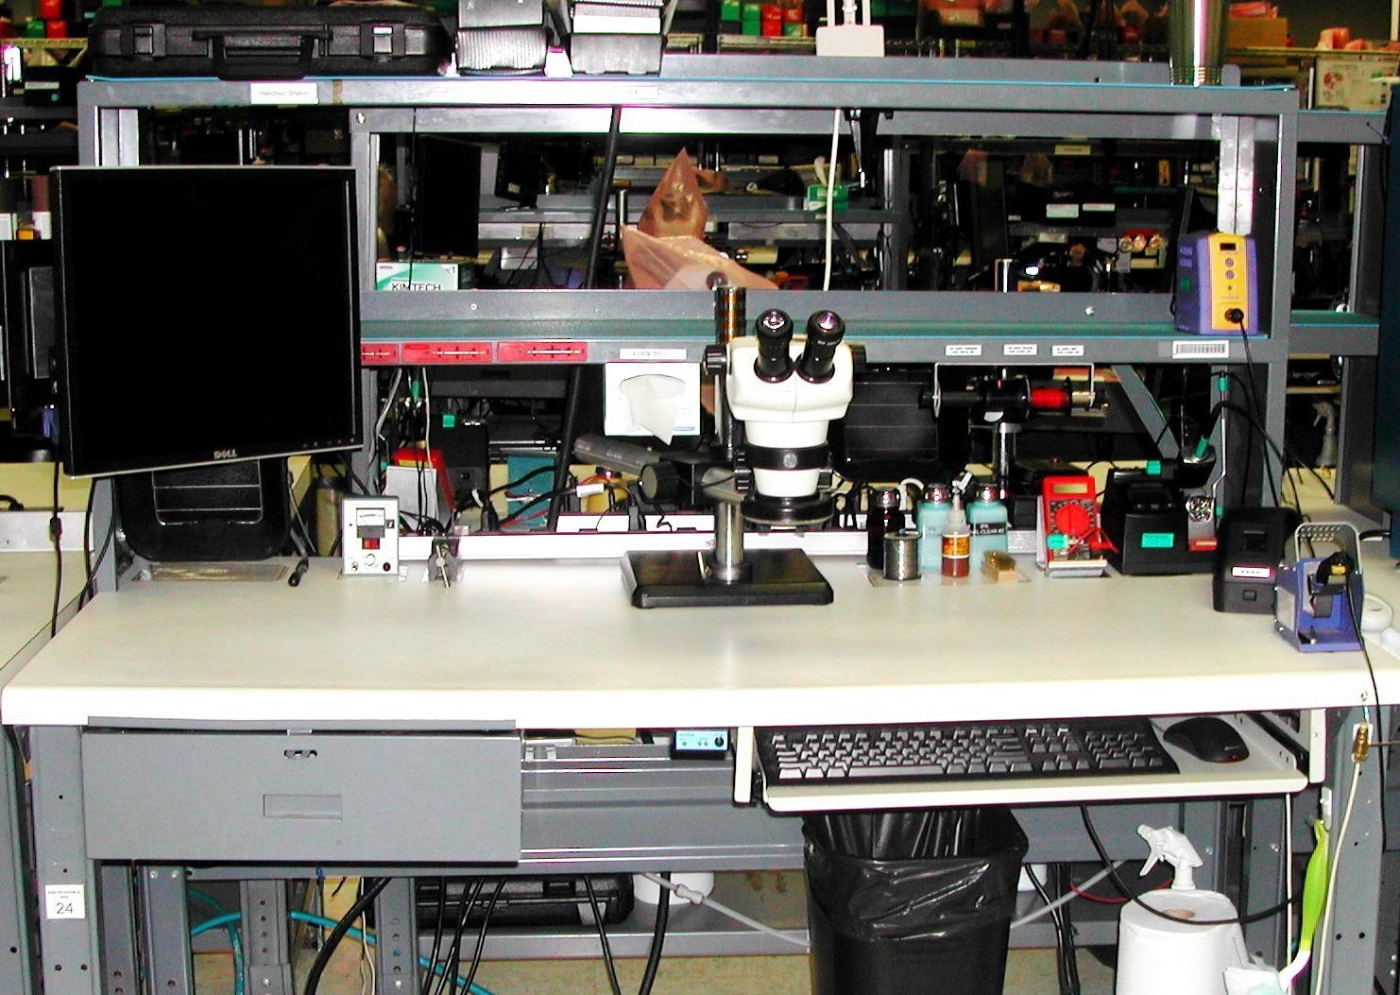

Monitor

Wip Shelf

Mouse

ESD Cleaning Material

Outlet strip

Thermal strippers

Paperwork Area

Cleaning liquids, fluxes, solder

Approved Drink Container

Keyboard

ESD Monitor Plugs

Tool Drawer

Typical Assembly Bench

# 0215161114a

Drawer with misc. fixtures and tools.

WIP shelf

Shaker amplifier

ESD Monitor

Monitor

Mouse

ESD Monitor

Bar Code reader

Approved Drink Container

Calibration Equipment

Paperwork

Key Board

Mid-Range Shaker

Sensors

Glue and Acetone

Card

Printer

Typical Calibration Station

# Work Station Product Contamination Prevention

### For contamination control requirements, see procedure TA1247 5S Work Benches.

2. For foreign object prevention see TA1074 Foreign Object Debris Prevention.

### For personal items allowed in an ESD designated area, the following applies:

#### One approved drink container stored/placed on the riser or in a company sanctioned cup holder attached to the side of the bench.

#### One approved audio electronic device shall be stored in the pocket of the ESD coat or on the open drawer.

#### All other personal item(s) must be stored in an assigned locker unless otherwise directed by supervisor.

#### Sweaters and jackets cannot be hung on the backs of workstation chairs and must be hung in designated and defined areas located outside of the ESD control area.

### Paper work (routers, assembly procedures, etc.) shall be kept in an anti-static bags/sleeve unless technician is recording data.

#### When recording data or referencing the procedure outside of the anti-static sleeve, be sure to keep paperwork approximately 1 foot (12 inches) away from exposed work-in-progress.

* + - 1. Approved ESD cleaner must be used to clean work mats and benchtops. It is recommended that all ESD control work surfaces be cleaned daily. ESD cleaning supplies including paper towels shall be stored on the foot riser.
      2. Static generating materials must be kept off ESD work mats and benches (e.g. plastic bottles, plastic bags, paper products, etc.).
      3. Clear plastic waffle trays are not allowed on an ESD work bench work area surface excluding micro mini waffle trays.
      4. Only ESD-safe double-sided tape may be used on ESD-controlled work benches.
      5. PCB issued Employee Identification Tags shall be covered by ESD coat.

# Non-Workstation Equipment;

## ESD Floor Mats ,ESD Conductive Flooring (NC facility) and Microelectronics Dissipative Flooring (NY facility):

### Testing conducted in accordance with “QA1040 ESD Control System Testing Requirements”.

## Miscellaneous Equipment

### Any employees transporting product in or out of an oven in an ESD controlled area are required to plug into the ESD grounding port.

### Benches, and equipment such as ovens, cleaning stations, nitrogen cabinets, etc., where ESD protection is required, but continuous monitors are not practical, provide personnel grounding directly through attached wrist strap cord jacks.

### Compliance of a strap and cord used at these locations must have been previously verified through successful testing or use of a continuous monitor.

# Transporting, Storage, Handling and Packaging

Equipment Descriptions:

Pink Anti-Static Bag: These bags are identified by their semi-transperant pink color. Pink Anti-Static Bags are used for holding parts non ESD sensitive they do not generate static, and are utilized for storing, identifying and transfering components when preparing for entry into an ESD Controlled Area.

Inventory Control Department to procure “Anti-Static Pink Poly Bags” compliant to MIL-B-81705, MIL-PRF-81705 (all types and classes), ANSI/ESD S541, and/or an equivalent specification.

E.S.D Shield Bag: These bags are identified by their silver metal color and reflective appearance. E.S.D Sheild Bags are for storing and/or transfering E.S.D sensitive components regardless of your location. For Inventory Control Department to procure: “Static Sheilding Bags” compliant to MIL-B-81705, MIL-PRF-81705 (all types and classes), ANSI/ESD S541, and/or an equivalent specification.

**ESD Transfer Box (Black):** These boxes are a black fluted plastic conductive boxes with lids. These boxes are used for transport and storage of ESD sensitive parts or products.

Inventory Control Department to procure“ESD Boxes” that comply with a surface resistance of RTT < 1x10E5

**ESD Waffle Pack & “Hinged” Box (Black):** These black conductive containers are used in Microelectronics Department for storing of microelectronic circuits. Inventory Control Department to procure “ESD waffle pack & hinged boxes” that comply with a surface reistance of RTT < 1x10E5.

## ESD Sensitive Parts

### All ESD sensitive product must be transported and stored in ESD Transport Boxes or ESD safe containers (i.e. transport boxes with their lids installed correctly, Faraday cages) capped with protective connector covers, shorting caps or springs and or in ESD protected bags. NOTE: Items in shipping containers i.e. jewel cases do not require ESD boxes.

### If a large enough ESD box is not available that allows the sensor \ cable combination to be covered, any exposed ESD sensitive section, or surface to be welded, must be covered by an ESD Sheild bag or approved ESD cap or cover.

### All ESD sensitive product must only be removed from an ESD container at a controlled ESD workstation.

### All special ESD packaging required per Customer Purchase Orders are documented on the appropriate BOM. Some examples of acceptable and unacceptable transport boxes and bags are shown in “QA1040 ESD Control System Testing Requirements”.

### Elements may generate a charge during handling, therefore all elements must be discharged prior to assembly per document “TA1085 Amp Handling and Preparation”.

## ESD Transport Containers:

### Each product group will maintain adequate inventory of ESD containers. Planning personnel, including inventory coordinators and pickers, and TA Supervisor(s) are responsible for:

### reviewing, evaluating and maintaining the integrity of their ESD containers inventory. Container condition is checked for ESD compliance per “QA1040 ESD Control System Testing Requirements” maintaining availability of sufficient container inventory by on-going review and replacement of worn containers.

### All ESD sensitive product shall be moved in ESD containers as defined in this procedure. When product is taken to Logistics, empty ESD containers may be stored in Logistics.

### Logistics and Production Inventory areas may use noncompliant containers for storage of Non-ESD Sensitive product.

### Where an assembly area only works on non-ESD product (such as the cables assembly area), it is acceptable to utilize noncompliant containers for product storage or transport.

### Each Product Group can utilize the empty ESD containers in Logistics for replenishment to their respective groups, but only those that are conforming, as per “QA1040 ESD Control System Testing Requirements”.

**Appendix A**

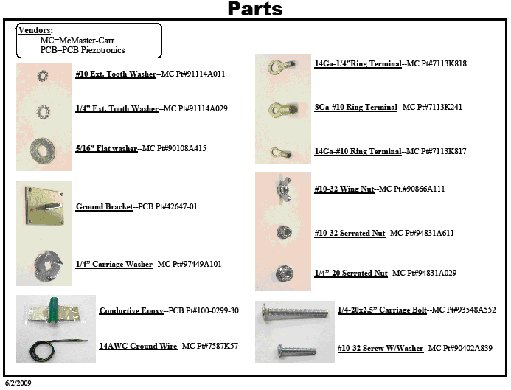

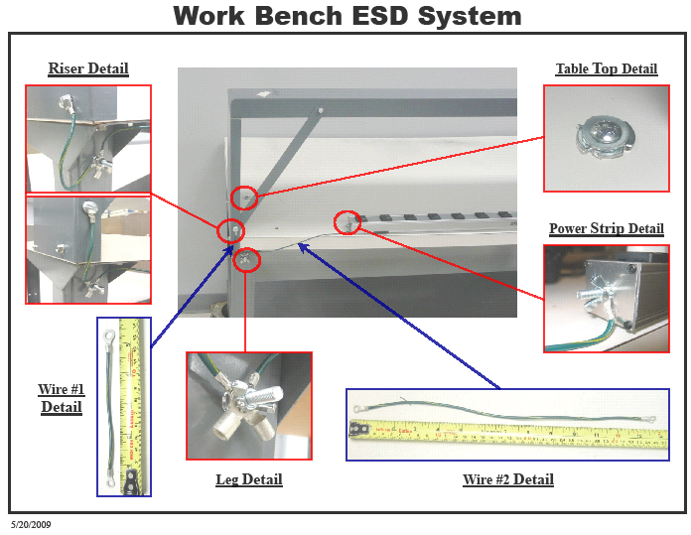

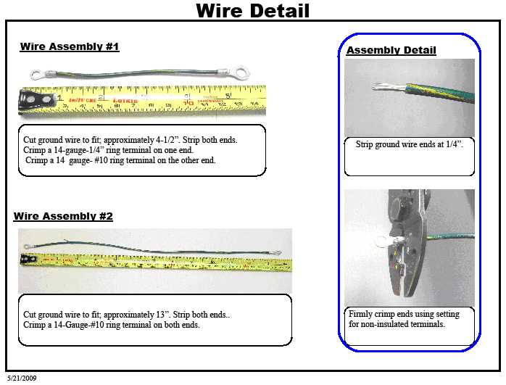

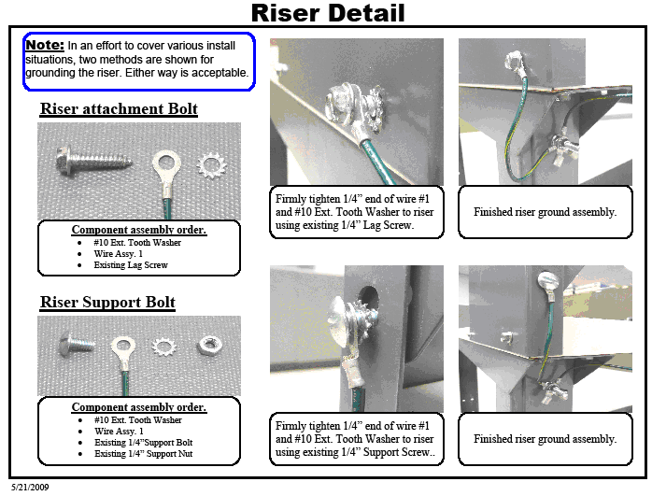

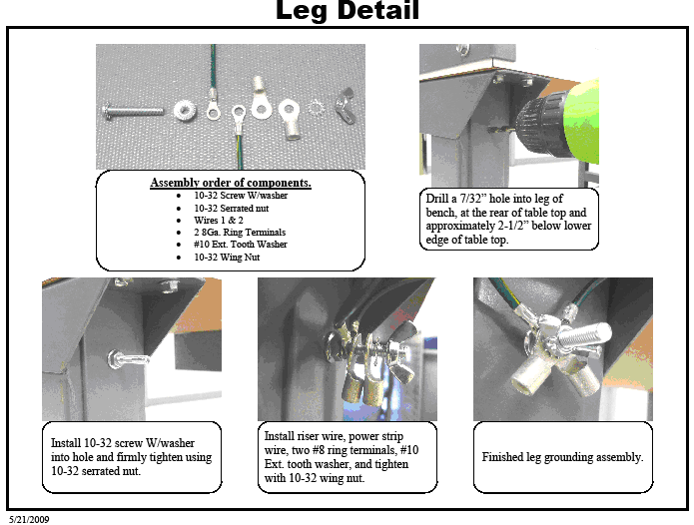

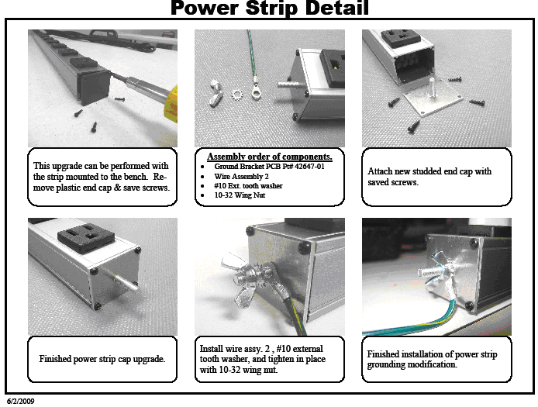



Wrist strap

ESD monitor

2 (1meg) Shelf connection cables

Phone type cable for wrist strap monitor box

Operator 2 Mat connection

Ground wire connected to metal housing of outlet strip

Ground bolt on leg of Bench

2 ground snaps (1 on each shelf mat)

1 ground bar wire

Operator 1 mat connection and snap (silver H20E applied between snap and surface)

Plug into properly grounded 110 volt AC outlet

1 Surface ground bolt through to metal leg

1 Surfaceground bolt through to metal leg (silver H20E applied between washers and surface)

Ground bolt on leg of Bench

**Appendix B - Process FMEA Information**

|  |  |  |  |  |  |  |  |  |  |  |  |  |  |  |  |  |  |  |  |  |  |  |
| --- | --- | --- | --- | --- | --- | --- | --- | --- | --- | --- | --- | --- | --- | --- | --- | --- | --- | --- | --- | --- | --- | --- |
|  | | | | | | | | | | | | | | | | | | | | | | |
|  | | |  |  | | | | |  |  | |  | |  | FMEA Original Date: | | | | | 11/18/2020 | | |
|  | | | | | | | | | | | | | | | FMEA Revised Date: | | | | | N/A | | |
| **Item or Process Step** | **Potential Failure Mode** | **Potential Effect(s) of Failure** | | | **S\*** | **Potential Cause(s)** | **O\*** | **Current Controls** | | | **D\*** | **R\*** | **RecommAction** | | | **Responsand Target Date** | **“After” Action Taken** | **S\*** | **O\*** | | **D\*** | **R\*** |
| Component storage & handling | Damaged SiO2 or trace | Will cause direct or latent failure | | | 8 | Packaging not adequate | 2 | EN1107 Sec. 4 & 5 | | | 5 | 80 |  | | |  |  |  |  | |  |  |
|  | Damaged SiO2 or trace | Will cause direct or latent failure | | | 8 | Re-Packaged into inadequate package | 2 | Product must be in proper container per QA1008 Sec. VI-5 | | | 5 | 80 |  | | |  |  |  |  | |  |  |
|  |  |  | | |  |  |  |  | | |  |  |  | | |  |  |  |  | |  |  |
| Sensor Assembly | Damaged SiO2 or trace | Will cause direct or latent failure | | | 8 | Tech. not properly grounded | 3 | QA1008 Sec. IV | | | 4 | 96 |  | | |  |  |  |  | |  |  |
|  | Damaged SiO2 or trace | Will cause direct or latent failure | | | 8 | Electrical charge from clothing | 3 | ESD jackets required per QA1008 Sec. III | | | 4 | 96 |  | | |  |  |  |  | |  |  |
|  | Damaged SiO2 or trace | Will cause direct or latent failure | | | 8 | Blue coat not effective | 3 | Coats regularly tested per QA1040 Sec. 3 | | | 3 | 72 |  | | |  |  |  |  | |  |  |
|  | Damaged SiO2 or trace | Will cause direct or latent failure | | | 8 | Electrical charge from hand tools | 2 | Hand tools must be tested per QA1008 Sec. II | | | 3 | 48 |  | | |  |  |  |  | |  |  |
|  | Damaged SiO2 or trace | Will cause direct or latent failure | | | 8 | Electrical charge from personal items/nonessential insulators | 3 | Approved personal items only per QA1008 Sec. VI. | | | 3 | 72 |  | | |  |  |  |  | |  |  |
|  | Damaged SiO2 or trace | Will cause direct or latent failure | | | 8 | Electrical charge from workbench | 2 | Workbench properly grounded per QA1008 Sec. IV. Benches tested regularly per QA1040 Sec. 1 | | | 2 | 32 |  | | |  |  |  |  | |  |  |
|  | Damaged SiO2 or trace | Will cause direct or latent failure | | | 8 | Unauthorized visitors | 4 | ESD areas marked per QA1008 Sec. II | | | 2 | 64 |  | | |  |  |  |  | |  |  |
|  | Damaged SiO2 or trace | Will cause direct or latent failure | | | 8 | Paperwork creating electrical charge | 2 | Paperwork must be kept in anti-static sleeves or bags per QA1008 Sec. VI. | | | 2 | 32 |  | | |  |  |  |  | |  |  |
|  |  |  | | |  |  |  |  | | |  |  |  | | |  |  |  |  | |  |  |
| Welding/ Etching | Damaged SiO2 or trace | Will cause direct or latent failure | | | 8 | Electrical charge during welding or etching operation | 5 | Foot straps worn and regularly tested per QA1008 Sec. III | | | 2 | 80 |  | | |  |  |  |  | |  |  |
|  |  |  | | |  |  |  |  | | |  |  |  | | |  |  |  |  | |  |  |
| Sensor Handling | Electrical overshock | Direct or latent failure | | | 8 | Damaged when transported from workbench to next operation | 4 | Product must be transported in proper container per QA1008 Sec. VI-5 | | | 2 | 64 |  | | |  |  |  |  | |  |  |
|  | Damaged SiO2 or trace | Will cause direct or latent failure | | | 8 | Incorrect box/bag/container used for transport | 4 | Product must be transported in proper container per QA1008 Sec. VI-5 | | | 3 | 96 |  | | |  |  |  |  | |  |  |
|  |  |  | | |  |  |  |  | | |  |  |  | | |  |  |  |  | |  |  |
| Final Test & Inspection | Electrical Overshock | Direct or latent failure | | | 8 | ESD susceptible product handled without ESD protection | 4 | Products requiring special handling in Final Inspection noted on Router FI step | | | 2 | 64 |  | | |  |  |  |  | |  |  |
|  |  |  | | |  |  |  |  | | |  |  |  | | |  |  |  |  | |  |  |
| Sensor Packaging & Shipping | Damage to internal curcuitry | Bad voltage bias | | | 8 | ESD warnings not adequate | 2 | ESD packaging, labelling per BOM & Router | | | 2 | 32 |  | | |  |  |  |  | |  |  |
|  |  |  | | |  |  |  |  | | |  |  |  | | |  |  |  |  | |  |  |
|  |  |  | | |  |  |  |  | | |  |  |  | | |  |  |  |  | |  |  |
| **Risk Priority Number =** | | | | | | | | | | | |  | “After” Risk Priority Number = | | | | | | | | |  |

*S = Severity, O = Occurrence, D = Detection Key

Scaling is 1-10 based on the rating scale in EN036

Note: RPN > 100 requires action to reduce risk