Contents

I. Instructions 2

A. Packaging – Large Window Box 2

B. Packaging – Clam Shell Box 3

C. Packaging – Outside Box 4

D. Packaging – High Temp 5

E. Packaging – Seismoprobes 6

# Instructions

Figure 1

## Packaging – Large Window Box

### The Part Number of the type of box is “0220604”.

### The Reference (model) Number to be package in this type of box is “190501-00-00-10”.

Figure 2

### Lay the box flat on the table with the clear window facing *up (see figure 1).*

### For 190501, apply the “510 Grease” lable to the inside of the box lid *(see figure 2)*

Figure 2

### 

Figure 3

### Remove the center square carboard section *(see figure 2).*

### Bend up the tabs of the box at the crease location as shown *(see figure 2).*

### Place the part in the window with the etching information facing up *(see figure 2)*.

### Fold up the tabs of the box so that the sensor in inclosed *(see figure 3)*.

### Ensure that etching of the sensor can clearly be seen in the opening *(see figure 4)*.

Figure 4

### Close up the lid of the box *(see figure 4)*.

### Apply the corresponding barcode label to the front of the box *(see figure 4)*.

### Apply the corresponding barcode label to the top and back (right side) of the box *(see figure 5)*.

### Once the sensor has been received in, open the “Bently Ship”screen and ensure that the serial numbers has been loaded in to the database *(figure 6)*.

Figure 5

Figure 6

## Packaging – Clam Shell Box

### The Part Number of the type of box is “02200118”.

Figure 1

### The Reference (model) Number to be package in this type of box is:

#### 142536-01

#### 142536-02

#### 142758-01

#### 142758-02

Figure 2

#### 330500-00-20

#### 330525-10

#### 16331

#### 164738

#### 137442-01

Figure 3

#### 200350-010000.

### Lay the box flat on the table with the clear window facing *up (see figure 1).*

### Remove the center squares carboard section *(see figure 2).*

### Assemble the outer box *(see figure 2).*

### Place the part in the window with the etching information facing up *(see figure 3)*.

top

Figure 4

### Fold up the two halve of the lids that the sensor in inclosed between to plastic sheets. Ensure that entire etching of the sensor can clearly be seen in the plastic *(see figure 3)*.

### Place the enclosed sensor in the the box ensuring that etching of the sensor can clearly be seen in the cardboard opening *(see figure 4)*.

### Close up the lid of the box *(see figure 4)*.

### Apply the corresponding “Avery” label to the top of the box *(see figure 4)* and the barcode label to the bottom *(see figure 5)*.

Bottom

Figure 5

### Once the sensor has been received in, open the “Bently Ship”screen and ensure that the serial numbers has been loaded in to the database (*figure 6)*.

Figure 6

## Packaging – Outside Box

### The Part Number of the type of box is “02200011”.

### The Reference (model) Number to be package in this type of box is:

Figure 1

#### 177230-02

#### 177230-00-01-05

#### 177230-01-02-05

#### 177230-01-01-05

#### 177230-02-01-0

### Remove the center squares carboard section *(see figure 1).*

### Assemble the outer box *(see figure 1).*

### Place the studs (081A19) and (081M84) in the pink bag and place on plastic window on the bottom of the cardboard clamshell *(see figure 1).*

Figure 2

### Place the part in the window (over the pink bag with studs), ensuring the the etching information isfacing up *(see figure 1)*.

### Fold up the two halve of the lids that the sensor in inclosed between to plastic sheets (see figure 2).

### Ensure that entire etching of the sensor can clearly be seen in the plastic *(see figure 2)*.

Figure 3

### Place the enclosed sensor in the the box ensuring that etching of the sensor can clearly be seen in the cardboard opening *(see figure 2)*.

### Close up the lid of the box *(see figure 2)*.

### Apply the corresponding “Avery” label to the front of the box and the barcode label to the bottom *(see figure 2)*.

### Fold Calibration Certificate in half and place in a 8 1/2” X 11”pink bag *(see figure 2)*.

Figure 4

### Place the boxed sensor into the pink bag (with certificate) and seal *(see figure 3)*.

### Once the sensor has been received in, open the “Bently Ship”screen and ensure that the serial numbers has been loaded in to the database ( *figure 4)*.

## Packaging – High Temp

### The Part Number of the type of box is “02290124”.

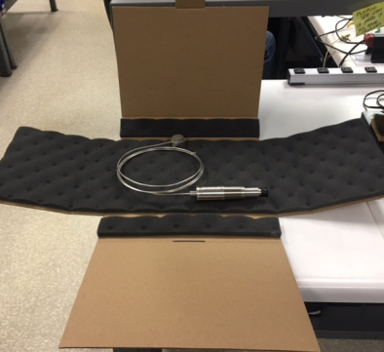

Figure 1

### The Reference (model) Number to be package in this type of box is:

#### 330450-XX

#### 330750-XX

#### 330752-XX

#### 350900-XXX

### Place sensor in box. *(see figure 1).*

### 

Figure 2

### Fold in left and right box flaps. *(see figure 2).*

### Fold front and back box flaps into poistion, inseting tab in slot.

### Apply the correcponding barcode label and Type S label to the front flap of the box. *(see figure 3).*

### Note: “Type S” label is only used on 330750 only.

Figure 3

### Apply the corresponding barcode label to the back of the box. *(see figure 4).* Note: This is placed on at final inspection.

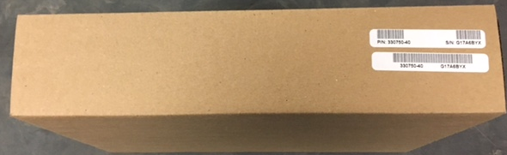

Figure 4

### Once the sensor has been received in, open the “Bently Ship”screen and ensure that the serial numbers has been loaded in to the database (*figure 5)*.

Figure 5

## Packaging – Seismoprobes

Figure 1

### Packaged same as “Large Window Box” except barcode label placement is different. *(see figure 1 and figure 2).*

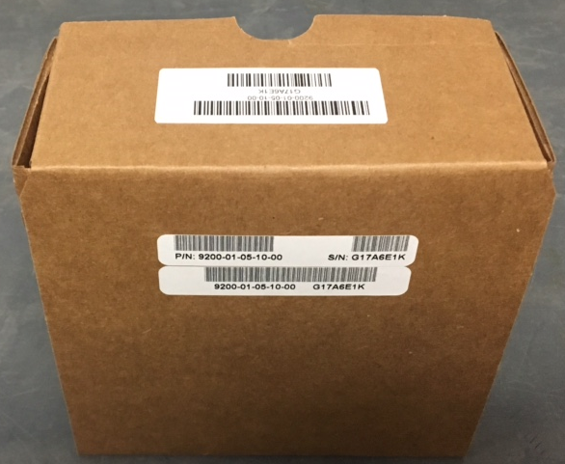

Figure 2

### Once the sensor has been received in, open the “Bently Ship”screen and ensure that the serial numbers has been loaded in to the database *(figure 3).*

Figure 3