I. Scope 2

II. Procedure 2

A. Bar Code Label 2

B. Printed Lable Configurations 2

# Scope

### This user guide defines general criteria for applying barcode labels all products processed through Quality Assurance Final Inspection in Depew and Halifax facilities.

# Procedure

## Bar Code Label

### **NOTE**: it is important to first verify that the bar code label’s model and serial number match what’s etched on the product.

### Attach the bar code labels to the applicable packaging

#### shear box

#### ESD bag

#### Pink bubble-wrap bag

## Printed Lable Configurations

### If the sensor has a configured number on the job router, there must be two different barcode labels. See figure 1. The bottom bar code should state the configured model (*see figure One*)

**Figure One**

### If the sensor is built per main assembly, then the barcode labels must display the base model number. The model may be manually changed to add or remove characters. Example when a cable is supplied, the /NC is removed *(see. figure two).*

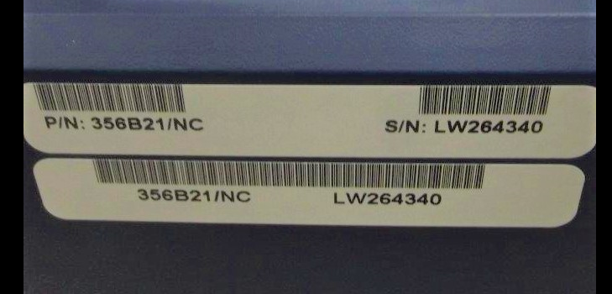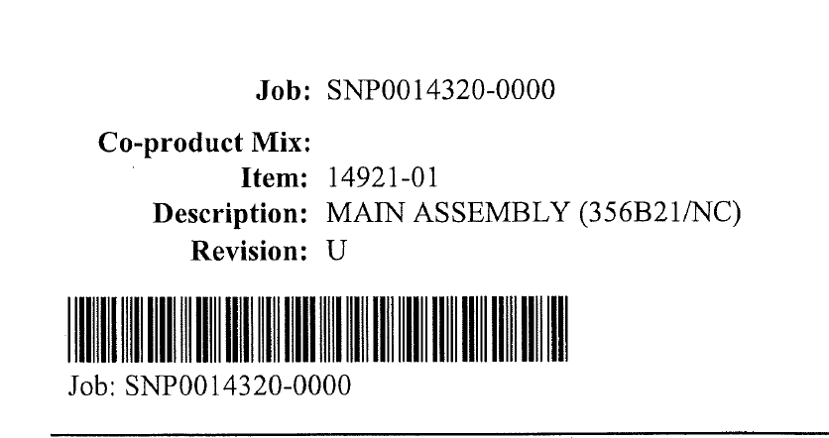

**Figure Two**

### If the sensor is a base model number it should have two matching barcode labels with model and serial numbers (*see figure three).*

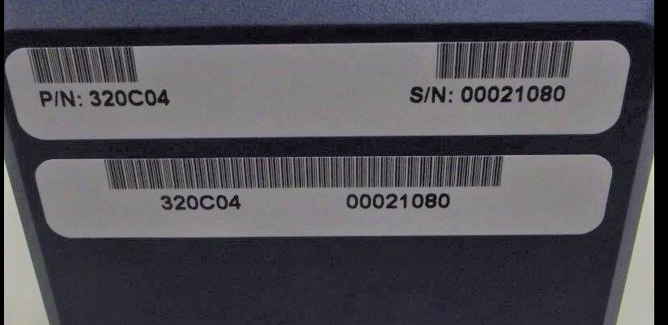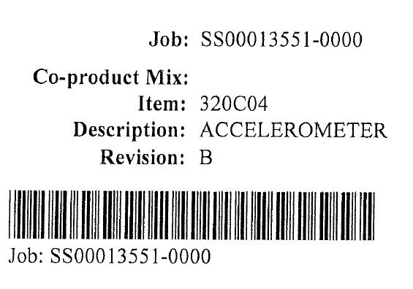

**Figure Three**