Contents

I. Scope 2

II. Procedure 2

A. Accessing the form 2

B. Section 1 2

C. Section 2 3

D. Section 3 3

E. Section 4 Root Cause Analysis 4

F. Section 5 Corrective Action 5

G. Section 6 Preventive Action 6

H. Section 7 Customer Satisfaction 7

1. Section 8 Quality Management Review: 7

J. Section 9 Follow-up 8

K. Special Considerations: 10

# Scope

### This procedure provides instructions for completing and processing the PCB QC Customer CAR form in Syteline. The QC Customer CAR (also referred to as simply QC) is used to document any customer complaint where some action may be required to prevent a recurring issue.

# Procedures

## Accessing the form

### The form is accessed through the “PCB” site in Syteline. The name of the form is “PCB QC Customer CAR”.

## Section 1

### The following information should be filled in by the **INITIATOR** on the “Description” tab:

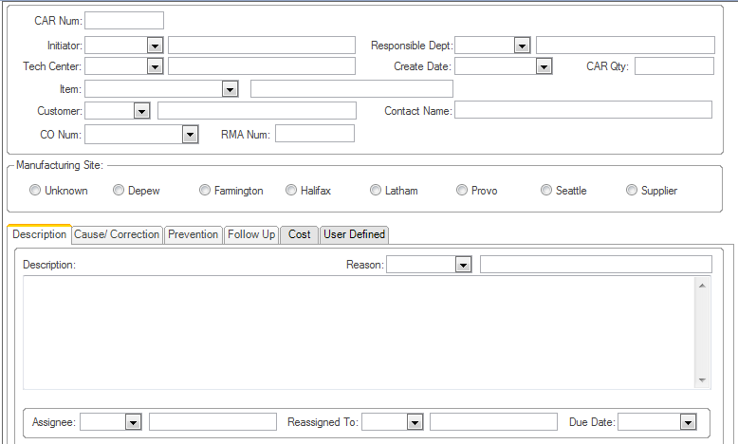

### CAR Num:

#### If the QC is associated with a product return, then the RMA number assigned to the return will be filled in this space preceded by one of the following prefixes:

##### “D” for product returned to Depew

##### “F” for product returned to Farmington Hills

##### “P” for product returned to Provo

#### For all other Quality Concerns, this number will be a sequential number automatically assigned in Syteline.

### Initiator: Enter the employee number initiating the QC. You can also search by entering the Last Name of the Initiator with a *.

### Responsible Department: From the pull-down menu, select the department responsible for the complaint. If the department is not known, it may be left blank and filled in later.

### Tech Center: From the pull-down menu, select the Tech Center where the product is manufactured. If the Tech Center is not known, it may be left blank and filled in later.

### Create Date: Fill in the date that the QC was initiated.

### CAR Quantity: Enter the number of pieces affected by the complaint.

### Item: Enter the PCB model number or part number that is nonconforming.

### Customer: Enter the Customer Number that reported the complaint.

### Contact Name: Enter the customer’s contact name who reported the complaint.

### CO Num: Enter the customer order number associated with the complaint.

### RMA Num: Enter the RMA number associated with the complaint, if applicable.

### Manufacturing Site: Check the site where the model / P/N was manufactured or check Unknown.

### Description of Concern: Enter a description of the customer’s complaint. Provide sufficient detail for the assignee to perform a root cause analysis.

## Section 2

### The following information is filled in by the **Quality Assurance Manager** or designee.

#### Assignee: Fill in the employee number of the person responsible for researching the complaint and completing the next section the form.

#### Reassigned to: This space is used to designate the name of the person the QC is reassigned to for further investigation or if a different employee is responsible for initiating preventive action or other follow-up action. This field may also be used later in the process to identify the person responsible for contacting the customer for feedback.

#### Due Date: The due date will initially be set for 30 days from the date of initiation or, in the case of product returns, 30 days from the date that the failure analysis is completed. At a minimum, the Containment Decision, Material Review Board Record (if required), Failure Analysis, Root Cause Analysis, and Corrective Action must be completed by the due date. If the Preventive Action cannot be implemented by the original due date, then the Assignee must provide a date for planned completion as detailed in Section 3.

## Section 3

### The Containment Decision on the “Description” tab is filled in by the **Assignee** designated on the QC form.

### 

#### Containment Decision: Determine if finished goods, work-in-process or component inventory must be contained and mark the appropriate box. If containment is required, the Assignee is responsible to confer with Quality Assurance to ensure that a containment report has been filed. The person that verifies that containment either has been initiated or is not required records their Employee Number and the containment completion date, if applicable.

## Section 4 Root Cause Analysis

### The **Assignee** designated on the QC form is responsible for performing a root cause analysis.

### 

#### Failure Analysis: On the “Cause/Correction” tab of the form, a description of the failure mode is selected from the drop-down menu on the form. If Quality Assurance or Engineering documents the failure analysis on an EN003 form, then the appropriate box is checked. If no failure anlaysis is required then the “No Failure Analysis required” box is checked. Record the name of the person that performed the failure analysis and the date the failure analysis was completed. If no failure analysis is required then the Assignee records their name and date.

#### Root Cause Analysis: The Assignee will record the problem statement. If there are more than one problem statements, they should be stated separately. For each problem statement the Assignee will determine the true root cause using the 5-Why analysis tool. See a representative in Quality Assurance for assistance using the 5-Why methodology.

#### Cause Code: Using the pull-down menu select the appropriate cause code for trend analysis.

## Section 5 Corrective Action

### The **Assignee** designated on the QC form is responsible for recording the corrective action taken to address the customer’s complaint.

### 

#### Corrective Action: Record the action taken to address the complaint. Examples of corrective action may include: “Replaced sensor with one from stock”, “Repaired sensor and returned to customer”, etc.

#### Completed By: Enter the employee number of the Assignee completing the Root Cause Analysis and Corrective Action sections.

#### If Closure Plan: If the Preventive Action cannot be completed with the 30-day due date, then the Assignee must provide a planned completion date and receive his/her Manager’s approval. The plan for Preventive Action completion will be reviewed with the CAR Committee on a regular basis.

##### Planned Completion Date: Enter the expected date for implementing preventive .

##### Manager Approval: Enter the Assignee’s Manager’s employee number indicating that the Manager has approved the closure plan and effective date for closure.

## 

## Section 6 Preventive Action

### The original Assignee is responsible for completing the Preventive Action section found on the “Prevention” tab of the form or consults with Quality Assurance to determine who should be responsible for implenting Preventive Action. If the Preventive Action is to be implemented by another employee, then the original Assignee is responsible for entering that employee’s number in the “Reassigned to” field on the “Description” tab and communicating the change in responsibility to the new Assignee.

### 

### Preventive Action: Record the actions taken to prevent a recurrence of the nonconforming condition. Ensure that the preventive actions are also applied to similar products or processes.

#### NOTE: *Preventive actions must address the systemic root cause of the problem that caused the complaint.*

### Verification Evidence: Record evidence that preventive actions have been implemented effectively. Evidence may include references to completed ECO’s, updated procedures, training records, etc.

#### NOTE: *Verification Evidence can be linked to the QC by means of the “Notes” function in Syteline.*

## Section 7 Customer Satisfaction

### Once the Preventive Action has been recorded, the Current Assignee will contact the appropriate Inside Sales Representative to contact the customer ensuring that the customer is satisfied with the actions taken to address their complaint.

### 

### Inside Sales Representative records if customer is satisfied: Check “Yes” or “No” indicating if customer is satisfied with actions taken to address their complaint. Notes and feedback from the customer can be noted in the “Review Notes”

### 

### Repaired/Replaced as per CO#: If the complaint was associated with a defective product and the product was repaired or replaced, check this box and record the customer order number. Check the “Verify CRM Updated” box once the latest communication with the customer is entered into the CRM system.

### Completed By: Record the employee number of the person who contacted the customer to ensure customer satisfaction.

### Completed Date: Record the date that the customer provided feedback.

## Section 8 Quality Management Review:

### The **Quality Management Representative** is responsible for completing this section.

### 

### Quality Management Review and Disposition

#### Quality Management Name: Record the employee number of the Quality Management Representative performing the review.

#### Review Date: Record the date of the review.

#### QA Effective: Record the date that the Preventive Action was reviewed for effectiveness.

#### Followup Date: If Quality Management determines a follow-up is required, record the date for a scheduled followup to ensure that the Preventive Action is proven to be effective in preventing a recurrence. Typically this is 6 months from closure of the Corrective Action. Leave blank if no follow-up is required.

### Disposition Status: Select one of the following:

#### Rejected: If the Quality Management Representative rejects the responses, he/she can reassign the QC to an employee for additional actions. The Quality Management Representative will then assign a due date in the NEW CLOSURE DATE field.

#### Corrective Action Plan Approved: This indicates that the Quality Management Representative found the responses sufficient and the QC can be scheduled for followup or closed if no follow-up is required.

### Corrective Action Closed: This box is checked when the Quality Management Representative has closed the QC, after follow-up has been scheduled if required. Checking this box will “lock-out” the QC and not allow any additional edits. Only authorized personnel can re-open the QC for follow-up or further edits.

## Section 9 Follow-up

### Quality Committee is responsible for conducting follow-up to ensure the effectiveness of the preventive actions taken. The “Corrective Action Closed” box is unchecked which will allow edits to the form. The following fields are completed on the “Follow Up” tab of the form:

### 

### Analysis Results: Choose one of the following selections:

#### Effective: This indicates that the actions taken have been to be effective in preventing a recurrence of the problem based upon the data analysis. If this selection is chosen the Follow Up is recommended for closure.

#### Ineffective: This indicates that the actions taken have not been effective in preventing a recurrence of this complaint. This will result in a new QC being generated.

#### Follow-Up: This selection is chosen if additional time is required from the initial followup date to perform a thorough review of the data for trend analysis.

### Trend Analysis: Complete sections A through C to answer the questions under this heading.

### Effectiveness Analysis: This section may be used to provide detail for the analysis performed.

### Quality Manager Approval/Sign-off: Once the followup is completed, the Quality Management Representative will enter his/her employee number and the date of final approval. The Quality Management Representative will then check the “Corrective Action Closed” box to prohibit unauthorized edits.

## Special Considerations:

### Material Review Board Record: If the Model / P/N is designated as a “Program” model in Syteline, then the individuals identified in QA018 must review the QC to ensure that nonconforming material is dispositioned properly and any special customer requirements associated with nonconforming material are carried out. A copy of the QC is printed using the “QC CAR FORM” function. The Quality Management Representative is responsible for noting the material disposition on the form and obtaining the applicable signatures of the Material Review Board. The completed form will be linked to the QC using the “Notes” feature in Syteline.