Purpose: 1

Related Documents: 1

Responsible: 1

Rules 1

BSD Forms 1

Instructions: 1

Kit Parts per Pick List 2

Job Material Issue **Error! Bookmark not defined.**

Move **Error! Bookmark not defined.**

Job Material Issue preformed in BSD **Error! Bookmark not defined.**

Move **Error! Bookmark not defined.**

Kit and Labelling 2

Place Job on the Designated Production Staging Shelf **Error! Bookmark not defined.**

Purpose: To provide instruction on kitting jobs for production.

# **Related Documents:**

TA1244 Product Handling, Storage and Inventory Users Guide

TA1085 Amplifier Handling and Preparation Users Guide

IC1004 Job Kit Data Entry

Responsible:Maintained and carried out by Inventory Control

Rules

1. Jobs having Priority are picked first
   1. Priority 1 jobs are picked immediately and hand delivered to the production supervisor or lead where the first production operation is to be done (NOT left on a shelf)
   2. Priority 2 and 3 jobs are picked before non-priority jobs and delivered same day.
2. If no jobs have Priority then pick jobs with oldest Start Date.

Buisness System Database (BSD) Forms PCB Job pick list Label Printing

# Instructions:

1. Obtain the job box labels. **PCB Job Pick List Label Printing** in BSD.
2. Labels will contain the following information: model number, job number, quantity and start date.
3. Making sure that all prior labling is removed, affix the first 2 labels, containing the Model and Job #, to the front of the job box. The remaining labels will be for componets to be pulled in OP5.

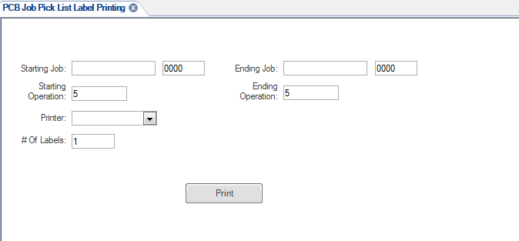

# Kit Parts per Pick List

1. Refer to the picklist (job packet) to determine which components to pick.
   1. The location of each component is listed on the picklist or on the label
   2. Adhere to TA1244 Product Handling, Storage and Inventory guidelines
   3. Adhere to TA1085 Amplifier Handling and Preparation guidelines

# Kit and Labelling

1. Choose a container based on the size and quantity of the items.
   1. Ensure that the correct Item, Quantity, Lot number and Serial number are being picked based on picklist or router requirements. IC personnal will put a line through any incorrect Lot or Serial numbers and will intial and date the line they crossed out. If Lot or Serial Numbers are not indicated for a part on the picklist or router then use the FIFO method to pick the oldest components first.
   2. **If a lot tracked item requires multiple lot #s to fill requirement, the lots must be sperated during packaging for the job.**
   3. For non-system lot tracked items, record the lot number of the item on the picklist,label and router.
   4. If the picklist data does not correspond with actual material on shelf, stop and notify Inventory Coordinator or Supervisor.
   5. If part # and location combination is followed by the suffix “-TR”, the parts are always required to be placed in trays for delivery to work cell.
   6. If part # and location combination is followed by the suffix “-BG”, each part must be individually placed into a bubble bag for delivery to work cell.
   7. If part number tray has Lapped tag inside from MS, these parts need to be in a tray and seperated from each other
2. Container labeling requirements
   1. Remove all previously used labels
   2. If the previous label cannot be removed then cover the previous label completely with the new label
   3. If the new label will not completely cover the previous label then use black marker to black out all information on the previous label before applying the new label
   4. Place the components into the labeled container
   5. After IC issues material to the job, all paperwork will go in an ESD safe sleeve and placed into the job box.
   6. Initial or stamp paperwork on the operation being picked and date the router signifying that the correct part and quantity has been picked.
   7. Depew Only: place all pulled jobs on the designated cart to be delivered (unless Priority 1 – deliver immediately to the Production Supervisor of the cell).
   8. When delivered – place the completed job in the correct production cell using the two letter prefix to determine the correct cell / shelf.
      1. Priority 2 jobs will be placed on the designated shelf in the production cell. Priority 3 jobs will be placed with non-priority jobs.