Purpose: To provide instruction on kitting jobs for production.

# **Related Documents:**

TA1244 Product Handling, Storage and Inventory Users Guide

TA1085 Amplifier Handling and Preparation Users Guide

IC1004 Job Kit Data Entry

IC1014 Warehouse Mobility user guide

Responsible:Maintained and carried out by Inventory Control

Rules

1. Jobs having Priority are picked first
   1. Priority 1 jobs are picked immediately and hand delivered to the production supervisor or lead where the first production operation is to be done (NOT left on a shelf)
   2. Priority 2 and 3 jobs are picked before non-priority jobs and delivered same day.
2. If no jobs have Priority then pick jobs with oldest Start Date.

Syteline Forms **PCB Job Pick List Label Printing**

# Instructions:

1. Obtain the job box labels. **PCB Job Pick List Label Printing** in BSD.
2. Labels will contain the following information: model number, job number, quantity and start date.
3. Making sure that all prior labling is removed, affix the first 2 labels, containing the Model and Job #, to the front of the job box. The remaining labels will be for componets to be pulled in OP5.
4. Do not issue any parts where the Job pick list lable has BF on it. It will be system issued when job is moved from OP 5 to the next operation! BF is a Backflushed item.

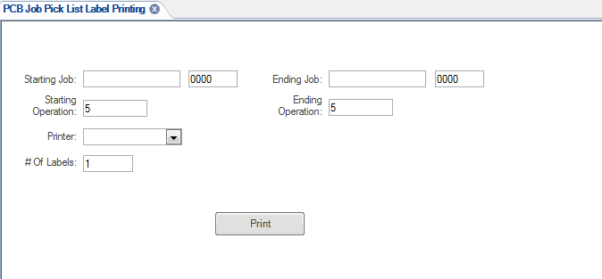

# Kit Parts per Pick List

1. Refer to the picklist (job packet) to determine which components to pick.
   1. The location of each component is listed on the picklist or on the label
   2. Adhere to TA1244 Product Handling, Storage and Inventory guidelines
   3. Adhere to TA1085 Amplifier Handling and Preparation guidelines

# Kit and Labelling

1. Choose a container based on the size and quantity of the items.
   1. Ensure that the correct Item, Quantity, Lot number and Serial number are being picked based on lable picklist or router requirements. IC personnal will put a line through any incorrect Lot or Serial numbers and will intial and date the line they crossed out. If Lot or Serial Numbers are not indicated for a part on the picklist or router then use the FIFO method to pick the oldest components first.
   2. **If a lot tracked item requires multiple lot #s to fill requirement, the lots must be seperated during packaging for the job.**
   3. If part # and location combination is followed by the suffix “-TR”, the parts are always required to be placed in trays for delivery to work cell. There will be a blue TR stamp on lable
   4. If part # and location combination is followed by the suffix “-BG”, each part must be individually placed into a bubble bag for delivery to work cell.
   5. If part number tray has a red (L) or Lapped tag inside from MS, these parts need to be in a tray and seperated from each other
2. Container labeling requirements
   1. Remove all previously used labels
   2. If the previous label cannot be removed then cover the previous label completely with the new label
   3. If the new label will not completely cover the previous label then use black marker to black out all information on the previous label before applying the new label
   4. Place the components into the labeled container
   5. After IC issues material to the job, all paperwork will go in an ESD safe sleeve and placed into the job box. (Jobs that start wit C or CSA do not require ESD Sleeve)
   6. Initial or stamp paperwork on the operation being picked and date the router signifying that the correct part and quantity has been picked.
   7. Depew Only: place all pulled jobs on the designated cart to be delivered (unless Priority 1 – deliver immediately to the Production Supervisor of the cell).
   8. Open job router to next operation. This is the department the job kit and router will be delivered to.
   9. Priority 2 jobs will be placed on the designated shelf in the production cell. Priority 3 jobs will be placed with non-priority jobs.

# Job Material Issue performed with Warehouse Mobility

1. Picking jobs using Warehouse Mobility Scanners
   1. Use the Job Material Issue transaction to pick and issue material for a job order.
   2. From the main menu of the hand held device, select form Job material Issue
   3. In the Job field, scan or enter specific job order number.
   4. In the Operation field, or enter specific the job operation number.
   5. In the Item field, scan item from the PCB pick list label.
   6. Go to location listed on label; scan the item in the location that is being picked. If user scans wrong number the device will give error. “Parts do not match”
   7. You will be requested to scan or enter location in which Item is being pulled from.
   8. If the item is lot tracked, scan lot number from the inventory label. (If lot# is valid the lot field will auto fill, if not the following error appears “Inventory details for lot not found”)
   9. After component is picked the picker will put the label on bag/tray to ensure the item is properly marked. Picker will also fill out lot number on label.
   10. In the Qty. field, scan the quantity to be issued from Pick List Label
   11. Press Enter. A Successful message is displayed
   12. Repeat until all labels are processed.
   13. Do not process any backflush items, when job is moved to the next operation the BF items will then be issued by the system.

# Move

1. Moving jobs using Warehouse Mobility Scanners
   1. From the main menu, select Move
   2. In the Job field, Scan in order number( Any job that has suffix after job will need to be typed into scanner)
   3. Enter the Operation you have completed
   4. In the QTY. Complete field, enter the quantity of items completed.
   5. In the Qty Moved field, enter the quantity of items moved.
   6. Specify Y in the Complete field to complete the operation.
   7. Otherwise, specify N or NO, N is only used when picker is not picking an item due to shortage or item will be pulled by production for specific reason’s (ex. Part is located on production floor and will be issued by production supervisor or technician)
   8. Press Enter. A Successful message is displayed.
   9. When the message Successful is given it will also mean all BF items have been issued also.

**Deliver Job to Next Operation**

**1.** Open job router to next operation. This is the department the job kit and router will be delivered to.

2. Place kitted job and router on pre-designated staging shelf.