Purpose: 1

Related Documents: 1

Responsible: 1

Instructions: 1

Purpose:To provide instruction on how to set up new Inventory locations in Buisness System Database (BSD). A physical inventory location needs to exist that corresponds to the system location.

Related Documents:None

Responsible:Maintained by Inventory Supervisor. Carried out by designated Inventory representative.

# Instructions:

1. Open form Locations
   1. Forms
   2. Open
   3. Locations

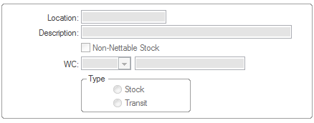

1. Click new and populate the form as follows.
   1. **Location:** Enter the new location to be created. (Following existing location logic)
   2. **Description:** Enter a description of the location that describes where the location is.
   3. **Non-Nettable Stock:** Click if location is to be Non-Nettable
   4. **WC:** Leave blank
   5. **Type:** Defaults to “Stock” leave as is.
   6. **Click Save.**