**Purpose: To bring parts into perpetual inventory whether manufactured or purchased.**

**Associated Documents:**

**NONE**

**Responsibilities:**

Approve: Supply Chain Manager or Senior Business Analyst

Maintain: Inventory Control Supervisor

Execute: Inventory Control staff

**Curriculums:**

INVCON

**Definitions:**  NONE

**Rules:**

1. Priority Order: Pink Sheet Jobs, Hot List PO’s, Machine Shop Jobs, All other Jobs/PO’s
2. Prior to processing any JOB material receipts, verify that all router signatures have been completed.
3. Job receiving, label printing and labeling shall be performed one job at a time to avoid mixing of parts
4. Receiver will make minimum of 2 and attempt to make 3 visits daily to pick up inventory that needs to be received or moved into IC.
5. Logistics Receiving will deliver purchased Items that need to be put away by Inventory to inventory.
6. If a discrepancy is found, the Receiver will provide parts and paperwork to the IC Specialist or IC Supervisors.
   1. The IC Specialiat or IC Supervisors will take Job back to the work cell supervisor; and purchased Items will be taken back to Logistics.

**Instructions:**

1. Verify the quantity physically provided matches the quantity on the paperwork provided.
2. JOB Receipts: Go to Unposted Job Transactions screen, change the transaction type to Move then click filter.

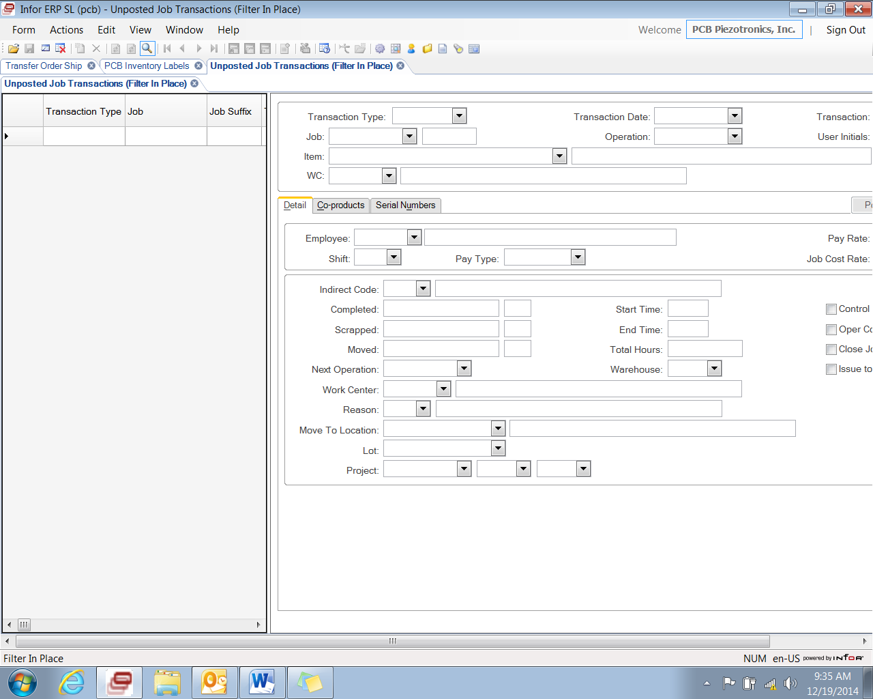

1. Scan job number in, hit tab key twice to verify **Operation** is 998, hit tab key twice to the **Complete** field box. In this field you will enter Quantity to be moved, Hit tab key again and the **Location** field will fill in automatically (when item has a location or will have stock as location).
2. If “Move to Location field indicates “STOCK”, Receiver is to locate and assign new location for material. The Receiver then opens the Items Form, selects Stock Room Location tab and changes the priority in Stock Room Location to Level 1 for the new location.
3. Click Save, top left
4. Go to the **PCB Inventory label** screen. If parts packaging includes item and/or job information, confirm that it matches the job/receiving paperwork.
5. Enter the part
6. Enter Lot#, or Job#/Transfer Order#

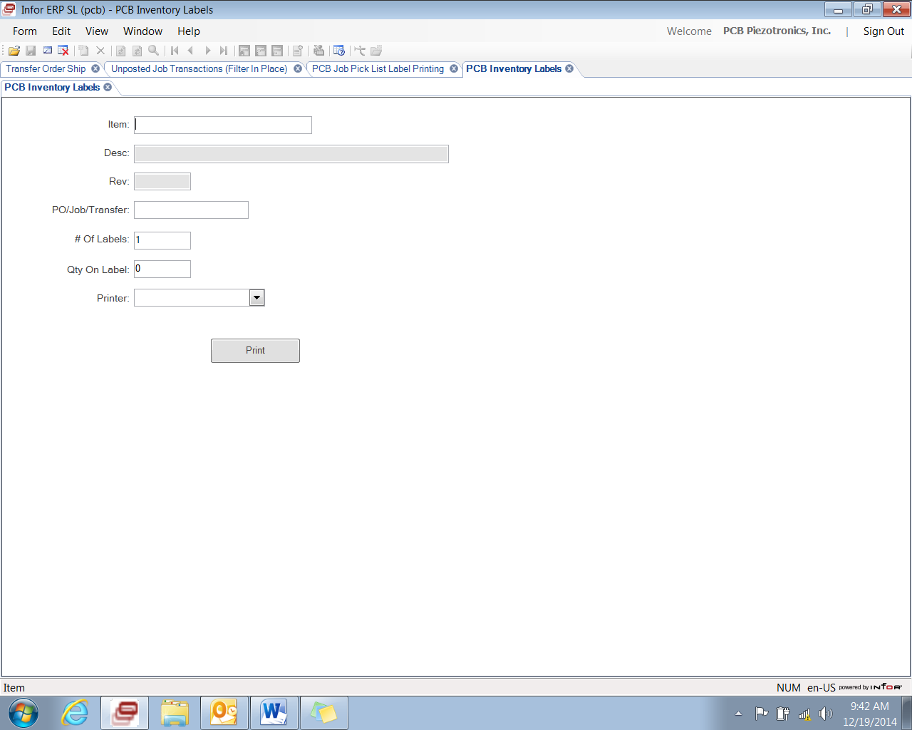

1. Enter the number of labels; enter the Qty. for each label. Repeat if multiple quantities.
2. Hit print box, Write the location on the label if it does not appear.
3. Label all items being received
4. Put material away in the location designated by the BSD. Make sure that all materials are rotated via FIFO and newer items are place to back or the bottom