Purpose: 1

Related Documents 1

Responsible 1

Rules: 1

Sort Items and Set A,B,C codes 2

Purpose: Update Item ABC Codes as part of ensuring the cycle count process effectively audits the accuracy of inventory.

Related Documents:PCB Cycle Count Set-Up

Responsible**:**

**Approve:** Supply Chain Manager, Depew; Sr. Accountant, Depew

**Maintain:** Sr. Business Analyst

**Execute:** IT

# Rules:

1. The Inventory Control Supervisor or other Authorized staffmember will send an IT help desk ticket semiannually for IT to perform the tasks and COMMIT for all in scope instances.
2. An assigned individual per site will have PREVIEW access to the form.

# Scope:

All MTS Sensors sites using the BSD

# Analyze, Sort and Set A,B,C codes

1. Open form titled PCB ABC Analysis.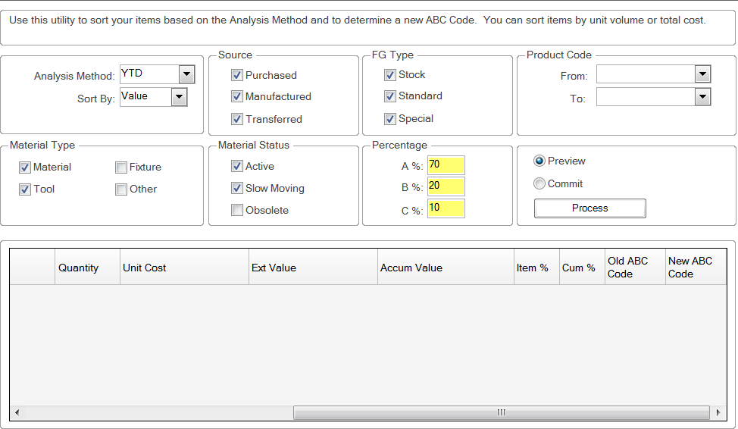
2. Set the parameters as follows for in-scope sites
   1. **Analysis Method** 
      1. From the dropdown box select YTD
   2. **Sort By** 
      1. From the dropdown box select Value
   3. **Source**
      1. Select all, **Purchased, Manufactured** and **Transferred**
   4. **FG Type**
      1. Select all, **Stock, Standard** and **Special**
   5. **Product Code**
      1. use the “**From**” and “**To**” dropdown boxes to select or enter the product code range based upon the instance being updated.
         1. Depew(PCB): 0100 - SA1500
         2. Halifax (NC): 0100 - SA0899
         3. Farmington (Farm): 0224 - SA0286
         4. Provo (FARM): 0267 - SA0650
         5. Latham (NYS): 0410 - SA0430
         6. Cincinatti (TMS) 0710 – SA0753
   6. **Material Type**
      1. Leave Material and Tool checked. Unselect Fixture and Other.
   7. **Material Status**
      1. Leave Active and Slow Moving checked. Unselect Obsolete.
   8. **Percentage**
      1. Populate the A, B and C percentages as follows

A – 70%

B – 20%

C – 10%

* 1. Commit. Commit will be performed semi-annually by IT.
  2. **Repeat steps a. – i.** for each instance.

1. Export file showing prior and new A,B,C Code. Send file to Senior Business Analyst and Inventory Control Supervisor.

# Manage Documentation

1. Preview is used for business analysis and will NOT change any codes.
   * 1. Steps a. through i. can be set based upon the analysis needed by the business.
     2. Select “**Preview**” and click “**Process**”