Contents

Purpose: 1

Related Documents: 1

Scope: All MTS Sensor sites using the BSD 1

Responsible: 1

Rules: 1

Definitions: 2

Generate Cycle Counts (Cycle Count Coordinator) 2

Create Count Sheets (Cycle Count Coordinator) 4

Perform Cycle Counts (Cycle Counter) 4

Cycle Count Quantity Update (Cycle Counter) 5

Additional Count Sheet Management (Cycle Count Coordinator) 5

Cycle Count Variance Report Monitoring (Cycle Count Coordinator) 6

Cycle Count Variance Report #1 7

Cycle Count Variance Report – Final (Cycle Count Manager) 8

Cycle Count Posting (Cycle Count Manager) 9

Cycle Count Purge (Cycle Count Manager) 11

Documentation (Cycle Count Manager) 11

Cycle Count Communication 11

## Purpose:

To provide instructions for generating, performing, posting and purging cycle counts including documentation to be maintained.

## Related Documents:

PCB ABC Analysis

PCB Cycle Count Set-Up

Additional Count Sheet

Recount Sheet

Cycle Count Root Cause / Corrective Action Sheet (RCCA)

## Scope: All MTS Sensor sites using the Buisness System Database (BSD)

## Responsible:

Approve: Senior Business Analyst, Planning Manager, Supply Chain Manager

Maintain: Inventory Control Supervisor (or site equivalent)

Execute: Cycle Count Coordinator, Cycle Counter, Cycle Count Manager.

## Rules:

1. 100% of counts Executed Daily
2. 100% of counts posted within the site cycle count timeframe (single date or across 2 dates)
   1. If after posting, variance found to be an incorrect count, force a new cc for current date.
   2. If after posting, variance found to be an incorrect transaction, do the correcting transaction(s).
3. Cycle Counter(s) only have access to Cycle Count Update form. *(Preventive Control)*
4. Cycle Count Update form, Cycle Count Sheets/Scanner can not display “cycle count cut-off quantity”. *(Preventive Control)*
5. Cycle Count Coordinator cannot Update Counts, Post or Purge Counts *(Preventive control)*
6. Cycle Count Manager cannot Update Counts*(Preventive Control)*

## ****Definitions:****

Accurate:

* The Item quantity, location, lot # or serial # (where applicable) match the system record.

Threshold Variance:

* The variance of a single Item quantity, location, lot # or serial #(where applicable) is greater than $300 OR
* The absolute value of the Item variance across locations is greater than $300.

## ****Generate Cycle Counts (Cycle Count Coordinator)****

Cycle Count Coordinator generates Cycle Counts to be performed by Cycle Counter.

1. **In the BSD open form: Cycle Count Generation and populate checkboxes as follows (note:”Display Cut-Off Quantity” is not accessible to check).**

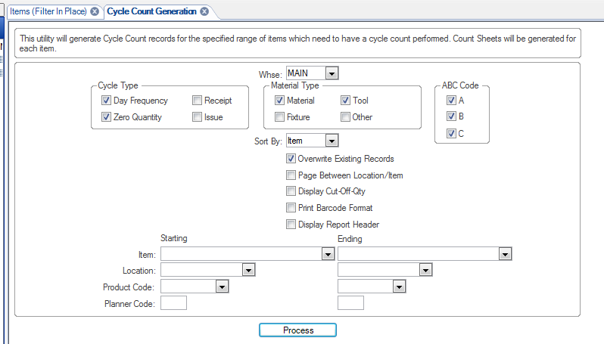

1. Click Process
   1. The following screen will appear.

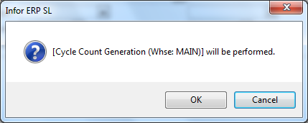

* + 1. Click OK.
    2. After the Cycle Count Generation is complete the following screen will appear.

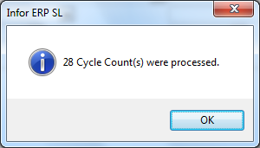

* + 1. The Screen “Report Submitted” appears, select “OK”

## ****Create Count Sheets (Cycle Count Coordinator)****

1. In the BSD open the form: Cycle Count Sheet Report and set up per the sample below . Option – Check “Page Between Location/Item if appropriate (eg. Depew) (note: Display Cut-Off-Qty not accessible)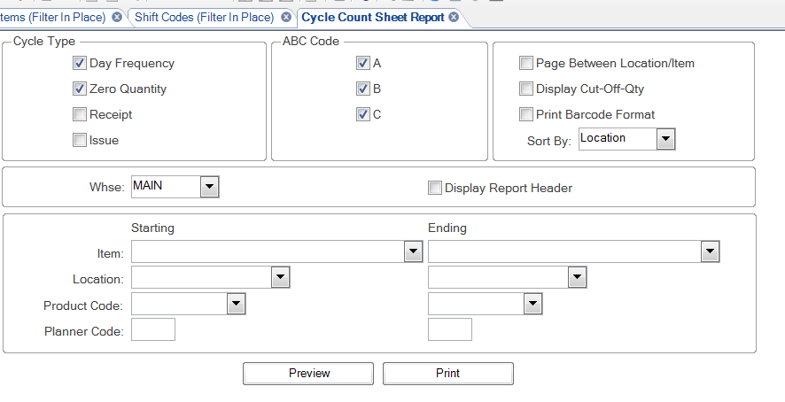
   * 1. Select Preview
     2. Report will display in report viewer.
     3. Print pages
     4. Provide Sheets to Cycle Counter(s)

1. Note: Sites that have the necessary barcoding and scanners can use scanners rather than using a count sheet or can use a combination of count sheets and scanner.

## Perform Cycle Counts (Cycle Counter)

1. Write the count quantity on the line provided for the Location/Item (lot/serial if applicable)
   1. Note: Sites that have the necessary barcoding and scanners can use scanners rather than the count sheet or can use a combination of count sheets and scanner.
2. If a Lot Tracked or Serialized Item is found and that Lot # or Serial # is NOT presented to be counted
   1. Record the Loc/Item/Serial or Lot # and Qty on an Additional Count Sheet.
   2. Provide the Additional Count Sheet to the Cycle Count Coordinator

## Cycle Count Quantity Update (Cycle Counter)

1. Counts recorded on Count Sheet
   1. Open the Cycle Count Update Form

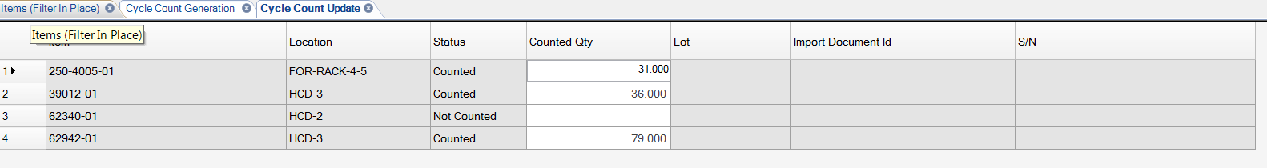

* 1. Select the Filter (magnifying glass or F4)
     1. Populate the Location field with the first two or three characters of the Location from your Sheet followed by an * (Shift 8) and Filter. Then double click in the Location Header Title field. This will cause the Update Form to sort from first to last location.
        1. The Update Form should now list Location/Item (lot # or serial #) in the same order as they are listed on the Count Sheet. Verify this. If the list in the update form does NOT match the list on your Count Sheet, stop and get the Cycle Count Coordinator to assist.
     2. Enter the Quantity from the sheet into the Counted Qty field for the Item / Location (lot # or serial # if applicable)
     3. Select the Save icon when you complete entering all counts on a Sheet, if interrupted and when all counts have been entered.
     4. Filter on Status column for any Items whose status = “Not Counted”. If any Items show as Not Counted, check your sheet and determine
        + 1. if you missed entering the count. If yes, enter the count and Save.
          2. If there is no count on your sheet for the Item. If yes, return to the location, count, record on the sheet, enter count into the Cycle Count Update form and Save.
          3. If a or b is not the cause

Unfilter the Status column

Compare your count sheet to the Count Update screen to determine where the error in entry is and fix any count entries as required.

* + 1. Turn sheets in to Cycle Count Coordinator

1. Counts recorded using Scanner - do not enter any information into the Cycle Count Update form. The count was saved when you entered quantity in Scanner).
2. Repeat steps for any re-counts done as requested by Coordinator.

## Additional Count Sheet Management (Cycle Count Coordinator)

1. If a Cycle Counter provides information that they counted a lot # or Serial # Item that was not listed on Sheet/Scanner to be counted.
   1. Verify physically.
   2. Open the appropriate form (Serial Number Form or Lots Form) enter the Lot # or Serial # and filter to determine if the system shows the Item with the lot# or serial # that the counter provided.
      1. If Lot # / Serial does NOT show in the Lots Form / Serial Number Form
         1. Perform a Miscellaneous Receipt transaction using Reason Code: CCA (Cycle Count Adjustment)
      2. If Lot # does exist per the filter and On Hand field shows a quantity >0, Perform Root Cause.
      3. If Serial # does exist on the Serial Number Form, Perform Root Cause.

***Items Not Counted*** ***(Cycle Count Coordinator)***

1. As appropriate, Periodically open the Cycle Count Update form and filter for “Not Counted”
   1. Communicate to counters Items that seem to have been missed (i.e. Updates exist for Location, but there is 1 or more Item in that Location that does not have a count entered)
   2. Determine if OT required in order to complete all counts before counter(s) end their work day.
   3. If yes, inform counters to stay

## Cycle Count Variance Report Monitoring (Cycle Count Coordinator)

1. As appropriate, Coordinator should **Preview** this form periodically to identify Items for Recount and to begin Root Cause Analysis.
   1. In the BSD open form: Cycle Count Variance Report.
   2. Set Parameters as shown in following figure.

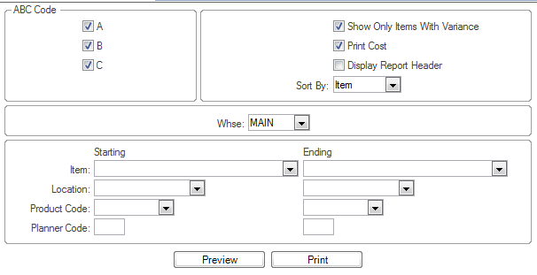

* 1. **Select PREVIEW**
  2. Identify Items that need to be Recounted
     1. Fill out a Recount Form and give to a Counter

## Cycle Count Variance Report #1

1. When counters indicate all counts/re-counts have been done
   1. Do a final check - Open the Cycle Count Update form, ensure ALL records generated are listed and filter for “Not Counted”
      1. If all items counted, proceed. If any Item NOT Counted do a final recount.
   2. Close any Open Report Viewers for Variance Report
   3. Open the PCB Cycle Count Information form

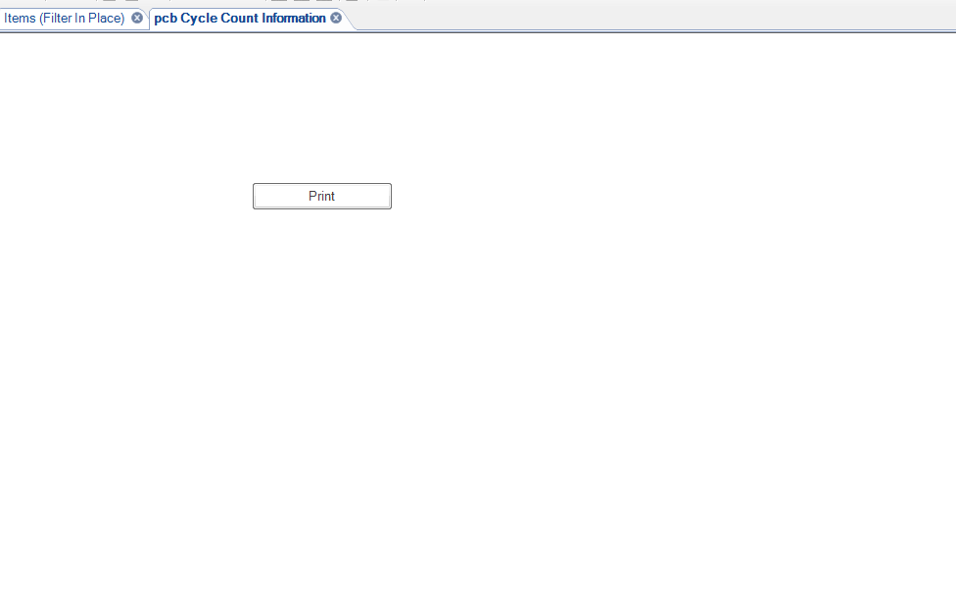

* 1. Select **Print** – Report will be saved in R:/SytelineReports/User Name/
  2. Go to the folder, select the report (don’t have to open), select SAVE AS: and Save in:

R/Supply Chain/1SOX Documents/”Site Name”/CycleCount/Variance Reports/ FY2017

* + 1. Select or Add Folder for Current Fiscal Month
    2. Name File using format: YRMODYVariance1.xlsx

***Managing Variances (Cycle Count Coordinator/Cycle Count Manager)***

1. A RCCA Sheet MUST be completed for Variances over the Threshold that remain after Recounts.
   1. If finding determines that variance is due to a transaction not being done – or being done wrong, do correcting transaction(s).
   2. All RCCA Sheets are turned into the Cycle Count Manager by Cycle Count Coordinator.

***Managing Variances with Exception Message (Coordinator/ Manager)***

Note: once the system has created an exception it will stay an ‘exception’ even if there is a ‘correcting’ action taken.

1. Exception Message: “On Hand is not equal to Cut Off Quantity”
   1. Cause: A transaction was done after the time of Generation.
   2. Action:
      1. Look at transaction(s) and determine if Counted Qty in Update form was done prior to or after transaction.
         1. If count was done AFTER the transaction then the Counted QTY is assumed correct and – if no variance over threshold remains, no further action. (Count will be posted as an exeption)
         2. If count was done BEFORE the transaction then the investigation needs to determine if the Counted Qty needs to be Recounted. If yes, issue a Recount Sheet to the Counter and have Counter enter Update per Recount.
2. “Item not found for Location”
   1. Cause: A transaction was done after Generation AND the transaction caused a ‘temporary’ Stockroom/Location to change to 0. When a temporary Stockroom/Location value is 0, it is no longer recognized as a location.
   2. Action:
      * + 1. No action can be taken – this Item will not post and will generate for recount the following day.

***Final Variance Actions (Cycle Count Manager)***

1. In the BSD open form: Cycle Count Variance Report.
   1. Set Parameters as shown in following figure



* 1. Select Preview

1. Review all Root Cause and Corrective Action forms.
   1. Ensure there is an RCCA for all variances over the Threshold
   2. Review the RCCA
      1. If root cause not determined and fixed, see/execute **Managing Variances / Managing Exceptions** Sections
   3. Complete Manage Section for all RC/CA Sheets.
   4. Corrective Action Recommendations will be reviewed for applicability to open CI activities.

## Cycle Count Variance Report – Final (Cycle Count Manager)

* 1. Close any Open Report Viewers for Variance Report
  2. Run the Cycle Count Variance Report again per the parameters below



* 1. Select **Print** – Report will be saved in R:/SytelineReports/User Name/
  2. Go to the folder, select the report (don’t have to open), select SAVE AS: and Save in:

R/Supply Chain/1SOX Documents/”Site Name”/Cycle Count/Variance Reports/ FY20xx

* + 1. Select Folder for Current Fiscal Month
    2. Name File using format: YRMODY VarianceFinal.xlsx

## Cycle Count Posting (Cycle Count Manager)

1. In the BSD open form: Cycle Count Posting
   1. Parameters will default to:
      1. Cycle Status: Counted
      2. Warehouse: Main

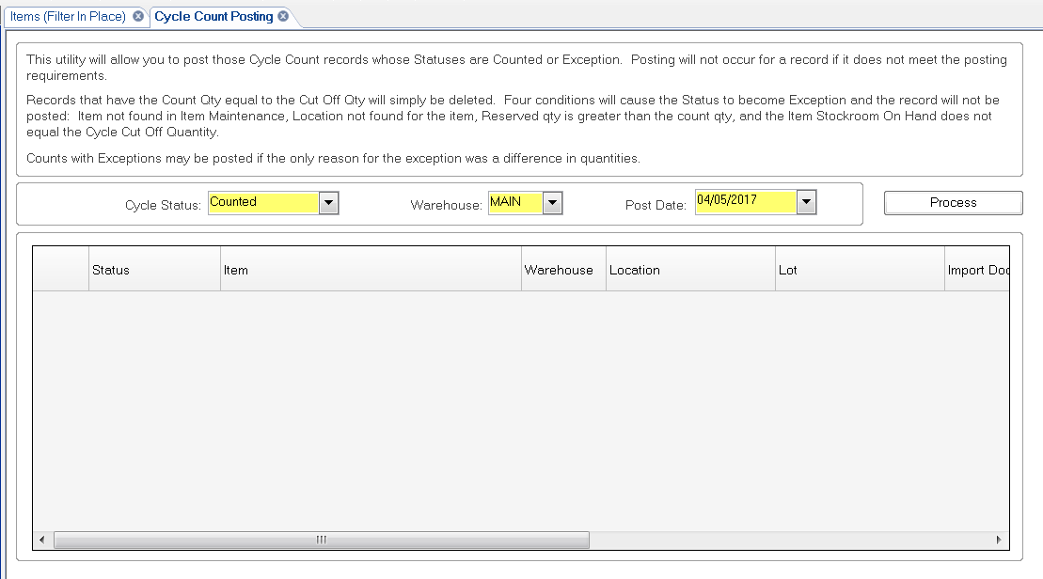

1. Click Process. Once posted a message will display indicating how many cycle counts were posted.

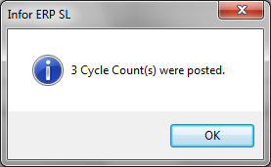

1. Change the Cycle Count Posting Form to Cycle Status = Exception

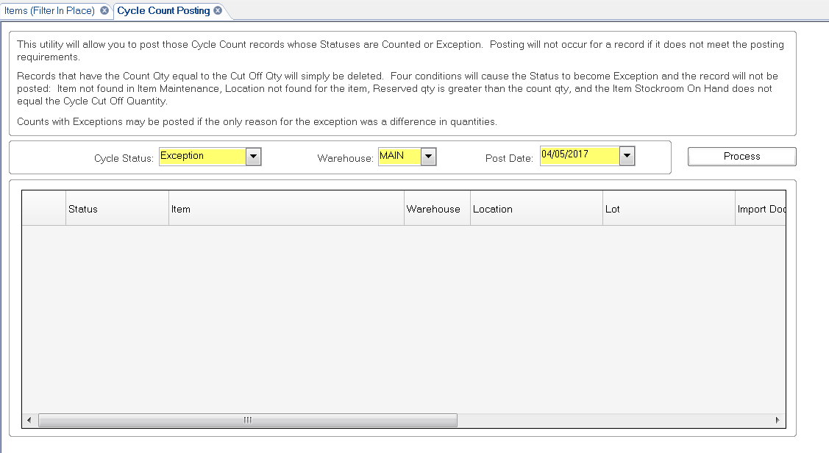

1. Click Process. Once posted a message will display indicating how many cycle counts were posted. Select OK

## Cycle Count Purge (Cycle Count Manager)

Important! Do not complete this step until all counted quantities have been posted. This step purges any unposted records from the Cycle Count program.

1. In the BSD open form: Cycle Count 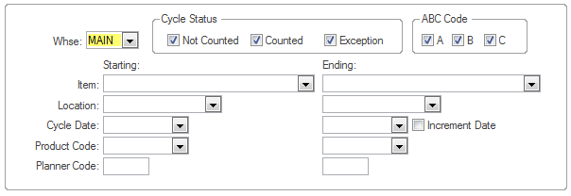
2. Click Process.
3. Screen will appear showing count of Items that were purged. Select OK

## Documentation (Cycle Count Manager)

1. Create package for Scanning
   1. RCCA Sheets and Additional Count Sheets
2. Give to Scanner or Scan
   1. Save in R/Supply Chain/1SOXDocuments/Site/Cycle Count/Variance Reports/FY20xx
      1. Select Current Fiscal Month folder
      2. Name File using format: YRMODY CC Documents.pdf

## Cycle Count Communication

Per site standard practice, communicate when the Cycle Count Process has been completed for the day.

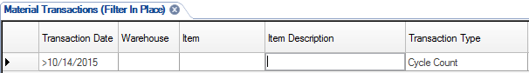Example:

1. In the BSD open form: Material Transactions
2. Filter on:
   1. Transaction Date = Current Date
   2. Transaction Type = Cycle Count
3. Export form to XCel
4. In excel, delete all columns except:
   1. Item
   2. Item Description
   3. Location
   4. Quantity
   5. Total Posted
5. Email file to all Planners, Buyers and Supervisors