Purpose: 1

Related Documents: 1

Responsible: 1

Rules: 1

Handheld Functions 2

Job Material Issue 2

Move 3

Issue Additional Material 3

Unissue Job Material 4

Item Inquiry 4

Location Inquiry 5

Miscellaneous Issue 5

Miscellaneous Receipt 5

Quantity Adjustment 5

Stock Move 6

Transfer Order Shipping 6

Cycle Count 7

Purpose:

To instruct on how to use the warehouse mobility handheld for processing inventory transactions.

Related Documents:

IC 1000 Job Kitting

# Responsible:

Maintained by Inventory Control Supervisor

Approved by Supply Chain Manager

Carried out by Inventory Control Staff

# Rules:

1. All applicable PCB rules apply to transaction performed on handheld.
2. The forms below are the current forms used by Inventory to preform tranactions, they may increase as we determine if other forms are benifical to PCB at a later date.

# Handheld Functions

ENTER

Up and down arrows to move on menu and forms

Power

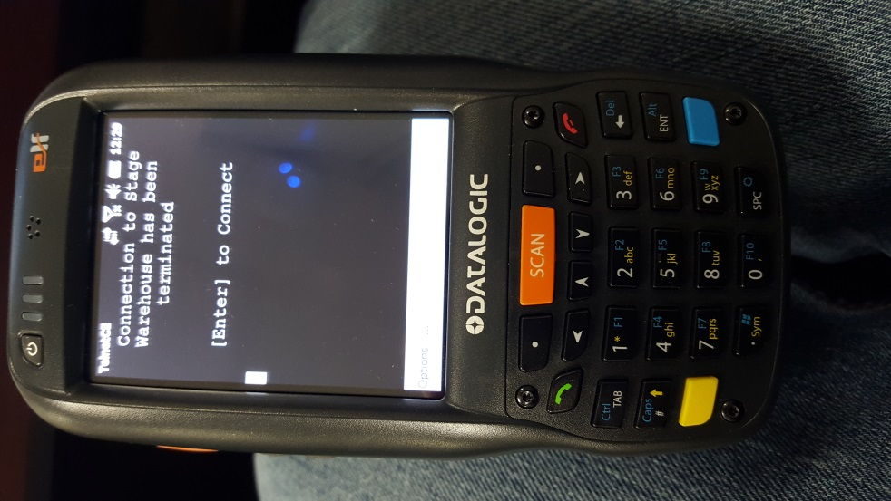

Return to previous screen and back page

Blue button is used to get to F4

To change from numbers to letters and to return back to numbers

Backspace

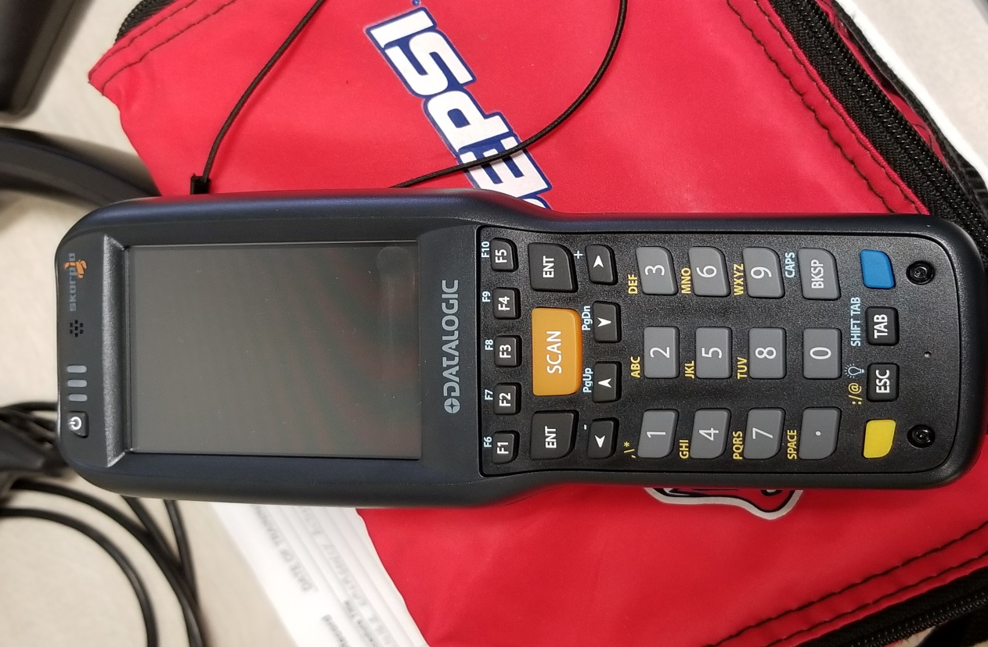

F4 is same as Syteline

Changes #s to Letters

Allows user to backspace

Exit out of screen or form

Scans Barcodes and turns scanner on out of sleep mode

Screen

Up and Down

Enter

Power Button

**Handheld Key Functions**

**Power button**- powers up the handheld, or pressing any of the scan buttons (there are four orange scan buttons)

**ESC button**- return to previous screen, or back to the main menu. Also can be used to log off from handheld.

**Position buttons**- move up and down or frontward and backward.

**Enter button**- processes all forms.

**Blue button** - is the shift key to select the blue keys. Example: blue button + number 4 = F4 (filter in place). On scanner screen if a feild has an * this is where this function is avaialble

**Yellow button**- same as the blue button, but is used to change from numeric to alpha.

**Backspace**- same as arrow keys.

# Job Material Issue ( Obtain jobpick list labels)

Use the Job Material Issue transaction to pick and issue material for a job order.

1. From the main menu, select form, **Job Material Issue**
2. In the Job field, scan or specify the job order number.
3. In the Operation field, scan or specify the operation number. Optionally, press F4 to select from a list of available operations
4. In the Item field, leave the Item field blank and press Enter. This will display all items required at the specified operation.
5. Select an item to pick.
6. In the Location field, scan or specify the location from which items will be issued. Optionally, press F4 and select from a list of available locations
7. If the item being produced is lot controlled, the available lot number automatically appears in the Lot field. Select the appropriate lot.
8. In the Qty. field, enter the quantity to issue.
9. Press Enter. A Successful message is displayed.
10. Continue to next item until all items are picked.

Note: When issuing **Lot tracked items**, user will use FIFO . In the case of requirements are more than first lot has available, the user will pick available amount from first lot and remaining balance fromn the second lot. **These lots must be picked and packed seperatly**

When picking **Serial Tracked items** user will scan the serial sheet that is with item. The scanner will count up to the quanity required. If you miss a number rescan items picked the gun will tell you if this serial # is already used on job with statement duplicate serial.

If user is unable to scan serial sheet, user will need to go to Syteline Job Materials Report and issue manually.

# Move

Use the move transaction to move the job from the picking operation to the next operation.

1. From the main menu, select **Move**.

2. In the Job field, scan or specify the job order number.

3. Details of the job are displayed. To report a different operation, enter the operation number you are completing in the Oper field. Optionally, press F4 to select from a list of available operations.

4. In the Qty Complete field, enter the quantity of items completed.

5. In the Qty Moved field, enter the quantity of items moved.

6. Specify Y in the Complete field to complete the operation. Otherwise, specify N. The same rules apply when picking a job. If parts are short or being pulled by another department and the job being delivered to the production floor, enter N.

8. Specify Y in the Close field to close the job. Otherwise, specify N.

9. Press Enter. A Successful message is displayed.

# Issue Additional Material

Use the Issue Additional Material transaction to issue additional material to jobs for all Operations,Parts Requests and 998 tags.

To issue additional material to jobs:

1. From the main menu, select **Issue Additional Material**
2. Enter the job number
3. Whse: MAIN is displayed
4. Operation: Specify the operation you are adding the material to.
5. Enter or scan the item number you are adding.
6. The item description will be displayed.
7. UM: The unit of measure is displayed.
8. Loc: F4 will list locaitons from where parts are to be pulled. Select the appropriate location.
9. Qty: Enter the quantity to issue.
10. Press Enter. The material is issued.

# Unissue Job Material

Use the Unissue Job Material transaction to return unused materials from a job order (WIP) to an inventory stock location.

1. From the main menu, select **Unissue Job Material**
2. In the Job field, scan or specify the job order number
3. In the Oper field, enter the operation number. Optionally, press F4 to select from a list of available operations.
4. In the Item field, scan or specify the item number to return.
5. In the Loc field, scan or specify a location from which items will be returned. Optionally, press F4 to select from a list of available locations.
6. The Avail Qty field shows the quantity of items already issued to this job. In the Qty field, enter the quantity to return. NOTE: **Do not enter a negative**.
7. Press Enter. A Successful message is displayed.

# Item Inquiry

1. From the main menu, select **Item Inquiry**
2. Scan or specify the item number in the Item field, then press Enter. Item attributes are displayed.
3. Scan or specify a location in the Location field, or leave the Location field blank to list all locations. Press Enter.
4. On the next page, items are listed by location, location ranking, quantity on hand, and reserved quantity. Select a location and press Enter.
5. On the next page, items are listed by lot number, quantity on hand, and reserved quantity.
6. Press Esc to return to the main menu.

# Location Inquiry

Use the Location Inquiry transaction to view a list of all available items at a specific location.

1. From the main menu, select **Location Inquiry**

2. Scan or specify the location in the Location field, then press Enter. The item list is displayed

# Miscellaneous Issue

1. From the main menu, select **Miscellaneous Issue**
2. Scan or specify the item number in the Item field, then press Enter
3. In the Loc field, scan or specify the location from which items will be issued. Optionally, press F4 and select from a list of available locations.
4. Enter or scan reason code or press F4 to select from a list of reason codes.
5. In the Qty field, enter the quantity to issue.
6. Optionally, scan or specify a document number in the Doc No field
7. Press Enter. A Successful message is displayed. In SyteLine, the Material Transactions form is updated

Note: Reason codes are the same as the ones used in Syteline

# Miscellaneous Receipt

1. From the main menu, select **Miscellaneous Receipt**
2. Scan or specify the item number in the Item field, then press Enter.
3. In the Loc field, scan or specify the location where items will be received. Optionally, press F4 and select from a list of available locations. If the item is lot tracked, the list will also display lots.
4. If the item is lot tracked and the lot does not exist, location and press enter, then enter new lot number.
5. Enter or scan the Reason field, or press F4 to select from a list of reason codes.
6. In the Qty field, enter the quantity being received.
7. Optionally, scan or specify a document number in the Doc No field
8. Press Enter. A Successful message is displayed. In SyteLine, the Material Transactions form is updated

Note: Reason codes are the same as the ones used in Syteline

# Quantity Adjustment

Use the Quantity Adjustment transaction to correct a discrepancy between the reported quantity in SyteLine and the actual quantity of an item at a specific location.

1. From the main menu, select **Quantity Adjustment**
2. In the Item field, scan or specify the item number.
3. In the UM field, specify the unit of measure
4. In the Loc field, scan or specify the location where item quantity will be adjusted. Optionally, press F4 and select from a list of available locations
5. Accept the default reason code in the Reason field, or press F4 to select from a list of reason codes
6. In the New Qty field, scan or specify the correct quantity
7. Optionally, scan or specify a document number in the Doc No field
8. Press Enter. A Successful message is displayed. In SyteLine, the Material Transactions form is updated.

# 

# Stock Move

Use the Stock Move transaction to relocate stocked items.

1. From the main menu, select, **Stock Move**
2. In the Item field, scan or specify the item number.
3. In the From Loc field, scan or specify the source location for the items. Optionally, press F4 to select from a list of available locations. On-hand and available quantities are displayed
4. In the Qty field, scan or specify the quantity to move.
5. In the To Loc field, scan or specify the destination location. Optionally press F4 to select from a list of available locations.
6. Press Enter. A Successful message is displayed.

Note: All items will need to have a permanent location. If new they will come in as STOCK and will need to be placed into a valid IC location.

# Transfer Order Shipping

1. From the main menu, select **Transfer Order Shipping**
2. In the Ord field, scan or specify the transfer order number.
3. In the Line field, scan or specify the line number. Optionally, press F4 to select from a list of available lines
4. In the Loc field, scan or specify the source location. Optionally, press F4 to select from a list of available locations
5. In the Qty field, scan or specify the quantity to ship.
6. Press Enter. A Successful message is displayed.

NOTE: Use position key to return to transfer order #.

1. After processing all lines that you need to pull, go into Syteline Transfer Ship Packing Slip form, and scan TO # and Line # with computer scanner not Warehouse Mobility Scanner.
2. Print out packing slip andattach to material being transfered

# Cycle Count (Can only be performed by Cycle Counters)

Use the Cycle Count transaction to count items by location, by item number, or both. In Syteline generate a cycle count as would be preformed daily, then follow steps below.

1. From the main menu, select **Cycle Count**
2. Perform the cycle count: To count by location, scan or specify a location in the Loc field and leave the Item field blank.
3. Press Enter. All items available in the specified location are displayed.
4. To count by location and item number, scan or specify a location in the Loc field and scan or specify an item number in the Item field. Press Enter. The quantity of the specified item in the specified location is displayed. In SyteLine, the counted quantity on the Cycle Count update form is updated.