Purpose: 1

Related Documents: 1

Responsible: 1

Rules: 1

Job Pick List 1

Job Packet 2

Serial Numbers 4

Compile Job Packet 5

Purpose:

To document the standard process for printing job orders, job pick lists and job serial numbers.

Related Documents:

None

# Responsible:

Maintained by Supply Chain Management

Carried out by Supply Chain Admin, Planners

# Rules:

1. PCB includes the Job Pick List, a portion of the Job Packet and if needed the serial number/calibration sheet as part of the Job Packet.
2. Depending on your default setting, when you press print, the report will either go directly to your printer or will go to the SyteLine Reports folders under your user name.

# Job Pick List

The Job Pick List prints a list of all materials with the quantities that are required for the job. Backflush items are also included on the pick list but are noted as backflush.

To print the job pick list go to Form, Open, Job Pick List. Fill in the job number to be printer and hit print. Do not fill in the operation starting and ending to allow all operations to print on pick list. Leave the check boxes selected as noted below.

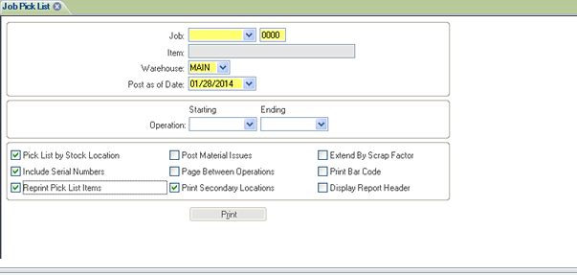

# Job Packet

The **Job Packet** provides a complete packet of shop floor documents. This job packet can consist of up to five separate but related documents.

These documents then can travel with the job items as they move through the production process.

The following table lists and describes in general terms the contents of each report.

| **Option** | **Description** |
| --- | --- |
| Job Header | Provides a summary of the job, including:   * Status of the job * Item description * Details about how the job was created * Information about job material quantities * Job schedule dates |
| Job Traveler  (Do Not Use) | Provides, in sequential order, a listing with details of all the stages (work centers) involved in the job. |
| Operation Listing  (Use except as noted below) | Provides a detailed list, for each operation, of the materials and time required at each stage (work center) of the job. |
| Material Pick List  (Do Not Use) | Provides a detailed list of all the materials required to complete the job. This report indicates:   * The quantity of each material item required * The quantity available * A place for someone to notate the quantity actually picked up. |
| Job Tickets  (Do Not Use) | Provides a form that employees can use to manually record labor and productivity information. This form can be used later to enter the information into the database, using the [Unposted Job Transactions](http://syteline.pcb.com/syteline/Language/en-US/forms/sftopics/unposted_job_transactions.htm) form. |

The first time you open this form you will need to check the boxes shown below and then go to actions, Store Options and when your user information displays, hit OK. To print the job packet for PCB go to Actions, Get Options and when your user information displays, hit OK. This will pull up the form as you defined earlier. Fill in the job number and suffix in both the starting and ending fields.

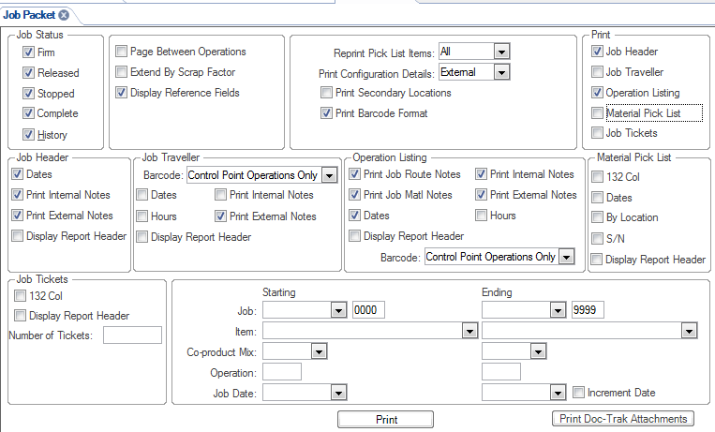

The following department(s) have discontinued use of the Operation Listings. IC personnel will uncheck Operations listings when printing these jobs.

|  |  |  |
| --- | --- | --- |
| Department | Job Prefix | Job Packet Contents |
| Microelectronics | M | Job Header without Job Dates and Job Pick List |
| EME |
| NME |

Hit Print. The message below will appear. Hit OK.

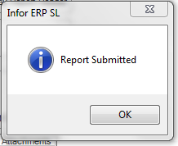

Print Doc-Trak Attachments for all the following job prefixes : CR, ECR NCR, and PMR.

All other job prefixes do not require the Doc-Trak Attachments.

When you hit the Print Doc-Trak Attachments, the screen below will appear. For any documents listed that has Assembly or Procedure in the Description column, uncheck the box under Select. This will not print this document. Notify Design Request to remove from Doc-Trak Print with Job Packet. When your review is complete hit print.

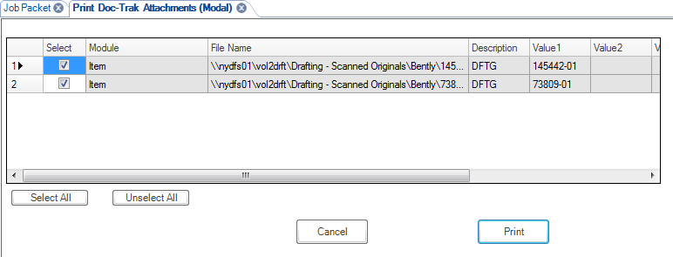

If you receive a message that states document can not print you will need to identify which document can not print and notify Design Request to correct the link. Doc-Trak will only print up to the file that errored. If you have no errors, the message below will appear. Hit OK.



# Serial Numbers

PCB has customized the allocation of serial numbers to allow for a combined model/serial number and allow the use of the serial number generation to give us a calibration sheet.

The PCB Job Release not Printed Report will indicate if a Serialization sheet is to be generated for a job. To generate, allocate and print serial numbers go to Form, Open, PCB Serial Master. This form opens in filter in place mode. In order to go to new mode, put an x in the item number and hit filter. Since an x does not exist, you will be in new mode.

Enter the item number on the job in the model field. Hit tab which will populate all grey fields. Enter the job number and suffix as well as the job quantity. Hit Save. If you receive an error that says the series cannot be null, or Print Serial Number contain ERR, contact the planner. This means the item is not set up correctly or may mean a serial number is not required.

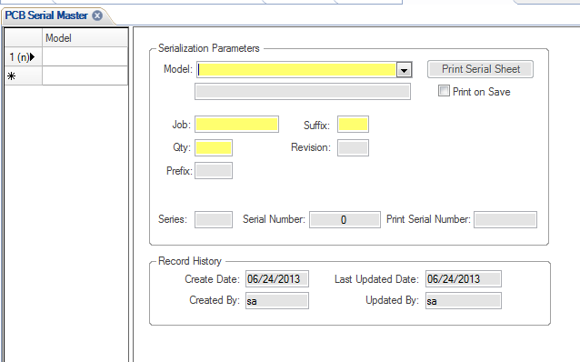

If there are no errors than hit Print Serial Sheet. The screen below will appear. Hit OK.



# Compile Job Packet

Compile job paperwork as follows:

* 1. Job header
  2. Pick List, if required.
  3. Doc-Trak documents , if requierd
  4. Job Operations Listing, if required.
  5. Serial number sheet if required