BUYER RESPONSIBILITIES DAILY: 2

FG Type Changes 2

New Item Review 3

Material Planner Workbench 4

Past Due Purchase Order Report 6

Transfer Order Report 7

Item Bottlenecks Report APS 8

Un –Acknowledged Purchase Orders Review 9

Purchase Order Status Report 10

BUYER RESPONSIBILITIES WEEKLY: 11

Inventory Below Safety Stock Report 11

SyteLEAN MRP Exception Summary Report 12

SyteLEAN Spike Demand Report 13

Blanket Expiration Report 14

BUYER RESPONSIBILITIES MONTHLY: 15

ROHS Compliance Updates 15

Purchase Order Complete Utility 16

SUPPLIER DEVELOPMENT ENGINEER RESPONSIBILITIES: 17

Supplier Approval Expiration Review 17

# BUYER RESPONSIBILITIES DAILY:

## FG Type Changes

* + Frequency – Daily
  + Objective – Identify items that the FG type has changed due to the top model FG type changing and make any necessary adjustments needed as a result to this change.
  + Form to Use – Items and Syteline Notification Changed FG Type Report daily email
  + Criteria to Use –
    - Planner Code
  + Process –
    - Open the Syteline Notification Changed FG Type Report from your email
    - Review this report by the following:
      * Look at both the NC PLAN column and the SITE PLAN column looking for your planner code
      * The OLD and NEW columns will tell you what the FG Type were (OLD) and what it is now changed to (NEW).
        + S=STOCK
        + D=STANDARD
        + P=SPECIAL
    - In Syteline Items form for the Purchase site (NY or NC) filter on the part number of the item(s) with your planner code that have changed
    - If the part is now a **SPECIAL** make the following updates:
      * Safety Stock = 0
      * SyteLEAN – if previously on SyteLEAN, have it removed and change the Planner Code from KBx to PBx
      * Paper Work Lead Time = 5
      * Order Min = 0 unless there truly is an order min
      * Order Mult = 1 unless there truly is an order mult
      * Order Max = 0
      * Days Supply = 63
      * Validate Buyer name is in the correct format
      * Validate the part has a correct Commodity
      * Cancel any blanket orders for this part and validate that any open order are for the correct quantity of a Special and not to fill safety stock.
    - If the part is now a **STANDARD** or **STOCK** make the following updates:
      * Paper Work Lead Time = 0
      * Order Min = 0 unless there truly is an order min
      * Order Mult = 1 unless there truly is an order mult or unless the part is on SyteLEAN
      * Order Max = 0
      * Days Supply
        + Standard = 21
        + Stock = 5
      * Validate Buyer name is in the correct format
      * Validate the part has a correct Commodity

## New Item Review

* + Frequency – Daily
  + Objective – Validate Purchase fields in items form are set-up properly for new items
  + Form to Use – Items
  + Criteria to Use –
    - Filter on Purchased and Fixed Lead time of 0 days
  + Process –
    - Validate and Update information in the following fields
      * Buyer – Buyer name must follow the following formats:
        + Default format is first initial followed by last name (jsmith = John Smith)
        + SyteLEAN parts format the buyer name as lastname + first initial (smithj)
        + Platinum parts use the above formats but they begin with a P (pjsmith or psmithj)
      * Planner Code – Reference the NY Planner Codes Matrix for formats
      * Paperwork Lead Time
        + Stock or Standard = 0 days
        + Specials = 5 days
      * Dock-To-Stock Lead Time
        + If the item is a QCS item = 2 days
      * Fixed Lead Time
        + Make the fixed lead time = to the replenishment time (in business days) and put the true order lead time (in calendar days) in the Vendor Contracts lead time field.
        + Update based on best in class parameters and feedback from supplier
      * Expedited Lead Time
        + The number of days the buyer can expedite to with an 80% confidence level

If the fixed lead time and the expedited lead time are the same, the expedited lead time should be set to 1 day less than the fixed lead time.

* + - * Order Min
        + 0 unless there truly is an order minimum
      * Order Mult
        + 1 unless there truly is an order multiple
        + SyteLEAN parts the order mult = bin size
      * Order Max
        + 0
      * Days Supply
        + Stock = 5 days
        + Standard = 21 days
        + Special = 63 days
      * Commodity – Refer to Buyer Assignments spreadsheet for commodity code guidelines
      * Infinite Flag – Should only be checked for Expense items that are true VMI items so the system will not constrain on lead time.
      * Stocked flag – Should be checked for all purchased items except for outside processing items.
      * Time Fence Rule –
        + Lead-Time if the item has a safety stock set
        + No Time Fence if the item does not have a safety stock set
      * Lot Track
        + Must be checked for all materials where the supplier specifies a shelf life
      * Shelf Life
        + Fill in appropriate number of days for shelf life as reported by the supplier
  + Repeat this process for all sites you are responsible for maintaining.

## Material Planner Workbench

* + Frequency – Daily
  + Objective – Ensure purchased items are ordered in a timely manner
  + Form to Use – Material Planner Workbench Generation
  + Criteria to Use –
    - Date – Today’s Date
    - Buyer Name or Planner Code
  + Process –
    - Open the form and enter the criteria. Press the Process button.
    - The system will return a pop-up notifying how many records were generated
    - Press Planner Workbench to open the workbench.

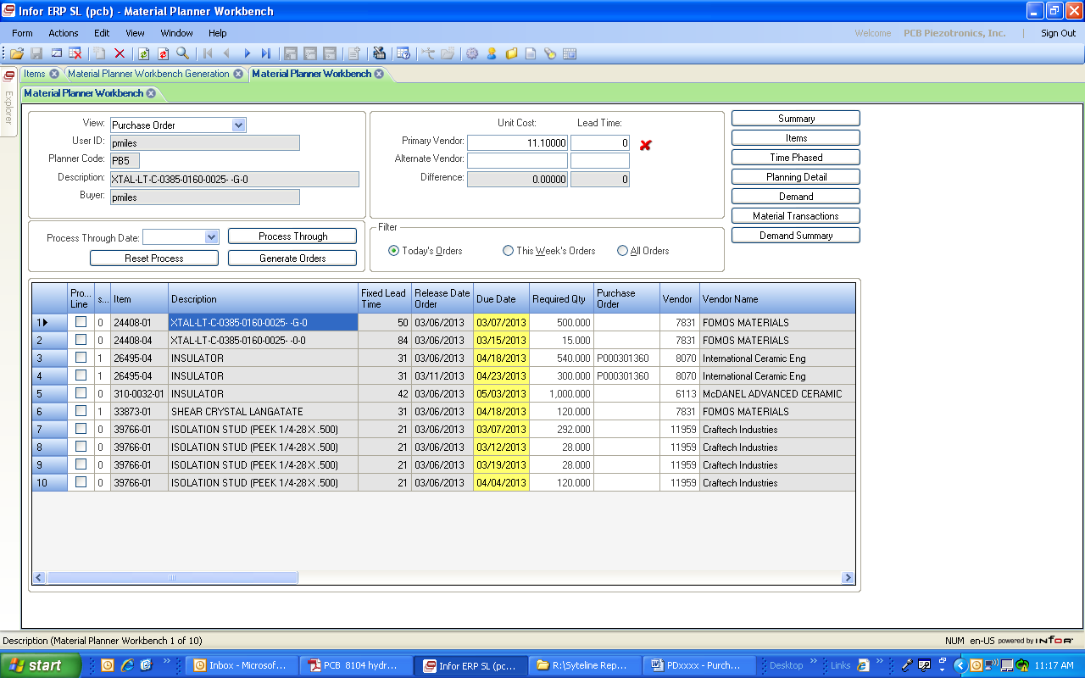

* + - Buyers must analyze and execute as appropriate all signals on the bench for today.
    - The workbench can be sorted in different ways to make ease of analyzing the information by double clicking on the column headings
    - Column 1 is the Process Line check box. After analysis of the demand a check mark in this box will signify that the line is ready to have an order generated.
    - Column 2 will identify error messages detected by the system. The last column on the workbench will describe what the cause of the error message is.
      * Error Code 0 = no error
      * Error Code 1 = Warning, the system will allow you to proceed with the order generation
      * Error Code 2 = System Stop, the system will not allow you to proceed with the order until the error is resolved and the Material Planner Workbench is regenerated.
    - The column labeled Purchase Order will identify the PO number of blanket purchase orders for that part.
      * To make this PO number listed you must have first entered the PO number in the Item/Warehouse form (from the Items form) under the Replenishment Order PO section.
      * When you generate an order from the workbench it will create a new release on the listed existing PO.
    - You have the ability to change the required quantity and due date information on the workbench prior to generating the PO. The changed information will be transferred to the new PO.
    - On the top right hand side of the workbench are links to other forms to be used in analyzing the demand signals. Clicking on these buttons will take you to a form with information of the part number of the line on the workbench that you are clicked on (identified by a “🢒” mark by the line number.
      * Summary – will take you to a form with the summary information of the Material Planner Workbench
      * Items – will take you to the Items form
      * Time Phased – will take you to the Time Phased form
      * Planning Detail – will take you to the Planning Detail form
      * Demand – will take you to the Planning Detail form
      * Material Transactions – will take you to the Material Transactions form
    - The box in the left top of the form is information about the item you are pointing to.
      * The View field is a drop down that will change the view of the demand signals and what form will be created when you generate. The views available are Purchase Order, Purchase Requisition, Job, Production Schedule, MPS Order, Transfer Order.
      * NOTE: The system will default to Purchase Order every time the form is opened. This is the view needed by Procurement to create Purchase Orders.
    - The next box to the right will provide information about the primary and alternate vendor of the part you are clicked on.
      * Unit Cost – originates from the blanket PO line, the vendor contract prices, or the items form Unit Cost field (based on the PO type and what information if available in Syteline)
      * Lead Time – originates from the vendor contract lead time or the items form Fixed Lead Time field.
      * Green Checkmark – If today's date plus the lead time does not exceed the due date, a green checkmark will appear next to this field. Signals the part can be purchased within the due date.
      * Red X – If today's date plus the lead time exceeds the due date. Signals the lead time will put the delivery outside of the due date.
    - Below that is the Filter Box. This allows you to filter the items on the workbench to only view Today’s Orders (order to be released on today’s date), This Week’s Orders, or All Orders
    - The box to the left of the Filter box is used to create the supply orders.
      * Process Through Date and Process Through
        + To mark a range of items to be processed, enter a date in the Process Through Date field. When you click the Process Through button, the Process Line check box is selected for all items with a Release Date on or before this date. If no date is entered when you click this button, the Process Line check box is selected for all displayed items.
      * Reset Process – clicking this will remove the checkmark from all of the Process Line check boxes.
      * Generate Orders – clicking this will initiate the generation of a Purchase Order or Purchase Order Line/Release for all items that has a check mark in the Process Line check box. Once the PO is generated, the item will be removed from the Material Planner Workbench.
    - After generating a PO, open the Purchase Order form and filter on a creation date of today. This will show all purchase orders created today. Find your purchase order(s)
      * Enter your buyer name on the Purchase Order form and save.
      * Click on the Lines button
        + Enter the Promise Date on the Purchase Order Lines form for each item/line
        + Validate that your quantity, due date, item cost are correct
      * Print the PO and any associated drawing to send to the supplier.
  + Repeat this process for all sites you are responsible for maintaining.

## Past Due Purchase Order Report

* + Frequency – Daily
  + Objective – Update all purchase order lines and releases with delivery dates in the past
  + Form to Use – Past Due Purchase Order Report Form
  + Criteria to Use –
    - Yesterday’s Date
    - PO Type – Regular & Blanket
    - PO Status – Planned & Ordered
    - PO Line Release Status – Planned & Ordered
    - Buyer Name
    - Clicking on Preview will supply the output in a PDF format
    - Clicking on Print will supply the output in an Excel format

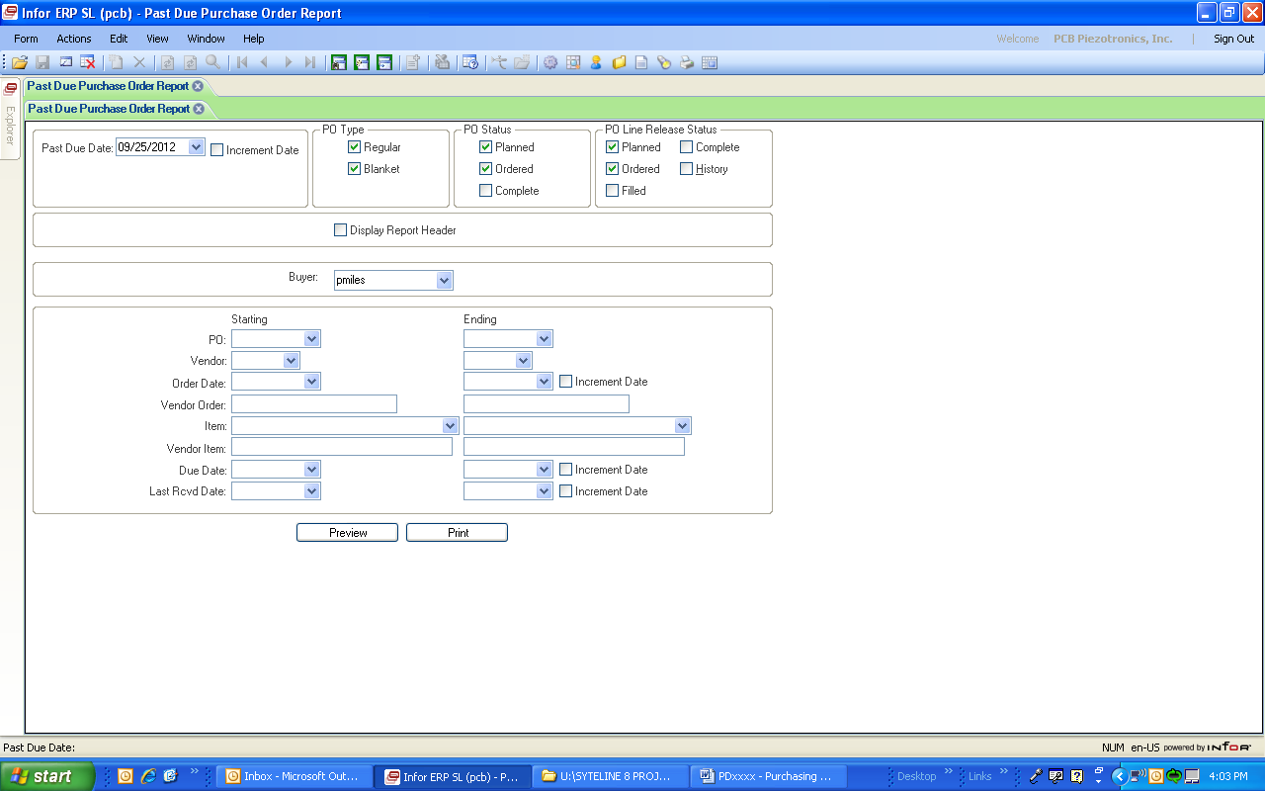

* + Process –
    - Run the Report based on the criteria above
    - Review each purchase order on the list for reason of late delivery
    - Contact vendors for status updates (if needed)
    - Update all past due lines to reflect accurate due date
    - If a due date cannot be obtained (MDR return in process, ECO issues, etc.) update the due date to 12/30/2050 to identify a problem with this delivery.
    - If a customer order is impacted by the delivery date change, notify the appropriate planner.
  + Repeat this process for all sites you are responsible for maintaining.

## Transfer Order Report

* + Frequency – Daily
  + Objective – Maintenance of updated due dates and promise dates on Transfer Orders and Communication
  + Form to Use – Transfer Order Line Items
  + 1ST Criteria to Use – Update Past Due TO Lines
    - Planner Code
    - Line Status <>C (not equal to Complete)
    - Sched Ship Date <today’s date
  + Process –
    - Run a filter using the 1st criteria to use above
      * Hint: Using the grid mode makes it easier to view and update the dates for groups of TO lines. In the grid, sort on the Item column to get all TO lines for a part number together.
    - For any item that has not shipped yet, review the items supply plan and determine what the updated ship date will be. Contact vendors for status updates (if needed).
      * Note: You may notice that stock is available of an item but the inventory level is below safety stock. The system will not show this part available to ship if it is below safety stock level. Take this into account when doing the analysis of dates.
        + First try to pull in a future shipment to bring the inventory above safety stock. Use the updated delivery date as the scheduled ship date of the TO.
        + If a future shipment cannot be moved in, use the expected delivery date of the earliest shipment as the scheduled ship date of the TO.
    - Update all past due lines to reflect accurate due date as outlined below
      * Delete the Sched Rcvd Date. The system will not allow you to enter a scheduled ship date that is beyond the scheduled received date so you need to remove the scheduled receive date first.
        + You will receive a pop-up box that a value is required in the Sched Rcvd Date box. Click on NO and it will allow you to move on the Sched Ship Date entry.
      * Enter the updated Sched Ship Date. The system will automatically calculate and enter the new Sched Rcvd Date.
      * If the Promised Date is already filled in, leave it as is.
      * If the Promised Date is not already filled in, enter the same date as you entered for the Sched Ship Date.
    - If a line has had a partial shipment and the partial is caused by a delay from the vendor, contact the planner to have the TO line split with the updated ship date for the balance.
  + 2nd Criteria to Use – Fill in blank Promised Ship Dates
    - Planner Code
    - Line Status <>C (not equal to Complete)
    - Promised Date = Null
  + Process –
    - Run a filter using the 2nd criteria to use above
      * Hint: Using the grid mode makes it easier to view and update the dates for groups of TO lines. In the grid, sort on the Item column to get all TO lines for a part number together.
    - For any item that has not shipped yet, enter the Promise Date (this is the Promised Ship Date)
    - The Promised Date should match the Sched Ship Date at the time of initial entry.
    - If parts will not be available to meet the Scheduled Ship Date do the following
      * Delete the Sched Rcvd Date. The system will not allow you to enter a scheduled ship date that is beyond the scheduled received date so you need to remove the scheduled receive date first.
        + You will receive a pop-up box that a value is required in the Sched Rcvd Date box. Click on NO and it will allow you to move on the Sched Ship Date entry.
      * Enter the updated Sched Ship Date. The system will automatically calculate and enter the new Sched Rcvd Date.
      * Enter the same date as you entered for the Sched Ship Date into the Promised Date.
  + Repeat this process for all sites you are responsible for maintaining.

## Item Bottlenecks Report APS

* + Frequency – Daily
  + Objective – Identify purchased parts that are causing delays and potential amendments on customer orders
  + Form to Use – Item Bottlenecks Report APS
  + Criteria to Use –
    - Planner Code starting and ending value (run for both Sytelean and APS Planner Codes)
    - Check List Delayed Demands
    - Clicking on Preview will supply the output in a PDF format
    - Clicking on Print will supply the output in an Excel format

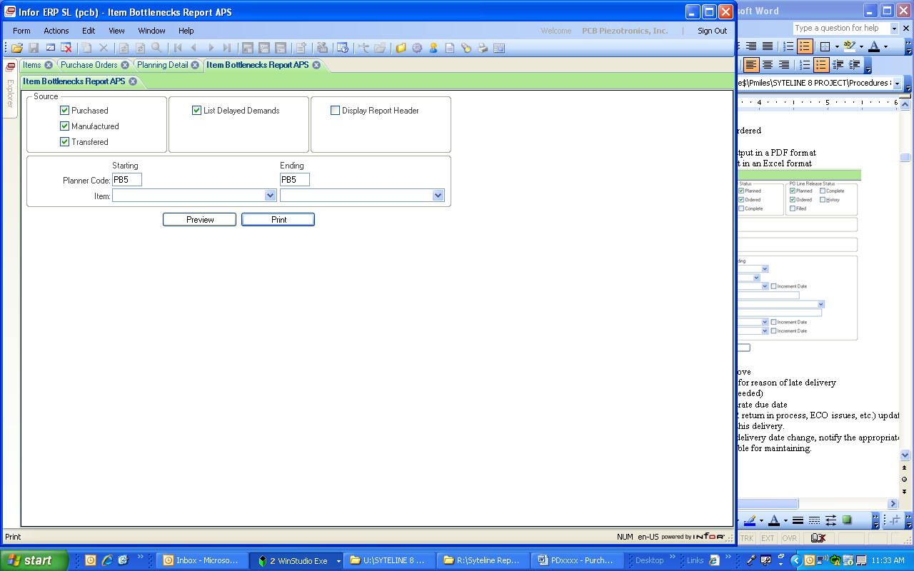

* + Process –
    - Run the Report based on the criteria above
    - Review each item number on the list
      * The report will identify if the impacted demand is from a transfer shipment (TRNS), a job order (JOB), forecast (FCST), customer orders (CO), safety stock (SSD), master production schedule (MPS)
    - Contact vendors to expedite delivery (if possible)
      * If the vendor can improve the delivery, update the purchase order with the new due date
      * If the vendor cannot improve the delivery date or the new due date does not satisfy the need date of the demand and your demand is for a CO, JOB, TRNS do the following:
        + CO – notify the appropriate planner and Purchasing Manager and have the customer order amended to the new schedule.
        + JOB – notify the planner to amend the job dates
        + TRNS – notify the planner to adjust the ship date on the transfer order.
  + Repeat this process for all sites you are responsible for maintaining.

## Un –Acknowledged Purchase Orders Review

* + Frequency – Daily
  + Objective – Obtain a collection of any purchase orders that the vendor has not yet acknowledged receipt.
  + Form to Use – Purchase Order Form
  + Criteria to Use –
    - Buyer Name
    - Vendor Acknowledged check box blank
  + Process –
    - Open the Purchase Orders form and click the filter in place button.
    - Enter the criteria above and click on the filter in place button again.
      * To enter the Vendor Acknowledged check box as blank – click on it once to enter a check mark and then click on it a second time to remove the check box. This will identify that your request is to search on that field without a checkmark.
    - Review the list of purchase orders collected and contact the vendors to confirm that they have received the purchase orders.
      * You can export the list of purchase orders into an Excel spreadsheet to sort by vendor and email the vendor their list, if needed.
    - If the vendor acknowledges receipt of the order, put a check mark in the Vendor Acknowledged check box.
  + Repeat this process for all sites you are responsible for maintaining.

## Purchase Order Status Report

* + Frequency – Daily
  + Objective – Obtain a collection of purchase order lines and releases still in the planned status and verify that the vendor has been informed of the order
  + Form to Use – Purchase Order Status Report Form
  + Criteria to Use –
    - PO Type – Regular & Blanket
    - PO Status – Planned & Ordered
    - PO Lines/Release Status – Planned
    - Optional – Sort by Purchase Order, Item or Vendor
    - Buyer Name
    - Clicking on Preview will supply the output in a PDF format
    - Clicking on Print will supply the output in an Excel format

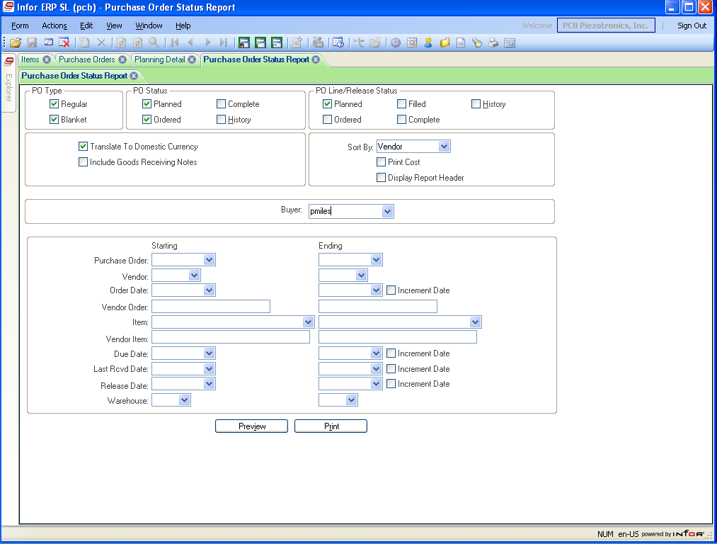

* + Process –
    - Run the Report based on the criteria above
    - Review each purchase order on the list and determine if the order has been communicated to the vendor.
    - Contact vendors for validation or order receipt (if needed)
    - If the order has not been received by the vendor
      * Verify if the order is in the management signature process
      * If within your signature approval, print the order and send to the vendor.
      * Update the status of the line/releases from planned to ordered and save.
    - If the order has been received by the vendor
      * update the status of the line/releases from planned to ordered and save.
        + Note: If the status does not get updated from planned to ordered, receiving will not be able to receive the parts when they arrive.
  + Repeat this process for all sites you are responsible for maintaining.

# BUYER RESPONSIBILITIES WEEKLY:

## Inventory Below Safety Stock Report

* + Frequency – Weekly
  + Objective – Identify purchased parts that the on-hand quantity is below full safety stock level
  + Form to Use – Inventory Below Safety Stock Report
  + Criteria to Use –
    - Material Type – Material, Tool, Fixture, Other
    - Source – Purchased
    - Exclude zero Net Requirement Items
    - Warehouse = Main (Starting & Ending)
    - Planner Code (Starting & Ending)
    - Clicking on Preview will supply the output in a PDF format
    - Clicking on Print will supply the output in an Excel format

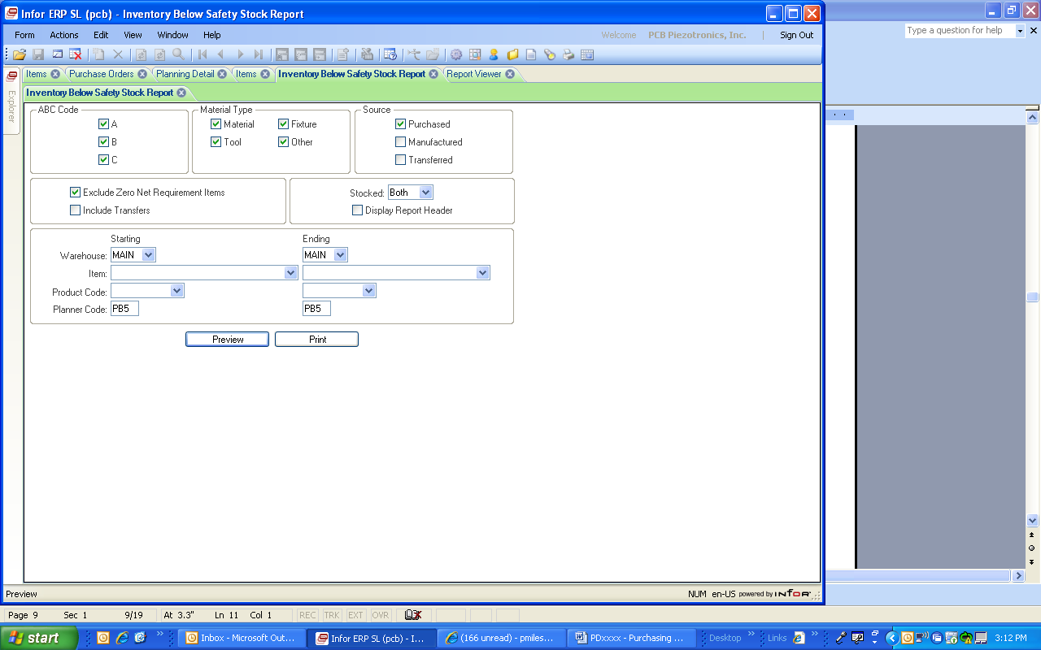

* + Process –
    - Run the Report based on the criteria above
    - Review the ouput file by looking at each part number in the Items form
    - Determine if there is sufficient quantity on order to fill the safety stock level
      * If not, place an order with the supplier
    - Contact the supplier to pull in items if they are needed sooner than the due date indicated
  + Repeat this process for all sites you are responsible for maintaining.

## SyteLEAN MRP Exception Summary Report

* + Frequency – Weekly
  + Objective – Identify exception message for resolution
  + Form to Use – SyteLEAN MRP Exception Summary Report
  + Criteria to Use –
    - Planner Code
    - Source = Purchased
    - Exception Types = On Hand Below Safety Stock, Sched Rcpt Past Due, Move In PO, PO Not Needed, Used Expedited Lead Time (at minimum, use any other that identify the exception type you want to review)

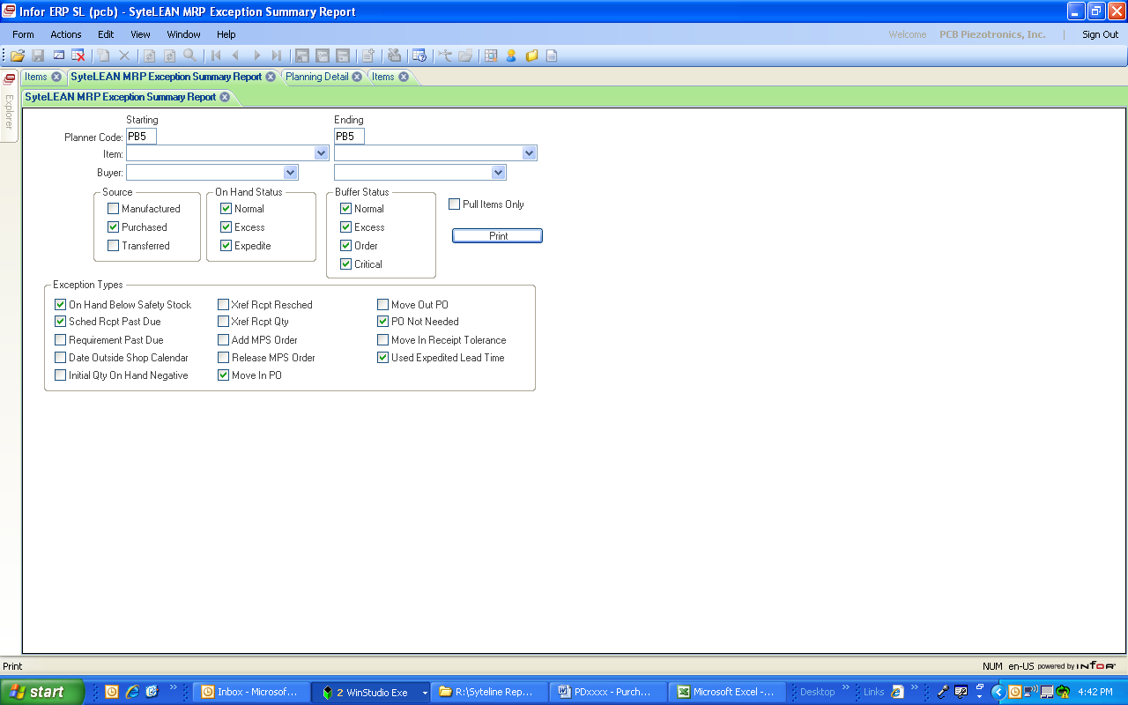

* + Process –
    - Run the report based on the criteria above
    - Evaluate the report for actions needed by reviewing the Exception Msg column
      * On Hand below Safety Stock – Ensure there is a PO issued and expedite the delivery date if possible. If no PO is issued, create one.
      * Sched Rcpt Past Due – Contact the supplier and update the Due Date on the PO with the new delivery schedule
      * Move In Rcpt xx/xx/xxxx – Expedite the parts to move in the receipt if possible
      * Receipt Not Needed – Evaluate if the PO is needed (eg. created from a requisition, blanket PO place holder, firm releases, etc.)
        + Ignore if parts are needed.
        + If parts are not needed (eg. Special and demand is canceled, etc.), contact the supplier and cancel the PO if possible.
      * Expedited xx Days – Ensure there is a PO issued and expedite the delivery date if possible. If no PO is issued, create one.
  + Repeat this process for all sites you are responsible for maintaining.

## SyteLEAN Spike Demand Report

* + Frequency – Weekly
  + Objective – Identify SyteLEAN items whose demand exceeds the threshold set in the parameters
  + Form to Use – SyteLEAN Spike Demand Report
  + Criteria to Use –
    - Planner Code
    - Check box for “Skip Spikes Covered by Inventory”

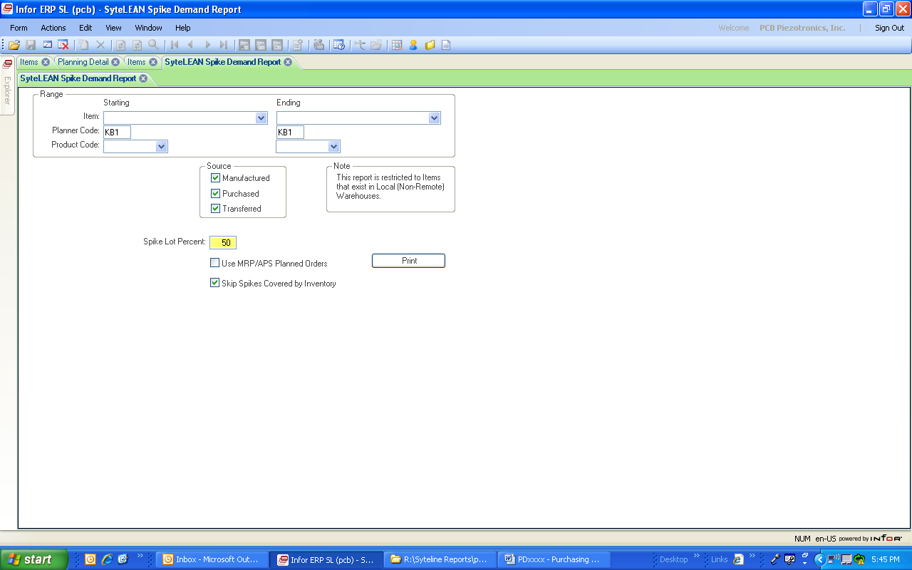

* + Process –
    - Generate the report using the criteria above.
    - Evaluate the report and validate if orders are in place to cover the spike in demand
    - If no order has already been issued, generate and issue a PO order/release to cover the spike in demand
  + Repeat this process for all sites you are responsible for maintaining.

## Blanket Expiration Report

* + Frequency – Weekly
  + Objective – Search for blanket order lines that will be depleted and requires a new blanket order created to maintain the flow of a part to PCB.
  + Form to Use – Purchase Order Blanket Lines
  + Criteria to Use –
    - Buyer Name
    - Blanket Line Order Status – Ordered
    - Expiration Date – greater than (>) today
  + Process –
    - Open the Purchase Order Blanket Lines form and filter on the criteria above.
    - Review the list for any blanket lines that have limited supply available.
    - Evaluate blanket lines for the rate of consumption and adjust the Expiration Date field in or out to reflect the estimated time left on the blanket purchase order.
    - Ensure that any blanket lines that have an Expiration Date within 3 months (at a minimum) have a new blanket purchase order in place to continue the supply, if needed.
      * If the lead time of an item is beyond 3 months, evaluate the blanket and ensure the supply will continue.
    - As releases are made on each blanket during normal order processing, continue to evaluate the Expiration Date and make changes as needed to ensure that an accurate estimate of blanket purchase order duration is maintained.
  + Repeat this process for all sites you are responsible for maintaining.

# BUYER RESPONSIBILITIES MONTHLY:

## ROHS Compliance Updates

* + Frequency – Monthly
  + Objective – Obtain the required ROHS compliance certification for all purchased products with a status of Requested to meet the needs of the customer.
  + Form to Use – PCB Item Certifications
  + Criteria to Use –
    - Buyer Name
    - ROHS Status – Requested
  + Process –
    - Filter in the PCB Item Certifications form on the criteria above
    - Contact the vendor of each item and validate if the item purchased is ROHS compliant.
    - If compliant –
      * Obtain certification from the supplier of the compliance
      * Forward evidence of RoHS from the supplier to Regulatory Affairs for review
      * Regulatory Affairs will update the ROHS Status on the PCB Item Certifications form to Compliant and select the evidence type from the drop down menu and save
      * Regulatory Affairs will maintain the compliance paperwork per RA1000.
    - If not compliant
      * Contact the engineer for that product, or Regulatory Affairs, to notify them that ROHS compliance could not be obtained.
      * Work with the engineer , or Regulatory Affairs, to obtain certification of any alternate manufacturer part numbers for this item.
      * If a complaint part is found, update the vendor contract with the new manufacturer part number and follow the “If Compliant” steps above
        + Review any on-hand parts with the sales person and engineer to determine if they need to be replaced with ROHS compliant parts, returned to the vendor or scrapped.
      * If no compliant replacement can be found, change the ROHS status on the PCB Item Certifications form to Not Compliant.
        + Contact the sales person for the top model to inform them that the ROHS compliance of the components could not be obtained.
  + Repeat this process for all sites you are responsible for maintaining.
  + Reference User Guide – PD2024

## Purchase Order Complete Utility

* + Frequency – Monthly
  + Objective – Changes the status of fully received and vouchered filled purchase order lines and releases to complete. When all lines are complete, the order status will be complete. The vendor contracts form is updated for year to date purchase history, last cost and lead time information and average lead time and costing information.
  + Form to Use – Change PO Status Utility
  + Criteria to Use –
    - Old Status – Ordered
    - Order Type – Both
    - Order Date Starting – 01/01/1999 (or date of earliest PO is database at ordered status)
    - Order Date Ending – one year prior to today’s date

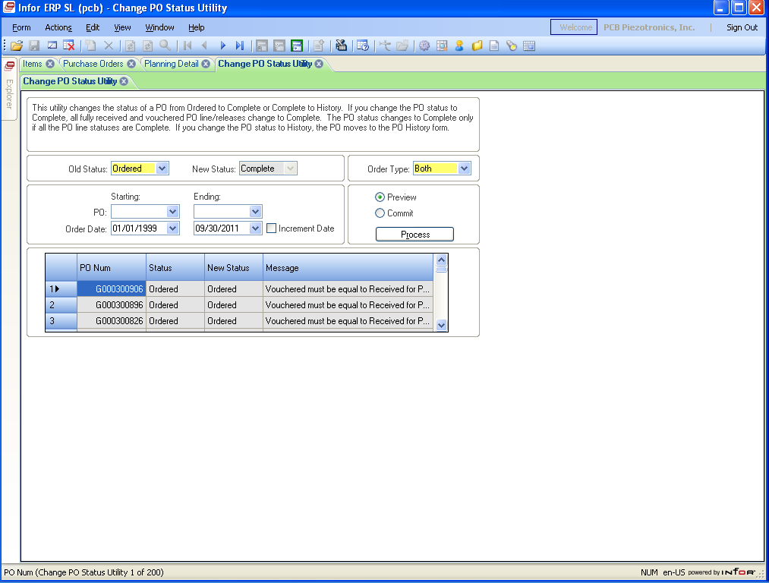

* + Process –
    - Open the form and enter the criteria above
    - Select the Preview radial button and click on the Process button
    - Review the grid for any issues needing resolution
    - Notify the buyer of any issues requiring their resolution (return discrepancies requiring a credit memo, etc.)
    - Resolve any problems that can be resolved
    - Select the Commit radial button and click on the Process button
  + Repeat this process for all sites you are responsible for maintaining.

# SUPPLIER DEVELOPMENT ENGINEER RESPONSIBILITIES:

## Supplier Approval Expiration Review

* + Frequency – Bi-Weekly
  + Objective – Monitor supplier approval and certification expiration dates and renew as needed to maintain a current Approved Supplier List.
  + Form to Use – Vendors form
  + Criteria to Use –
    - Status = L, P, U
  + Process –
    - Open the Vendors form and filter on the criteria above
    - Export the data into an Excel Spreadsheet
    - Analyze the spreadsheet for Cert Expiration Date as well as status
    - Filter on vendors with a Cert Expiration Date prior to today and vendors with a blank Cert Expiration field
    - Review if any purchase activity year to date and previous year
      * If no purchase activity change the status to R (rejected)
      * If there is purchase activity proceed with the process to re-approve the vendor
    - Send out the Supplier Survey to the suppliers that need to be re-approved
      * If the supplier is a source of electronic components, also send the Counterfeit Electronics Parts Survey (form PD111)
    - Upon receipt of the completed Supplier Survey, evaluate for approval as per PD01
    - Update new expiration dates in Vendors form in NY & NC BSD as per PD2032 – Updating Supplier Status in Syteline