Purpose: 1

Related Documents: 1

Responsible: 1

Item Setup 1

Add Items to SyteLean Pull Item Maintenance 2

SyteLean Buffer Data Utility 3

SyteLean Buffer Status Utility 5

Creating Orders using Pull System criteria 6

SyteLEAN Pull Item Status Report 7

Purpose:

The purpose of this users guide is to supply instruction on how to set up and manage items using the alternative planning method -SyteLean Pull System.

Related Documents:

PL05 – Production Planning Standard Work Process Map

PL06 – C&S Planning Standard Work Process Map

PL07 – Machine Shop Planning Standard Work Process Map

PL09 – Halifax Production Planning Standard Work Process Map

PD2042 – Purchasing Standard Work

# Responsible:

Maintained by: Supply Chain Continuous Improvement Coordinator;

Adding, removing and executing the utilities are carried out by SCCI and/or Planning Management.

Execution: of the SyteLean signals are carried out by Planning and Purchasing Staff

# Item Setup

After you have selected an item to be added to SyteLEAN, you need to update the following fields in the Syteline Items form. These fields are used in the calculation or to identify them as a SyteLean item.

.

1. Buyer Name: For purchase SyteLean items the buyer name is set up as buyer last name and 1st initial. For Manufactured SyteLean items see the site Planner Code Matrix for details of each planner code.
2. Planner Code: See the site Planner Code Matrix for details of each planner code.
3. Fixed Lead Time.
   1. Paperwork lead-time is ignored. Typically those items which qualify for a repetitive or event-driven planning do not have long pre-order paperwork requirements
   2. Dock-to-stock lead-time is ignored. This system does not “back plan” from the required date. For this reason, we do not need the normal allowance for dock-to-stock or inspection.
4. Days Supply. As implemented in the ERP system, Days Supply functions as the Order Interval for an item. It will be used in the same context within the pull system.
5. Order Minimum. All new orders resulting from the pull system will consider this minimum. The order recommended by the pull system, in its exact quantity will be shown on the Pull Item screen. The order in theERP system will be no less than this value.
6. Order Multiple. Orders in the Planning System will be expressed as a multiple of this number.

# Add Items to SyteLean Pull Item Maintenance

1. Open SyteLEAN Pull Item Maintenance form

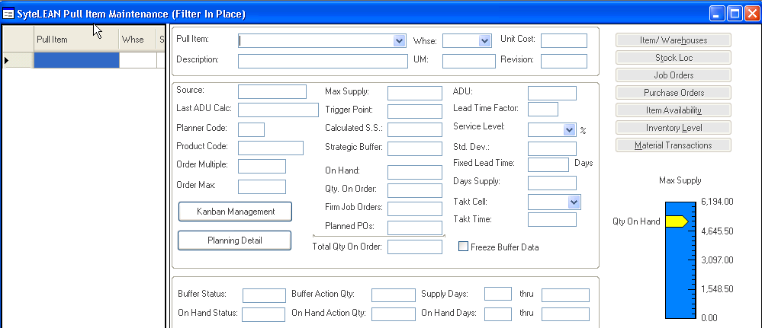

* + Select New
  + Add valid SyteLine item in “Pull Item” field
  + Add Valid Warehouse in “Whse” field
  + Save

When you save the item the system extracts from the SyteLine Item form the following fields:

**From the item File (General Tab) we utilize:**

1. Source (P, M, T)
2. Product Code
3. Unit of Measure
4. Revision
5. Total On Hand (Nettable inventories only)
6. Total On Order (Jobs, Purchase Orders or both)
7. Unit Cost

**From the item File (Planning Tab) we utilize:**

1. Fixed Lead Time.
   1. Paperwork lead-time is ignored. Typically those items which qualify for a repetitive or event-driven planning do not have long pre-order paperwork requirements
   2. Dock-to-stock lead-time is ignored. This system does not “back plan” from the required date. For this reason, we do not need the normal allowance for dock-to-stock or inspection.
2. Planner Code – Used for reporting Purposes

**From the item File (Addtl Planning Tab) we utilize:**

1. Days Supply. As implemented in the ERP system, Days Supply functions as the Order Interval for an item. It will be used in the same context within the pull system.
2. Order Minimum. All new orders resulting from the pull system will consider this minimum. The order recommended by the pull system, in its exact quantity will be shown on the Pull Item screen. The order in the MRP system will be no less than this value.
3. Order Multiple. Orders in the Planning System will be expressed as a multiple of this number.
4. Order Maximum. Do not Use.

# SyteLean Buffer Data Utility

The Buffer Data Utility generates, for each Pull System Item:

1. Average Daily Usage
2. Standard Deviation in the usage data
3. Safety Stock
4. Trigger Point
5. Maximum Supply
6. Strategic Buffer

Open SyteLEAN Buffer Data Utility

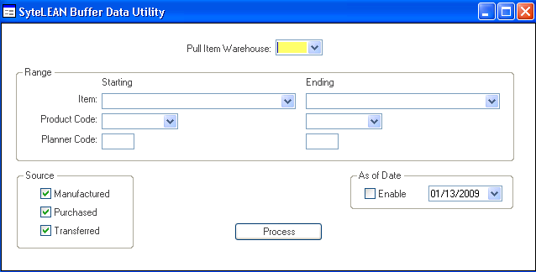

Functionality

* Select the Warehouse
* Select a Range of Items or Product Code or Planner Code or leave blank to calculate all items
* You can select/de-select by the “Source” of items within the range
* Process

The system submits a background task. To ascertain the status, review in the “Background Task History” form.

This utility must be run when adding a new item. This is also run monthly to recalulate the Inventory Profiles for all SyteLean planned items.

**The Pull Item Maintenance screen displays the values calculated by the Buffer Data Utility**

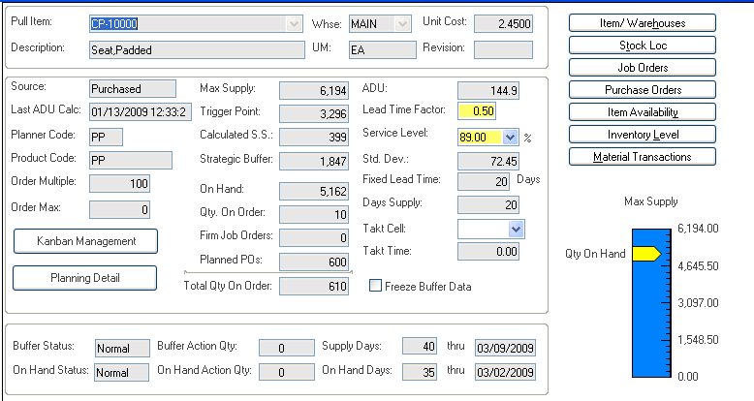

With the screen we have consolidated the elements necessary to define and display the unique inventory profile created for each item.

From the profile we can immediately determine:

* Minimum inventory requirements,
* Current inventory levels,
* Current on order balances.

# SyteLean Buffer Status Utility

The last Step is to activiate a Utility that will compare the Inventory Profile against On-Hand and On-Order quantities to initiate the signals to replenish inventory.

This step is accomplished by running the Buffer Status Utility. The utility is set to run in the background at night – AFTER the nightly planning run.

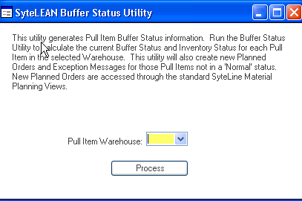

The **Pull Item Status** screen displays the values calculated by the Buffer Status Utility



**Buffer Status Utility**

In basic terms, the BSU has two outputs:

1. New Replenishment Orders, and
2. Reschedule advice

The BSU uses the standard SyteLine interface – The Order Action Report, and The Material Planner Workbench – to alert the user to a requirement to make or buy an item. The order details are:

* Release Date = Today’s date
* Due Date = Today’s date plus the item’s lead-time.
* Order Quantity = Buffer Action Quantity, modified by any order minimums or multiples.
* The PLN Number is implemented as in SyteLine with the reference indicating the source of the demand as “SyteLEAN Pull System Replenishment.”

# Creating Orders using Pull System criteria

SyteLean uses Syteline standard functionality to diplay and execute the SyteLean Pull Item plans using three basic methods of order launch.

1. The Planning Detail Display may be accessed based upon records in the Order Action Report. Orders can be firmed from this interface as either individual orders or multiple releases against the same order.
2. Using SyteLine’s Planner Work Bench, orders can be viewed, maintained and then launched either as individual orders or as multiple releases against the same order.
3. Using the Replenishment Order Process in SyteLine orders may be pre- assigned to specific vendor or manufacturing orders and launched within these parameters using the Planner Work Bench.

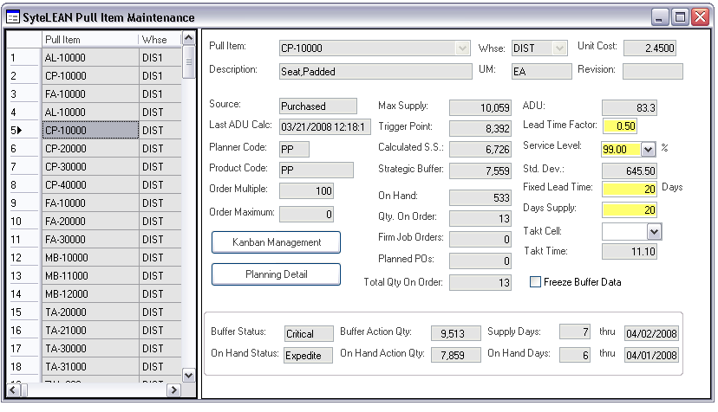

# SyteLEAN Pull Item Status Report

The report allows you to select any combination of items/status from the system.

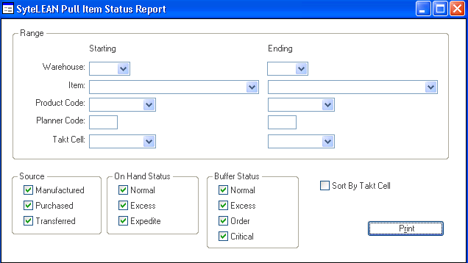

Functionality

* Select Ranges
* Select On-Hand Status
* Select Buffer Status

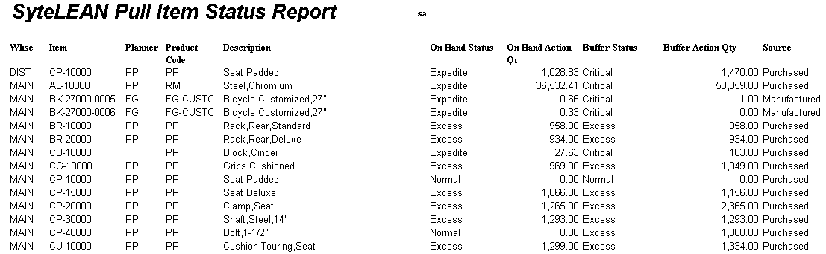

* Print