Purpose: 1

Related Documents: 1

Responsible: 1

Rules: 1

Item Bottlenecks Report APS 1

Generating the Report 1

Review the Report and Take Appropriate Action 2

Purpose:

Use this report to identify items that are causing delays and potential amendments on customer orders.

Related Documents:

PD2042 – Purchasing Standard Work

PL05 – Production Planning Standard Work Process Map

PL06 – C&S Planning Standard Work Process Map

PL07 – Machine Shop Standard Work Process Map

# Responsible:

Maintained by Supply Chain Continuous Improvement Coordinator

Carried out by Planning and Purchasing Staff

# Rules:

1. To be done per standard work schedule.

# Item Bottlenecks Report APS

This form is used only with the APS planning mode.

This report displays each item's lead time and the number of demands that are delayed due to shortages of the item. This Delayed Demands count is calculated as the number of late demands for which the item is on the **critical path** and the demand had to wait for the item to be received.

Select the List Delayed Demands field to include details of each delayed demand on the report, including the number of days the demand had to wait for the item to be received and the number of days past the due date the demand will be available.

The report output is sorted by Planner Code, Delayed Demands, and then Item.

# Generating the Report

1. Open the Item Bottlenecks Report APS form.
2. Leave all Source options checked
3. Check List Delayed Demands
4. Enter your planner code or a planner code range in the starting and ending planner code fields (run for both Sytelean and APS Planner Codes)
5. Click on Preview to veiw the report in a PDF format. Click on Print to view the report in an Excel format.

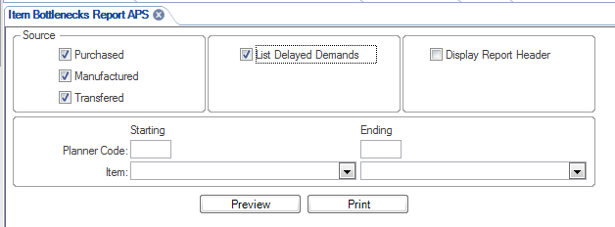

# Review the Report and Take Appropriate Action

1. Review the ouput file by looking at each item number in the Items form.
2. The report will identify if the impacted demand is from a transfer shipment (TRNS), a job order (JOB), forecast (FCST), customer orders (CO), safety stock (SSD), master production schedule (MPS)
3. Determine if there is sufficient quantity on order to fill the safety stock level and cover demand through lead-time.
   1. If not, place an order with the supplier or create a job order(s) as appropriate by source.
   2. Contact the supplier or production supervisor to pull in items to the best possible date.
   3. If the supplier or production supervisor can improve the delivery, update the purchase order or job order(s) with the new due date.
   4. If the supplier or production supervisor cannot improve the delivery date or the new due date does not satisfy the need date of the demand and your demand is for a CO, JOB, TRNS do the following:
      1. CO – notify the appropriate planner and the Purchasing Manager as applicable. Have the customer order amended to the new schedule by the appropriate responsible area.
         1. Purchasing Manager for Purchased items causing the delay
         2. Production Supervisor for Manufactured items causing the delay due to an Operations issue.
         3. Planning for Manufactured or Transferred items causing the delay because of a planning issue.
         4. Production Site for Transferred items causing the delay
         5. Etc.
      2. JOB – notify the planner to amend the job dates.
      3. TRNS – the source planner or buyer should adjust the ship date on the transfer order.
      4. When the delayed demand is type FCST or SSD, there is no effective action that can be taken to move out the demand date in order to remove the message from this report.
4. Repeat this process for all planner codes and/or sites you are responsible for maintaining.