Purpose: 1

Related Documents: 1

Responsible: 1

Rules: 1

Inventory Below Safety Stock Report 1

Generating the Report 2

Review the Report and Take Appropriate Action 2

Purpose:

The Inventory Below Safety Stock Report lists each item that has an on-hand quantity that is below the specified safety stock quantity on the Items form.

Related Documents:

PD2042 – Purchasing Standard Work

PL05 – Production Planning Standard Work Process Map

PL06 – C&S Planning Standard Work Process Map

PL07 – Machine Shop Standard Work Process Map

# Responsible:

Maintained by Supply Chain Continuous Improvement Coordinator

Carried out by Planning and Purchasing Staff

# Rules:

1. Execute per the standard work schedule.

# Inventory Below Safety Stock Report

The Inventory Below Safety Stock Report lists each item that has an on-hand quantity that is below the specified safety stock quantity on the items form. The quantities on-hand, allocated to jobs, work in process, and allocated to customers are included on the report. The net requirements and suggested order quantities, along with the primary and secondary vendors, are also included for each item.

The suggested order quantity is calculated as a multiple of the lot size specified in the Items form. The order minimum and maximum fields on the Items form are not used in calculating the suggested order quantity.

You can produce this report for a range of warehouses, items (stocked and/or non-stocked), product codes, and planner codes. You can select the A, B, and C codes to include, as well as the material types and sources.

# Generating the Report

* 1. Open the Inventory Below Safety Stock Report form
  2. Do not change the ABC Code, Material Type or Source selections. Your planner code will reduce these options by retrieving only items with your planner code assigned.
  3. Check Exclude Zero Net Requirement Items.
  4. Leave Include Transfers checked and Stocked as Both.
  5. Enter MAIN in the starting and ending Warehouse fields.
  6. Leave Item and Product Code blank.
  7. Enter the planner code or a range of planner codes in the starting and ending planner code field.
  8. Click on Preview to veiw the report in a PDF format. Clickon Print to view the report in an Excel format

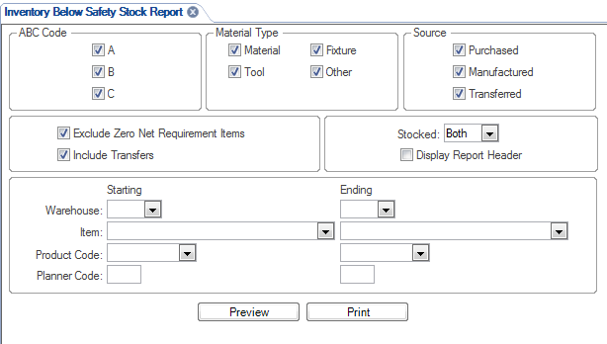

# Review the Report and Take Appropriate Action

1. Review the ouput file by looking at each item number in the Items form.
2. Determine if there is sufficient quantity on order to fill the safety stock level AND cover demand through lead-time.
   1. If not, place an order with the supplier, create a job order(s) or transfer order as appropriate by source.
   2. Temporary Action effective March 4, 2014 and until further notice: Do not expedite transfer orders for safety stock. Contact the supplier, production supervisor or production site to pull in items to the best possible date without jeopardizing other supplies.
   3. If the supplier, production supervisor or production site can improve the delivery, update the purchase order, job order(s) or transfer order with the new due date.
3. Repeat this process for all planner codes and/or sites you are responsible for maintaining.