Purpose: 1

Related Documents: 1

Responsible: 1

Rules: 1

How to Request a Change to OBS/EFF Dates on BOM Structures 2

Create the file 2

Review parent items for any related OBS/EFF Dates 2

Analyze and recalculate your new OBS/EFF Dates. 3

What to do if there is 0 on hand of the old item. 3

Purpose:

This process is to be utilized to request changes to the OBS and EFF dates that have already been implemented via a formal ECO. This secondary process is necessary as consumption of inventory is dynamic (as opposed to static). The OBS / EFF dates identified when the original ECO was submitted was the best date that could be derived *with the information that was available at that time*.

This process can only be used to request changes to OBS and EFF dates. The End User of the spreadsheet that will be created during this process is a Drafting Admin. Should additional tasks need to be completed in conjunction with the change to the OBS and EFF Dates (i.e. Create a job to allocate on-hand material, scrap inventory, etc), DO NOT include those tasks in your Design Request ticket.

Related Documents:

None

# Responsible:

Maintained by Supply Chain Continuous Improvement Coordinator (SCCI)

Approved by: Production Planning and Inventory Control (PPIC) Manager; Supply Chain Manager; Purchasing Manager

Carried out by Purchasing and Production Planning Staff.

# Rules:

1. A buy or make signal for a Slow Moving – SLL/UTD will be addressed as follows: The person receiving the signal will work with the planner where the demand originated. Within 2 business days the two will perform the necessary inquiries and calculations and agree on the new OBS/EFF effectivity date. The person who is the source supplier for the item on Slow Moving – SLL/UTD is responsible to then submit the Design Request ticket to have the OBS/EFF date updated.

# How to Request a Change to OBS/EFF Dates on BOM Structures

# Create the file



Figure 1

1. Identify all BOM Structures containing the P/N with an invalid OBS date.
   1. Open the Current Materials form in Syteline.
   2. In the “Material” field (Note: Not the “Item” field), enter the item that is going obsolete. Run your query.
   3. Export the data collection to Excel.
2. Identify all BOM Structures containing the P/N with an invalid EFF date.
   1. Open the Current Materials form in Syteline.
   2. In the “Material” field (Note: Not the “Item” field), enter the item that will replace the item going obsolete. Run your query.
   3. Export the data collection to Excel.
3. Complete the process above in NC, if applicable.
4. Merge all data into a single Excel spread sheet (one tab only). Note: List data from NY, then list data from NC.
5. Delete the following columns: S – AI.
6. Add the following header to column S “Change To”.
7. Add the following header to column T “Site”.
8. Verify the column headers are identical to the headers that appear in the example above (see figure 1). If the columns do not match, please notify the Supply Chain Continuous Improvement Coordinator.

# Review parent items for any related OBS/EFF Dates

1. View the BOM Structures of all Parent Items (Column A) from the spreadsheet created above, to ensure that the material you are requesting a change to is not associated with another item on the BOM Structure. For Example: 38546-01 (483C05 (Rev H)) has a Lexan overlay that attaches to the front panel. In the past, changes made to one part often required Engineering to make a change to the other. Since the two parts mate, if you adjust the OBS / EFF dates on one of these items you need to adjust the other as well.
2. Review the current BOM in Syteline looking for more than 1 item on a BOM structure with the same OBS / EFF date. If you encounter this, contact Engineering to determine if the parts mate and the OBS / EFF dates need to match.
3. Based on the response from Engineering you may need to add additional items to your spread sheet (Repeat steps 1-6 in the “Create the File” section above.

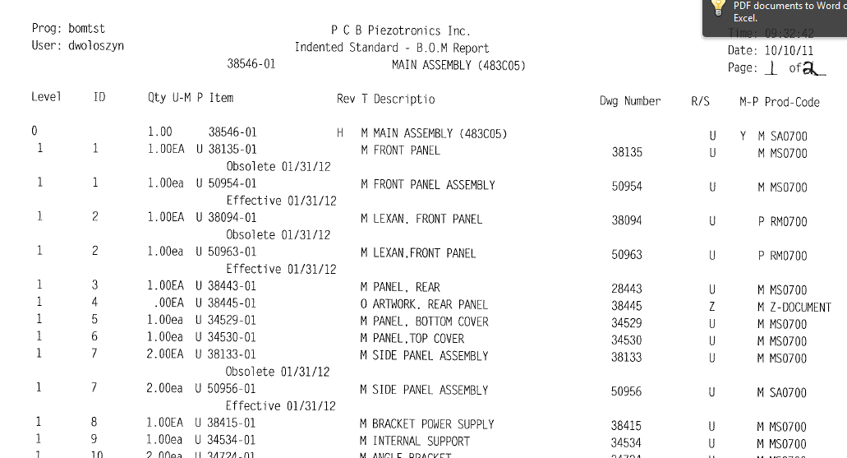

Figure 2

# Analyze and recalculate your new OBS/EFF Dates.

1. Analyze demand / usage to recalculate your new OBS / EFF dates.
2. Populate the revised date in column S (“Change To”) of the file created above.
3. Save the spread sheet using the following naming convention OBS EFF Date Mod - xxxxx-xx to xxxxx-xx (Note: Where xxxxx-xx enter the actual PCB P/N).
4. Submit the change to the Engineering Configuration Coordinator. The ECC will submit the approved file to Design Request for action in Syteline.

# What to do if there is 0 on hand of the old item.

1. Once all material has been depleted on the obsolete part, you should request that the item be removed from the BOM and the effectivity date removed from the corresponding item using the same file format created above.
2. For the Obsolete item, populate “Delete Item from BOM) in column S (“Change To”) of the file created above.
3. For the Effective item, populate “Remove Effective Date” in column S (“Change To”) of the file created above.
4. Save the spread sheet using the following naming convention OBS EFF Date Mod - xxxxx-xx to xxxxx-xx (Note: Where xxxxx-xx enter the actual PCB P/N).
5. Submit the change to the Engineering Configuration Coordinator. The ECC will submit the approved file to Design Request for action in Syteline.