Purpose: 1

Related Documents: 1

Responsible: 1

Rules: 1

Summary: 1

Generate Data out of Syteline: 2

Correcting AutoClose Syteline Errors: 6

# Purpose:

Daily report that identifies jobs that have material or operation errors that are stopping production Job Orders from completing successfully.

# Related Documents:

TA1257 Identifying and Fixing ShopTrak Transaction Errors

# Responsible:

Approved by: Senior Business Analyst

Maintained by: Senior Business Analyst

Carried out by: Supply Chain Administrative Assistant or Operations Administrative Assistant

# Rules:

1. Must be done daily.
2. Applicable to Standard Cost sites only (PCB and NC)
3. Perform all steps below for all applicable sites sending e-mails to the following:
   1. Inventory Control Specialist for PCB site
   2. NC Labor Track Supervisors for NC site, and Barb Little

# Summary:

Run Job Closure and commit to update status of any jobs that have no errors and have quantity complete equal to quantity released. Produce the exception report for any jobs where that may contain the following errors:

1. Quantity completed plus the quantity scrap is greater than the quantity released.
2. Job Operation quantity complete plus quantity scrapped is greater than job operation quantity received
3. Material quantity issues is greater than or less than the quantity required at the operation. Quantity required is calculated by quantity per times job quantity.

# Generate Data out of Syteline:

1. Log into Syteline and open form PCB Auto Job Close.

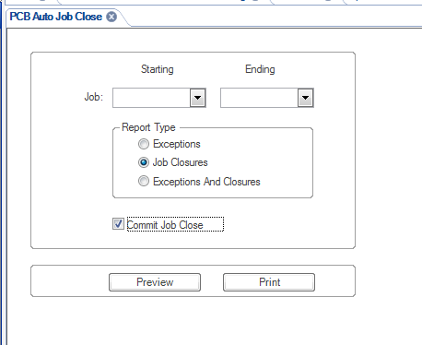

1. Select Job Closures and Commit Job Close. Press the Preview button.
2. This will open explorer when the report has finished and a PDF file of the jobs that closed will appear. If this report errors, see section Correcting AutoClose Syteline Errors. Once errors are corrected, redo Step 1 and 2.

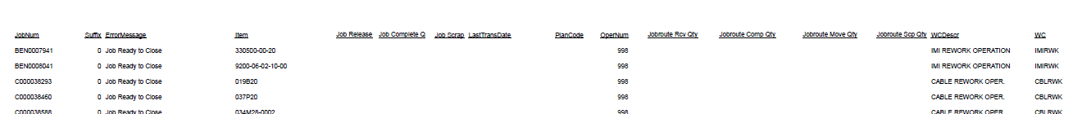

1. Close out of the report.
2. Click “Exceptions” instead of “Job Closures” (“Commit Job Close” box will become inactive).
3. Select Print.

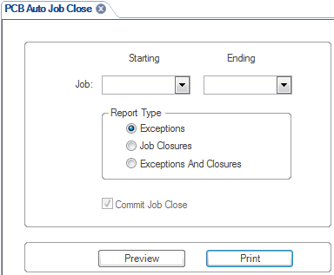

* 1. Click Print (OK box will not pop up)

1. Open “JobCloseReport [yesterday’s date YY-MO-DY]” in R:\Operations\Auto Close Exceptions\[year]\[month]
   1. Save as: “JobCloseReport [today’s date YY-MO-DY]
   2. In the review section of the taskbar, click “Share Workbook” to unshare the workbook to allow updates.
   3. Uncheck “Allow changes by more than one user at the same time” and click “OK”

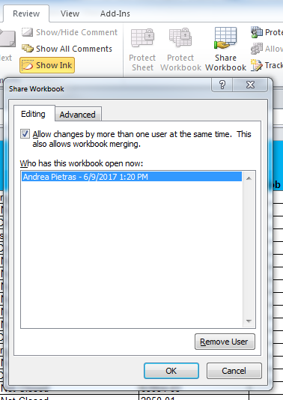

* 1. A message will pop up, asking if you are sure you would like to Unshare workbook. Select yes.

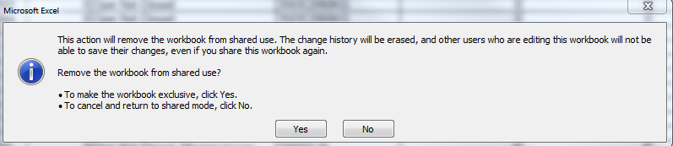

1. Open “pcb_JobCloseReport” from today’s date (created in step 6) in R:\Syteline Reports\[your name]
   1. Select A2-N2 and down through the bottom of the data and hit “CTRL C” to copy and right click on B2 in the Job Close File on the data tab and “paste values” (by clicking on the paste option labeled as 123)

[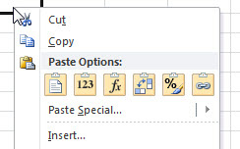](http://www.google.com/url?sa=i&rct=j&q=&esrc=s&source=images&cd=&cad=rja&uact=8&ved=0ahUKEwjDtoj9prHUAhWGMj4KHUPTDhUQjRwIBw&url=http://www.excelarticles.com/LE10ePub-54.html&psig=AFQjCNHEDueZ1tMgLFduZ_c2CCFa6uEWAQ&ust=1497116279065641)

* 1. In the Export, select O2- P2 and down through the bottom of the data and hit “CTRL C” to copy and right click on Q2 in the Job Close File on the data tab. Right click and “Paste Value” by clicking on the option labeled as 123.

[](http://www.google.com/url?sa=i&rct=j&q=&esrc=s&source=images&cd=&cad=rja&uact=8&ved=0ahUKEwjDtoj9prHUAhWGMj4KHUPTDhUQjRwIBw&url=http://www.excelarticles.com/LE10ePub-54.html&psig=AFQjCNHEDueZ1tMgLFduZ_c2CCFa6uEWAQ&ust=1497116279065641)

* 1. If there are more rows than the previous day, make sure formulas in columns A, P and S are copied all the way down.
  2. If there are less rows than the previous day, delete the blank rows at the bottom.
  3. Calculate the Spreadsheet



1. In the “Actions” column (column V) filter to hide blanks
   1. Delete any text in this column for the remaining jobs
2. Update “Pivot to Owner Error” tab
   1. In the “Options” section of the taskbar under “PivotTable Tools”, click “Change Data Source”

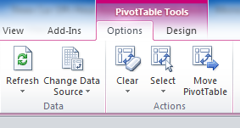

* 1. To ensure that all data is selected:
     1. Hit Ctrl Shift down or Make sure the “Table/Range” reads the last row number of your data and hit okay.

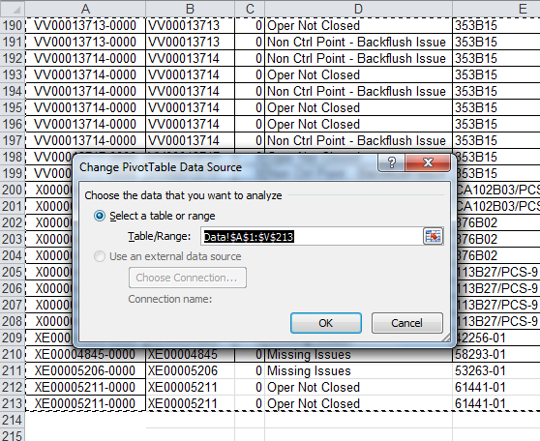

* 1. Click refresh to ensure that the table calculates



1. Repeat step 9 for the tabs called “Pivot to WC Error” and “Pivot to Job”
2. Save, then re-share the file under the review tab



1. Go to the Data Tab and Highlight A1-V1.
   1. Hit CTRL Shift and Down Arrow to select all data
   2. Put gridlines in.
2. Email to appropriate site based on rules above.

## Correcting AutoClose Syteline Errors:

If PCB Auto Job Close Report results in an error, send Helpdesk Ticket and cc:Inventory Control Supervisors at both sites with below subject / content:

Subject: Error running PCB Auto Job Close

Please fix the error that caused the PCB Auto Job Close report to fail and advise when fixed.

Note: typical reasons are:

Job material Transactions Error Processing, Job Error processing, Job receipt Error Processing, Pending job labor transactions, Pending material transactions.