Purpose: 1

Responsible: 1

Rules: 1

Instructions: 2

To copy data from Syteline: 2

Update File Creation 2

Items Form Export #1: Main Assembly Information 3

Items Form Export #2: Customer Order Information 4

Demand Summary APS Form Export: Customer Order Projected Late Information 4

Current Materials Form Export: Main Assembly Information 5

Job Orders Form Export: Jobs Not Picked Information 6

Item Stockroom Locations Form Export: Items in “Recal” Information 7

Extraction of Previous Day’s Notes 7

CO Line Priority 7

Business Objects Report: Customer Order Log 8

Reporting File Creation 8

# Purpose:

To give production and planning increased visibility of customer order information due dates, along with any potential obstacles that go along with them.

# Responsible:

Approved by: Supply Chain Continuous Improvement Coordinator

Maintained by: Supply Chain Continuous Improvement Coordinator

Carried out by: Supply Chain Administrative Assistant or Operations Administrative Assistant

# Rules:

1. Run exports daily
2. Create CO Log Report daily
3. Send report out every morning

# Instructions:

# To copy data from Syteline:

In procedure below, anywhere that “Copy from Syteline” is reference, use the process below.

1. Input specified data and hit filter
2. Click the top left blank square of the data collected to highlight all data

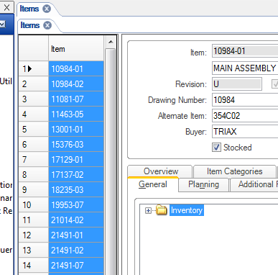

1. Hit “Ctrl” “C” to copy all data
2. Then “Ctrl” “P” to Paste data in specified location.

# Update File Creation

1. **Open file “CO Analysis Daily Update Master RevS” in R:\Supply Chain\Sales and Operations Planning\Customer Order Log Reports\Customer Order Log Creation\Masters**
2. **Log into Syteline Using your regular login.**
3. Go to View🡪Settings
   1. Expand the “Runtime” field and then click “Behavior”
   2. Select “Retrieve all” under “Data records”

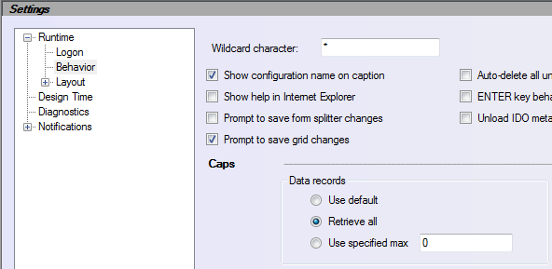

# Items Form Export #1: Main Assembly Information

1. In the Items form:
   1. Enter “*main*” in the Item description field
   2. Enter “>0” in the Quantity WIP field of the General tab

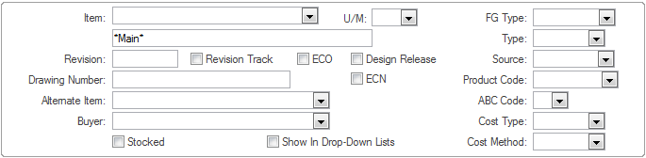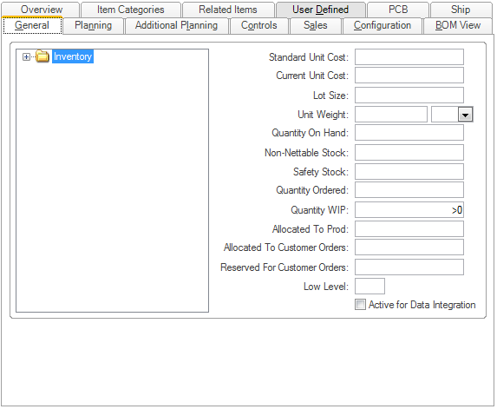

* 1. Run filter.
  2. Copy data from Syteline and Paste in “Items” tab of Excel Spreadsheet in cell A3
  3. Check that headers match up and delete second row of headers

# Items Form Export #2: Customer Order Information

1. In the Items form:
   1. Clear out data from Step 1
   2. Enter “>0” in the “Allocated to Customer Orders” field on the General tab

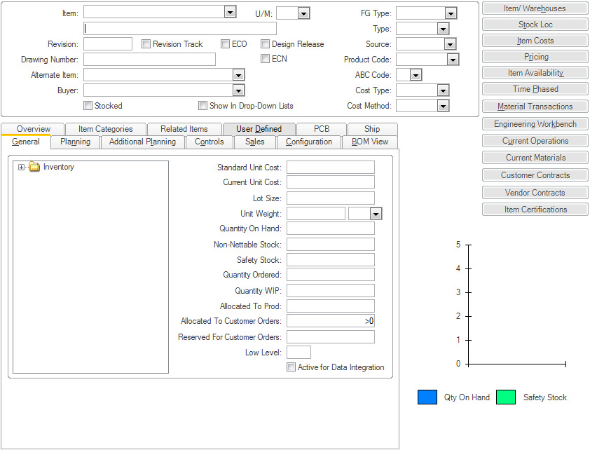

* 1. Run filter.
  2. Copy data from Syteline and paste in “Items” tab of Excel Spreadsheet below data from Items Form Export #1
  3. Delete header row

# Demand Summary APS Form Export: Customer Order Projected Late Information

1. **Open the Demand Summary APS Form in Syteline**
2. **In the “Type” field, select “CO”**
3. **In the “Days Late” field, enter “>1”**

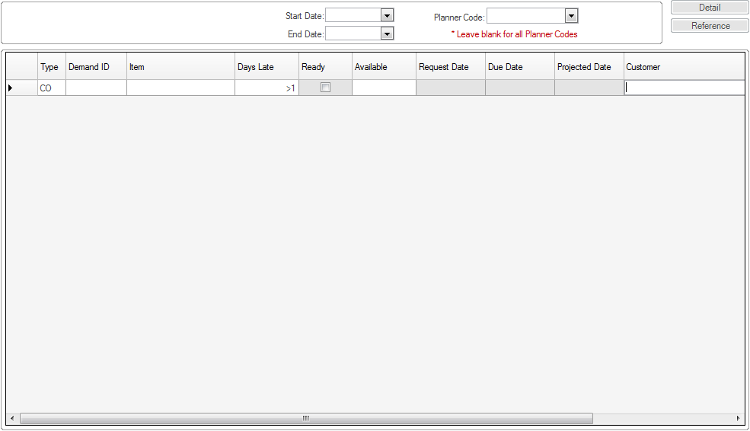

1. **Run filter.**
2. **Copy data from Syteline and paste in “Demand Summary (Lates)” tab of Excel Spreadsheet**
3. Check that headers match up and delete second row of header

# Current Materials Form Export: Main Assembly Information

1. **Open the Current Materials Form in Syteline**
2. **In the “Status” field, enter “<>O” for not equal to Obsolete.**
3. **In the description field under “Material”, enter “*Main*”**

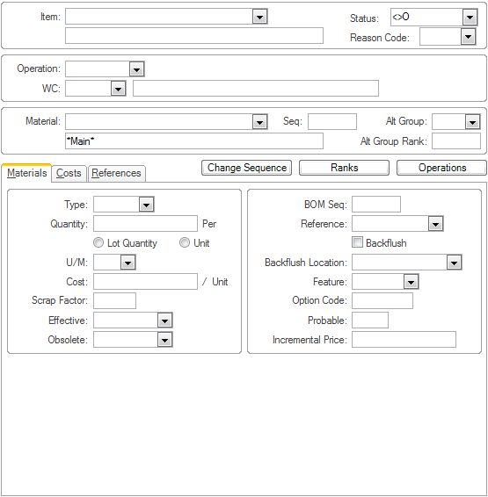

1. **Run filter.**
2. **Click “Form” then click “export to file”**
3. **An Export collection to file box will pop up**
4. **In the Cap Option field select “Unlimited query”**
5. **In the Output File Type field select “Tab-separated”**
6. **In the File Name field type u:\Main Assembly YY-MM-DD and hit Okay**

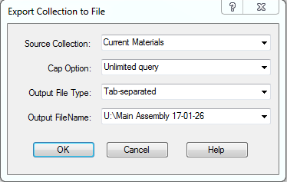

1. **Open U:\Main Assembly YY-MM-DD using excel**
2. **A Text Import Wizard box will pop up**
   1. **Hit next for step 1 of 3 and 2 of 3**
   2. **For step 3 of 3 change Material and Item to text.**
3. **Highlight column F and right click and select delete to delete entire column**
4. **Highlight column E and right click and select cut**
5. **Highlight column D and right click and Insert Cut Cells**
6. **Select all data in columns A-AI and hit ctrl c to copy**
7. **Paste data in the “Main Assembly” tab of Excel Spreadsheet in cell in A4**
8. **Verify that the copied headers are in the same position as the existing headers**
9. **If all is correct, highlight row 4, right click and select delete to delete the row**
10. **If Headers don’t match, adjust data as needed by deleting or inserting columns to align copied in headers to match existing headers.**

# Job Orders Form Export: Jobs Not Picked Information

1. **Open the Job Orders Form in Syteline**
2. **In the “Status” field, select “Released”**
   1. **Check and then uncheck the box next to “Job Picked”. By checking the “Job Picked” box, you collect Jobs that were picked. By checking and unchecking the “Job Picked” the data becomes jobs that have not been picked.**

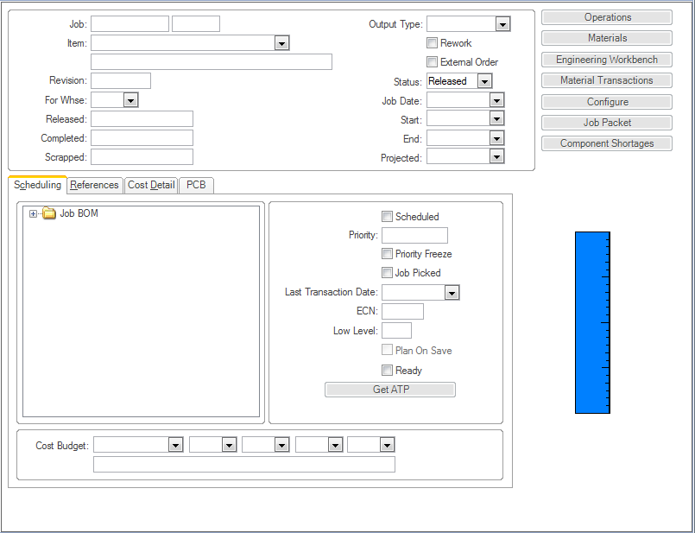

1. **Run filter.**
2. **Copy data from Syteline and paste in “Jobs to be Picked” tab of Excel Spreadsheet**
3. **If headers match up, delete second row of headers**

# Item Stockroom Locations Form Export: Items in “Recal” Information

1. **Open the Item Stockroom Locations Form in Syteline**
2. **In the “Location” field, type “*recal*”**
3. **In the “Location On Hand” field, type “>0”**

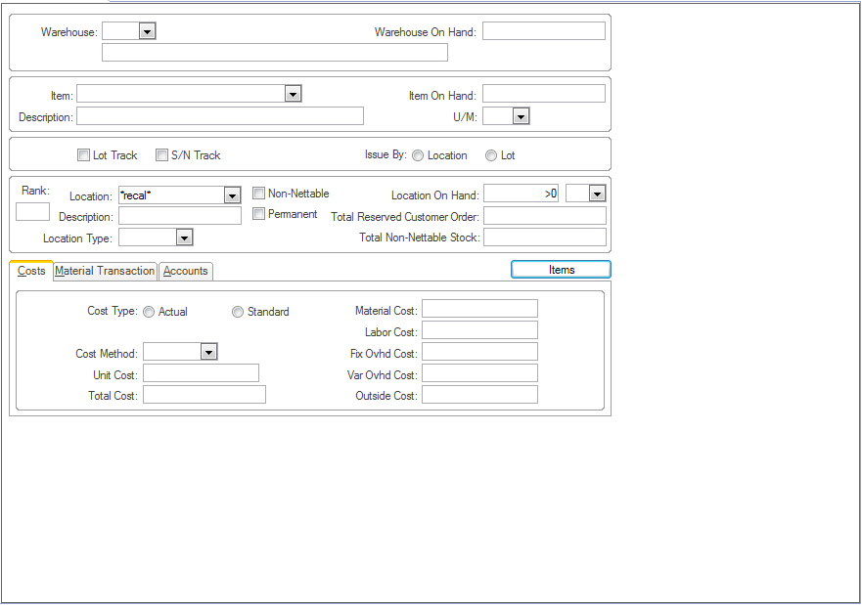

1. **Run filter.**
2. **Copy data from Syteline and paste in “Recal” tab of Excel Spreadsheet**
3. If headers match up delete second row of headers

# Extraction of Previous Day’s Notes

1. **Open yesterday’s report file in R:\Supply Chain\Sales and Operations Planning\Customer Order Log Report\CO LOG RPTS (yyyy)(mm)\Customer Order Log Daily Report (yyyy)(mm)(dd) RevA**
2. **Clear all filters**
3. **Copy Column A (CO # - Line #) and Column V (Comments)**
4. **Paste into Column A and Column B of “Previous Day’s Notes” tab of current day’s Excel Spreadsheet**
5. **Close file**

# CO Line Priority

1. **Open the Customer Orders Form in Syteline**
2. **Filter on** 
   1. **Status: Ordered**
   2. **Priority: <9 (On Ship Tab)**
   3. **Filter**

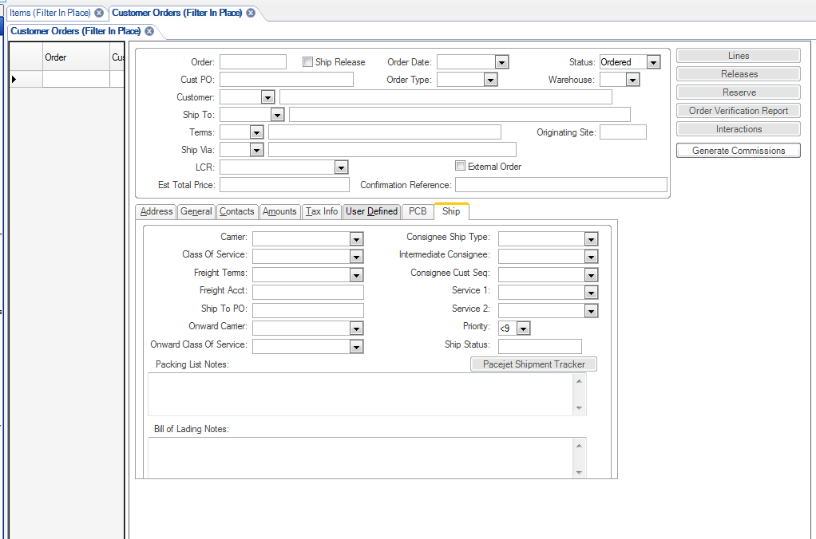

1. **Copy from Syteline into CO Line Priority Tab**
2. **Paste Data into A2**
3. **If headers line up delete second row of headers**
4. **Select entire column A**
5. **Select Data, Text to columns**
6. **Hit next, next, then change column to text**

# Business Objects Report: Customer Order Log

1. **Open current day’s Customer Order Log Business Objects Report.**
2. **Copy all data in columns A-Q starting with A2 to Q2 and down through all rows.**
3. **Paste in B2 of the red CO Analysis tab of the Excel Spreadsheet**
4. **Copy formulas in Columns A and R-BH down for all rows of data.**
5. **Copy all data from the CO Analysis Tab A3-BH3 Down through all rows.**
6. **Paste Values in tab called Template of Deleted Columns.**
7. **Delete all Columns highlighted in Red.**
8. **Save file in R:\Supply Chain\Sales and Operations Planning\Customer Order Log Report\CO Log Daily Update Files as Co Analysis Daily Update YY MM DD**

# Reporting File Creation

1. **Open file “Customer Order Log Daily Report yyyy-mm-dd RevA (Master)” in R:\Supply Chain\Sales and Operations Planning\Customer Order Log Reports\Customer Order Log Creation\Masters**
2. **Copy all data from the tab called Template of Deleted Columns**
3. **Paste Values into Reporting File opened in step 1**
4. **Save file in R:\Supply Chain\Sales and Operations Planning\Customer Order Log Report\(current month) Customer Order Daily Log Report YYYY-MM-DD**
5. **To Share file:**
   1. **Click on Review on the task bar**
   2. **Select Share Workbook**
   3. **Check the checkmark that states, “Allow changes by more than one user at the same time”.**

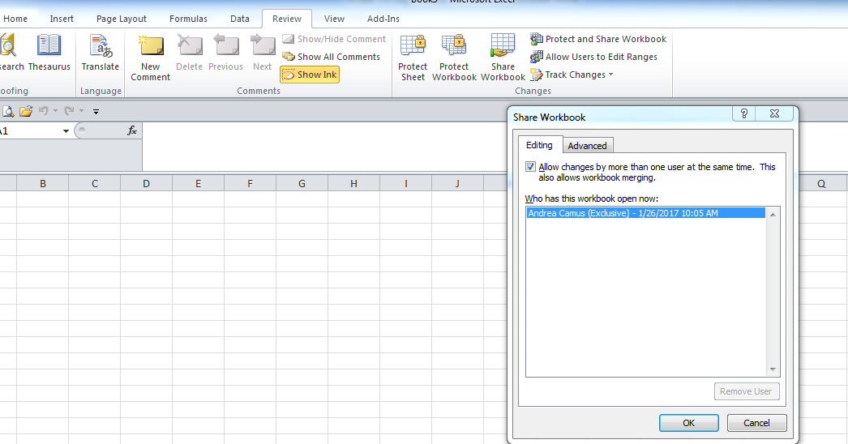

1. **Send folder link to email group “Customer Order Log Report”.**