Purpose: 1

Associated Documents: 1

Responsibilities: 1

Rules: 1

Instructions: 2

Creating the Forecast Exception Data: 2

Creating the Forecast Non-Statistical Data: 2

Forecast Status (Detail) 2

Halifax Items 2

Depew Items 3

Exception Message 3

Year and MRP 3

Combine Year and MRP Data into the Base Data tab 4

Combined All 4

Exceptions-Review 5

Combined Exceptions 6

Sales Exception Review File 6

Updating forecast as requested by review 6

Updating a Forecast Quantity 6

Removing a Forecast (taking it to 0) 7

Create / Change a non-level loaded forecast 7

Audit of Forecast Updates 7

Remove Forecast Exceptions EXC Codes- After Exception File is Complete 9

Purpose:To create the forecast exception file for sales review, update Syteline Forecast after sales review and document review of Syteline update.

Associated Documents:

# Responsibilities:

Approve: Planning Manager or Supply Chain Manager

Maintain: Supply Chain or Operations Administrative Assistant

Execute: Supply Chain Administrative Assistant or Operations Administrative Assistant

Rules:

* Forecasts are entered for all finished goods with an FG Type Stock using forecast type of Order.
* Forecasts can be entered for finishes good with an FG Type of Standard or Special if requested by sales.
* Components or Finished goods with usage should be forecasted using the Type of Usage.
* Forecast needs to be entered in the site the item will be shipped or consumed in.
* Forecast Monthly Utility is ran the 1st day of the month in a background task.

# Instructions:

## Creating the Forecast Exception Data:

1. Open most recent file from R:\Supply Chain\Planning\S&OP\Forecast\Exceptions Reports\PCB Depew\ Last month’s report and rename with current date.2
2. Click “Enable Links” This is a trusted document.
3. Remove color from all tabs
4. Run Forecast Detail Report and Forecast Exceptions Report in PCB and NC-Select Print
5. Open Forecast files created in step 3-Files are found in your Syteline Reports folder.
6. For the Forecast Detail Report, in column DB add site, Depew for PCB file and Halifax for NC file. Copy site down all rows of data
7. Combine Depew and Halifax files into one file and copy into the Forecast Detail Report tab of the file created in step 1. Color tab green to indicate it is updated.
8. For the Forecast Exception Report, in column BO add site, Depew for PCB file and Halifax for NC file. Copy site down all rows of data
9. Combine Depew and Halifax files into one file and copy into the Forecast Exception Report tab of the file created in step 1. Color tab green to indicate it is updated.

## Creating the Forecast Non-Statistical Data:

1. In Syteline open the Forecast Non-Statistical Input form and export the data from both PCB and NC using excel icon.
2. Forecast files created in step 1 will open.
3. Copy data into the Non-Statistical tab into column A. Paste 2nd file below first. (Remove any extra lines of data if new data is shorter)
4. Update pivot tables for each step making sure all data is selected.
   1. Select a cell in Depew pivot table
   2. Select Analyze
   3. Select data source, view and correct to include all data needed in pivot table.
   4. Repeat for the Halifax pivot table
   5. Refresh both tables.
5. If any Forecast dates are on the 15th of the month, change the date in the data to the 1st of the month. Refresh the pivot table. This will consolidate the forecast into months in the pivot allowing formula to work properly.
6. Color tab green to indicate it is updated.

## Forecast Status (Detail)

1. Copy Forecast Detail Report to the Forecast Status (Detail) tab (Copy entire page by clicking the corner of the spreadsheet)
2. In BE10 on the Forecast Status (Detail) tab, enter formula =B2. Copy the formula down through all data, calculate and then highlight/Copy and then paste values.(This removes the formula)
3. Delete columns A through BD
4. Delete rows 1 through 8
5. In A1 type Item
6. In C1 enter formula =B2
7. Copy formula from C1 ~~to D1~~ through AW1, calculate and then copy and paste special values (Right click and select the 123 option)
8. Delete every other column starting at column B-AW
9. Highlight sheet, turn filters on, sort by Model a-z (Note columns may very:Columns H or I)
10. Filter on Model equal to blank and delete all rows. Unfilter. (Note:Highlight the entire first row and ctrl-shift-down.)
11. Sort Status column a-z. Then, Filter on Status of Inactive (I) and delete all rows. Unfilter.
12. Color tab green and save the file.

## Halifax Items

Copy Halifax Items Rev B into the Halifax All Items tab. Color tab green and save the file.

R:\Supply Chain\Planning\Supply Chain Planning Measures\Data\Halifax Item Key Rev B

## Depew Items

Copy Depew Items Rev B into the Depew All Items tab. Color tab green and save the file.

R:\Supply Chain\Planning\Supply Chain Planning Measures\Data\Depew Item Key Rev B

## Exception Message

1. Copy Forecast Exception Export into the Exception Message tab
2. Title column B as Items
3. Title column F as Exceptions
4. Delete column A, C, D, E and G through BN
5. Put filters on. Sort Items column in ascending order (a-z)
6. Resort Exceptions column in ascending order (a-z)
7. Filter on Exceptions column by Unchecking any exceptions containing the following:
   1. Review Date
   2. Not Tracking
   3. Demand Filter
8. Delete all other exceptions (All exceptions that do not contain the above three)
9. Unfilter
10. Color tab green and save the file.

## Year and MRP

1. Copy the Forecast Exception Export into the **Three, year tabs** and the **MRP tab**.
2. To Format the Year tabs so the history for each year is lined up with the item number. Follow the steps below:
   1. Copy column B and insert before column A
   2. Shift Item in A2 down until Item lines up with the “year” for the tab in column B
   3. Delete O-BO
   4. Delete rows 1 and 2
   5. Label A1 Item
   6. Sort by Item and then by Year (Sort warning, Sort anything that looks like a number)
   7. Filter on Year and uncheck the year of the tab you are working on. Delete all rows. Unfilter.
   8. Sort by Item-Check that all three year tabs have items in the same cell so that data matches up.
   9. When all three years are done be sure to:
      1. On the oldest year tab Cut (Ctrl X) and paste Oct-Dec data into the middle year tab
      2. On the Middle year tab, Cut (Ctrl X) the last Oct-Dec columns data into the current year tab
      3. On the current year tab, delete the last Oct-Dec columns.
      4. This will collect the data per fiscal year. (Data collection however is still per calendar month)
      5. Turn all three Year tabs Green
3. Format the MRP tab so the forecast (MRP) is lined up with the item number. Follow the steps below:
   1. Highlight H10 thru S10. Select Copy
   2. Go to cell AU9. Select Paste.
   3. Go to cell AS10, input the formula “=B2”
   4. Copy the formula down through all rows.
   5. Calculate
   6. Select all data in column AS. Select Copy, then Paste Special – values
   7. Delete columns A through AR
   8. Delete rows 1-8
   9. Label A1 as Item and B1 as MRP
   10. Delete columns O-V
   11. Sort by Item and then MRP. (Sort warning)
   12. Turn filters on.
   13. On the MRP Column, uncheck MRP. Delete all rows (Be sure to delete blank rows as well). Unfilter
   14. Format columns so that they are in Oct-Sep order. (Cut and insert entire columns)
4. Color tab green and save the file.
5. NOTE: For New Fiscal Year: On the second month of the fiscal year (Nov), you will need to add a fourth “year” tab
   1. You will have 4 “year” tabs until new Calendar year. After new Calendar year starts (Feb), You can delete the oldest year tab.
   2. For the newest year tab:
      1. Copy Headers from a prevous years tab.
      2. Copy over column A from any of the other year tabs.
      3. Type the new year number into cell B2. Example: If new Fiscal Year is 2019 you would type 2019 into B2 and copy 2019 all the way down.
      4. To capture New Fiscal year data, Cut Oct, Nov, Dec Columns from the previous year tab. Example: if new fiscal year was 2019 we would copy Oct,Nov, and Dec from the 2018 Tab.
      5. Make all other months 0 in row 2 and copy all the way down.

## Combine Year and MRP Data into the Base Data tab

1. Highlight cells Q2-AE2 on the Base data tab.
2. Hit Ctrl Shift down to highlight all cells below
3. Tap the Delete key to clear cells. *Note, do not delete entire rows of data
4. Copy the two most current year tabs and the MRP tab (data only no headers) into cell Q2 of the Base Data tab.
5. Highlight entire columns Q-AE.
6. Sort columns Q-AE item in ascending order and year in Smallest to Largest (If you use the custom sort option under HOME, Custom filter, this will already be set up for you)
7. Copy data from Q-AE into A1 cell pasting as Values.
8. Color tab green and save the file.

## Combined All

1. Copy starting at A2, A-N from the Base Data tab into A3 of the “Combined All” tab Be sure to check and see if the data is longer or shorter. If Longer-Copy formulas down (NOTE- Formulas are copied down in rows of 3 because there are different formulas in different rows), If shorter- Delete extra rows of data.
2. Change B1 to a number that represents the number of calendar months that have past.
3. Make sure all vlookup formulas are pulling the data correctly.
   1. Known monthly Error is column S Change A:A to A:B in the formula. Formula should read as picture shows.
   2. 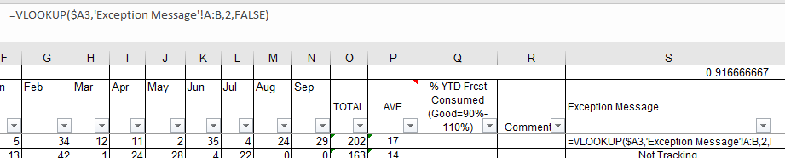
4. Double check to Make sure formulas are on all rows of data.
5. Calculate the % forecast should be consumed. Based on number of fiscal months that have past.
   1. To populate this is the number of months that have past, divide by 12 and then multiplied by 100.

(this needs clarification - I think we should just create a table with % for each month)

|  |  |  |  |  |
| --- | --- | --- | --- | --- |
| Month # | Fiscal month | % of forecast used | 10% Low tolerance | 10% High tolerance |
| 1 | Oct | 8.33 | -1.67 | 18.33 |
| 2 | Nov | 16.67 | 6.67 | 26.67 |
| 3 | Dec | 25.00 | 15.00 | 35.00 |
| 4 | Jan | 33.33 | 23.33 | 43.33 |
| 5 | Feb | 41.67 | 31.67 | 51.67 |
| 6 | Mar | 50.00 | 40.00 | 60.00 |
| 7 | Apr | 58.33 | 48.33 | 68.33 |
| 8 | May | 66.67 | 56.67 | 76.67 |
| 9 | Jun | 75.00 | 65.00 | 85.00 |
| 10 | Jul | 83.33 | 73.33 | 93.33 |
| 11 | Aug | 91.67 | 81.67 | 101.67 |
| 12 | Sept | 100.00 | 90.00 | 110.00 |

1. Update the header in Q2 to be a range +/- 10% of value calculated above
   1. Note: For new Fiscal year: In Nov (0 to 18.3%), You will need to set conditional formatting from .003 to .183 and <.003 as yellow and >.183 as Red. This will cause 0’s to be yellow so that they are still reviewed.
2. Update conditional formatting in column Q with new ranges.
   1. Select home, Conditional Format, Manage rules, Edit rule, hit apply, hit okay
3. Calculate.
4. Filter on Consensus in column Y-Filter by site separately to create v-lookups
   1. Go to column C on the MRP line for the first item
   2. Create a vlookup to the non-statistical pivot table
5. Color tab green and save the file.

## Exceptions-Review

1. Filter on the Combined all Tab, in the Exception Message column, Type "Review" in the search field, hit enter and copy entire page
2. Paste **VALUES ONLY** into the Exception-Review Tab and then paste Format.
3. Copy columns Q and R from the combined all tab and paste (Ctrl V) into Q and R of the Exception-Review Tab (this carries over formulas as well)
4. For each item with an exception of review: Review in Forecast Main form looking at notes and Item information.
   1. Go into Syteline Forecast Main form and filter on an item.
   2. Review the note on that item to understand the reason for the review.
   3. Update the forecast as appropriate.
5. Color tab green and save the file.

## Combined Exceptions

1. Unfilter the Combined all tab
2. Copy the Combined All tab (Select the entire page and copy by hitting Ctrl C) into the Combined Exceptions tabs and paste values and then paste formatting. DO NOT Hit Ctrl V because we do not need formulas copied over. (This will minimize the size of the file)
3. Copy (by hitting Ctrl C) the entire columns Q and R from the Combined All and paste (by hitting Ctrl V) into the Combined Exceptions tab. This ensures that we still have working formulas in columns Q and R.
4. Delete all three rows for any item that is green in column Q on the MRP line.
5. Color tab green and save the file.

# Sales Exception Review File

1. Make a copy of the Combined Exceptions tab in a New Workbook.
2. Turn Filters on.
3. Save the New Workbook in R:\Supply Chain\Planning\S&OP\Sales Exception Review\YEAR and name it Exception YR-MN-DY Review.
4. Share the file.
5. Open last month’s e-mail and update appropriate file, dates and % consumed and send to appropriate forecast owners.
6. Sales will review and respond to the exception report via email, “Energy done, note changes in the file”, following the instructions included in the file.
7. Each respective Sales “owner” will update the exception report as appropriate.
8. Supply Chain team will collect Sales responses.
9. Any item that was not dispositioned by Sales Supply Chain will default the reply to be “let it ride-SC”.
10. Supply Chain will execute the disposition of exceptions.
11. Delete table in the e-mail
    1. Open R/SC/Planning/S+OP/Forecast/Exception Messages Metrics File
       1. Hide top Month row
       2. Column A-Insert Recent Month
       3. Column B- In the Forecast Creation file, Forecast Status Detail tab, Count Rows
       4. Column C- In the File sent out to sales, highlight entire column A and subtract 2, then divide by 3.
       5. Column D- Drag formula down from row above
       6. Column E- Using the number in column D, subtract from 100 to get % Accuracy.

# Updating forecast as requested by review

## Updating a Forecast Quantity

1. Open Forecast Main 8.02.05 Form
2. Select Calculations Tab –
   1. Select Auto Calc Fcst to compare what system forecast recommendation is.
      1. If system forecast is a significantly different quantity than requested and the request does not have an explanation request more information from the owner that you can record in the notes.
3. Change the Forecast Average field to new quantity from Sales Exception Review file.
4. Select Manual Calc Fcst button.
5. Verify Net Forecast reflects new number.
6. SAVE
7. Select update MRP button
8. Select Planning Tab - update Revised Date field to current date.
9. Color code the disposition in the Sales Exception Review file as green to indicate it has been updated in Syteline.

## Removing a Forecast (taking it to 0)

1. Follow steps 1 – 7 as in Updating a Forecast Quantity. Set the Forecast Average field to 0.
2. In step 8 - on the Planning Tab, change the Status to Inactive (in addition to changing the Revised Date field).
3. Color code the disposition in the Sales Exception Review file as green to indicate it has been updated in Syteline.

## Create / Change a non-level loaded forecast

(Level loaded=all quantities in the Net Forecast column are the same)

1. Open Forecast Main 8.02.03 Form
2. Select Calculations Tab –
3. Select Auto Calc Fcst to compare what system forecast recommendation is.
   1. If system forecast is a significantly different quantity than requested and the request does not have an explanation request more information from the owner that you can record in the notes.
4. Right click on the Item Adjustment column (or any particular month in that column; you will open the Item Adjustment Form).
5. Figure out the math to multiply the Net Forecast quantity by in order for the Net Forecast on the Forecast Main Form to equal the requested amount for each month.
   1. Note: you can enter any ‘estimated’ number into a month field on the Item Adjustment Form, go back to the Forecast Main Form and see if the Net is what you wanted and dial in the Item Adjustment quantity in this way.
6. When multiplier is as you want it, copy that multiplier into the specific months you were requested to make the forecast non-level loaded.
7. Verify that the Net Forecast on the Forecast Main Form reflects the amount you want for each month.
8. SAVE then close the Item Adjustment Form
9. SAVE the Forecast Main Screen
10. Select update MRP button
11. Select Planning Tab - update Revised Date field to current date and add a review date to force an exception the following month.
12. Create a note indicating what the specifics of the non-level forecast are who requested change, reason if have one, what the forecast was before change. Most recent note goes on top of older notes.
13. Color code the disposition in the Sales Exception Review file as green to indicate it has been updated in Syteline.

# Audit of Forecast Updates

1. After all forecast items have been updated based on the review, notify audit delegate that updates are complete.
2. Audit delegate will do a comparison of 5 randomly selected items that required update from the Sales Exception File and compare to Syteline.
3. Record items checked and date preformed in the Sales Exception File.
   1. Create a tab called Review.
   2. Copy all three lines of the item columns A-R into the Review tab.
   3. Open the Forecast Main V8.02.05 form in Syteline. Filter on the item copied into the review tab and take a screenshot of the Syteline form and past into the Review tab.

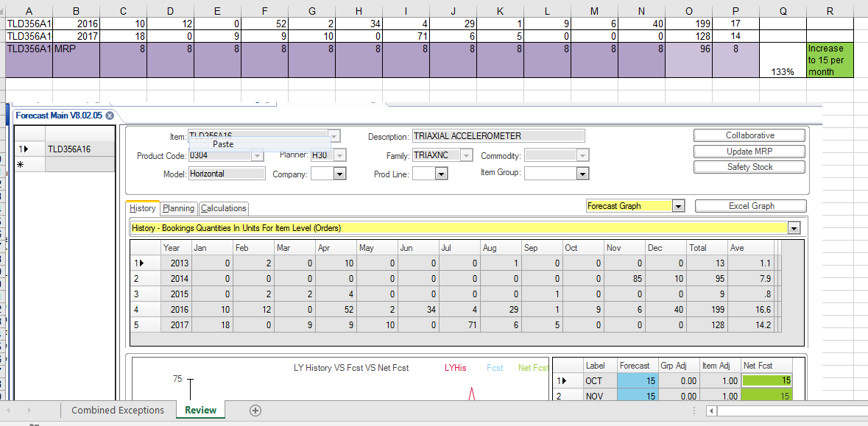

# Remove Forecast Exceptions EXC Codes- After Exception File is Complete

1. Open the form called Forecast main V8.02.05 in NY
2. Hit Ctrl 2 to change the form view
3. Type *T* in the Exc code field
4. Hit filter
5. Hit Ctrl 2 to change the form view
6. Go to view, settings, expand the runtime by hitting the + then click on behavior and select “Retrieve All”
7. Close settings window
8. On the Planning tab click on the Sum Of Errors field **(Make sure you are on the first Item)**
   1. Go To Edit and click on Replace Value in collection
   2. A window will pop up.
      1. Select the box labeled All Values
      2. In the With field type 0 (Zero)
      3. Hit okay
      4. Select Yes to All
9. On the Planning tab click on the Ave Error field **(Make sure you are on the first Item)**
   1. Go To Edit and click on Replace Value in collection
   2. A window will pop up.
      1. Select the box labeled All Values
      2. In the With field type 0 (Zero)
      3. Hit okay
      4. Select Yes to All
10. On the Planning tab click on the Track Value field **(Make sure you are on the first Item)**
    1. Go To Edit and click on Replace Value in collection
    2. A window will pop up.
       1. Select the box labeled All Values
       2. In the With field type 0 (Zero)
       3. Hit okay
       4. Select Yes to All
11. Hit the save button in Syteline.
12. Hit Ctrl 2 to change the form view
13. Click in the Exc Codes field **(Make sure you are on the first Item)**
    1. Go To Edit and click on Replace Value in collection
    2. A window will pop up.
       1. Select the box labeled All Values
       2. In the With field, delete the zero leaving this field blank
       3. Hit okay
       4. Select Yes to All
14. Hit the save button in Syteline.
15. Repeat steps 1-14 by putting *D* in the EXC code
16. Repeat all steps 1-15 for NC Site