Purpose: 1

Related Documents: 1

Responsible: 1

Instructions: 1

# Purpose: To record job on-time-to-delivery, load, projected late metrics which will better enable the Microelectronics planner to schedule jobs in alignment with capacity using the current WIP target method.

# Related Documents:

Syteline, Form, Export to File

# Responsible:

Approved by: Planning Manager or Supply Chain Manager

Maintained by: Supply Chain Administrative Assistant or Operations Administrative Assistant

Carried out by: Supply Chain Administrative Assistant or Operations Administrative Assistant

# Instructions:

1. Open the Load Analysis Spreadsheet Template
   1. R:\Lean\Training\KATA\Supply Chain\RGP Dispatch\Micro\Load Analysis Spreadsheet
   2. Save file as: Load Analysis Spreadsheet YY-MM-DD
2. In Syteline, Open the form called “Material Planner Workbench Generation”
   1. Change End Date: to two weeks from today’s date
   2. Type in A10 into the Planner Code field
   3. Remove your login name from the Buyer field
   4. Hit Process
   5. Click on Planner Workbench
   6. In the View field select Job from the drop down menu.
   7. Select the blank header located next to the “Process Line” column header (this selects all items in the grid view)
   8. Hold down Ctrl and hit C to copy all data
3. Back in the Load Analysis file:
   1. On the workbench tab
      1. select the cell A2
      2. Hold down Ctrl and hit V to paste all data
      3. Make sure the headers in row 1 and 2 match and delete row 2
      4. Select B2 through J2 by clicking and dragging your mouse
      5. Hold Ctrl, Shift and hit the Down Arrow to select all data under the B2 through J2 cells.
      6. Hold Ctrl and hit C to Copy
   2. On the Load Analysis Spreadsheet tab
      1. Select A2
      2. Hold Ctrl and hit V to Paste
      3. Delete all data that did not get overridden
4. In Syteline, Open the form called “Material Planner Workbench Generation”
   1. Remove the A10 planner code from the Planner code Field
   2. Type your login name into the buyer field and hit process
   3. This clears the workbench so that the planner that owns A10 can run their bench.
5. In Syteline, Open the form called “Items”
   1. On the Planning tab, in the Planner Code field enter A10
   2. Hit filter
   3. Export using Syteline, Form Export to file.
   4. Name file u:\Micro Load Items
6. In Excel, Open the Micro Load Items file created in step 5. To Open file:
   1. Click on File, Open, Browse.
   2. Select your U:\ Drive and make sure you are viewing all files

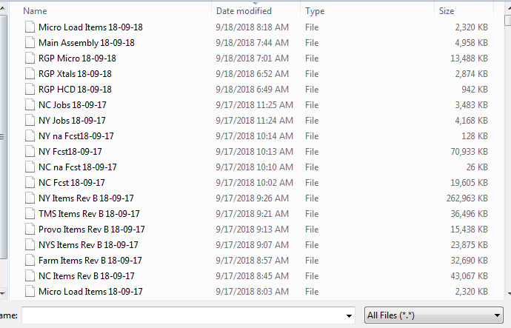

* 1. Select Open
  2. A Pop up box called, Text Import Wizard, will appear
  3. Hit Next, Hit Next again, and then Change your Items, Product code, Planner Code, and Family columns to text by selecting each one individually and hitting the text bubble.

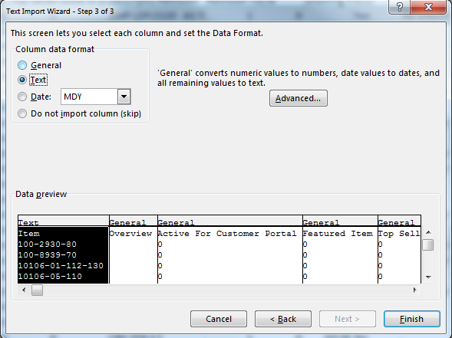

* 1. Then hit Finish.
  2. Select A1 and Hit Ctrl, Shift, Right arrow and then down arrow. To select all data
  3. Hit Ctrl C to Copy

1. In the Load Analysis File
   1. Click on the Items tab in cell A3
      1. Hit Ctrl V to Paste
      2. Double check that the columns in row 2 match row 3 and delete row 3
      3. In Cell B2 Change Date to current date
      4. Calculate spreadsheet
   2. Click on the Load Analysis Spreadsheet tab
      1. Highlight A1-P1 and hit Ctrl Shift Down arrow to select all data
      2. Go to Home, Sort and Filter Custom Sort. A window should appear
      3. The sort parameters are already entered into they file. Hit Okay. Save File.

