Purpose: 1

Responsible: 1

Rules: 1

Instructions: 1

# Purpose:

This report is to communicate Items that require review by the planner.

# Responsible:

Approved by: Planning Manager or Supply Chain Manager

Maintained by: Supply Chain Administrative Assistant or Operations Administrative Assistant

Carried out by: Supply Chain Administrative Assistant or Operations Administrative Assistant

# Rules:

1. Report is done Monthly

# Instructions:

1. Open “Phantom Items Template” found in R:\Supply Chain\Planning\Supply Chain Planning Measures\Phantom Items
2. Save File As: Phantom Items YY-MM-DD
3. Open Syteline Items form in the PCB Site.
   1. On the General tab, type >0 in the Quantity On Hand Field

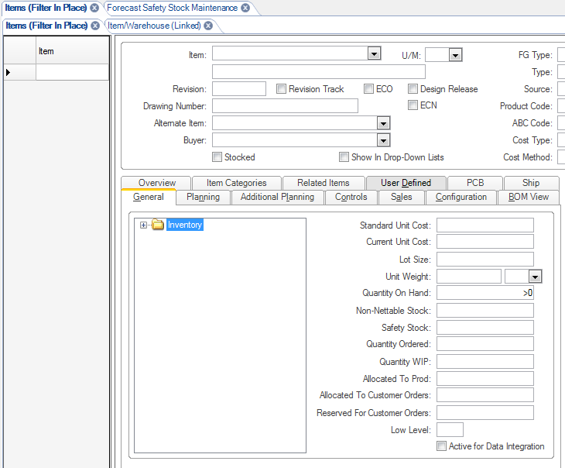

* 1. On the Planning Tab, Click (to check) the Phantom Box

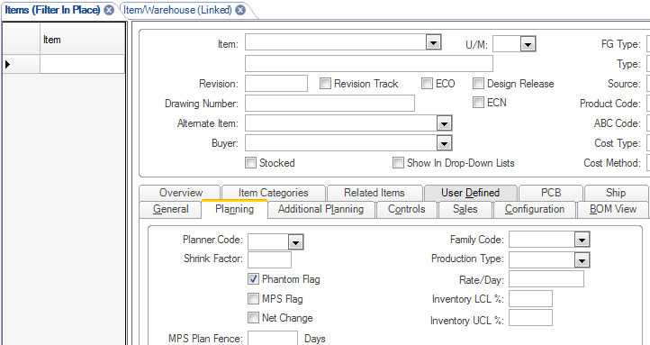

* 1. Hit Filter
  2. **If Items appear:**
     1. Click the Export to Excel button

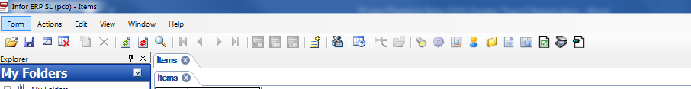

* + 1. Copy Rows from this export into the “Depew” tab in A2 your “Phantom Items YY-MM-DD” file
    2. Turn the appropriate sites tab Red
    3. For Depew and Halifax Files: Highlight cell FO2 and copy formula’s down to the end of your data.
  1. **If There are no items that appear:**
     1. Turn the appropriate sites tab Green in your “Phantom Items YY-MM-DD” file



* 1. Repeat the following steps for all Sites
     1. PCB-Depew
     2. NC-Halifax
     3. TMS-The Modal Shop
     4. Provo-Larson Davis
     5. Farm-Load and Torque
     6. NYS-Accumetrics
  2. Send file by email to planning representative(s) at each site.