Purpose: 1

Responsible: 1

Rules: 1

IT Setup: 1

Instructions: 1

# Purpose: Working capital information.

# Responsible:

Approved by: Supply Chain Manager

Maintained by: Supply Chain Administrative Assistant or Operations Administrative Assistant

Carried out by: Supply Chain Administrative Assistant or Operations Administrative Assistant

# Rules:

1. Report is Created on the 1st of every Fiscal Month
2. Year changed every new Fiscal Year

# IT Setup:

1. Have IT set up a Business Objects account.

# Instructions:

1. Have the owner of this report send you a copy to your Business Objects Account.
2. Open you web browser, and allow PCB’s homepage load
3. Hover your mouse over the tab names Applications
4. Select PCB Customer Reports
5. Open your inbox and save the Inventory Value Data file to your favorites
6. Click on the Documents Tab
   1. Select Inventory Value Data file
   2. Select the dropdown on the Refresh Icon and select Refresh Query

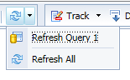

* 1. A Popup box will appear

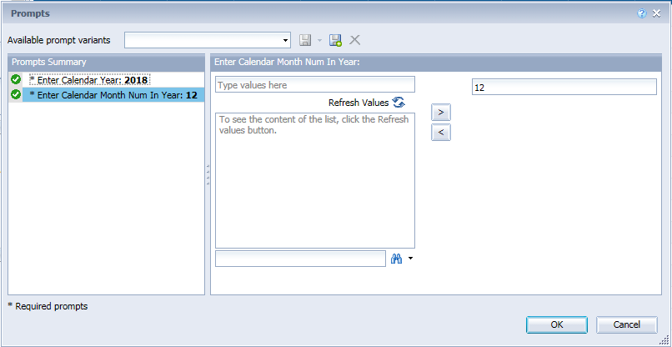

* 1. For a new Fiscal Year:
     1. Select the “Enter Calendar Year”
     2. To change the “Calendar Year number” Select the < symbol on the right to bring the month number out of the query.
     3. To Add the new year number: Type the new number in “Type Values Here” field and hit the > symbol.
     4. NOTE: Year stays the same until new Calendar Year
  2. For a new Fiscal Month:
     1. Select the “Enter Calendar Month Num in year”
     2. To change the “Calendar month number” Select the < symbol on the right to bring the month number out of the query.
     3. To Add a new month number: Type the new number in “Type Values Here” field and hit the > symbol.
     4. NOTE: Your Month number reflects how many months have already passed in the fiscal year.
     5. Hit OK.
  3. Once the report is created click on the Export symbol



* 1. An Export window will appear
     1. Scroll down to the File Type:PDF and change to Excel (.xlsx)
     2. Hit OK
     3. The following window will appear on the bottom of the page



* + 1. Hit Open
  1. Copy the entire Excel Spreadsheet by selecting the upper left corner (Where Columns and Rows meet) and hit Ctrl C

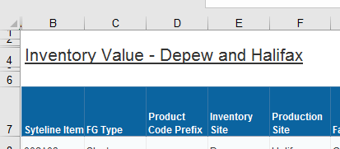

* 1. Open Last Month’s file found in:
     1. R:\Supply Chain\Inventory Management\Inventory Value\Inv Value Detail\FYYYY
  2. Save File as: Inventory Value Data with updated Year, Month number, Month prefix.
     1. Example: Inventory Value Data 2018 12-Sept (Sept is the last month of the Fiscal year 2018)
  3. Paste the copied file (created in business objects) into the ”Inventory Value - Depew and Hal” Tab
     1. Filter on Commodity Code (column J) by typing “PLT” into the search bar (this includes PLT and NLW-PLT)
     2. Uncheck any Product codes (column D) that start with a letter (SA,RM,MS) Leaving only Finished goods (product codes with numbers only)
     3. Change the FG Type to “Platinum” in column C.
     4. Unfilter
  4. Update Pivot Tables on the “Pivots” tab by clicking inside the pivot table and Click Analyze, Change data source and select all data from the Inventory Value - Depew and Hal. tab from B7 to M7 and down on the Inventory Value - Depew and Hal. Tab and hit Okay.
     1. Go to Analyze and Click on the Refresh button
     2. Do for both pivot tables
  5. Save your file
  6. Print the pivot tables
  7. Close files
  8. Open File called Inventory Inventory Value Data.xlsx found in:
     1. R:\Supply Chain\Inventory Management\Inventory Value
     2. In the “total” row associated with your file/month update the appropriate columns.
     3. Note: “Blanks” on the Pivot table are Finished Goods (FG)
  9. This spreadsheet feeds/updates the file named Inventory Value Charts FYYYY.
     1. This file needs to be updated Yearly