Purpose:
This procedure provides a general Spot Welding workmanship standard for all PCB Production Operations.

Contents

Page
1) Safety 2
2) Approved Equipment 2
3) Standard Controls 3
4) Processes 4
Process A Spot Welding with Pressure Head 4
Process B Spot Welding with Portable Hand-Held 5
Process C Spot Welding with Pressure Pencil 6
5) Troubleshooting Guide 7
6) Equipment Settings Tables 8
Note: Each spot welder uses a different scale (Watt-Second (W-S) or Percentage (%)). 8
It is extremely important to understand which scale your spot welder uses when referencing the charts below. 8
(e.g. for a 125 Watt spot welder, 50% is not the same as 50 watt-seconds. 50% is 62.5 Watt-seconds.) 8
7) Spot Welding Quality Requirements 12
8) Fusing with pressure head 13
9) Fusing Manually 15

Safety
  - Accidental contact of electrode to metal objects can cause sparks, overheating or fire. Check and be
sure the area is safe before doing any welding.
  - Ensure that flammable liquids are covered during spot welding.

Approved Equipment
  - Spot Welders
Manufacturer | Model | Wattage | Scale | Spot-Weld Settings | Fusing Settings
Unitek | 1-059-04 | 45 | W-S | Table 1 | N/A
Hughes | HRW50C | 50 | W-S | Table 2 | N/A
Unitek | 60 | 60 | % | Table 3 | Table 7
Tweezer Spotwelder | DC80D | 80 | W-S | Table 4 | Table 8, 10
Miyachi/Unitek | 100 ADP | 100 | W-S | Table 5 | N/A
Miyachi/Unitek | DP125 | 125 | % | Table 6 | Table 9, 11
Miyachi/Unitek | 125 ADP | 125 | W-S | Table 6 | Table 9, 11
  - Heads and Handles
    - Thin-line Weld Head – Unitek Peco model 80F
    - Thin-line Weld Head – Unitek Peco model EZAK/SAK
    - Miniature Weld Head – Unitek model 101F
    - Welding Tweezer Hand Piece – Miyachi/Unitek model ET0402

c) Spot Welding Tips
- Generic: Electrode design which isn’t specific toward the spot-welding application is deemed generic and is not required to be on the BOM (i.e. – ground tabs).
- Specialized: Electrode design which is specific toward the spot-welding application (i.e. structural) is deemed specialized and is required to be on the BOM (i.e. – diaphragm & end piece spot-welding on pressure sensors).
NOTES:
- Engineering has the responsibility of determining if the electrode is deemed Generic or Specialized.
- As a rule all specialized electrodes shall have their part number marked accordingly. If the electrode is unable to be marked (i.e. – tip to small) label the storage container where kept.

Standard Controls
Note: Do not store in-process work containing an amplifier and/or LTA within 12 inches of any spot welder.

  - Preparation for Spot Welding
i) Wash any components to be spot welded per TA1061.
NOTE: Dirty components will not spot weld properly. Components to be spotwelded should be free of all contaminants and debris
  - See applicable table in Section 6) for proper setting for the spot welding equipment that will be used.
  - Make sure the electrodes are clean and properly aligned prior to using equipment.
  - Per the spot welding equipment user manuals, PCB does not maintain a calibration or preventive maintenance program for spot welders.
  - The standard number of spot welds on a ribbon tab is three equally spaced spot welds. More than or less than three may be required based on the length of the ribbon tab to ensure flatness, or as required by Assembly Procedure or Router. Generally, spot welds are spaced approximately 1/32” apart.
  - Technician must spot weld an initial verification piece and perform a self-inspection to determine that the result is visually and functionally acceptable (see Section 7) for quality requirements) before spot welding the remainder of the product on the job.
  - If the initial piece produced yields an unacceptable spot weld, refer to the troubleshooting chart in Section 5). Another piece must be spot welded and tested for acceptability whenever changes are made to the settings.
  - Electrode Maintenance – Clean or reshape electrodes as necessary for the specific application.
- Remove the buildup of excess material from the electrode using a sharpening stone (#400 grit or finer) to return the electrode to its previous size.
- Rub the electrode against the sharpening stone in a back and forth motion, while turning the electrode, to create a rounded tip. For a pressure head spot welder, shape the electrode by operating the foot-pedal (if applicable) and applying very light pressure to the sharpening stone while moving the stone back and forth between the electrodes.

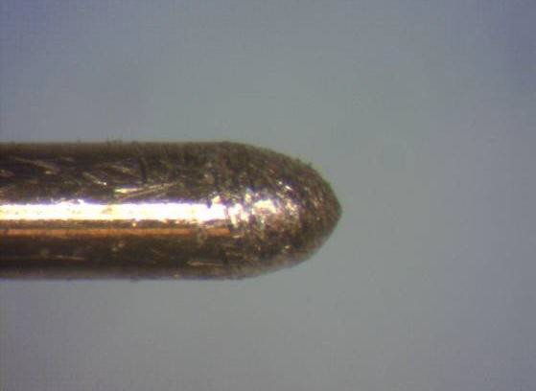

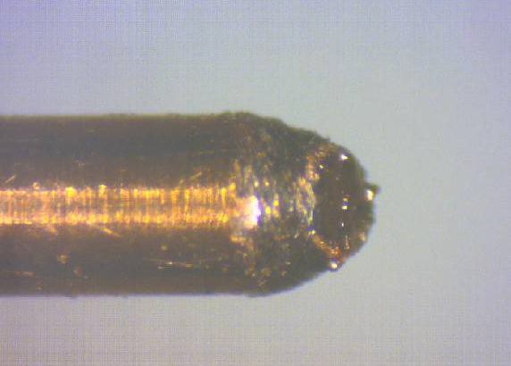
Figure 1 – Good Tip; filed electrode shape is well defined Figure 2 – Bad Tip; end is burnt (from electric arcing)

Processes

Process A Spot Welding with Pressure Head

Guidelines: This process may be used in special applications when specified on the Router or in the Assembly Procedure. (Reference 29625)

Procedure:

  - Verify configuration of the pressure heads: negative (-) should be on top and positive (+) on bottom.
  - If ribbon wire material is made from Nickel, Palladium or Platinum, then use copper electrodes in the upper and lower electrode holders; for other materials refer to Router or Assembly Procedure.
  - Turn on power supply and wait until power supply has charged.
  - Adjust or verify the settings per the tables in Section 6) unless otherwise stated in Router or Assembly Procedure.
  - Insert the part onto the lower electrode and position (each) work piece at the intended location.
  - Depress foot-pedal; as the upper electrode arm moves down, make certain work pieces are in the desired positions for the weld.
  - When upper electrode contacts the work piece, continue applying pressure to the foot-pedal; welder will fire automatically when the correct pressure is attained. The foot-pedal can then be released.
  - Visually inspect the spot weld per Quality Requirements in Section 7) and perform pull test.
  - If work piece becomes damaged during the spot welding process (for example, broken ribbon wire, excessive spot weld) remove the work piece, clean the part surface of any leftover material, and reapply.
  - Remove excess wire by cutting or breaking wire by working it back and forth.

Process B Spot Welding with Portable Hand-Held

Guidelines: This process may be used for ground tabs and strain reliefs or when specified on the Router or in the Assembly Procedure.

Procedure:

- Adjust or verify the settings per the tables in Section 6) unless otherwise stated in Router or Assembly Procedure.
- See Figure 3. Connect an electrode to the vise (or fixture) using predrilled holes. Initially connect the positive (+) side of the electrode to the vise (or fixture).

Electrode placed in predrilled hole

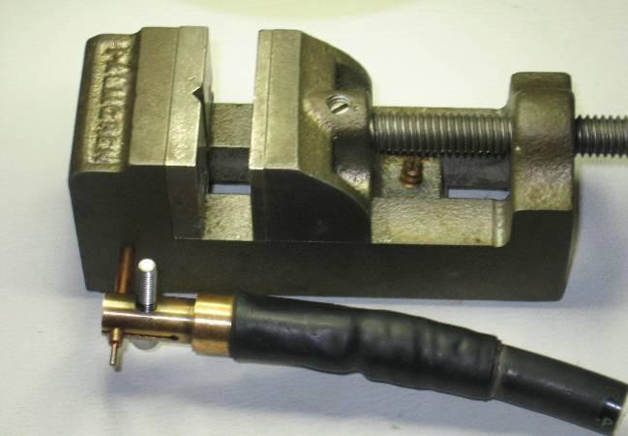
Figure 3 – Electrode attached to vise

NOTE: Connection to the vise or fixture is preferred to prevent scorching of spot-welded components. However, it is not required that an electrode be connected to the vise or fixture. The electrode may be pressed against the component as opposed to being inserted into the vise or fixture if necessary to achieve a good ground.

- Insert part to be welded into bench vise (using a fixture as appropriate).
- Place ribbon wire in desired position.
- Touch electrode to ribbon wire and depress foot-pedal.
- Inspect completed spot weld per Quality Requirements in Section 7).
- If work piece becomes damaged during the spot welding process (for example, broken ribbon wire, excessive spot weld) remove the work piece, clean the part surface of any leftover material, and reapply.
- Remove excess wire by cutting or breaking wire by working it back and forth.

Process C Spot Welding with Pressure Pencil

Guidelines: This process may be used for ground tabs or when specified on the Router or in the Assembly Procedure.

Procedure:

- Adjust or verify the settings per the tables in Section 6) unless otherwise stated in Router or Assembly Procedure.
- See Figure 4. Connect an electrode to the vise (or fixture).

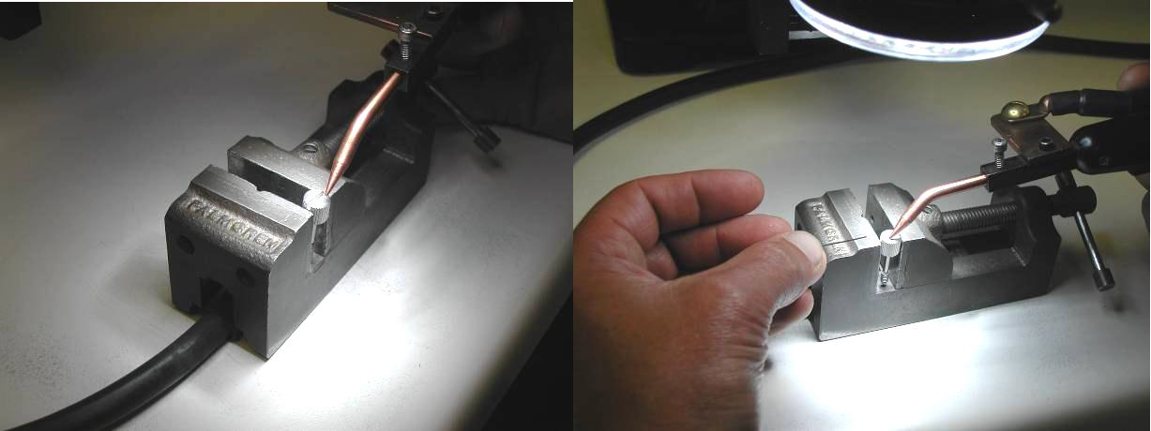

Figure 4 – Cable attached to vise

NOTE: Connection to the vise or fixture is preferred to prevent scorching of spot-welded components. However, it is not required that an electrode be connected to the vise or fixture. The electrode may be pressed against the component as opposed to inserted into the vise or fixture if necessary to achieve a good ground.

- Insert part to be welded into bench vise (using a fixture as appropriate).
- Place ribbon wire in desired position.
- Touch electrode to ribbon wire and operate hand control.
- Inspect completed spot weld per Quality Requirements in Section 7).
- If work piece becomes damaged during the spot welding process (for example, broken ribbon wire, excessive spot weld) remove the work piece, clean the part surface of any leftover material, and reapply.
- Remove excess wire by cutting or breaking wire by working it back and forth.

Troubleshooting Guide

welding operation
Problem |  | Cause | Remedy
Tips arcing on material | Not enough pressure or insufficient contact  between electrode and material. |  | Increase pressure, make sure electrode is contacting ribbon  wire sufficiently.
 | Amperage too high. |  | Reduce amperage setting, keeping amperage within  specified range (see appropriate table for settings).
 | Tips not aligned correctly. |  | Realign tips or dress tips to proper diameter.
 | Ribbon wire and base material not parallel. |  | Check to be sure materials are parallel and flat.
 | Base material may be welded to tips, causing  high resistance and poor electrical current flow. |  | Clean or dress tips.
 | Possible contamination on work piece and/or  electrode. |  | Check for contamination. If necessary, re-clean workpiece  per TA1061 and redress electrode.
Spatter or molten material  being expelled out during | Incorrect tip alignment. |  | Dress tips so they align and are flat on the material.
 | Tip size too small. |  | Check with Mfg. Engineering for proper electrode tip size for  application.
 | Output amperage too high. |  | Reduce amperage setting, keeping amperage within  specified range (see appropriate table for settings).
 | Contamination on work piece and/or electrode. |  | Clean workpiece per TA1061 and redress electrode.
Inconsistent spot weld | Base material may be welded to tips, causing  high resistance and poor electrical current flow. |  | Clean or dress tips.
 | Not enough pressure or insufficient contact between electrode and material. |  | Increase pressure, make sure electrode is contacting ribbon wire sufficiently.
Poor weld (too light) or no  weld | Contamination on work piece and/or electrode. |  | Clean workpiece per TA1061 and redress electrode.
 | Poor ground. |  | Recheck setup for proper grounding.
 | Insufficient contact between electrode and  ribbon wire. |  | Reshape tip for proper contact.
 | Output amperage too low. |  | Increase amperage setting, keeping amperage within specified range (see appropriate table for settings).
 | Polarity reversed. |  | Change polarity of the electrodes.
 | Material too thick for spot welding machine. |  | Contact Mfg. Engineering for further investigation.
Electrode Sticking | Output amperage too high. |  | Reduce amperage setting, keeping amperage within  specified range (see appropriate table for settings).
 | Contamination on work piece and/or electrode. |  | Clean workpiece per TA1061 and redress electrode.
 | Improper ground connection. |  | Ensure good ground connection:  - If using a fixture or the vise, ensure a good connection between the electrode and the fixture.  - If not using a fixture, check to see if an optional fixture is  available, or reposition the ground electrode.
 | Excessive weld head force (if applicable). |  | Reduce force.
 | Polarity reversed. |  | Change polarity of the electrodes.
Poor weld (too heavy) | Output amperage too high. |  | Reduce amperage setting, keeping amperage within  specified range (see appropriate table for settings).
 | Polarity reversed. |  | Change polarity of the electrodes.
Base piece warping | Output amperage too high. |  | Reduce amperage setting, keeping amperage within  specified range (see appropriate table for settings).
 | Wrong electrode tip shape. |  | Contact Mfg. Engineering for further investigation.

Excessive pressure. Reduce pressure.

Equipment Settings Tables

Note: Each spot welder uses a different scale (Watt-Second (W-S) or Percentage (%)).

It is extremely important to understand which scale your spot welder uses when referencing the charts below.

(e.g. for a 125 Watt spot welder, 50% is not the same as 50 watt-seconds. 50% is 62.5 Watt-seconds.)

Table 1 – 45 Watt-Second Spot Welder Settings
 |  | 1ST PULSE SETTING | 2ND PULSE SETTING | Pressure head
SPOT WELD MATERIAL | BASE MATERIAL | (watt-sec) | (watt-sec) | Force
Palladium, Platinum, and Nickel Ribbon Wire | Stainless steel, Titanium, Inconel, Tungsten, Memory rings | 1-4 W-S  (9WS scale) | N/A | N/A
Palladium, Platinum, and Nickel Ribbon Wire | Stainless steel, Titanium, Inconel, Tungsten, Memory rings | 5-10 W-S  (45WS scale) | N/A | 20-40 oz

Table 2 – 50 Watt-Second Spot Welder Settings
 |  | 1ST PULSE SETTING | 2ND PULSE SETTING
SPOT WELD MATERIAL | BASE MATERIAL | (watt-sec) | (watt-sec)
Ø.020 (24 AWG) Nickel | Inconel | 7-13 W-S | N/A

Table 3 – 60 Watt-Second Spot Welder Settings
 |  | 1ST PULSE SETTING | 2ND PULSE SETTING | Pressure head
SPOT WELD MATERIAL | BASE MATERIAL | (%) | (%) | Force
Palladium, Platinum, and Nickel Ribbon Wire | Stainless steel, Titanium, Inconel, Tungsten, Memory rings | 2-12%  (Low Scale) | N/A | N/A
Palladium, Platinum, and Nickel Ribbon Wire | Stainless steel, Titanium, Inconel, Tungsten, Memory rings | 5–10%  (High Scale) | N/A | 20-40 oz

Table 4 – DC80-D Tweezer-Weld Spot Welder
 |  | 1ST PULSE SETTING | 2ND PULSE SETTING
SPOT WELD MATERIAL | BASE MATERIAL | (watt-sec) | (watt-sec)
Palladium, Platinum, and Nickel Ribbon Wire | Stainless steel, Titanium, Inconel, Tungsten, Memory rings | 4-20 W-S | N/A

Table 5 – 100 Watt-Second Spot Welder Settings
 |  | 1ST PULSE SETTING | 2ND PULSE SETTING
SPOT WELD MATERIAL | BASE MATERIAL | (watt-sec) | (watt-sec) | Polarity | Pulse
(Qty 1) .001 Thick Inconel 600 Electrodes | (Qty 3-4) .001 Thick Inconel 600 Electrodes | 3-5 W-S | N/A | Positive | Very Short
Ø.005-Ø.015 (36AWG-26AWG) Inconel 600 | (Qty 3) .001 Thick Inconel 600 Electrodes | 9-11 W-S | N/A | Positive | Very Short
Ø.005-Ø.015 (36AWG-26AWG) Inconel 600 | Inconel X750 | 9-11 W-S | 15-17 W-S | Positive | Very Short
.003 Thick Nickel Ribbon Wire | (Qty 2-4) .001 Thick Inconel 600 Electrodes | 3-5 W-S | N/A | Positive | Very Short
.003 Thick Nickel Ribbon Wire | Inconel X750 | 9-11 W-S | 15-17 W-S | Positive | Very Short
.003 Thick Nickel Ribbon Wire | Inconel 600 | 9-11 W-S | 15-17 W-S | Positive | Very Short
.003 Thick Nickel Ribbon Wire | Stainless Steel | 5-8 W-S | N/A | Varies | Varies
Platinum Wire Ball | Inconel 600 on Hardline Inner Shield | 9-11 W-S | N/A | Positive | Very Short
Platinum Wire Ball | Inconel 600 | 7-9 W-S | N/A | Negative | Very Short
Platinum Wire Ball | Inconel X750 | 15-17 W-S | N/A | Negative | Very Short
Platinum Wire Ball | (Qty 2-4) .001 Thick Inconel 600 Electrodes | 7-9 W-S | N/A | Positive | Very Short

Table 6 – 125 Watt-Second Spot Welder Settings+
 |  | 1ST PULSE SETTING | 2ND PULSE SETTING | 1ST PULSE SETTING | 2ND PULSE SETTING
SPOT WELD MATERIAL | BASE MATERIAL | (watt-sec) | (watt-sec) | (%) | (%)
(Qty 1) .001 Thick Electrode (Inconel 600) | (Qty 1-4) .001 Thick Inconel 600 Electrodes | 1-4 W-S | 2-5 W-S  (If applicable) | 1-3% | 2-4%  (If applicable)
(Qty 1) .001 Thick Electrode (Inconel 600) | (Qty 5-8) .001 Thick Inconel 600 Electrodes | 2-5 W-S | 3-7 W-S | 2-4% | 3-6%
Nickel Ribbon Wire | (Qty 3) .001 Thick Inconel 600 Electrodes | 1-19 W-S | N/A | 1-15% | N/A
Nickel Ribbon Wire | (Qty 4) .001 Thick Inconel 600 Electrodes | 2 -20 W-S | N/A | 1.5-16% | N/A
Nickel Ribbon Wire | Stainless Steel | 2-9 W-S | N/A | 2 -7% | N/A
Nickel Ribbon Wire | Inconel x750 | 2-16 W-S | N/A | 2-13% | N/A
Nickel Ribbon Wire | Inconel 600 | 2-13 W-S | N/A | 2-10% | N/A
Nickel Ribbon Wire | Tungsten | 2-10 W-S | N/A | 2-8% | N/A
Palladium and Platinum Ribbon Wire | Stainless steel, Titanium, Inconel, Tungsten, Memory rings | 2-10 W-S | N/A | 2-8% | N/A
**Note: Unless otherwise specified, the default settings for the Miyachi/Unitek 125 ADP should be as follows:
Pulse – Short; Upslope – on; Polarity – Positive.

Table 6 (continued) |  | 1ST PULSE SETTING | 2ND PULSE SETTING | 1ST PULSE SETTING | 2ND PULSE SETTING
SPOT WELD MATERIAL | BASE MATERIAL | (watt-sec) | (watt-sec) | (%) | (%)
(Qty 1-8) .001 Thick Inconel 600 Electrodes | Stainless steel, Titanium, Inconel, Tungsten, Memory rings | 1-4 W-S | 2-5 W-S  (If applicable) | 1-3% | 2-4%  (If applicable)
Ø.020 (24 AWG) solid Nickel | Stainless steel, Titanium, Inconel, Tungsten, Memory rings | 5-8 W-S | N/A | 4-6% | N/A
Inconel 600 Hardline Inner Shield | Stainless steel, Titanium, Inconel, Tungsten, Memory rings | 12-50 W-S | N/A | 10-40% | N/A
Inconel 600 | Stainless steel, Titanium, Inconel, Tungsten, Memory rings | 4-20 W-S | N/A | 3-16% | N/A
Inconel x750 | Stainless steel, Titanium, Inconel, Tungsten, Memory rings | 4-38 W-S | N/A | 3.5-30% | N/A
Ø.005-Ø.015 (36AWG-26AWG) Inconel 600 | (Qty 3) .001 Thick Inconel 600 Electrodes | 3-25 W-S | N/A | 2.5-9% | N/A
Ø.005-Ø.015 (36AWG-26AWG) Inconel 600 | Inconel x750 pin | 4-25 W-S | N/A | 3-20% | N/A
Ø.005-Ø.025 (36AWG-22AWG) Inconel 600 | Inconel x750 pin | 6-32 W-S | N/A | 5-25% | N/A

**Note: Unless otherwise specified, the default settings for the Miyachi/Unitek 125 ADP should be as follows:
Pulse – Short; Upslope – on; Polarity – Positive.

Spot Welding Quality Requirements

- Inspect completed spot welds at min.10X magnification using the following inspection criteria:
    - Welds must have an even, concentric appearance with no excessive dishing.
    - Welds should be centered on the ribbon wire.
    - Test strength of weld by gently pulling on ribbon wire.
    - See figures below for acceptance and rejection samples.

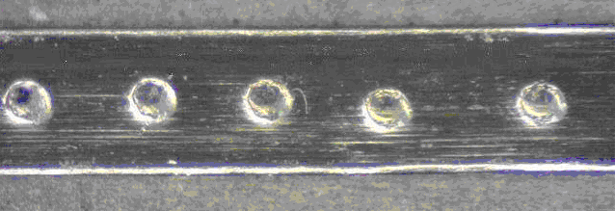

Figure 5 – Acceptable Spot Welds

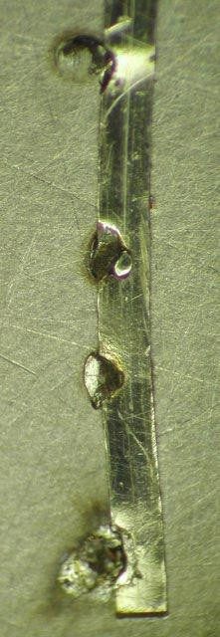
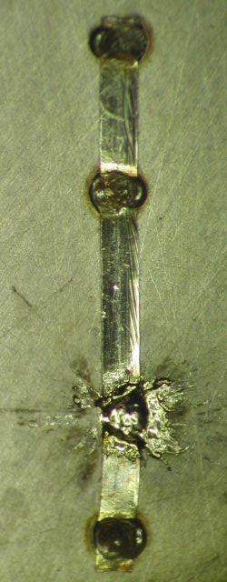
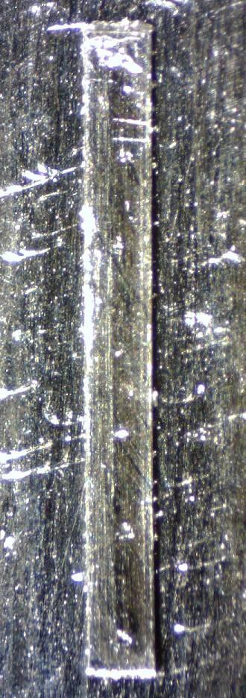
Figure 6 – Reject: TOO LIGHT Figure 7 – Reject: TOO HEAVY Figure 8 – Reject: NOT CENTERED

Fusing with pressure head

- Set the spot welder to the appropriate fusing settings based on the type of spot welder:

Table 7 – 60 Watt-Second Spot Welder Settings for Fusing
 |  | 1ST PULSE SETTING | 2ND PULSE SETTING
FUSE MATERIAL | BASE MATERIAL | (%) | (%)
Stainless Steel | Stainless Steel | 40 ±15 | N/A

Table 8 – DC80-D Tweezer-Weld Spot Welder

FUSE MATERIAL | BASE MATERIAL | 1ST PULSE SETTING  (watt-sec) | 2ND PULSE SETTING  (watt-sec)
Stainless Steel | Stainless Steel | 40 ±15 W-S | N/A

Table 9 – 125 Watt-Second Spot Welder Settings

 |  | 1ST PULSE SETTING | 2ND PULSE SETTING | 1ST PULSE SETTING | 2ND PULSE SETTING
FUSE MATERIAL | BASE MATERIAL | (watt-sec) | (watt-sec) | (%) | (%)
Stainless steel | Stainless steel | 25 ±15 W-S | 50 ±15 W-S | 20 ±15 | 40 ±15
If you do not see the welder being used on this chart please contact engineering for assistance
**Note: Unless otherwise specified, the default settings for the Miyachi/Unitek 125 ADP should be as follows:
Pulse – Short; Upslope – on; Polarity – Positive.
.

- Place the correct fusing electrode in the fusing fixture and verify that the fusing surfaces are clean. Fusing electrode surfaces can be cleaned with ScotchBrite. (See Figure 9)
- Put the sensor between the fusing electrodes and activate the clamp with the pneumatic switch. (See Figure 10)
- Cycle the welder twice, release the sensor and verify that the parts have been fused together.
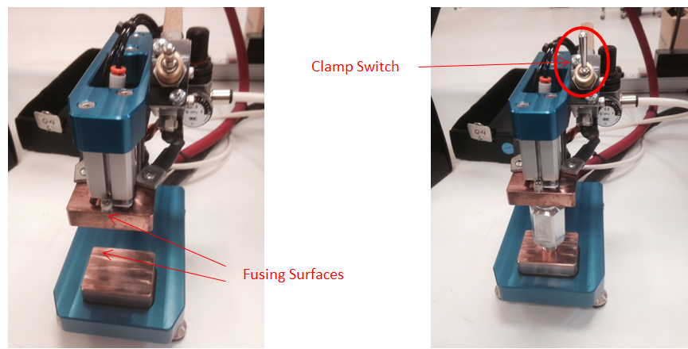
Figure 9 – Fusing Fixture Figure 10– Fusing Fixture

Fusing Manually

Reference Figure 11, Table 10, and Table 11
- Unless otherwise stated, install the fusing electrode (67247-01) or equivalent into the electrode clamp on the end of the wire.
- Set the spot welder to the appropriate fusing settings.
- With the component in place, place the fixture on the component to be fused.
- Place Electrode onto the fixture and fuse the component to the base material.
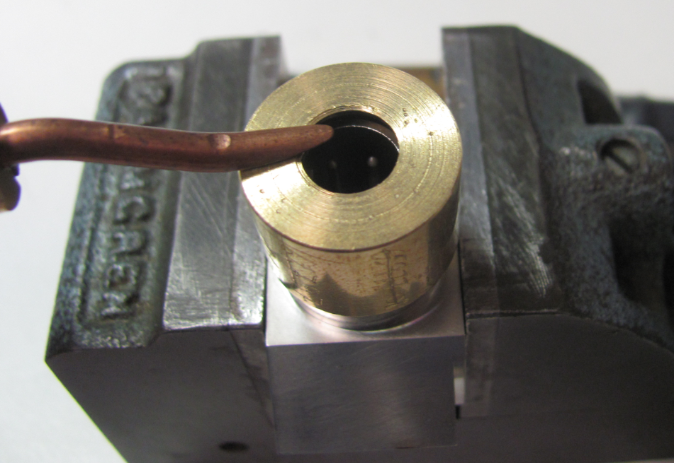
Sensor
(Base material)
Component
(Spot-Weld material)
Fusing Electrode
Fixture
Figure 11 – Fusing Manually

Table 10 – DC80-D Tweezer-Weld Spot Welder Settings for Manual Fusing
 |  | 1ST PULSE SETTING | 2ND PULSE SETTING
FUSE MATERIAL | BASE MATERIAL | (watt-sec) | (watt-sec)
Ø.25-Ø.50  Inconel | Inconel | 35 ±15 W-S | N/A
Stainless Steel | Stainless Steel | 40 ±15 W-S | N/A

Table 11 - 125 Watt-Second Spot Welder Settings for Manual Fusing
 |  | 1ST PULSE SETTING | 2ND PULSE SETTING | 1ST PULSE SETTING | 2ND PULSE SETTING
FUSE MATERIAL | BASE MATERIAL | (watt-sec) | (watt-sec) | (%) | (%)
Ø.25-Ø.50  Titanium (Ti6Al4V) | Titanium (Ti6Al4V) | 50 ±15 W-S | 63 ±15 W-S | 40 ±15 | 50 ±15
Ø.50-Ø1.00  Titanium (Ti6Al4V) | Titanium (Ti6Al4V) | 50 ±15 W-S | 70 ±15 W-S | 40 ±15 | 56 ±15
Ø.25-Ø.50  Stainless Steel | Stainless Steel | TBD | TBD | TBD | TBD
Ø.50-Ø1.00  Stainless Steel | Stainless Steel | 50 ±15 W-S | 63 ±15 W-S | 40 ±15 | 50 ±15
Ø.13-Ø.25  Inconel | Inconel | 15 ±5 W-S | NA | 12 ±5 | NA
Ø.25-Ø.50  Inconel | Inconel | TBD | TBD | TBD | TBD
**Note: Unless otherwise specified, the default settings for the Miyachi/Unitek 125 ADP should be as follows:
Pulse – Short; Upslope – on; Polarity – Positive.

Appendix A

Process FMEA Information
 |  |  |  |  |  |  |  |  |  |  |  |  |  |  |  | FMEA Original Date: |  |  |  |  | 11/23/2020
 |  |  |  |  |  |  |  |  |  |  |  |  |  |  | FMEA Revised Date: |  |  |  |  |  | N/A
Item or Process Step | Potential Failure Mode | Potential Effect(s) of Failure |  |  | S* | Potential Cause(s) | O* | Current Controls |  |  | D* | R* | RecommAction |  |  |  | Responsand Target Date | “After” Action Taken | S* | O* |  | D* | R*
Component Storage & Handling | Amplifier damaged by electrical charge | Will cause direct or latent failure |  |  | 7 | Electrical charge created by weld equipment | 2 | In-process work w/ amp and/or LTA must be kept 12” from spot welding equipment per TA1000 |  |  | 4 | 56
 | Parts mechanically damaged | Direct or latent failure |  |  | 7 | Parts dropped in transport | 2 | Training |  |  | 4 | 56
Pre-weld preparation | FOD on components | Weak spot weld bond |  |  | 6 | Components not cleaned adequately | 4 | Components cleaned per TA1061 prior to spot weld |  |  | 4 | 96
 | Poor spot weld bond or weld spatter | Spot weld will come loose |  |  | 6 | Poorly maintained electrode | 4 | Electrodes maintained per TA1000 Sec. 3 |  |  | 4 | 96
Spot Weld Process | Poor spot weld bond | Ribbon tab will come loose |  |  | 7 | Insufficient number of spot welds on ribbon tab | 3 | Number of spot welds specified in TA1000 Sec. 3. |  |  | 4 | 84
 | Poor spot weld bond | Ribbon tab will come loose |  |  | 7 | Poor ground | 3 | Proper grounding per set-up instructions in TA1000 |  |  | 4 | 84
 | Poor spot weld bond | Ribbon tab will come loose |  |  | 7 | Insufficient contact between electrode and ribbon wire | 3 | Guidelines for proper tip shape in TA1000 Sec. 3 |  |  | 4 | 84
 | Poor spot weld bond | Ribbon tab will come loose |  |  | 7 | Output amperage too low | 3 | Proper amperage settings specified in TA1000 Sec. 6 |  |  | 4 | 84
 | Poor spot weld bond | Ribbon tab will come loose |  |  | 7 | Polarity reversed | 3 | Proper set-up specified in TA1000 |  |  | 4 | 84
 | Poor spot weld bond | Ribbon tab will come loose |  |  | 7 | Material too thick for spot weld machine | 3 | Thickness limits specified in TA1000 Sec. 6 |  |  | 4 | 84
 | Tips arcing on material | Poor adhesion of spot weld |  |  | 6 | Insufficient pressure or contact between electrode and material | 4 | Settings specified in TA1000 Sec. 6 |  |  | 4 | 96
 | Tips arcing on material | Poor adhesion of spot weld |  |  | 6 | Amperage too high. | 4 | Settings specified in TA1000 Sec. 6 |  |  | 4 | 96
 | Tips arcing on material | Poor adhesion of spot weld |  |  | 6 | Tips not aligned correctly. | 4 | Tip maintenance specified in TA1000 Sec. 3 |  |  | 4 | 96
 | Tips arcing on material | Poor adhesion of spot weld |  |  | 6 | Ribbon wire and base material not parallel. | 4 | Set-up instructions in TA1000 |  |  | 4 | 96
 | Tips arcing on material | Poor adhesion of spot weld |  |  | 6 | Base material may be welded to tips, causing  high resistance and poor electrical current flow. | 4 | Tip maintenance specified in TA1000 Sec. 3 |  |  | 4 | 96
 | Tips arcing on material | Poor adhesion of spot weld |  |  | 6 | Possible contamination on work piece and/or  electrode. | 4 | Components cleaned per TA1061 prior to welding |  |  | 4 | 96
 | Spatter or molten material  being expelled out during  welding | Loose particles could cause shorting condition if not removed |  |  | 6 | Incorrect tip alignment. | 3 | Tip maintenance specified in TA1000 Sec. 3 |  |  | 5 | 90
 | Spatter or molten material  being expelled out during  welding | Loose particles could cause shorting condition if not removed |  |  | 6 | Excessive pressure | 3 | Proper pressure specified in TA1000 Sec. 6 |  |  | 5 | 90
 | Spatter or molten material  being expelled out during  welding | Loose particles could cause shorting condition if not removed |  |  | 6 | Output amperage too high | 3 | Set-up instructions in TA1000 |  |  | 5 | 90
 | Spatter or molten material  being expelled out during  welding | Loose particles could cause shorting condition if not removed |  |  | 6 | Tip size too small | 3 | Guidance on tip size in TA1000 |  |  | 5 | 90
 | Inconsistent spot weld | Poor adhesion of spot weld |  |  | 6 | Base material may be welded to tips, causing  high resistance and poor electrical current flow | 4 | Tip maintenance specified in TA1000 Sec. 3 |  |  | 4 | 96
 | Inconsistent spot weld | Poor adhesion of spot weld |  |  | 6 | Not enough pressure or insufficient contact between electrode and material. | 4 | Proper pressure specified in TA1000 Sec. 6 |  |  | 4 | 96
 | Electrode sticking | May pull spot weld nugget out |  |  | 4 | Output amperage too high | 4 | Set-up instructions in TA1000 |  |  | 4 | 64
 | Electrode sticking | May pull spot weld nugget out |  |  | 4 | Contamination on work piece and/or electrode | 4 | Components cleaned per TA1061 prior to welding |  |  | 4 | 64
 | Electrode sticking | May pull spot weld nugget out |  |  | 4 | Improper ground connection | 4 | Set-up instructions in TA1000 |  |  | 4 | 64
 | Electrode sticking | May pull spot weld nugget out |  |  | 4 | Excessive weld head force | 4 | Set-up instructions in TA1000 |  |  | 4 | 64
 | Electrode sticking | May pull spot weld nugget out |  |  | 4 | Polarity reversed | 4 | Set-up instructions in TA1000 |  |  | 4 | 64
 | Heavy weld | May interfere with other components |  |  | 4 | Output amperage too high | 4 | Set-up instructions in TA1000 |  |  | 2 | 32
 | Heavy weld | May interfere with other components |  |  | 4 | Polarity reversed | 4 | Set-up instructions in TA1000 |  |  | 2 | 32
 | Base piece warping | May cause mechanical stress on components |  |  | 6 | Output amperage too high | 4 | Set-up instructions in TA1000 |  |  | 4 | 96
 | Base piece warping | May cause mechanical stress on components |  |  | 6 | Wrong electrode tip shape | 4 | Tip maintenance specified in TA1000 Sec. 3 |  |  | 4 | 96
Risk Priority Number = |  |  |  |  |  |  |  |  |  |  |  |  | “After” Risk Priority Number =
*S = Severity, O = Occurrence, D = Detection Key
Scaling is 1-10 based on the rating scale in EN036

Note: RPN > 100 requires action to reduce risk

